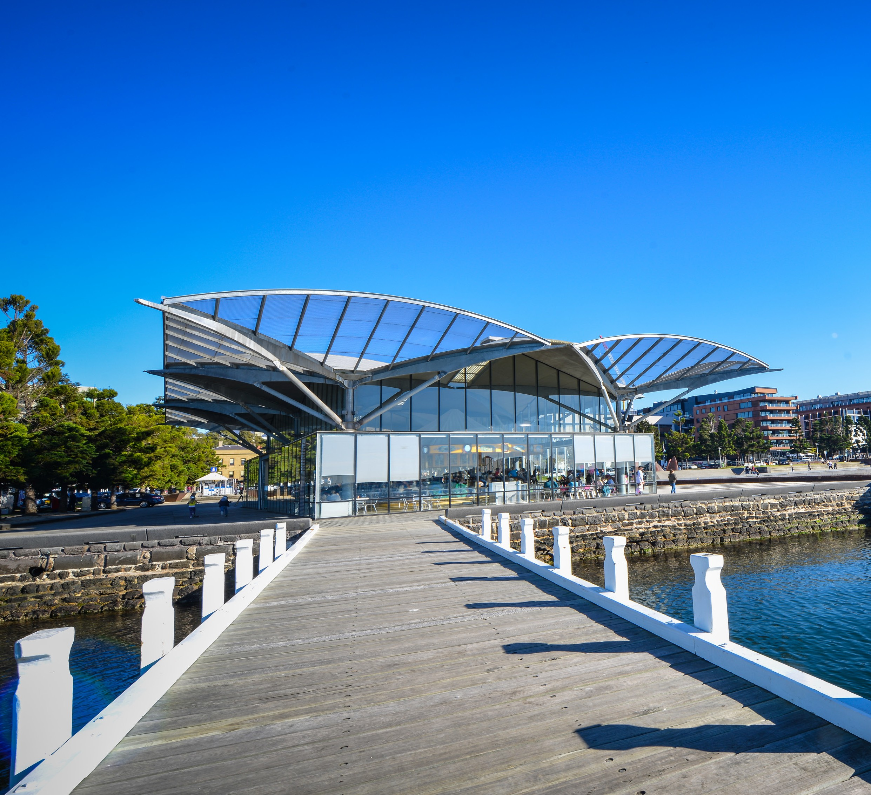

THE CITY OF
GREATER GEELONG

GEELONG WATERFRONT
MASTERPLAN

COMMUNITY AND STAKEHOLDER ENGAGEMENT - STAGE 1 SUMMARY
JULY 2023
FINAL

COMMUNITY ENGAGEMENT SUMMARY
The City of Greater Geelong invited feedback on the current Geelong Waterfront masterplan, listening to the community and visitors to discover what they value and
envision for its future. This summary presents the broad range of ideas and aspirations provided during the Stage 1 engagement period, from mid-April to May 2023.
The City would like to thank the participants who generously shared their time and energy throughout this stage of the engagement process.

Project background and phases Aim

The Geelong Waterfront is an iconic site on the traditional lands of the Wadawurrung People. The current masterplan prepared in 2011 is due for review.
Over a six week period, the City, and engagement practitioners, MosaicLab, began Stage 1 engagement. The team sought to gain insight from the community and visitors and discover what they value and envision for its future, as they prepare the new masterplan.
This summary outlines the process undertaken and the feedback provided by the community and key stakeholder groups. The full engagement report from MosaicLab is provided as an appendix. This summary
will also explain how the feedback will be incorporated into the draft masterplan.
When the draft masterplan is complete, it will be shared with the community for another round of feedback before the Masterplan is finalised in late 2024.
The updated masterplan will set the vision and guide works along the Corio Bay foreshore over the next 10 to 20 years. It will provide urban design integration with several major projects including the Geelong Convention and Exhibition Centre and Geelong Waterfront Safe Harbour Precinct Project, along with connections to our Wurriki Nyal Civic Precinct and Mercer-Gheringhap Streetscape Upgrades.

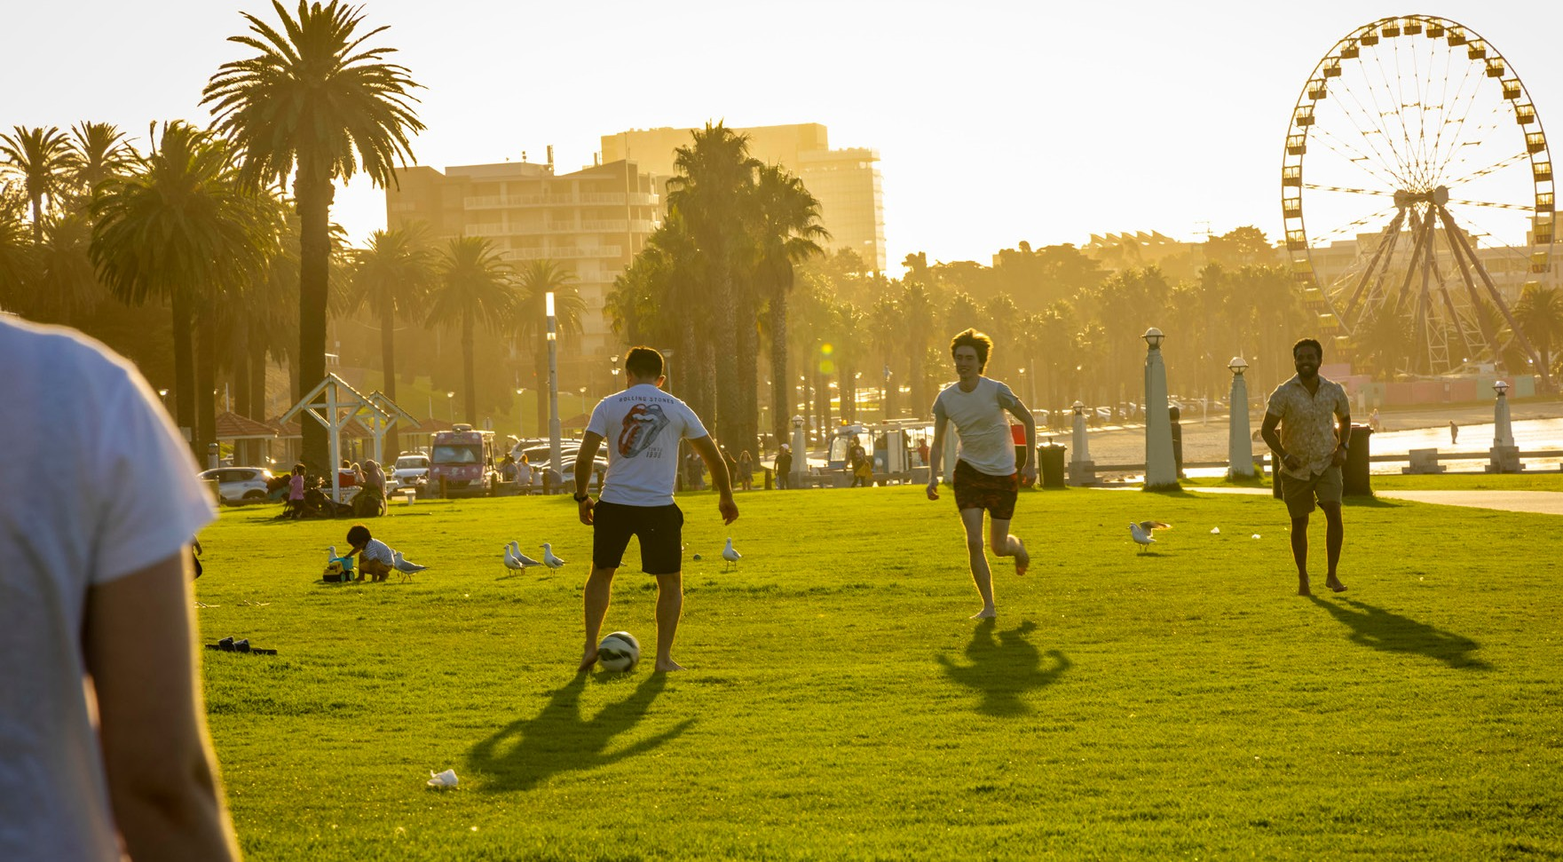

HOW AND WHO WE ENGAGED
The community consultation was open for six weeks, closing at the end of May 2023. The City engaged MosaicLab, local community engagement practitioners to lead the process and report on their findings as part of Stage 1 engagement. The methods and levels of engagement used during the process included:
Four face-to-face listening post sessions were held on-site. Sessions were held during the school holidays to engage with visitors, at night time to understand the site after business hours and whilst the Geelong Makers and Growers Market was underway.
165 contributions were received.
Listening Posts
An online community survey with social pin-point maps & ideas posting page was widely distributed via the ‘Have Your Say’ (HYS) platform allowing the community to provide feedback on issues and opportunities for the planning project.
361 survey contributions and 204 comments and posts on the maps and ideas pages were received.
Community Survey

Meetings were held with the following organisations to learn about their plans and vision and use of the site. Participants included Department of Energy, Environment and Climate Action, Development Victoria, Regional Development Victoria and Deakin University
Interviews with Victorian State
Government and Deakin University
Consultants ran a deep dive session with a key interest group from Barwon Health representing older residents, seeking to understand how they use the site, listen to memories and understand their experience and challenges of using the site.
12 community members participated.
Community Deep Dive Session
20 one to one interview sessions for key business and community stakeholders were offered in either a face to face or phone call format.
13 organisations participated.
Interviewing Business and Community Organisations
One face-to-face workshop was attended by 5 community and business members. 2 online sessions and 1 other face to face session were offered but no registrations were received.
5 community and business members attended.
Community Workshop

The City attended an onsite walk with Wadawurrung traditional owners to listen and learn.
Site Walk
Staff presented the project to the youth council and engaged with them in a short visioning workshop.
Youth Advisory Committee

HOW WE COMMUNICATED

48 3

1,900

days of engagement for Stage 1

responses to the Have Your Say survey
361
articles printed in local Geelong and Melbourne based newspapers

people following the Have Your Say page
91
reach / impressions a6ctio2ns (clicks,
comments, shares, reactions etc)
204

suggestions from the public provided via social map & ideas page

WHAT YOU TOLD US

A high quality public
open space integrating word class sustainability
features. A pedestrian oriented space that celebrates the Indigenous and non-Indigenous heritage of the area. A diverse land use providing
opportunities for increased residential population and range of retails and community uses, including art
spaces and public/street art.

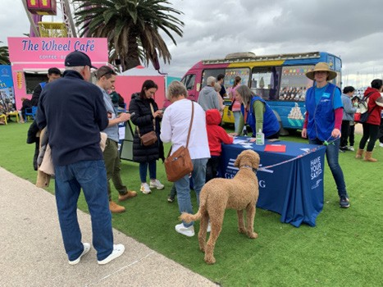
I
would imagine a clean less polluted waterfront.
I hope the waterfront can be a home to wildlife.

HIGHLIGHTS FROM WHAT WE HEARD
The following is a selection of ideas and quotes submitted by the community during the Stage 1 engagement phase.

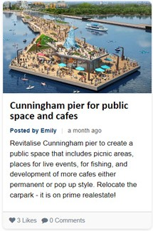
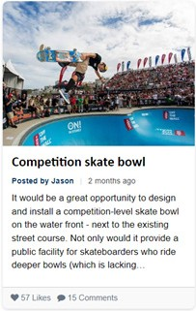
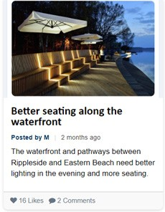

Corayo
(Corio Bay) has always been a gathering space for our
people, for the community and for visitors. Moving forward we want people to know our story when they visit and gather.
Corrina Eccles, Wadawurrung Traditional Owner

An

I
would like to see a shared path all
the way from Limeburner’s to Rippleside. Although there is a path now it has frequent

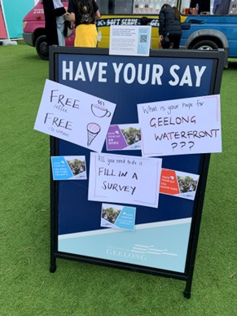
engaging space that
encourages participation from all age groups and is renowned for its beautiful scenery and facilities.
interruptions and disappears really from Cunningham Pier to the Western Beach sheds. Beyond there to Rippleside it is too narrow, too rough and the
light poles are unsafe for cyclists.

KEY PRIORITIES AND THEMES
The key purpose of seeking community input is to ensure the new masterplan reflects the needs and aspirations of the community and other stakeholders. The following is a summary of the key priorities and themes from our engagment.

Leisure and recreation activities Improvements to amenities

- More and improved walking and cycling opportunities were frequently mentioned, with a desire for continuous tracks, wider paths to improve safety, smoother surfaces, and tracks in natural settings.
- Common requests included the addition of swimming and bathing opportunities through saltwater pools and improving beach swimming quality.
- Respondents expressed a need for outdoor physical activity spaces, equipment, and development of boating facilities.
- Cunningham Pier received comments opposing it as a car park.
- Common requests included clean amenities, removal of rubbish, and the presence of more trees and plants for shade (preferably native species).
- Respondents requested additional seating, tables, and high-quality and upgraded children’s playgrounds.
- The majority wanted the bollards preserved.
- Opinions differed regarding dog management; while some maintained they enjoy exercising their dogs, others advocated for stricter controls.
- Improvements to the quantity and quality of toilets, showers, changing facilities, lighting, artwork, signs and interpretation, water fountains and features, the sea well, and BBQs were sought.
- More shade was desired.

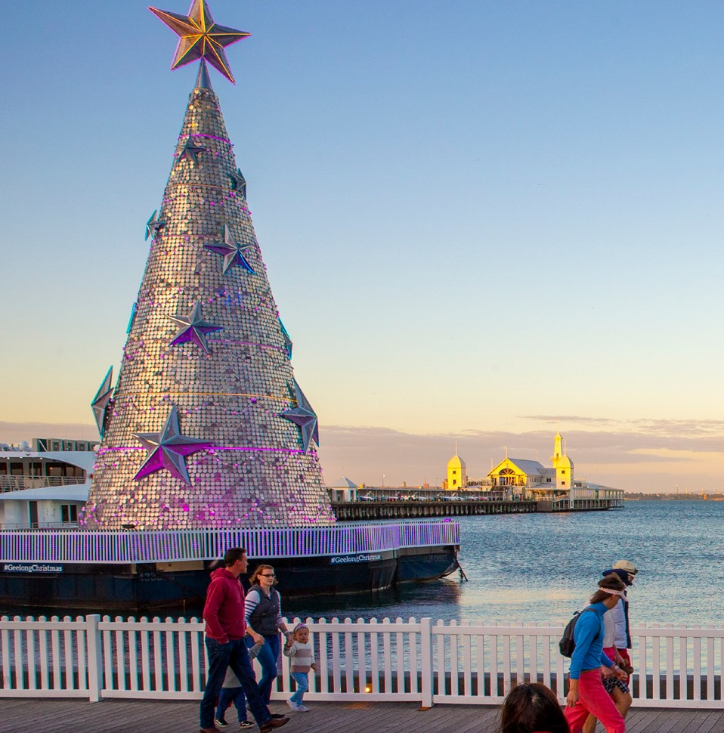
Inclusion and diversity improvements

  - Respondents wanted better disability access, especially to beaches and organized activities.
  - They also sought the incorporation of Indigenous representation into the waterfront design.

Transportation issues and preferences

P

  - Respondents argued that there should be more and better public parking available. There was not a consensus on where more parking should go but they would like it away from the water, not disturbing the view.
  - A safer and pedestrian-focused future was desired, with reduced traffic congestion and diverted flow away from the waterfront.
  - Better connectivity to the rest of Geelong via improved links with public transport, walking and cycling paths, and a better ferry service to Melbourne and around the bay were requested.

Urban design preferences and suggestions

- Respondents frequently suggested providing vast green open spaces for outdoor activities, with detailed comments describing smaller spaces and the provision of shelter or shading.
- The desired overall presentation and feel of the area included a cohesive design highlighting historic, indigenous, modern, built, and natural features.
- Respondents sought the preservation and integration of heritage into modern design and development features.

Commercial enterprise preferences and suggestions
  - Respondents wanted cafes, restaurants, bars, and food trucks located near the water and open for longer hours.
  - Live music events were the most popular entertainment option mentioned.
  - Improvements to the area to attract tourists, as well as the addition of shops and weekly markets, were requested.

Overall management issues and preferred focus

  - Respondents sought a community and family-focused area that is welcoming and universally popular.
  - Environmental quality was important, with a desire for a thriving, healthy, and unpolluted environment that people can enjoy safely.
  - Safety at all hours of the day, appropriate maintenance of facilities, and high-quality presentation were emphasized.

NEXT STEPS
The information, issues and ideas gathered through the consultation will inform the development of the draft master plan. Once the draft masterplan is complete, it will be released for another round of engagement where the community will have the
opportunity to provide further feedback on what is proposed.

Timeline

MID-JULY 2023
JULY -
DECEMBER
FEBRUARY 2024
APRIL 2024
LATE 2024

Share feedback on Stage 1 engagement
Prepare draft masterplan
Undertake Stage 2 engagement on draft masterplan
Share feedback on Stage 2 engagement
Prepare final masterplan

STAY IN THE LOOP
To receive the latest updates, follw the project at:
https://yoursay.
geelongaustralia.com.au/ GWFMP

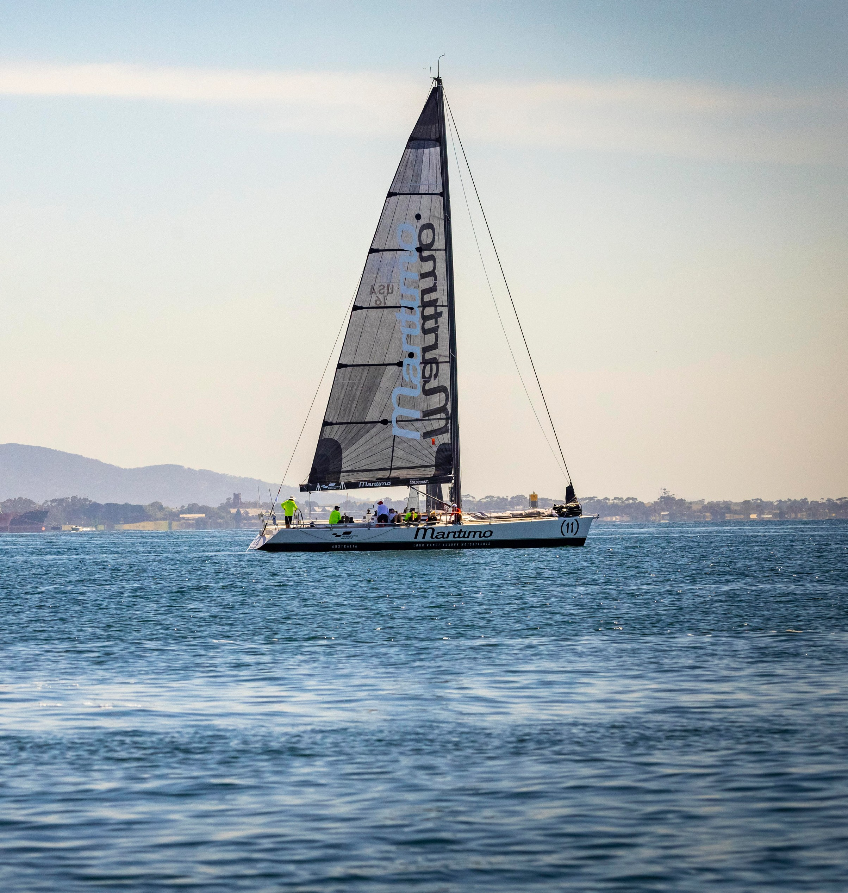

ACKNOWLEDGEMENT OF COUNTRY
We Acknowledge the Wadawurrung People as the Traditional Owners of the Land, Waterways and Skies. We pay our respects to their Elders, past and present. We Acknowledge all Aboriginal and Torres Strait Islander people who are part of our Greater Geelong community today.

CITY OF GREATER GEELONG
PO Box 104
Geelong VIC 3220
P: 5272 5272
E: contactus@geelongcity.vic.gov.au www.geelongaustralia.com.au

CUSTOMER SERVICE CENTRE
100 Brougham Street
Geelong VIC 3220 8.00am – 5.00pm

© City of Greater Geelong 2022

LATEST NEWS:
@CityofGreaterGeelong @GreaterGeelong @CityofGreaterGeelong CityofGreaterGeelong

