

GEELONG WATERFRONT MASTERPLAN REVIEW

Community and Stakeholder Engagement - Stage 1

ENGAGEMENT REPORT

April-June 2023

# TABLE OF

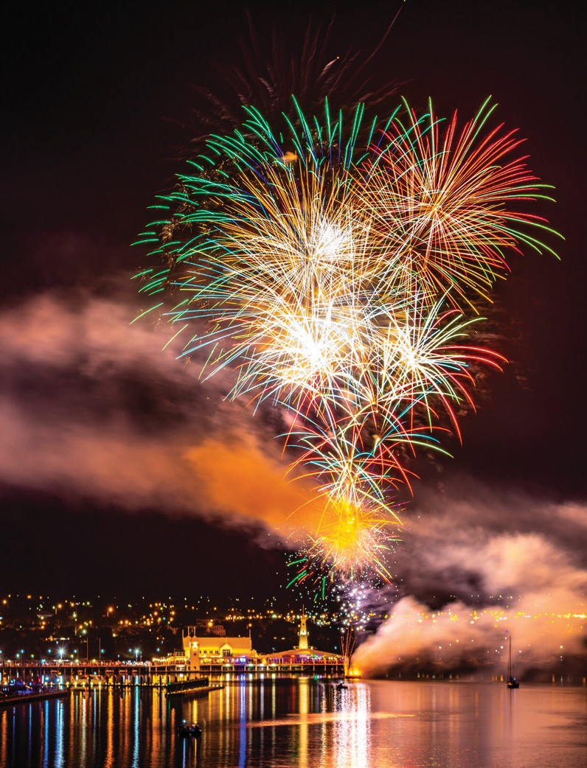

CONTENTS

Introduction 1 Project objectves 1 Engagement objectives 2

Scope 2

Engagement process overview 3 Activity 4

Engagement findings 5

Wadawurrung site walk 5

Survey - key findings 6 Listening posts 10 Workshop 11 Interviews - business and community 16

Interviews – state government& Deakin University 23 Deep dive conversation 25

survey analysis 26 Overview 26 Option selection results 27 What respondents said 34 Respondent details 54

next steps 58

appendix 1 59

Geelong Waterfront Masterplan Survey 59

# INTRODUCTION

1

Corayo (Corio Bay) has always been a gathering space for our people, for the community and for visitors. Moving forward we want people to know our story when they visit and gather.

**Corrina Eccles, Wadawurrung Traditional Owner**

This engagement report has been prepared to share the results of the engagement activities that were delivered through April – June 2023, to help City of Greater Geelong understand the ideas and aspirations of people living, working in, and visiting Geelong Waterfront.

The Geelong Waterfront is an iconic site on the traditional lands of the Wadawurrung people. In preparing to update the Geelong Waterfront Masterplan, the City of Greater Geelong has engaged with people living, working in, and visiting the area to discover what they value and envision for its future.

This report presents the key findings of the engagement activities so that those who participated in the engagement can see the extent and types of feedback received, and for the project team to use to support their preparation of the draft Waterfront Masterplan. When the draft Masterplan is complete, it will be shared with the community for another round of feedback before the Masterplan is finalised in late 2024.

### PROJECT OBJECTIVES

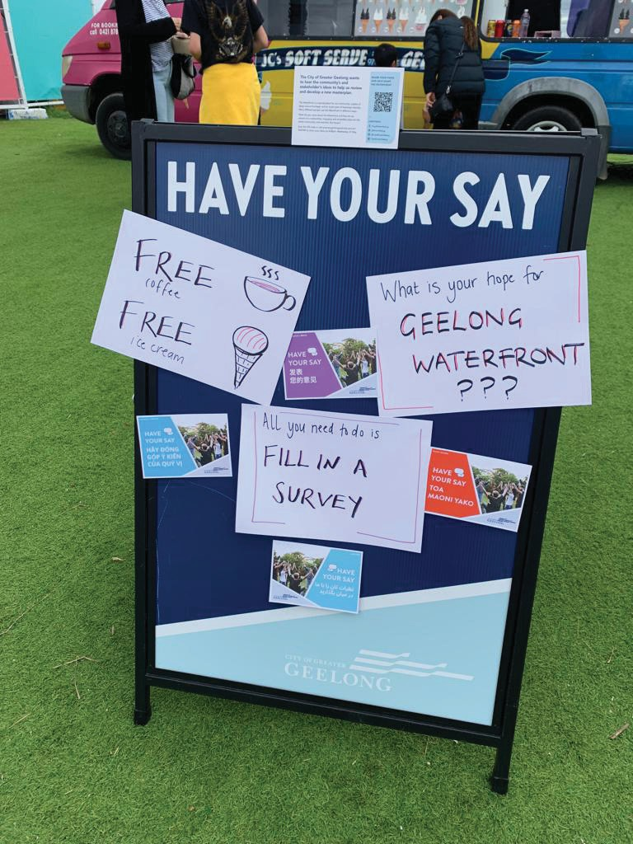

The objectives of the Waterfront Masterplan are to produce an overall strategic framework to guide future development and public realm upgrades for the waterfront to enhance:

* The landscape quality of the foreshore reserve.
* Public accessibility and safety compliance.
* Walking and cycling connections.
* Connection with water experiences.
* Visitor amenity and facilities.
* Events and temporary business provisions.
* Tourism and cultural experience.
* Operational management and services.

Geelong Waterfront Masterplan Review | Stage 1 Engagement Report | April to June 2023

### ENGAGEMENT OBJECTIVES

The objectives of the engagement were to:

* Provide a clear direction for the masterplan
* Hear from a wide range of perspectives
* Understand how people use and value the waterfront
* Ensure those involved felt heard, optimistic and connected through the engagement process
* Provide a clear, inclusive and accessible process

The level of influence the community can have on this project is set at the level of INVOLVE according to the International Association for Public Participation Engagement Spectrum� This means that the City of Greater Geelong will document and record all inputs to the engagement, report back on what they have heard, and work to understand community and stakeholder concerns and priorities and reflect these in the draft masterplan. Where the City cannot incorporate a recommendation they will explain why, the City will provide transparent, regular progress updates during finalisation of the draft masterplan.

*\*Please note the project and engagement objectives are included in more detail in the Strategic Engagement Plan which was created to guide the project.*

### SCOPE

The scope of the engagement is detailed below. Some engagement responses were beyond scope, however, they have been included in this report where possible in order to reflect community and stakeholder sentiment in connection to the waterfront.

Negotiable

– what you can influence:

How the waterfront is experienced i�e� the qualities of the area, the types of experiences available

How spaces are used and what facilities and services might be needed

What changes should be prioritised

Where the gaps and issues are in walking and movement connections, where planting and shade is required, where safety and access needs to be improved etc

How the waterfront is connected to other areas

Ideas about how heritage features, including cultural heritage, are incorporated

What acknowledgment of Wadawarrung looks like

Non-negotiable

– what you cannot influence:



The project scope excludes detailed design, planning scheme amendments and built form guidance

There are some constraints relating to privately owned sites but the City can share community feedback with those entities

Future builds that are already underway e�g� Royal Geelong Yacht Club & Geelong Convention Centre

Legislative requirements and regulations, including the Marine and Coastal Act, and the Heritage Act

### ENGAGEMENT PROCESS OVERVIEW

The engagement activities began with a codesign process to produce a Strategic Engagement Plan to guide the wider engagement� This step included a walk with Wadawurrung Traditional Owner, Corrina Eccles� Engagement with the community and other stakeholders began in April and the process concludes with the writing of this report in June 2023� Following the drafting of the masterplan, phase two of engagement will begin�

**ROADMAP**



Phase 2 will be a round of community engagement on the draft

masterplan, later in 2023, details to be announced.

**PHA S E 1 p ha S e 2**

**activation**

**engagement**

**reporting**

**draft dates**

***June 2023***

***April - May 2023***

***March 2023***

**purpose**

Review of engagement findings to help inform the masterplan development

Wider engagement with community & stakeholders to capture their values and vision for the waterfront

Connect with Traditional Owners

Notify and activate community in preparation for consultation

**activities**

Analysis of engagement findings Theming

On-site meetings with stakeholders Community forums Stakeholder forums

Listening post sessions Online survey

Wadawurrung site walk Codesign planning session Engagement planning

**outputs**

Wider Engagement Report

Summary reports

Strategic Engagement Plan

**who**

MosaicLab

City of Greater Geelong - Urban Design and Heritage

Local residents Business owners and operators

Recreational users & visitors Broader community

Wadawurrung Traditional Owners City of Greater Geelong MosaicLab

#### ACTIVITY SUMMARY

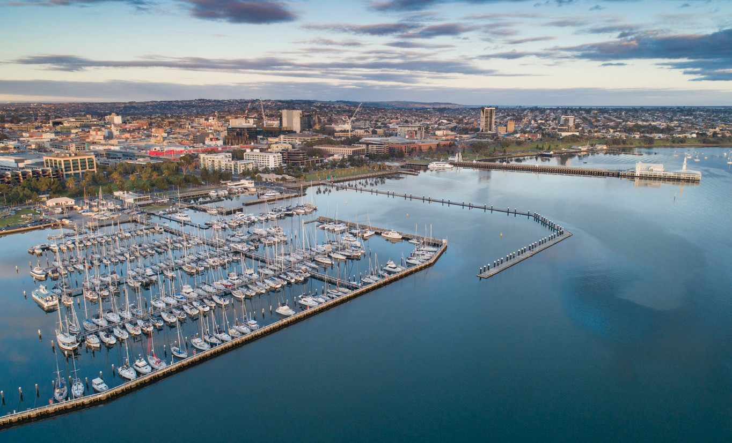

All activities are summarised below.

|  |  |  |
| --- | --- | --- |
| Activity | Date | Participants |
| Wadawurrung site walk | 6 March | 10 |
| Survey (hosted on the City’s Have Your Say platform) | 14 April to 31 May | 361 |
| Listening post – school holiday focus | 17 April | 70 |
| Listening post – after dark focus | 28 April | 35 |
| Listening post – market focus | 8 May | 60 |
| 2-hour community workshop | 11 May | 5 |
| Deep dive session | 18 May | 12 |
| Interviews by MosaicLab | 24 May to 1 June | 13 |
| Interviews by City of Greater Geelong staff | 24 May to 1 June | 3 |

* *Numbers at the listening posts are estimates only*

The original plan for the project was to conduct four 2-hour workshops - two during business hours and two after hours. Due to low uptake, the process was adapted to offer deep dive sessions to targeted groups including those who are socially isolated, youth, and the arts and environment sectors� Of those groups, a social support group took up the opportunity to participate.

# ENGAGEMENT FINDINGS

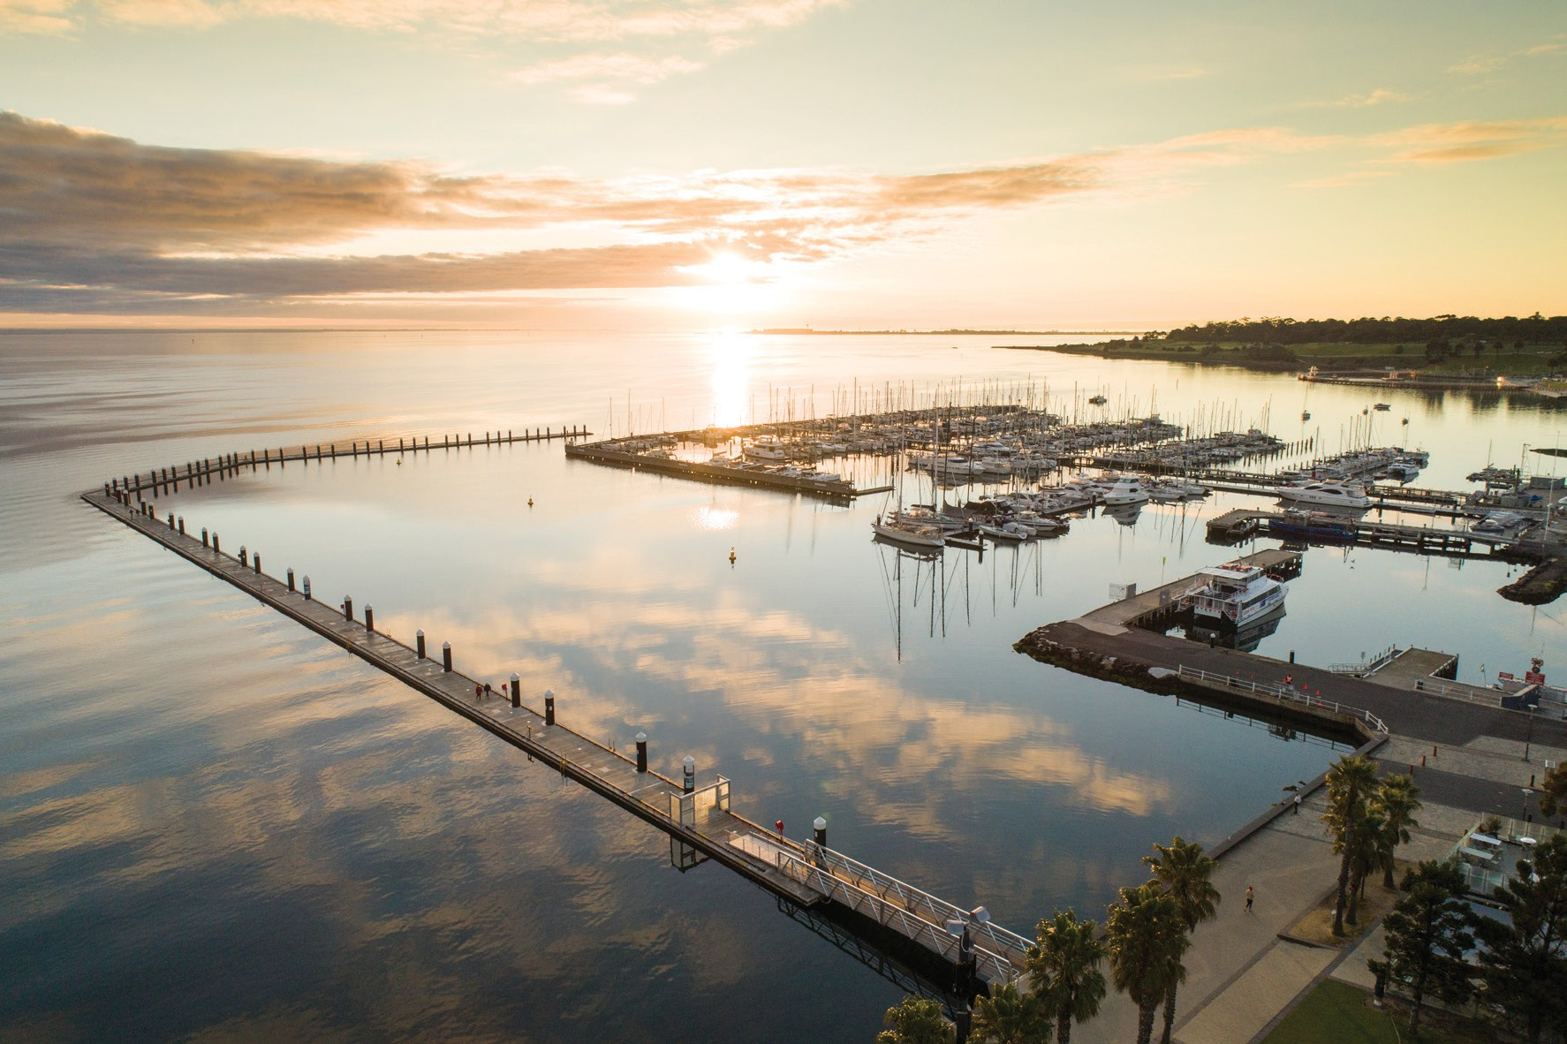

#### WADAWURRUNG SITE WALK

The wider engagement began with a site walk on Wadawurrung country, led by Corrina Eccles, Wadawurrung Traditional Owner and Cultural Education Manager, and Sarah Price, Project Manager and Engagement Specialist. Participants included members of City of Greater Geelong engagement and project teams, along with facilitator Jessica Connor Kennedy.

Aspects of the cultural history and importance of the waterfront for the Wadawurrung people were shared, along with aspirations to think about culture early in the design process and to embed Wadawurrung culture and language across the site� Opportunities for this include indigenous planting with appropriate signage in playgrounds, signage and artworks that reflect stories of water and the land surrounding the bay, and structural design that allows people to experience the waterfront at different levels and continue to connect with the site as a gathering place.

#### SURVEY - KEY FINDINGS



This section summarises the results of a survey conducted by the City of Greater Geelong that sought to gather ideas and inspiration from the community for the future of the waterfront precinct.

The survey was available electronically for a duration of six weeks (14 April to 31 May 2023). The results have been analysed by Global Research Ltd for the City of Greater Geelong on behalf of MosaicLab.

361 surveys were received and included within the analysis�

##### OPINIONS EXPRESSED IN SURVEY QUESTIONS

Improved facilities (e�g� more lighting, wider pathways, or better seating options)



55%

61%

79%

The three things that **respondents wanted more of**:

Well-connected trails

Arts and cultural experiences

Exercise



29%

44%

46%

The top three things **respondents**

**wanted to do** at the waterfront:

Relax

Meet up with others

Children and families



82%

86%

The communities that have their **needs met best**:

People who live within 15 minutes of the waterfront

People using the site at night



57%

45%

The communities that have their **needs met least**:

The arts and performing community

The information that would most help people **engage with the waterfront**:

Events

Recent history and cultural information



49%

63%

##### SUMMARY OF KEY THEMES

Consistent opinions regarding the ideal waterfront in 15 years and desired changes were expressed in the responses to both free-text questions. This summary presents the frequently discussed themes and topics in all the written comments.





Outdoor leisure and recreation activities

* More and improved walking and cycling opportunities were frequently mentioned, with a desire for continuous tracks, wider paths to improve safety, smoother surfaces, and tracks in natural settings.
* Common requests included the addition of swimming and bathing opportunities through saltwater pools and improving beach swimming quality.
* Respondents expressed a need for outdoor physical activity spaces, equipment, and development of boating facilities.
* Cunningham Pier received comments opposing it as a car park.





Improvements to amenities

* Common requests included clean amenities, removal of rubbish, and the presence of more trees and plants for shade (preferably native species).
* Respondents requested additional seating, tables, and high-quality and upgraded children’s playgrounds.
* While some respondents identified bollards as

quirky, the majority wanted them preserved.

* Opinions differed regarding dog management; while some maintained they enjoy exercising their dogs, others advocated for stricter controls.
* Improvements to the quantity and quality of toilets, showers, changing facilities, lighting, artwork, signs and interpretation, water fountains and features, the sea well, and BBQs were sought.
* More shade was desired.





urban design preferences and suggestions

* Respondents frequently suggested providing vast green open spaces for outdoor activities, with detailed comments describing smaller spaces and the provision of shelter or shading.
* The desired overall presentation and feel of the area included a cohesive design highlighting historic, indigenous, modern, built, and natural features.
* Controlled residential development, particularly low-rise buildings, was popular.
* Respondents sought the preservation and integration of heritage into modern design and development features.





Commercial enterprise preferences and suggestions

* Respondents wanted cafes, restaurants, bars, and food trucks located near the water and open for longer hours.
* Live music events were the most popular entertainment option mentioned.
* Improvements to the area to attract tourists, as well as the addition of shops and weekly markets, were requested.





Transportation issues and preferences

* Respondents expressing opinions on car parking wanted more spaces without obstructing the view of the water.
* A safer and pedestrian-focused future was desired, with reduced traffic congestion and diverted flow away from the waterfront.
* Better connectivity to the rest of Geelong via improved links with public transport, walking and cycling paths, and a better ferry service to Melbourne and around the bay were requested.





Overall management issues and preferred focus

* + Respondents sought a community and family-focused area that is welcoming and universally popular.
  + Environmental quality was important, particularly in the marine environment, with a desire for a thriving, healthy, and unpolluted environment that people can enjoy safely.
  + Safety at all hours of the day, appropriate maintenance of facilities, and high-quality presentation were emphasized.





Inclusion and diversity improvements

* + Respondents wanted better disability access, especially to beaches and organized activities�
  + They also sought the incorporation of Indigenous representation into the waterfront design.

### LISTENING POSTS

The aim of the listening posts was to create more awareness of the engagement process underway and to encourage people to complete the survey. There was a noticeable increase in survey completion on the days the listening posts occurred.

There were a wide range of people who engaged with the project representatives at each listening post session. People from all over the world, of all ages got involved, including children from 4 years old upwards, with comments such as:

I like the Eastern Beach pool

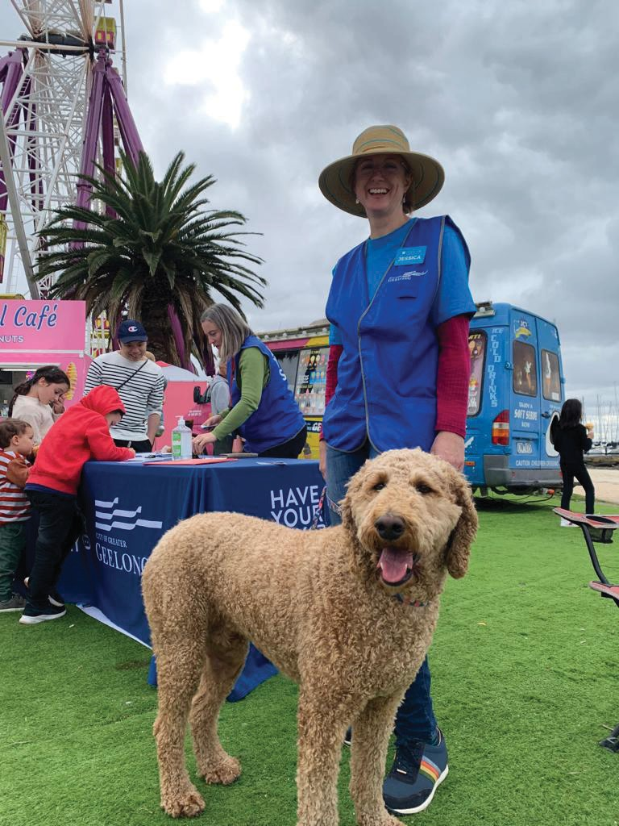

I like that there is a beach

I like the sand, I like the water and a clean beach

I love the sand� I can see the sky

and the boats� This is awesome� The ferris wheel is great� We like driving down here so

we can have fun�

I like the ice cream

I like that there’s food and fun activities and water

I want the playground to stay� More stuff for older kids

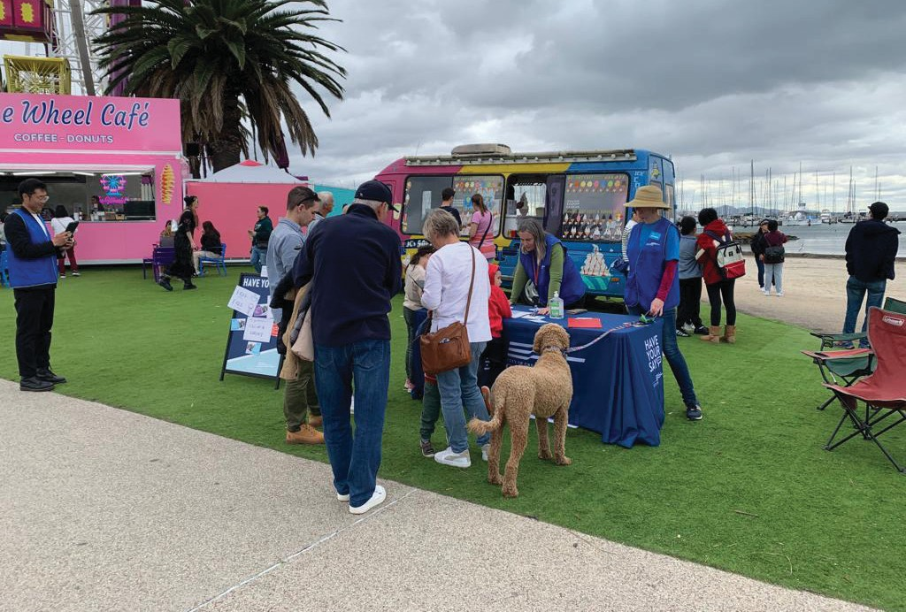

#### WORKSHOP

The workshop held on 11 May 2023 was held at Wurriki Nyal in Mercer Street Geelong. Five people participated in the workshop including representation from residents and business. The project team was represented at the session by Jennifer Kelynack, Senior Landscape Architect. The session was facilitated by Jessica Connor Kennedy, MosaicLab.

##### PURPOSE

The purpose of the workshop was to support attendees to:

* **Understand** the stages of the master planning process
* **Share and discuss** their best picture of what the waterfront could be
* **Explore** what is helping and what is getting in the way of making the waterfront the best it can be
* Meet other people who want to help **shape the waterfront’s future**

##### VISION FOR ThE WATERFRONT

The group was invited to describe their vision for the waterfront in 2038. Together, the participants created the following statement:

*The waterfront is accessible and connected within waterfront precincts and all around, including to the Botanic Gardens. There are ways other than cars that people can move around i.e. flexible transport. The bespoke development is done in harmony, with wellness in mind, with this beautiful, natural precinct.*

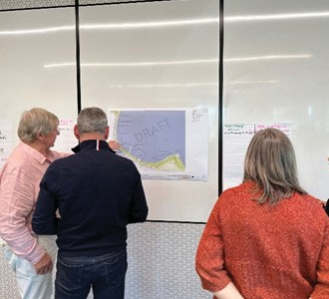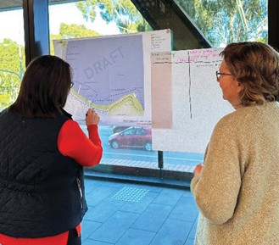

##### FEEDBACK ON THE THREE PRECINCTS OF GEELONG WATERFRONT

The next group discussion focused upon three different precincts across the waterfront area:

CENTRAL PRECINCT EASTERN PRECINCT

WESTERN PRECINCT

begins at Rippleside Park and covers the Bob

McGovan path down to the Western Beach Boat Shed.

begins at the Western Beach Boat Shed through to the Geelong Ferris Wheel, including significant features like Cunningham Pier, the Skate Park & Playground, Steampacket Place, The Carousel and Visitor Information Centre, the Royal Geelong Yacht Club and many other features.

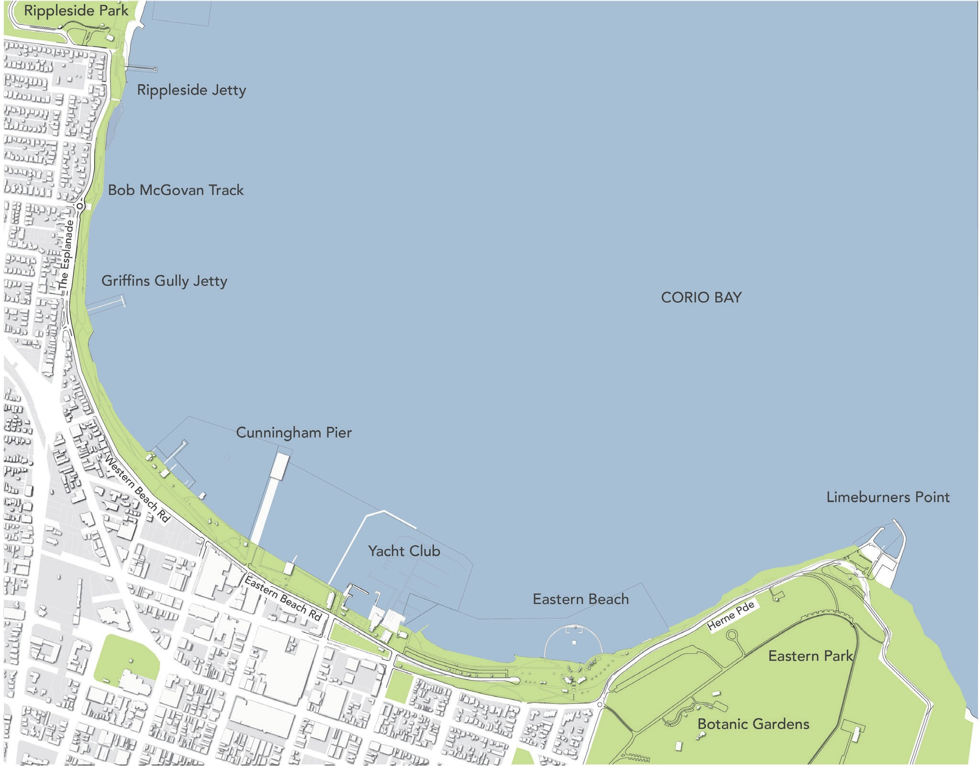

starts adjacent to the Geelong Ferris Wheel and continues east around past Limeburners Point, featuring the historically significant Eastern Beach facilities�

The participants worked in small groups and were invited to discuss and make comments on each waterfront precinct, noted below.

WESTERN PRECINCT

#### What is helping?

Tourists and locals want access to the precinct.

#### What is getting in the way?

The general amenity of the precinct limits access and enjoyment.

Comments:



Demand for more access Tourism

Beach usage Recreation Bollards Views

Variety of activity, attractions

Comments:

Smell

Lack of beach Storm water Waste

Poor paths Lack of lighting Toilets

No easy way to ride a bike around –

dangerous road and corner (at Rippleside)

Outdoor showers

Cliffs

Access – car only Less pedestrian activity

Walking next to faster cars

Connection to Rippleside

Weedy embankment

Landscape, experience around piers

CENTRAL PRECINCT

#### What is helping?

What is getting in the way?

The central precinct has a tourist focus - it is a destination.

Need places of interest and better facilities

to draw people to the precinct.

Comments:

Shops, restaurants across the road, and on the water – views of the bay

Steam packet gardens

Comments:

More ‘attractive’, appropriate shops

Accessibility to playground (not just by car) - more

Cunningham Pier – just a big car park – waste! In other places in the world piers are the destination as well

active space – basketball,

– event space, market Access

More usage of the bay

fitness, exercise, it smells

Safety or more passive surveillance between hill and sheds

Shops – unattractive, lack design principles

Lack of public facilities

Boats

Places for ‘selfies’ that are

Ferries Dinghy sailing

Lots of traffic

Place to park car

Need things to do at all times of day and in different seasons -

unique to Geelong - points of interest, places to be remembered – come back!

Need better facilities, a more comfortable place, less cars

sometimes things are

closed at 5pm, need places to seek shelter on rainy day

Congestion – cars, people, bikes during events

Need things to attract people to want to come down from Geelong city – be drawn towards waterfront and have a

reason to stay in that place

Yacht club mess



EASTERN PRECINCT

#### What is helping?

What is getting in the way?

Public open space is a huge attraction.

Limited access and connection to other points of interest and activities.

Comments:



In some other countries it costs a lot of money to go to a pool, to be in beautiful open spaces

Concept of public, open, free spaces that are safe is important

Geelong’s reputation linked to the Art Deco heritage

Open spaces - free safe beach and enclosure

Reputation / tourism attraction views / beauty

North facing bay - huge advantage

Public amenity e.g., volleyball net

Wide path Infront of beach – enough space for pedestrians, skaters, cyclists (path wider)

Demand from new residents

Opportunity for people regardless of economic status to have an enjoyable experience in nature

Many people travel, particularly from western suburbs, spend an entire day there

Comments:

Limited access especially to Limeburners Point

No public transport, carparking causes a

lot of vehicle congestion

General maintenance – very slow

Poor facilities e.g., lighting and outdated toilets

Connection – walkability towards Limeburners

Lack of connection to Botanic Gardens Water based activity – lack of

No uniformity between precincts

Jet skis - safety and noise

Unmade / surfaced paths at eastern beaches

Narrow area adjacent to residential

housing

Recreational activities on water that can coexist with people, amenity and enjoyment

#### INTERVIEWS – BUSINESS AND COMMUNITY

The interviews were conducted over a two-week period, from 10 to 24 May. People were nominated to be interviewed by the City of Greater Geelong based on a database of business owners and other stakeholders� All people on the database were emailed an invitation to be interviewed, with the choice of a face-to-face or phone interview of about 20 minutes, guided by these questions:

1. Why did you set up your business or activity on the waterfront? Why do you stay?
2. What is your main hope for the waterfront, people and community around it?, which included a response received via email.
3. What is working in the area?
4. What is most in the way?

Thank you to the interviewees whose responses have been themed below. The following organisations were consulted and 1-4 representatives from each organisation shared their views. The interviewees were asked open questions about their experience as someone working or running a business or community group within the waterfront area however, we do not suggest that these views are representative of all stakeholders who operate along the waterfront.

Royal Geelong Yacht Club Western Beach Boat Club Cunningham Pier

Wah Wah Gee

The Wharfshed Mr Pro Whipp

Geelong Helicopters Geelong Bungy Trampolines

Friends of Rippleside Park

The Carousel Corio Bay Cruises

Tourism Greater Geelong & The Bellarine

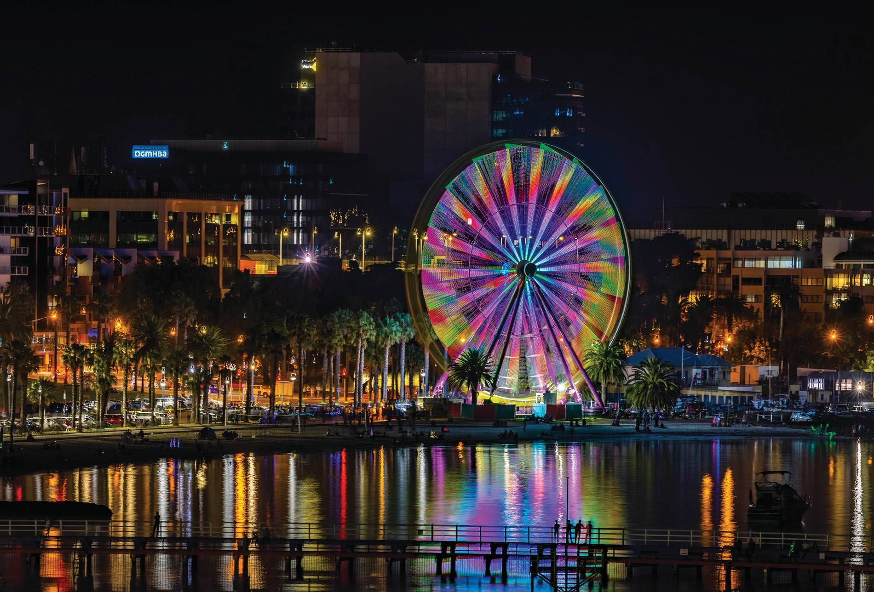

##### WHY DID YOU SET UP YOUR BUSINESS OR ACTIVITy ON THE WATERFRONT?

Great tourist opportunity

Providing a memorable experience to people

Family already had business on the waterfront

A lot of Geelong people don’t realise what is in our own backyard

WHY DO YOU STAY?

Various quotes are included here to give a sense of the range of reasons interviewees provided:

Support people with disabilities

To provide access to the water for the community

Natural progression to move business to this prominent location



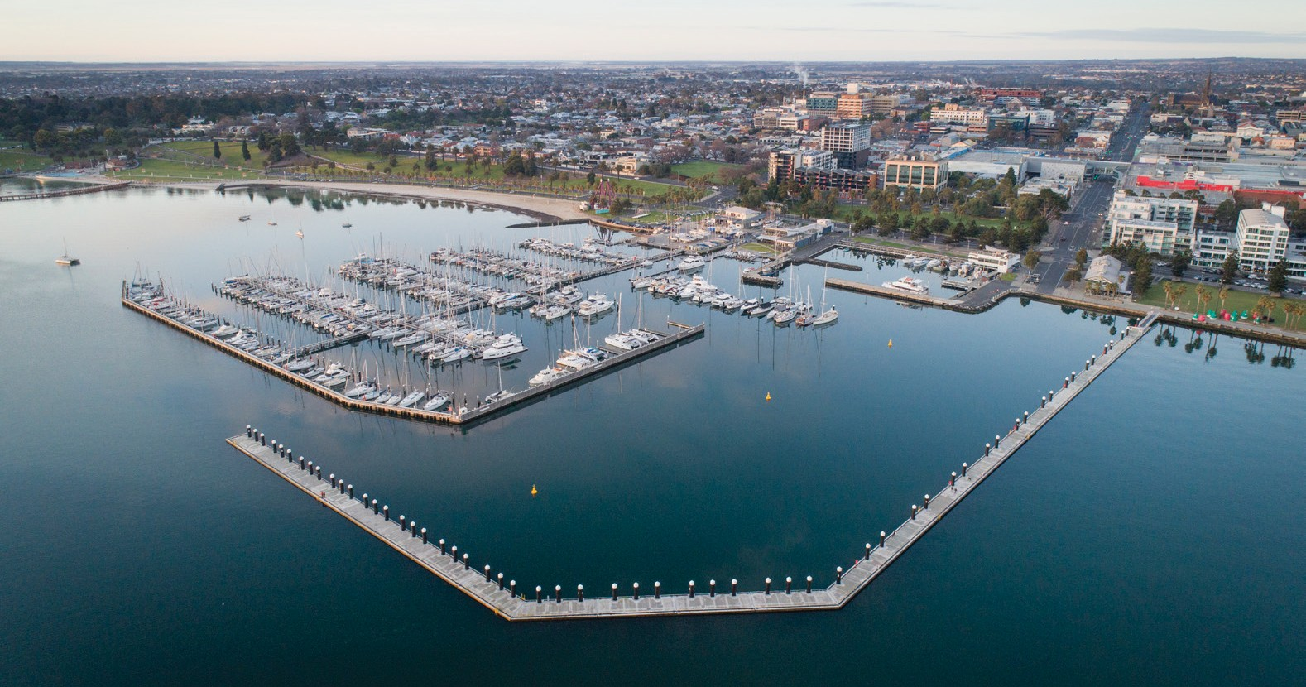

##### WHAT IS YOUR MAIN HOPE FOR THE WATERFRONT, PEOPLE AND COMMUNITY AROUND IT?

The top 5 themes from the interviews are presented below followed by an indication of the other themes.

Over half of the interviewees hoped for greater activation of the waterfront that suits a range of needs, mostly through activities but also through development.

overall activation and placemaking

**(7)**

*Families need to have accessibly priced activities/treats. Find ways to give community ownership of the area.*

*There are certainly terrific opportunities for more activations, attractions, and venues to encourage visitors to stay longer, immerse themselves more, lift spend and inspire repeat visitation. Specific projects like the proposed mineral springs, the Convention Centre, and connections with new accommodation and even as far as the Spirit of Tasmania terminal provide opportunities to grow the visitor economy and deliver memorable visitor experiences if they’re connected with the precinct well.*

While also appreciating the current ‘vibe’ of the area, the suggestions that the area has potential for more activity included some ideas that are already happening in other waterfront precincts around Australia and the world:

* + *Multicultural floating restaurants down the Western Beach end.*
  + *A floating entertainment venue, e.g., for high quality music events, don’t want events that cause trouble.*
  + *A place to throw ashes and add a plaque e.g., Gippsland Lakes.*
  + *New Zealand example: shipping containers owned by council and leased out to anyone who has a sustainable business proposal.*
  + *Host cruise ships - tenders (small boats) come in from side of ship. People disembark here and go into town. Bus lines come in. Balance from council perspective how buses come in.*
  + *The skate park is good but we should have boats there to hire so the kids can do other things. Facilitate boating activities, fishing activities.*
  + *Consider accommodating kayakers, paddleboarders, and being open to visitors by sea from Melbourne.*

Over half of the interviewees hoped for greater activation of the waterfront that suits a range of needs, There was support for the waterfront to remain largely the same, or for most aspects of the waterfront to be preserved, noted by almost half of the interviewees.

appreciation for the current state

**(5)**

*We want to maintain the character of Corio Bay, the history of the site contributes to this.*

*The mooring grid of boats in the bay is attractive - features in a lot of photographs.*

*The majority of our customers are tourists or people who used to live in Geelong...they remember coming down as a child to get ice-cream, good to keep some things the way they were.*

A top theme was a hope that the waterfront would become more accessible for people of all abilities as well as providing ease of access for people in general wanting to visit the waterfront. This included having a range of options for people to be able to travel to and around the waterfront.

all-abilities access and overall ease of access **(4)**

*Integrated transport to and from Geelong CBD.*

*Paths that enable easy access for people, wider so that bikes can pass easily.*

*Path along the west side of The Wharf Shed Café - there is a boat bridge then people walk along rough ground. Safety concerns regarding this.*

*We run events for people with disabilities - the precinct needs to be set up to support that.*

*Some related comments appear below in ‘what is most in the way’, relating to parking and transport.*

Events bring a high level of activation to the waterfront and are positive for tourism� A number of interviewees also commented that they hoped that the impact of events on businesses would be managed (see ‘what is most in the way’ below).

Events **(4)**

*I like to see events; they benefit us but need to balance impact. Need more communication re events.*

Jetties and piers, as well as access to the water, were mentioned in relation to hopes for the future, particularly in regard to optimising the use of Cunningham Pier and existing jetties such as the relatively recently built 440 metre Wangim Walk, which also functions as a wave attenuator.

Jetties, piers, and access **(4)**

*Could berth large vessels on Cunningham Pier but it is not currently in a condition for large vessels to tie up. Berthing dolphins would take stress off pier.*

*Being able to promenade around the water’s edge is a real feature.*

*Acknowledge and keep cultural identity and celebrate more recent history of the waterfront. Development can override history.*

other comments

*Maintain a high level of overall feel and presentation (including clean pathways). Maintenance and safety go together.*

##### WHAT IS WORKING IN THE AREA?

The water-based activities are a strong aspect of the waterfront and access to the water is important. There is a lot of diversity in the ways people can use and interact with the water, including boat and yachting clubs that encourage public access and community connection. These facilities also contribute to the amenity of the area, with the boat mooring areas providing iconic imagery that is representative of the Geelong Waterfront� In addition, these facilities may also have responsibilities to maintain vessels, help the members and other boat owners by providing maintenance facilities and want to see vessels on the water in good repair.

Water-based activities and other water-based

comments **(10)**

The waterfront has and will continue to attract cruise ships and international boating events and is well-placed to facilitate arrivals by vessels of many sizes for people coming from nearby areas as well as from afar.

*Flexibility of use at Limeburners to enable world class Yachting events.*

*Lots more opportunities on the water - sailing is very popular. On Gippsland Lakes and in Sydney you can have a picnic on a yacht. From Geelong you could sail to Werribee, have lunch and sail back.*

At the Western Beach Boat Club:

*Passing people enjoy looking at the working slipway as it is open to public viewing.*

The fact that the waterfront is north facing is a significant benefit to the

experience of the area, as commented on by many interviewees:

*Capitalise on point of difference of north facing harbour, half the city still has its back to waterfront.*

*North facing bay and marina is not just functionality, it provides an attractive addition to the Waterfront.*

The maintenance and management of the area by the City of Greater Geelong was noted as important to the waterfront.

maintenance and management by council **(3)**

*Council do a good job at maintaining the area.*

*We rely on and appreciate council restricting the number of permits, this helps us to run a sustainable business.*

##### WHAT IS MOST IN THE WAY?

Parking and transport were the standout comments in relation to accessibility and improving pedestrian access for all users. Car parking is significant with a range of views as to where parking should be, including some commentary as to whether it should be time limited and ticketed.

Parking and transport **(14)**

*Masterplan needs to address ease of public access including public transport, walkway to connect different sides of the road. Masterplan needs to bridge public access from the CBD. Needs to be integrated.*

*We need public transport, be innovative, e.g., underground railway, trackless trams, tuk tuks. Many cities have a public transport loop.*

*I’d like to see the ferry succeed.*

*We are the gateway to the Great Ocean Road, it is embarrassing to think there is not a place for a caravan to park near here, look at examples in New South Wales and Queensland.*

*Ease of pedestrian access including for people with accessibility needs.*

*Carparking is a major problem. I don’t think there is a fix, no land to make a carpark.*

A number of interviewees commented that while they understood events to be of great benefit, and were happy for events to continue, there were also downsides from their perspectives.

Impact of events **(7)**

*Because we are on northern side of Eastern Beach Road, when we have events where they close the road off it shuts our business down. When we had a business on the south side of the road we boomed during events.*

*Pier closed for parking during events, looks closed.*

*Events are on what should be our busiest weekends of the year, warmer months but because we get shut down e.g. Australia Day weekend.*

*Events are not the problem, it is the setting up and packing up.*

Increasing biodiversity and continuing to improve the environmental quality of the waterfront were identified as key concerns. Participant comments included:

Biodiversity, environmental quality **(4)**

*Down towards the western end of the waterfront there is a transition from commercial to community to natural features. We can see that is enjoyed.*

*Regarding the smell when the tide goes out, some people don’t understand - complain when the tide is out about smell - that can be addressed by education.*

*Contaminated stormwater is a concern, see the water bottles, debris - a lot washes down from the east, we pick up a lot of rubbish. Not as bad as it was 10 years ago.*

*Like to see more indigenous planting.*

*Wanting more effective maintenance of the path and seawall down western end - crumbling August 2021, still not fixed.*

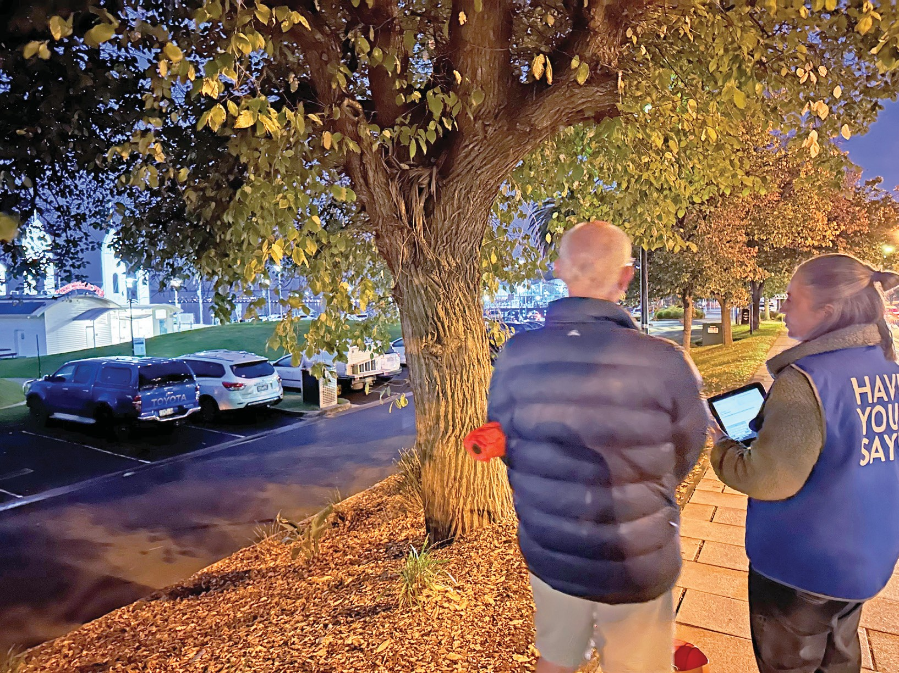

other comments

*There is opportunity for greater investment in public assets like art and infrastructure – the precinct does come under some volume of people pressure. There is a better opportunity to connect the precinct with the CBD – the connection to shopping, hospitality and cultural attractions is all walkable. Likewise, the Geelong Botanic Gardens. It would be fabulous to enable and empower businesses in the precinct to get creative with their activations – Customs Lawn and the hospitality businesses connected to it could be used in clever and iconic ways.*

#### INTERVIEWS – STATE GOVERNMENT & DEAKIN UNIVERSITY

During the engagement period, several state government representatives were interviewed along with representatives from Deakin University.

|  |
| --- |
| **Development Victoria** |
| **Regional and Suburban Development teams** *representing the Exhibition & Convention Centre located on Western Beach Road next to Deakin University* |
| **Deakin University** |
| **Revitalising Central Geelong** |

There are a range of masterplans and frameworks that impact the stakeholders interviewed, the Waterfront Masterplan as well as Gheringhap and Mercer Masterplans and the Central Geelong Framework.

Areas of consideration for the stakeholders interviewed, include:

*We would like to see different types of investment in transport.*

transport,

parking, and

pedestrian

movement

**Transportation, parking, and the flow of people to and around the waterfront precinct,**

**and into the Geelong**

**CBD was a common theme.**

*Concerned about traffic management along Western Beach Rd – already busy and chaotic.*

*Challenge for the City to link Waterfront to the rest of the CBD. Big elements like Westfield create a black hole where people drive to and leave from without engaging in Geelong. How to draw them out and down to the waterfront?*

*Cunningham Pier - ridiculous that this significant landmark is a carpark.*

*There will be a need to get large numbers of people to and from events at the [future Convention] Centre. Considerations will include bus connections, the connection to the train station, managing cars and activating pedestrian movement as a priority after events.*

*Needs better and more connection – especially walking and other forms of transport beyond the vehicle.*

*The west and the eastern precincts need attention for improved linkages. Paths need to be well linked and logical.*

*Love the small cultural surprises that are starting to appear around Geelong. It was very quiet and dull in the early days. Would like to keep the small moments of delight coming e.g. bollards and neon lights, laneways, and food hub.*

activation

**There was positivity about the extent to which the waterfront area has been activated as well as encouragement for activation to grow**

**in an ambitious and creative way.**

*Eastern side could benefit from ‘breadcrumb’ moments being provided – give people reasons to ride or walk out there or host low key informal events – it has a natural amphitheatre shape.*

*Look after the space and have future-based thinking.*

*Be creative and ambitious in the planning here, but not a Gold Coast.*

*Western Beach precinct could benefit from more investment and activation including more engagement with water over and around and in.*

*There is an opportunity for ambitious development at the western end of the precinct to ‘balance’ all the activity down at Eastern Beach, for example, potential for more water-based activities and hospitality.*

Business and

tourism

**Interviewees identified the importance**

**of hospitality in creating a welcoming atmosphere to the waterfront. The role of events was also mentioned including the need for events of small and large scale, that are managed well e.g., food needs**

**to be relatively easy to**

**access during events.**

*Test and plan for large events as well as smaller interventions which might be temporary.*

*Types of retail on the waterfront. How to encourage the right mix of retailers?*

**Placemaking**

other

comments

*Waterfront is clean and green and is done well by the Council. Challenge for the future would be to amplify the green and a challenge is to show the ‘right’ green e.g., Indigenous landscape?*

*Follow recommendations of the Central Geelong Framework.*

**Safety**

*Needs to feel safe. Night especially is challenging.*

**New conference centre**

*The new Conference Centre will bring many people – want them to spill over and walk or enjoy a taste of Geelong. Challenge of topography.*

### DEEP DIVE CONVERSATION

Twelve participants of the Barwon Health social support program shared their views in interview in pairs or threes. Participants are involved for a range of reasons, including social isolation. Many had grown up with a strong connection to the waterfront. The ages ranged from 70 to 95.





Hopes

Many people shared their hope that the waterfront would remain the same, stating that it is beautiful as it is� Comments emphasised preservation of the sea front, ensuring no private housing down to the water’s edge and keeping the waterfront as a family-oriented place (including availability of inexpensive food and activities).

Some people spoke about the need to manage parking, public transport, and access more effectively, with a range of comments including:

* *Create a road bridge from Avalon Beach to Point Henry.*
* *More ferry times to Docklands.*

Some people commented on the need for activation to include a more multicultural element:

*Conduct the seafood festival in a way that brings multicultural awareness.*



What is Working well

Several participants commented on the aspects of the waterfront that are working well, which include:

* *The public, shared nature of the space, where many cultures gather.*
* *The places to sit on chairs, the promenade, coffee shops and wide walking areas.*
* *The accessibility for dog walking and accessible food from food trucks.*

*I sometimes go down with a carer, we get an ice cream takeaway and sit on the wooden chairs and talk in the sun.*



What is not working well

The top comments were about parking and accessibility for people who have walkers, or are in wheelchairs:

*You can’t push a walker on the grass, the chairs are sometimes hard to access, provide a few more disabled parking spots. I would be thankful even if there was disabled parking on other side and cross at the crossing.*

# SURVEY ANALYSIS



The following analysis was conducted by Global Research Ltd for the City

of Greater Geelong on behalf of MosaicLab.

### OVERVIEW

361 surveys were completed.

##### QUANTITATIVE ANALYSIS

Frequency analysis was completed for all quantitative questions asked in the City of Greater Geelong Waterfront Masterplan Survey (see Appendix 1).

Results have been presented in charts and one table, accompanied by descriptions of the results�

##### QUALITATIVE ANALYSIS

All written feedback has been read and analysed (coded) by data analysts� This includes all written responses to the free-text questions about how the waterfront was imagined in 15 years and one thing participants would change about the waterfront.

To give a clear and consistent indication of the number of comments received on each topic, the following key was used to describe the relative number of comments on each:

|  |  |  |
| --- | --- | --- |
| key for comment numbers | | |
|  | 2 comments | A couple |
|  | 3 comments | A few |
|  | 4-7 comments | A small number |
|  | 8-14 comments | Several |
|  | 15-24 comments | A moderate number |
|  | 25-49 comments | A considerable number |
|  | 50-74 comments | A substantial number |
|  | 75-99 comments | A sizeable number |
|  | 100-149 comments | A large number |
|  | | |

Verbatim participant comments are included throughout this report to show the ways in which respondents discussed particular issues and expressed their opinions—grammatical errors or spelling mistakes have been corrected with care taken to not change the meaning or content of the comment.

#### OPTION SELECTION RESULTS



the waterfront needs more or less of…

**Respondents were asked:** *state if they would like less of, about the same, more of, or not applicable for the seven aspects listed below.* The charts on the following pages present the results for each aspect.

###### FINDINGS

These are the aspects that respondents were asked to rate in order of most to least wanted:

* 79% of respondents wanted more **improved facilities (e.g. more lighting, wider pathways or better seating options)**
* 61% of respondents wanted more **well-connected trails**
* 55% of respondents wanted more **arts and cultural experiences**
* 54% of respondents wanted more **festivals, celebrations and special events**
* 53% of respondents wanted more **high-quality parks and open space**
* 53% of respondents wanted more **improved access to water**
* 48% of respondents wanted more **shopping, cafes and dining**

100%

IMPROVED FACILITIES (EG. MORE LIGHTING, WIDER PATHWAYS OR BETTER SEATING OPTIONS)

80%

60%

40%

20%

5%

2%

0%

Less of

About the same

More of

Not applicable

39%

54%

###### FINDINGS

* Over half of respondents (54%) wanted more improved facilities (e.g. more lighting, wider pathways or better seating options)
* Over one third (39%) wanted about the same, and
* Around 5% of respondents wanted less.

WELL CONNECTED TRAILS

100%

80%

60%

40%

20%

0%

Less of

About the same

More of

Not applicable

2%

2%

33%

62%

###### FINDINGS

* Over half of respondents (62%) wanted more well-connected trails
* Around one third (33%) wanted about the same, and
* Around 2% of respondents wanted less.

ARTS AND CULTURAL EXPERIENCES

100%

80%

60%

40%

20%

0%

Less of

About the same

More of

Not applicable

4%

5%

36%

55%

###### FINDINGS

* Over half of respondents (55%) wanted more arts and cultural experiences
* Over one third (36%) wanted about the same, and
* Around 5% of respondents wanted less.

FESTIVALS, CELEBRATIONS AND SPECIAL EVENTS

100%

80%

60%

40%

20%

0%

Less of

About the same

More of

Not applicable

2%

5%

39%

54%

###### FINDINGS

* Over half of respondents (54%) wanted more festivals, celebrations and special events
* Over one third (39%) wanted about the same, and
* Around 5% of respondents wanted less.

HIGH QUALITY PARKS AND OPEN SPACE

100%

80%

60%

40%

20%

0%

Less of

About the same

More of

Not applicable

1%

1%

45%

53%

###### FinDinGs

* Over half of respondents (53%) wanted more high-quality parks and open space
* Just under half (45%) wanted about the same, and
* Around 1% of respondents wanted less.

IMPROVED ACCESS TO WATER

100%

80%

60%

40%

20%

0%

Less of

About the same

More of

Not applicable

1%

3%

44%

53%

###### FINDINGS

* Over half of respondents (53%) wanted improved access to water
* Almost half (44%) wanted about the same, and
* Around 1% of respondents wanted less.

MORE SHOPPING, CAFES AND DINING

100%

80%

60%

40%

20%

0%

Less of

About the same

More of

Not applicable

2%

8%

42%

48%

###### FINDINGS

* Almost half of respondents (48%) wanted more shopping, cafes and dining
* Almost as many (42%) wanted about the same, and
* Around 8% of respondents wanted less.



top four things respondents want to do

**Respondents were asked:** *What are the top 4 things you want to do at the waterfront?* Identify and rank your top 4 options (1 highest) by either dragging and dropping or writing 1 to 4.

**These 12 options were presented to respondents:** Exercise; Relax; Play or skate; Meet up with others; Swim; Go boating / kayaking / yachting; Invest in a new business; Eat in cafes / restaurants; Shop; Study and learn; Attend events; and Spend time connecting to nature.

To order the results, the number of times each option was rated one or two was added and then the options were ordered from highest to lowest (left to right in chart).

37%

22%

22%

19%



50%

TOP FOUR THINGS WANT TO DO

1 2 3 4

40%

30%

20%

10%

0%

Exercise Relax

Meet up with others

Eat in Spend time Swim Go Attend

cafes / connecting restaurants to nature

boating / events kayaking

/ yachting

Play or skate

Invest in Shop a new

business

Study and learn

###### FinDinGs

9%

9%

9%

14%

8%

13%

6%

11%

5%

4%

2%

5%

4%

2%

1%

0%

0%

1%

0%

1%

* **Exercise** was the option ranked either 1 or 2 the most times-46% of respondents
* **Relax** was the option ranked either 1 or 2 the second most times-44% of respondents
* **Meet up with others** was ranked the third highest-29% of respondents ranked it 1 or 2.
* **All other** options were ranked 1 or 2 by fewer than 25% of respondents, in order they were: Eat in cafes / restaurants (23%); Spend time connecting to nature (21%); Swim (17%); Go boating / kayaking / yachting (9%); Attend events (7%); Play or skate (5%); Invest in a new business (1%); Shop (1%); Study and learn (1%).

**Respondents were also asked:** *Did we miss anything?*

Around sixty respondents suggested other things they would like to do:

* **Walking or cycling**—10 comments
* **Use outdoor facilities, such as picnic, BBQ, showers**—9 comments
* **Recreation activities, such as skate-bowl, gym equipment**—8 comments
* **Relaxing, scenery**—6 comments
* **Transport, such as public, charging**—5 comments
* **Markets, events, retail**—4 comments
* **Cultural, heritage**—4 comments
  + **Hospitality, such as restaurants**—3 comments
  + **Enforcement, services, such as police and medical**—2 comments
  + **Other topics**—8 comments



How well the waterfront is meeting

the needs of different groups

**Respondents were asked:** *How well is the waterfront meeting the needs for different groups?:* very well; well enough; not well; or don’t know.

**These nine options were presented to respondents:** Children and families; People who live within 15 minutes of the waterfront; Businesses; Young people; People who live more than 15 minutes from the waterfront; People over 65 years of age; New investors; The arts and performing community; and People using the site at night.

Those who selected *don’t know* were removed from the analysis.

The percentage of respondents who selected that the waterfront met particular needs either *very well* or

*well enough* were added and then ordered from highest to lowest (left to right).



70%

60%

50%

40%

30%

20%

10%

0%

HOW WELL WATERFRONT MEETING NEEDS OF COMMUNITIES

55%

56%

54%

57%

58%

55%

44% 43% 43%

37%

36%

31%

26%

27%

28%

20% 20%

14%

18%

18%

19%

15%

14%

10%

Children and families

People who live within 15 minutes of the waterfront

Businesses Young people

People who live more than 15 minutes from the waterfront

People over New The arts and People 65 years of investors performing using the

age community site at night

**FINDINGS**

26%

26%

Very well Well enough Not well

52%

Communities having needs **met best**:

* + **Children and families** was the community group considered to have its needs met best-86% of respondents rated them being met very well (31%) or well enough (55%)
  + **People who live within 15 minutes of the waterfront** was the community considered to have its needs met second best-82% of respondents rated them being met very well (26%) or well enough (56%)

Communities having needs **met least**:

* + **People using the site at night** was the community considered to have its needs least met-45% of respondents rated them being met very well (10%) or well enough (36%)
  + **The arts and performing community** was the community considered to have its needs second least met-57% of respondents rated them being met very well (14%) or well enough (43%)
  + **New investors** was the community considered to have its needs third least met-63% of respondents rated them being met very well (19%) or well enough (44%)

**The three other** communities’ needs were considered to being met very well or well by between 75% and 72% of respondents: **Young people** (75%); **Businesses** (74%); **People who live more than 15 minutes from the waterfront** (73%); and **People over 65 years of age** (72%).



Information that would help respondents

engage with the waterfront

**Respondents were asked:** *What information would help you engage with the waterfront?* Identify and rank your top 2 options (1 highest) by either dragging and dropping or writing 1 and 2.

**These four options were presented to respondents:** Events; Recent history and cultural information;

Wadawurrung culture; and Improved wayfinding signage.

To order the results, the number of times each information type was rated one or two was added and then the information types were ordered from highest to lowest (left to right in chart)



INFORMATION RESPONDENTS WOULD ENGAGE WITH

50%

40%

39%

31%

30%

24%

27%

22%

20%

18%

16%

10%

10%

0%

Events

Recent history and cultural information

Wadawurrung culture

Improved wayfinding signage

###### FINDINGS

* + **Events** was the option ranked 1 or 2 the most times - 63% of respondents
  + **Recent history and cultural information** was the option ranked 1 or 2 the second most times - 49% of respondents
  + **Wadawurrung culture** was the option ranked 1 or 2 the third most times - 43% of respondents
  + **Improved wayfinding signage** was the option ranked 1 or 2 the least number of times - 32% of respondents

**Respondents were also asked***: Is there anything else?*

Respondents provided around seventy-five comments, but the majority of these covered general topics discussed in other parts of the report and were not focused on information� The few comments which discussed relevant information were:

* + **Cultural, historic**—3 respondents
  + **Other topics**, such as update signage; water activities, tour guides—3 comments

#### WHAT RESPONDENTS SAID

The analysis that follows presents the themes and topics that respondents discussed in written comments.

**Respondents were asked:** *If you could imagine your ideal waterfront in 15 years, what would you see?*

While some respondents answered the question directly, more frequently they focused on aspects that could be added, enhanced, or changed.

## Leisure and recreation activities

392 comments

***Land based activities*** *156 comments*

***Walking, cycling tracks and paths (103)***

A considerable number of respondents expressed their appreciation for existing walking facilities or stated that they would like more or improved walking along the coast. Various start and end points were suggested for the walkway, or ‘promenade’. This was a typical comment:

*A continual and enveloping harbour side from St Helen’s through to Point Henry. I would envisage walking and cycle connectivity to the entire bay shore area.*

A considerable number of respondents made suggestions for how continuous walking opportunities could be improved. A moderate number of respondents made the point that the walking path should be wider or separated from other users, such as cyclists.

A similar number of respondents discussed a variety of different aspects of walkways that could be improved: upgrading generally; safer; nonslip; more nature-oriented experience; smoother surfaces, particularly for wheelchairs; shaded areas. Below is a comprehensive comment which discusses the provision of a wide path and other improvements that could be made.

*I would like to see a shared path all the way from Limeburners to Rippleside. Although there is a path now it has frequent interruptions and disappears really from Cunningham Pier to the Western Beach sheds. Beyond there to Rippleside it is too narrow, too rough and the light poles are unsafe for cyclists. This shared path could serve a dual purpose being both a lovely walk for pleasure but also an excellent commuter route for cyclists crossing the city from the east to the north.*

A moderate number of respondents made simple requests for more and better cycling opportunities. The most common suggestion in these comments was for there to be enough room for cyclists. Below is a typical statement.

*Lots of space for cycling and walking,*

Several respondents referred to walking/running tracks or ‘trails’ specifically, and it was inferred from these comments that preferred walking opportunities located in natural settings. This was a comment which sought improved connections between trails:

*Better connection to well-connected walking cycling running trails.*

***Physical fitness activities or equipment (21)***

A moderate number of respondents suggested there should be more exercise areas and/or equipment provided. Often these were quite short and to the point statements, similar to these two:

*Quality adult exercise areas and children’s playgrounds.*

*…multiple workout stations, improved running, walking & riding paths.*

***Community events (8)***

Several respondents expressed support for community events, often these were short statements, stating “community events.” This was a longer comment:

*More cultural events near green space near Eastern beach and steam packet gardens.*

***Sports activities (6)***

A small number of respondents suggested various different sports activities, such as: basketball ½ court; skatebowl; or generally sports and events. This suggestion was for a larger proposal:

*Usage of lime burners point. A sport field or stadium should be built in this area.*

***Ferris wheel (5)***

A variety of different points were made regarding the ferris wheel in this small number of comments. Remove it, upgrade it, and develop around it, were representative of the points made.

***Other land-based activity topics briefly discussed (13)***

A few respondents suggested a museum or similar facility, one of these comments suggested emphasising Geelong’s history with wool and another suggested an aquarium focusing on the indigenous marine life and plant life� One comment suggested an art gallery.

Three comments discussed the carousel, two were in favour of development and one suggested removal� Two respondents suggested a monorail, and two requested more free activities.

A variety of one-off comments were made: a variety of destinations/uses along the walkway; extending activities west of boathouse; no electric vehicles on walking paths; and better usage of the area west of the skate park.

***Water based activities*** *138 comments*

***Swimming and bathing (48)***

A considerable number of respondents discussed swimming opportunities, predominantly with regard

to improving the current provision or adding more high-quality options. Nearly three-quarters of these respondents discussed pool facilities, particularly saltwater pools. The point was made that what is currently provided is busy and so additional options are needed. This type of facility was also considered an attraction for the area. There was also reference to a spa facility by a few respondents. This was a typical comment proposing a saltwater pool:

*Western side to put in an enclosed swimming section. I lived in NSW short term and think we could take inspiration from their saltwater pools at most beaches. There is perfect opportunity at St Helen’s Park to do this at the current pier. It would bring a diversity of people to the area. A café down there would also be great - or markets.*

This comment was an example of how existing facilities could be improved:

*The Childrens Pool repaired or restored, and heated a little.*

Several respondents described and were enthusiastic about the beach swimming options. Some suggested that water quality needs to be improved� This was one of the comments:

*Swimming is great as there are several options - the pool, the enclosed bay, the open “beach”.*

A small number of respondents made general statements supportive of swimming as an opportunity.

***Beaches (27)***

A moderate number of respondents made consistent comments requesting that beaches are improved by adding more area (reclaimed land), adding sand at times, and ensuring there is cleaner water. Some suggested that currently beaches are very crowded. This was a typical comment:

*Well maintained beaches free of weeds and topped up with sand every couple of years.*

***Boating activities and facilities (22)***

A moderate number of respondents discussed boating or sailing opportunities. Over half of these comments referred to the completion/development of a thriving yacht club. This was a typical comment:

*Yacht club is built up so it’s not an ugly expanse of nothingness like it is now - it’s now a proper clubhouse and restaurant/bar open to the public.*

While a few respondents made general comments supportive of boats, such as “more boats”, the reaming several comments discussed a variety of issues related to boating, such as: docks further away from the waterfront, less overcrowding of boats; mid-size ferry; old pirate ships; boating open to all. These were a couple of comments seeking balanced development in this area:

*A balance of local residents having access to traditional sporting pursuits such as sailing and fishing, whilst maintaining the link to our proud maritime history and the beautiful presentation of well-maintained sailing boats moored in the bay.*

*…boating clubs and a working marine waterfront that supports marine history, ongoing boating uses, marine facilities and on water moorings.*

***Cunningham Pier and other jetty, wharf (15)***

The vast majority of these comments sought a better use for Cunningham Pier than a car park, the comment below sums up the points made in these comments:

*Cunningham pier would be SO MUCH MORE THAN A CARPARK. This is so sad. It needs to become public space and space for more venues that utilise the view.*

A few other comments suggested tidying up fishing on the pier and one comment suggested accessible

mooring at reasonable rates.

***Floating recreation activities and facilities (11)***

Around half of these comments supported a quality water park being developed. This was one of the comments:

*Seasonal floating waterpark,*

The remaining comments suggested more kayaking, canoeing, or stand-up paddle board opportunities.

*Better usability of non-powered water activities (swimming, kayaking, stand up boarding).*

***Fishing (5)***

A small number of respondents made comments regarding fishing. Most of these were supportive of fishing opportunities and a couple made points suggesting there needs to be cleaner or better behaviour. This comment summed up the sentiment:

*Upgrade piers for fishing with cleaning and line rubbish bins.*

***Opposition to jet ski use (5)***

All of this small number of comments opposed the use of jet skis in the area, or a specific zone created, with

noise being the most common criticism. This was one of the comments:

***Other topics (5)***

*I’d love to see a no jet ski zone introduced in place.*

A small number of one-off comments were made: more aquatic activities; Go-Boat rentals; more water entertainment options; water sport hire facilities; and more access to the water.

## more and improved amenities

272 comments

Cleanliness, rubbish and overall quality presentation 51 comments

The majority of these comments focused on the cleanliness of the area with the most repeated sentiment being either ‘cleanliness’ or ‘improve the cleanliness’. This was a typical statement:

*A safe, clean and spacious environment for family and recreation.*

A moderate number of comments focused on rubbish and the need to manage waste that is left behind, with specific comments referring to the need for more bins or more frequent rubbish collection. These were a couple of these comments:

*The only things I can think of are a bit more garbage clean-up.*

*It’s pretty good at the moment but need a couple of bins between the Carousel and the Wharf Shed.*

A moderate number of comments generally described an overall well-kept area including pavers and built facilities. They also discussed the overall presentation of the area and what was sought, such as:

*A well-maintained foreshore - the following need upgrades:*

*A lovely area with great facilities with less seaweed around the area.*

***Trees and plants*** *29 comments*

The majority of trees and plants comments suggested should be more trees in the area. Specific comments

were appreciative of the shade they provide and favoured native trees.

*Beautiful native trees providing shade in summer to those using the picnic tables and beaches.*

There were a few mixed comments in favour of and in opposition to palm tree. This comment discussed the balance between native and palm trees.

*Ideally it would native trees rather than palm trees but that’s also iconic to this area.*

***Seating and tables*** *28 comments*

The majority of these comments were simple statements suggesting a need for more seating or areas to sit. These were generally short, to the point comments. Some mentioned shade in conjunction with seating. This was one of the typical comments:

*More seating along the way where people could stop and rest and take in the views.*

A small number of respondents referred to the need for more tables or benches.

***Playgrounds*** *24 comments*

Overall, these comments were relatively consistent in what they suggested which was more and upgraded, high quality modern playgrounds for children. A few comments suggested they should be shaded. These were a couple of representative comments:

*...better parks and playgrounds.*

*Large modern play area for children.*

*Also to ensure that all the kids play areas are kept current.*

***The bollards*** *18 comments*

A large majority of these comments were in favour of retaining or adding to the decorative bollards. Around two thirds of the comment focused on the need to maintain and repair the bollards. This was one of the comments which explained the importance of maintaining the bollards and a suggestion for how it could be done:

*All the bollards in excellent condition, not rotting away (how sad would their original designer be to see them now): this could be a community/men’s shed/ school project - with explanations of their history nearby.*

Nearly all the remaining comments were supportive of their retention or expansion. This was a typical

comment:

*…bollards should stay, they’re a bit quirky, but nice.*

One comment stated they didn’t mind if they disappeared.

***Dog management*** *17 comments*

Comments were split into two broad groups. A slightly larger group were supportive of dogs in the area and generally described how they enjoyed exercising them. These were a couple of these comments:

*More parkland, playgrounds, dog parks, walking trails.*

*Dog friendly spaces.*

The other half of the comments regarding dogs focused on the need for more focus on management, such as not allowing dogs to be off lead and ensuring that dog waste is picked up. This was one of the comments:

*No dogs off leads. No dog poo on lawns and walking paths.*

Facilities: toilets, showers, changing facilities 16 comments

The majority of these comments suggested the need for more or better toilets. This was one of these comments:

*There needs to be more shelter and up-graded toilet block and showers.*

Other facilities that were suggested were: showers (4), changing facilities/rooms (4), and a parent’s room.

***Shade*** *15 comments*

These comments consistently stated that there is a need for greater provision of shade. Specific examples

were suggested: with seats, from trees, umbrellas, and over picnic areas.

***Lighting*** *14 comments*

These comments generally sought more and better lighting at night. Some specific points were made: coloured light features; for safety at night; for exercise and walking at morning and night; ground lighting on walking paths; and feature spotlights.

***Artwork*** *14 comments*

Comments regarding art were generally short requests, with some specific examples being suggested: indigenous art; art added along the beach walk; more art/sculptures relevant to the area; lots of public art; and open space surrounded by nature and art. These were a couple of the comments:

*Art and sculptures along the waterfront.*

*Better connection to indigenous culture through permanent art, information and cultural activities.*

***Signs and interpretation*** *14 comments*

A variety of different sign and interpretation comments were suggested: cultural significance signs; explanation of heritage; remove unsightly signs; learning points; Chinese character signs; information such as where to park etc; tourist information boards; information centre; an educational walk; and education re birds and trees. This was one of the comments:

*I would also see more art and information points, on history, indigenous stories, and interactive pieces that engage children as well as adults.*

***Water fountains and features*** *8 comments*

These were short simple comments split into two groups, one requesting more water features and the other more water drinking fountains.

***Sea wall*** *8 comments*

These comments focused on improving and repairing the sea wall. This was one of these comments:

*Rebuild the brick wall walkways along the water’s edge, keeping the same bluestones.*

***BBQs*** *8 comments*

These comments consistently provided support for more BBQs. This was one of the comments:

*Possibly more BBQ areas spread along the waterfront rather than all in one place.*

***Other amenity comments*** *8 comments*

A variety of other topics were discussed: amphitheatre or stage (2), extension of Botanic Gardens, storm water drain extended further into the bay, public bike tools, and an improved tourism information centre.

*Get rid of the grass at Steampacket Gardens and replace it with a wheelchair accessible sensory garden that attracts birds and butterflies.*

## urban design suggestions and preferences

195 comments

***Open space and greening*** *86 comments*

Overall, the sizeable number of respondents who made comments regarding open space wanted a lot of green, open areas for people to enjoy while participating in enjoyable social or individual activities such

as picnicking, BBQs, meeting with family and friends, playing, and experiencing and enjoying the natural environment.

These respondents also described the physical space that they would like to see and enjoy. The most common suggestion, expressed by about one half of these respondents was that there be an abundance of green open space. This is how some of these respondents expressed this sentiment:

*A picturesque scene with lots of green spaces.*

*Green spaces that represent the local native environment. Plenty of green space and sand for families to relax and play.*

A moderate number of these respondents (just over one quarter) described more detailed design, or opportunities they would like provided in some of the spaces. While there was a broad range of opinions expressed in these comments, most commonly they described smaller spaces, or spaces with shelter or shading. This is a selection of these comments:

*more sheltered spaces.*

*Many and varied places to sit & eat, in public spaces.*

*I would see more seating, dedicated landscaping that incorporates seating areas, planting, areas for play into the open spaces.*

Another moderate number of these respondents (just under one quarter) focused on the quality of landscaping they would appreciate. Again, there was a broad variety of points made, with the desire for better, more considered and deliberate, and vegetation enhanced landscaping. This is a selection of the variety of comments:

*Largely unchanged, enhanced landscaping along the western part of the waterfront with more focus on family areas.*

*A more nature-oriented experience from Eastern Beach along the waterfront where the Easter Gardens are, with paths for bikes and walkers continuing around to the wetlands all the way to Point Henry.*

*I would like to see an open space surrounded by nature and art, where kids could play, people from all ages could exercise, relax, enjoy the bay and city views, a show and event or festival.*

***Overall presentation, feel and function*** *53 comments*

A considerable number of respondents made points similar to those in the open space section but focused more on the overall outcomes of the area. There was quite a lot of overlap between these two topics, but these comments were more focused on overall design, feel and functionality.

In summary, these comments sought a cohesive design which incorporates historic, indigenous, modern, built, and natural features. It would be a place where a variety of different activities can be enjoyed, with an overall relaxing vibe. There was also a desire for some of the space to foster activity and health. People want the space to accentuate the overall natural beauty and opportunities of the area-a space the local community is proud of and enjoys in a wide variety of ways. Below is a selection of the many detailed comments made in this section.

*Design is inclusive of the senses - sight, sound, smell, feel to create an immersive and vibrant experience; activate western beach foreshore, challenging with the drop to water’s edge from the road.*

*A high quality public open space integrating word class sustainability features. A pedestrian oriented space that celebrates the Indigenous and non-Indigenous heritage of the area. A diverse land use*

*providing opportunities for increased residential population and range of retails and community uses, including art spaces and public/street art.*

*In 15 years I’d like to see a more homogenised or themed approach to the waterfront and not the piecemeal style of development that we have at the moment. Many beautiful European cities were recreated after the second world war, we can surely do something similar and make the waterfront a real treasure to be proud of and a must-see destination for tourists and locals alike.*

A small number of respondents urged the area to be developed in a more progressive way, making comments similar to this one:

*A busy waterfront with lots of local shops, a modern design…*

Built form, particularly residential development 27 comments

A large majority of these comments described a low-rise or minimally developed area in terms of built form, particularly residential development. Most of these comments focused on the heights of buildings, while a small number discussed building design.

A variety of different building heights and descriptions were preferred. Those who preferred lower heights made these types of suggestions: “NO MORE high-rise buildings!”; “more low rise”. These were some full comments making this point:

*Not destroyed by a large number of large and ghastly high rise apartment towers.*

*No more high-rise buildings along the waterfront. To be able to view the town from along the waterfront area.*

*Low rise development (no more than 3 levels) along roads on water’s edge so views are maintained - both from sea and on land. Nothing worse than creating a high rise like surfers paradise right on the water.*

A few respondents suggested a staggered approach moving from lower to higher, further back from the beach.

*Buildings graduating in height from 2 story at waterfront to no more than 8 stories at Ryrie St.*

*I would like a clear, wide margin before the high rise of buildings start, and preferably only low-rise buildings no closer than they are now. We are rapidly ruining our central waterfront area by bringing buildings too close.*

A small number of respondents suggested greater development. One made this suggestion:

*Let development happen along Eastern and Western Beach Rd up to 28 metres high.*

This comment again suggested an integrated approach but also emphasised high quality:

*High-quality dense housing within the few blocks of the waterfront, including innovating retail and business spaces.*

***Heritage*** *22 comments*

The comments on this topic made two main points, one was a desire to preserve the heritage that remains in the area and the other point was to celebrate it by raising people’s awareness through information or attractions. The overall impression of these comments was that heritage shouldn’t be lost or forgotten and its preservation should be woven into the fabric of any development.

The comment below is typical of those who agreed that the heritage of the area be retained and protected.

*The history of Corio Bay, including the old Western Beach Boat Club shed, preserved*.

These comments were from those who felt that there is an opportunity to celebrate heritage by telling the stories of the past in a variety of different ways:

*A pedestrian oriented space that celebrates the Indigenous and non-Indigenous heritage of the area.*

*Geelong has a great history with wool and we could utilise that history outside of the Wool Museum onto the waterfront or St Helens beach and Osborne House. It would bring more tourist attraction to the waterfront and the city, and I feel that that will be very beneficial for all of Geelong and surrounds.*

***Other urban design comments*** *7 comments*

A small number of other urban design points were made. A few respondents sought unobstructed views of the bay. Other points were: lively laneways; items of interest on the streets; and a thriving kiosk at St Helens.

## commercial preferences and suggestions

221 comments

***Hospitality and dining*** *121 comments*

***Cafes (46)***

A considerable number of respondents agreed that there should be more cafes close to the water, with a couple emphasising St Helens Park as ideal. A small number of respondents expressed the desire for better looking cafes with a variety of food that includes vegan and gluten free options and decent coffee. It was also offered by a small number of respondents that it would be beneficial for cafes to be open more hours on the weekend.

*Cafes along all the waterfront overlooking the water.*

*Modern cafes. Many of the current businesses are old and aren’t appealing.*

***Overall approach (33)***

A small number of respondents expressed the desire for eateries to be located closer to the water as it would be more enjoyable to spend time there. A small number suggested more outdoor eating options. A few respondents were in favour of a variety of dining options, stressing the need for affordability. A couple of respondents argued for longer opening hours of cafés and restaurants, discussing the possibility of “vibrant nightlife”.

*More options and diversity of cafes/restaurants away from the highway and near the waterside! Currently there is very limited on offer and the quality limited. Residents do not really want to visit a cafe/restaurant that sits on the highway. There is definitely a need for more options and competition. Ripples restaurant cafe has the monopoly and quality has suffered. There is plenty of space for other options.*

***Restaurants (19)***

A moderate number of respondents stated that they wanted more restaurants with an importance placed on views. Most of these comments were short, for example: “with lots of restaurants and bars”; “more restaurants”; and “thriving cafes and restaurants”. Western beach as a location was mentioned by a couple of respondents.

***Food trucks (13)***

Several respondents suggested food trucks, vans, vendors, and stalls. Most of the comments were short, simply stating; “more food stalls” and “healthy food trucks”. A couple of respondents were in favour of regular food truck events either weekly or monthly.

*Family friendly open play spaces with community events every month (food trucks, markets, music).*

***Bars (10)***

Bars on the waterfront were discussed by several respondents� There was agreement for them to be “good” and “trendy” with a couple of respondents suggesting a wine bar.

*A wine bar and improved eateries in the waterfront area for evenings to sit and have a drink while admiring the view.*

***Entertainment*** *38 comments*

***Events (26)***

A considerable number of respondents expressed a desire for more events. Most revolved around free outdoor performances with music, ranging from world class to pop-up market style events. A couple of respondents suggested sport focused and food focused events.

*Vibrant space where people gather and events are run regularly.*

***Overall entertainment (12)***

*Free concerts on the grassed area.*

Several respondents discussed entertainment options. The most popular idea was live music. A couple of respondents supported evening entertainment while another couple proposed beach activities such as a sandcastle competition and swimming events.

*Regular free live music (especially during warmer months).*

***Tourism*** *19 comments*

A moderate number of respondents saw the future of the waterfront as a tourist attraction. They suggested improvements with the purpose of making the area a better destination; from attracting day trippers from Melbourne to international tourists. A couple of respondents suggested better public transport connectivity in order to achieve this.

*A place the locals love and visitors want to come back.*

***Retail*** *16 comments*

Several respondents were in favour of more shops with various locations suggested. A couple of respondents stated that there should be no more shops. There was support for retail to be strategically planned to create an experience on the waterfront with suggestions of sports gear and bicycle hire� A couple of respondents reported that there should be a range of retail options.

*A busy waterfront with lots of local shops.*

***Markets*** *13 comments*

Several respondents were in favour of markets; a small number suggested weekend markets and a couple proposed night markets. Cunningham pier and St Helens carpark were proposed locations. A small number of comments simply expressed the desire for markets, for example “weekly markets”. A couple of respondents specified they would like artisan markets.

*More frequent weekend events like markets or pop-up kid’s activities.*

***Other*** *14 comments*

A small number of respondents were in favour of other business ideas; a waterfront spa centre, accommodation, shops, fun park, pop up street vendors, and a boat/building repair industry. A small number of respondents supported the waterfront accommodating cruise ships. A couple of respondents opposed more business and heavy industry in favour of open green space.

## transportation issues and preferences

143 comments

***Parking*** *39 comments*

A considerable number of respondents argued that there should be more and better public parking available. A few respondents expressed the desire for free parking, especially for residents or ratepayers. There was not a consensus on where more parking should go but a few mentioned they would like it away from the water, not disturbing the view.

*More accessible parking that is nearby, that doesn’t cost heaps for the day/doesn’t have time limits for when we are spending the day down here with family.*

Alternatively, several of these respondents were in favour of less parking, especially on Cunningham Pier. Note there is more discussion of the removal of car parking in the earlier Cunningham Pier section. Respondents agreed that there are better uses for the areas currently used as carparks.

*No parking on Cunningham Pier and convert to something all of the public can enjoy.*

***Vehicle access and management*** *35 comments*

A considerable number of respondents agreed that there is too much traffic congestion. They wanted a better flow of traffic diverted away from the waterfront. Almost all of these comments were in favour of less or no car access and prioritising a pedestrian-friendly zone, especially in the central beach area.

*I envisage one way traffic skirting around the waterfront with the waterfront being left for bicycle and foot traffic.*

***Public transport*** *16 comments*

A moderate number of respondents expressed support for easier access of public transport to the waterfront. Apart from one respondent who wanted the trains gone, there was agreement for better public transport options such as trams or a bus dedicated to tourist attractions.

*If I was a real dreamer, I would hope for a tram.*

***Pedestrian access*** *16 comments*

Easier pedestrian access to and along the waterfront was discussed by a moderate number of respondents. They stated that they wanted a pedestrian oriented space with well linked and maintained paths; a couple requesting separate cycling and walking lanes. A couple of respondents argued that the crossings to access the waterfront are unsafe to cross.

*Prioritisation of pedestrians and cyclists. Currently it feels car traffic on the Esplanade has priority. As a pedestrian there are significant delays to cross at traffic lights.*

***Link between Waterfront and CBD*** *15 comments*

Several respondents articulated how they want better active and public transport connectivity between the waterfront and the CBD. They suggested improved maintenance of walking and cycling paths and for connection to public transport, in particular the existing train lines� Respondents requested quality paths not only from Rippleside to the CBD, but all over Geelong.

*I would see more pedestrian and bike/scooter access and connectivity along its length and linking into the park, public transport and other access points for other suburbs.*

***Cycling*** *14 comments*

Several respondents proposed that cycling be prioritised as well as walking. They proposed bike lanes alongside walking paths along the waterfront, to the CBD, and throughout Geelong.

*Safe high quality styled and maintained cycling, walking all abilities access from Limeburners point to Spirit of Tasmania Dock and beyond.*

A few respondents argued that cycling and e-scooters should be restricted.

***Ferry*** *8 comments*

Several respondents were in favour of a more affordable, fast, and frequent ferries to Melbourne. A couple of respondents suggested a smaller ferry service in the bay area as a commuter option.

*If the ferry ran a little more often to Melbourne - like 9am on a Saturday, that would be excellent too.*

## overall management issues, preferred focus and suggestions

112 comments

***Community and family focus*** *29 comments*

These comments focused on providing a place which is inviting for the community, in particular families. People wanted a place which is welcoming and provides for many different groups, as well as being a place which is very popular across the community. These were a few representative comments:

*An engaging space that encourages participation from all age groups and is renowned for its beautiful scenery and facilities.*

*A destination area that builds community, has plenty to do and space for everyone.*

*Largely unchanged, enhanced landscaping along the western part of the waterfront with more focus on family areas.*

***Environmental quality*** *29 comments*

The marine environment was the most frequently discussed in terms of environmental quality and the need for improvement. The desire of this moderate number of respondents was for there to be a thriving, healthy, unpolluted environment that people can enjoy safely. Below are a couple of the comments.

*I’d love to be able to swim at Western Beach but the water quality is terrible.*

*I would imagine a clean less polluted waterfront. I hope the waterfront can be a home to wildlife.*

A small number of respondents focused on the smell that emanates from seaweed, making comments such as this:

*No stinking seaweed in the water or floating rubbish there.*

Several respondents made comments which sought improvements for the land environment or the environment overall. Note that similar comments were also included in the trees and plants section under More and improved amenities, above. These respondents generally wanted environmental quality to improve in the area, while a few respondents focused on including indigenous biodiversity, particularly in the form of plants.

*Open and exposed, planting some bigger and leafier trees may help make the area feel more enclosed and settled. I would love to see more native plants along the waterfront, especially those which would attract native birds.*

***Safety*** *19 comments*

A moderate number of respondents expressed the need for safety in the area. Often these respondents used ‘safe’ as an adjective describing what they want in the area in a short statement. Respondents who went into greater detail implied that the greatest threat to safety came from the actions of strangers and wanted safety measures in place such as better lighting. These were a couple of the comments which focused on the how respondents would like safety improved:

*More lights for safe evening walks around eastern garden.*

*Safety cameras to allow people to feel safe at night and to reduce anti-social behaviour.*

***Maintenance*** *19 comments*

Several respondents focused on the need for ongoing maintenance of the area, so facilities don’t deteriorate and the overall appearance remains high. Note that similar comments were made in the Cleanliness, rubbish and overall quality presentation section under More and improved amenities, above. These were a couple of representative comments:

*As it is with a maintenance plan that keeps all the facilities and infrastructure in tip top condition.*

*The waterfront from Rippleside to Geelong is used and enjoyed by hundreds of people every day and is a wonderful aspect of Geelong. It does need maintenance.*

***Rules*** *6 comments*

A small number of respondents discussed a range of rules or regulations and their enforcement. Below is one example focused on camping, others focused on things such as group sizes, driving, and vaping.

*barriers put in place to prevent people camping at Eastern Beach.*

***Climate change*** *4 comments*

A small number of respondents made comments identifying the need to prepare for climate change. This was one of the comments:

*More needs to be done to prepare for climate change and with water quality.*

***Other management issues*** *6 comments*

A few other points were made. A few respondents requested no commercial development; a couple suggested that there should be an investment for the future; a couple suggested providing opportunities for youth; and another made the point that developers should also fund infrastructure.

## Inclusion and diversity improvements

37 comments

***Accessibility*** *21 comments*

A moderate number of respondents discussed accessibility. Half of these comments expressed the desire for better disability access, especially to beaches. A few respondents made the point that parks, activities, and infrastructure should be accessible for everyone.

*Totally universal access, all shops are stepless, flat entry, wheelchair friendly atmosphere. All play parks from Rippleside to Limeburners Point are wheelchair accessible for kids in wheelchairs, parents in wheelchairs and aunty and uncles in wheelchairs. Wheelchair yacht/ sails weekends public holidays […].*

The other half of the comments were short statements in favour of easier access to the waterfront: “access to all areas”; “easy access for locals”; and “easy access to waterfront”.

***Indigenous people*** *11 comments*

Several respondents discussed the lack of indigenous connection in the design of the waterfront and offered ways to integrate Wadawurrung culture. Suggestions included artwork, information about local wildlife and history (including early European), integration of language, and cultural activities.

*A place embracing aboriginal values and stories. Less European landscaping, replaced with local indigenous plants.*

***Other*** *5 comments*

General comments about the waterfront becoming a multicultural and inclusive space for diverse communities were made by a small number of respondents. One respondent suggested the coffee places to be run by social enterprises.

## other topics

74 comments

***Minimal change required*** *39 comments*

A considerable number of respondents expressed their appreciation of the current design or wanted minimal change. Many comments were short: “similar to how it is now”; “good enough”; “we love Geelong”; “much as it is”; and “I’m happy with the waterfront”. There was a sense of fear of change from some of the comments, a couple of respondents made the statement “don’t wreck it please” with others opposing development. The longer responses complimented the waterfront and made small suggestions for change such as more bins and maintenance.

*It gets a lot of things right at the moment especially Eastern Beach open spaces and swimming spots.*

A few respondents insisted that the council focus on something else and save money.

***Examples from other places*** *29 comments*

A considerable number of respondents provided examples from other places for how they want the waterfront to look. The most popular example was Sydney with a few comments on the Victorian style walk from Bondi to Bronte and the Bondi icebergs pool building. A few respondents supported eateries close to the water and offered Southbank in Brisbane, St Kilda, and Lorne and as examples. There was disagreement over whether respondents wanted the area to resemble the Gold Coast. A couple of respondents supported the feeling of the Cairns waterfront, with more water-based interactions.

***Other*** *6 comments*

A small number of respondents expressed support for unobstructed views of the bay. A couple of respondents proposed the idea of laneways.

##### ONE THING RESPONDENTS WOULD CHANGE ABOUT THE WATERFRONT

**Respondents were asked:** *If you could change one thing about the waterfront what would it be?*

Note that most respondents identified more than one thing that they would change—all comments

received were included in the analysis�

## Leisure and recreation activities

114 comments

***Water based activities*** *65 comments*

***Swimming, swimability and pools (29)***

Several respondents expressed support for enhanced swimability of the area and made suggestions for improvements. They agreed that there should be improved water access in the form of another enclosed area or pool (especially for kids, toddlers, and babies) as the current option is too crowded. Several respondents stated the importance of cleaner water especially at the Western and Eastern beaches. The beaches were expected to be more swimmable after cleaning up seaweed and debris. Suggestions for maintenance included shade cover over the swimming area, upgrading the changing rooms, adding hot showers, and having longer opening hours.

*Revamp the swimming pool and update the change rooms at St Helen’s Park. The enclosure at Eastern Beach is too busy in the summer. As a lap swimmer, I would love another outdoor pool to train at.*

*Improve water quality to safe standards for locals & to draw international events such as triathlons.*

Several respondents offered ideas for more ways they would like to interact with water. These included hot pools, sea baths, a waterpark, and more free saltwater swimming pools.

*There are very few destinations to encourage people to explore further than the main CBD foreshore.*

*Eastern gardens needs to have a destination (bring back the public baths at Limeburners), Western Beach needs destinations.*

***Beaches (15)***

A moderate number of respondents commented on the beaches. There was support for cleaner, more sandy beaches, with improved water access for people with limited mobility, especially at Eastern Beach. One respondent noted the danger of the pine trees dropping branches on windy days. Respondents were in favour of improving the environment for wildlife, in particular between Rippleside and Western beachside. A couple of respondents called for development at Western beachside.

*The cliff area between Eastern Beach and the “Solace” moon art viewing area work needs landscaping to enhance a newly created sandy beach below. What is already existing is magnificent, truly enjoyable, a credit to those who work there.*

*An environmental upgrade of the beach that encourages sea grasses and other attractions to bird and sea life. We don’t need a swimming beach from Western Beach to Rippleside.*

***Cunningham Pier (12)***

A small number of respondents were in favour of the pier no longer being used as a carpark and instead as an interactive/destination area with footpaths, cafes, and restaurants. A couple of respondents noted that they wanted the carpark to remain and there to be improved vehicle access. A few respondents supported pier development to accommodate cruise ships.

*Get rid of that noisy monstrosity on the end of Cunningham Pier. Have nice cafes or restaurants there, but not that place where they play the loud music. Make it quieter and more peaceful. The helicopter could take off from somewhere further away too, to make it quieter.*

***Other topics (9)***

A small number of respondents commented on boating clubs. There was agreement for them to remain and be supported by the council and for the rebuild of the Royal Geelong Yacht Club to be completed. A few respondents proposed more access for fishing, especially at night. One respondent opposed jet skis.

*The yachts on the western side are iconic to the vista and the boat club is very important to maintaining those vessels, the buildings there are also iconic to the area so I would like to see that area remain and perhaps have the council services maintain the access and landscape there.*

***Land based activities*** *49 comments*

***Walking/cycling tracks or paths (28)***

A considerable number of respondents stated the importance of better, wider paths for cycling and walking as it is currently too narrow to be safe for the large number of users. Respondents were in favour of paths being more connected, longer than they are at present, and the creation of a loop walk. A couple of

respondents suggested improved lighting. The path from Cunningham Pier to Rippleside was mentioned in particular the need for an upgrade, with the suggestion of a boardwalk.

*The dream would be a 3-4 metre wide path extending the entire length of the waterfront, within close proximity to the water, i.e. closer to the water than any buildings, (think Barwon river trail) which does not have any vehicle crossings at all and the design criteria should be that its safe for a child on a bike.*

***Outdoor attractions such as playgrounds and parks (12)***

A small number of respondents commented on the need for either a new modern playground or updating the current playground. Skatepark improvements were discussed by a couple of respondents, one proposed a competition skate bowl and the other wanted the skatepark to be more inclusive of other users such

as scooter and BMX riders. Other suggestions for attractions included a basketball court, aquarium, and monorail.

***Other topics (9)***

A small number of respondents stated their support for more community events such as concerts and both fruit and veg and craft markets around Eastern beach and in the botanical gardens. A couple of respondents noted the carousel, one complaining that the wheelchair lift on it has been broken for years� One respondent proposed the removal of the Ferris Wheel stating: “It’s an eyesore.”

## transportation

99 comments

***Parking*** *35 comments*

A considerable number of respondents were in favour of more or cheaper car parking. Many of these comments were short and simply stated “free parking” or “more parking.” More detailed comments argued that the cost of parking prevented use of the area and complained about the inability to get a park during events or busy periods.

*Parking!! You always want everyone to ride their bikes but that’s ridiculous especially for families, out of towners, elderly and when the weather is poor, but you can still enjoy the Bay. Longer time periods to really enjoy themselves and not so expensive at various points around the Bay.*

A small number of respondents argued for the removal of carparking and making the area more pedestrian friendly. A couple of respondents mentioned EV parking, one stating it should be moved elsewhere and the other wanting more as they noted that the current ones are used by the same cars all day long.

***Accessibility and connectivity*** *25 comments*

Several respondents discussed accessibility, especially the difficulty of getting to the waterfront itself as a pedestrian with the Bellarine intersection in particular being noted as dangerous. Suggestions for better access as an alternative to cars were a free shuttle bus from the CBD and trams. The improved connections

respondents proposed along the waterfront were between Eastern Gardens and Rippleside Park and between Eastern Beach and Swanston Street.

*Access. We can see the water from our home but access to it is genuinely frightening due to insufficient pedestrian access.*

Several respondents argued for improved walking access along the whole waterfront.

***Roading and traffic*** *19 comments*

A moderate number of respondents expressed general support for reducing car traffic along the waterfront. Half of these comments were short statements such as “less traffic” and “traffic flow.” Respondents suggested decreasing the speed limit and having a shared zone, increasing the footpath area, sequencing the traffic lights for pedestrians, and reducing the road to one-way. A few respondents strongly supported prioritising pedestrians over cars and insisted on having sections with no cars such as by the restaurant and hotel.

*Reducing the road to one-way and swapping road space for footpaths and planning (like the green spine) would be ideal. The City has done a great job starting to move the CBD and waterfront in this direction – would be great to see this accelerate!*

***Cycling*** *11 comments*

A small number of respondents expressed frustration around cyclists disrupting pedestrians and were in favour of separate cycling and walking paths.

*Separate bicycle paths for cyclists. They are menace to the elderly and those who use wheelchairs.*

A small number of respondents discussed cycling with support for more cycling infrastructure such as bike parking, improved paths, and more trees for shade and shelter.

***Public transport*** *9 comments*

Several respondents made the point that there should be better public transport options to the waterfront from Bellarine, Drysdale, and Port Arlington or from the libraries of neighbouring suburbs. A few respondents suggested a free shuttle bus around the city, especially over summer.

*Better connection to arrive at the waterfront through public transport.*

## amenities

89 comments

***Shade and seating*** *17 comments*

The need for more seating was mentioned by several respondents, most of the comments were short statements such as “shade and covered seats” and “more seating, benches with weather protection.” Most comments argued for more shade as well as seating; respondents discussed designing them with disabled people in mind and adding more trees for shade.

*Probably quite a few more rest areas that are shaded either with trees or built structures.*

***Maintenance and upkeep*** *16 comments*

A moderate number of respondents agreed that upgrades and better maintenance are necessary. A couple of respondents suggested better landscaping of quality plants and removal of weeds along the Bob McGovan path and the promenade while another couple noted the bad seaweed smell and rubbish at low tide.

*Make tourist attractions and upgrade almost everything to be more modern and fun.*

***Bollards*** *10 comments*

Several respondents stated that the bollards must be repaired and maintained to a high standard, with a couple suggesting more information about them.

*Look after the bollards, they are unique to us and visitors love them. Be professional with maintaining them.*

***Lighting*** *9 comments*

Several respondents agreed that more lighting at night is required, especially along the Bob McGovan path. Most of these comments were short, simply stating “lighting at night”, “more evening lighting”, and “better lighting for visiting the waterfront at night”.

***Cleanliness and litter*** *9 comments*

Several respondents stated that they want the rubbish cleaned up and littering to be discouraged. The statements conveyed a sense of urgency; “clean up the rubbish!” and “clean it up around Rippleside… it’s disgusting!!” One respondent suggested asking the Lions Breakfast Club of Geelong to do some volunteer rubbish clean ups.

***Toilets, showers, changing rooms*** *8 comments*

Toilets were commented on by several respondents. They expressed a desire for more modern toilets and changing rooms as well as increasing the amount of toilet blocks, especially closer to the beach and near the old clay target range.

*Keep the charm but newer modern facilities, toilet etc are needed.*

***Dogs*** *8 comments*

Dogs were discussed by several respondents� A few reported incidents of dogs being off leash while a small number complained about the large amount of dog waste. Respondents suggested providing poop bag dispensers throughout the area and fining people for not picking up after their dogs.

*Increased doggy poop bag dispensers all through this area so that people pick up after their dogs and others can enjoy the amenity of the area.*

***Other topics*** *12 comments*

A small number of respondents noted that the seawall and bluestone retaining walls need fixing and maintenance. A couple of respondents proposed more drinking fountains for both humans and dogs. The option for improved facilities was expressed by a couple of respondents, one suggesting a café included within the toilet/changing area. A few respondents mentioned public art and historic buildings; for them to be maintained and accessible.

## commercial activities

31 comments

***Hospitality and dining*** *24 comments*

A moderate number of respondents were in favour of more cafes and restaurants with a variety of culinary and cost options. The importance of late-night options and good coffee was well illustrated� There was also support for more food trucks� These were a couple of representative comments:

*Need more restaurants, bars and shops that open late. Need to attract more people on evenings, particularly during weekdays.*

*More food and coffees, I would come here a lot more.*

***Other commercial topics*** *7 comments*

Business was commented on by a couple of respondents, with one supporting more shopping and one against commercialisation. A couple of respondents made the point that there should be more events such as triathlons and maritime related events. A few comments suggested cruise ship development, these have also been discussed under ‘Cunningham Pier’.

## urban design

29 comments

***Greenery and planting*** *12 comments*

Several respondents maintained a focus on biodiversity and more trees. They supported increasing sustainability by planting endemic species and responding to climate impacts, as well as making the area look pleasant and support recreation. A few respondents specified the Eastern Beach hills as an area for more green space and landscaping.

*Increased focus on biodiversity and improving outcomes for local animal, bird, and plant species.*

***General urban design comments*** *9 comments*

General urban design comments were made by several respondents. A couple of them had a negative opinion on high rise buildings in close proximity to the beach. Most of the comments were short and non- specific such as: “scenic”; “the design and layout of everything”; and “better beach frontage”. A couple of respondents proposed a better transition from the built environment to the bay.

***Other topics*** *8 comments*

A small number of respondents agreed the beachfront should be made more appealing to attract more people, making it safer and allowing for better utilisation. A couple of respondents offered themes for the entire area, one being cultural and one being nature. A couple of respondents were in favour of connection to indigenous culture and history and wanted to stop the removal of heritage features.

## management focus

21 comments

Environmental sustainability, climate change 7 comments

A small number of respondents expressed the desire for improved water quality, this is discussed under “swimming and swimability and waterparks or pools.”

Safety and rules 5 comments

A few respondents noted that the area should be safer at night, with one suggesting more policing. A couple of respondents requested more rules such as banning tourists from camping there.

***Equitable access*** *5 comments*

A small number of respondents argued that there needs to be better access for disabled people. Suggestions included wider paths for mobility devices, more disabled parks, and more seating.

***Aboriginal connection*** *4 comments*

A small number of respondents supported more indigenous culture along the waterfront, noting that Wadawurrung values, stories and cultural heritage are currently absent. One respondent proposed that other groups of people associated with the area are represented as well as Aboriginal culture�

## other topics

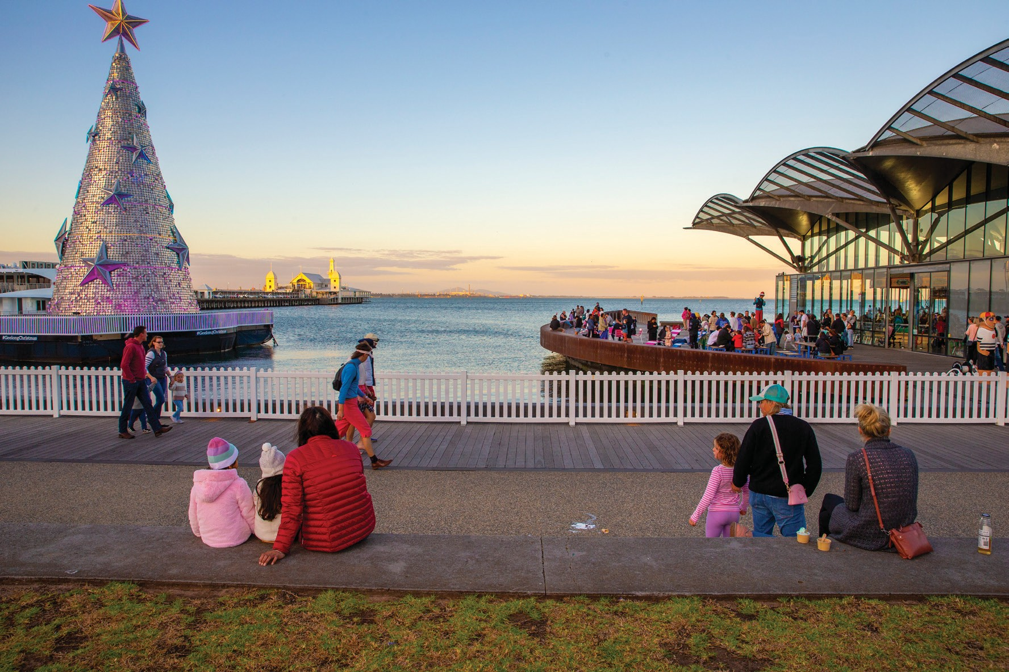

23 comments

***Other*** *20 comments*

Several respondents stated that there was nothing wrong with the area and didn’t want it to change. Statements varied from “nothing, I love it as it is” and “I would like if the council stops trying to develop it” to “No” and “Xxx”. One respondent had the opposite opinion, stating “everything.” A couple of respondents were unsure and one suggested more information on sea life�

***Specific place*** *3 comments*

A couple of respondents mentioned specific places they wanted to change without specific information; the area west of the skate park and Limeburners area. One respondent suggested taking ideas from the waterfronts of Darwin and Cardiff in Wales�

### RESPONDENT DETAILS



age of respondents

**Respondents were asked:** *to select their age group from a list of options*



RESPONDENT AGE GROUPS

50%

40%

30%

20%

10%

0%

Under 18-24

18 years years

25-34

years

35-49

years

50-59

years

60-69

years

70-84

years

0%

85+

years

8%

18%

19%

5%

6%

12%

32%

###### FinDinGs

* Over half of respondents (51%) were aged between 35 and 59 years of age:
  + The largest single group of respondents (32%) were those aged between 35-49 years of age
  + The second largest group (19%) were those aged 50-59 years of age
  + 23% of respondents were under 35 years of age�



gender of respondents

**Respondents were asked:** *to select the gender they identify with*



RESPONDENT GENDERS

60%

50%

40%

30%

20%

10%

0%

1%

Woman Man Non-binary

Prefer not to say

0%

Self describe

3%

43%

54%

###### FINDINGS

* + Women were the largest gender group (54%) that responded to the survey, and made up over half of respondents
  + Slightly fewer men (43%) completed the survey
  + Fewer than 1% of respondents selected non-binary
  + No one preferred to self-describe
  + Less then 3% of respondents preferred not to say



Location of respondents

**Respondents were asked:** *to identify the suburb they live in*

RESPONDENT SUBURB WHERE LIVE

20%

15%

15%

10%

7%

5%

5%

4% 3%

2%

1%

0%

0%

###### FINDINGS

Geelong Rippleside Geelong West

Belmont East Geelong Newtown Drumcondra

Highton Hamlyn Heights North Geelong

Curlewis Leopold Manifold Heights Whittington Clifton Springs

Corio Grovedale Bell Park Bell Post Hill Breakwater

Lara South Geelong Armstrong Creek

Herne Hill Ocean Grove St Albans park Waurn Ponds

Drysdale Marshall Newcomb Indented Head

Norlane Point Lonsdale Portarlington St Leonards

Wandana Heights Barwon Heads

Batesford Charlemont Fyansford Grovedale East

Moolap Mt Duneed

* + Respondents were most likely to live in Geelong (15%)
  + Less than one tenth of respondents lived in Rippleside (7%) and Geelong West (7%)
  + The rest of the respondents lived in 33 other suburbs with less than 5% in each one

**Other places** (respondents stated): Aspendale; Ballarat (2); Bannockburn; Brighton; Craigieburn; Darebin; Footscray; India; Kyabram; Lilydale; Macleod (4); Melbourne (11); Modewarre; Moriac; Mount Waverley; Pascoe Vale; Perth at present; Stony Creek; Torquay (4); Truganina; Warrnambool; Werribee; Yarra Junction; and Yarra Valley�



things respondents do

**Respondents were asked:** *to select the things they do at the waterfront.* (Respondents could select all the options that applied to them from the six below)



ThINGS RESPONDENTS DO AT ThE WATERFRONT

70%

60%

50%

40%

30%

20%

10%

0%

0%

6%

10%

11%

31%

47%

58%

###### FINDINGS

I use this space for exercise or relaxation

I live near or within 5 minutes of the waterfront

I visit the waterfront for tourism/holiday

purposes

I run of participate

in events

I work at the waterfront

I am a business owner on the waterfront

Other

* + Over half of respondents (58%) use the waterfront space for exercise or relaxation
  + Almost half the respondents (47%) live near or within 5 minutes of the waterfront
  + Almost a third of respondents (31%) visit the waterfront for tourism/holiday purposes
  + Less than a fifth run or participate in events (11%) or work at the waterfront (6%)
  + No respondents were business owners on the waterfront

**Other things respondents do** (written explanation): Eleven people said that they live close by but greater than 5 minutes away; six stated things they do at the waterfront, such as picnic, or skateboarding; and five made a range of other comments such as a visitor�

# NEXT STEPS

### TIMELINE

Stage 1 - engagement open - gather ideas

Began 10.00am 14 April 2023

Stage 1 - engagement closed

Closed 11:59pm, 31 May 2023

Stage 1 - Analyse and share feedback

June 2023

Prepare draft masterplan

July - December 2023

Stage 2 - engagement - seek community feedback on draft masterplan

February 2024

Stage 2 - Analyse and share feedback

March 2024

Prepare final masterplan

The masterplan is expected to be finalised in late 2024

# APPENDIX 1

#### GEELONG WATERFRONT MASTERPLAN SURVEY

##### QUESTIONS

About me (tick all that apply)

* I live near or within 5 minutes of the waterfront
* I am a business owner on the waterfront
* I work at the waterfront
* I visit the waterfront for tourism / holiday purposes
* I run or participate in events
* I use the space for exercise or relaxation
* Other (please specify)

Age group (select from drop-down options)

What is your gender? *This information enables us to consider the impact of Council service on people of different genders. This will help us to ensure that our services are equitable and meeting the needs of the Geelong Community.* (Select from drop-down options)

Town or Suburb (select from drop-down options)

if you could imagine your ideal waterfront in 15 years, what would you see?

thinking about what you wrote, does the waterfront need ***(more of, less of, or about the same)***:

* High quality parks and open space
* Well-connected trails
* Improved access to water
* More shopping, cafes and dining
* Arts and cultural experiences
* Festivals, celebrations and special events
* Improved facilities (e.g. more lighting, wider pathways or better seating options)

What are the top 4 things you want to do at the waterfront? *Identify and rank your top 4 options:*

* Exercise
* Relax
* Play or skate
* Meet up with others
* Swim
* Go boating / kayaking / yachting

Did we miss anything?

* Invest in a new business
* Eat in cafes / restaurants
* Shop
* Study and learn
* Attend events
* Spend time connecting to nature

How well is the waterfront meeting the needs for different groups? *(Not well, well enough, very well, don’t know)*

* + Children and families
  + Young people
  + Businesses
  + New investors
  + New investors
  + The arts and performing community
  + People over 65 years of age
  + People using the site at night
  + People who live within 15 minutes of the waterfront
  + People who live more than 15 minutes from the waterfront

What information would help you engage with the waterfront? *Identify and rank your top 2 options (1 highest) by either dragging and dropping, or writing 1 and 2 (phone). Clicking a button moves the item between the two lists.*

1. Wadawurrung culture
2. Recent history and cultural information
3. Events
4. Improved wayfinding signage

is there anything else?

if you could change oNe thing about the waterfront, what would it be?

thank you for taking the time to contribute to our survey. We look forward to reading all the comments.



PLEASE NOTE: This report has been prepared by MosaicLab on behalf

of and for the exclusive use of City of Greater Geelong�

MosaicLab accepts no liability or responsibility whatsoever for or in respect of any use of or reliance upon this report by any third party�

*MosaicLab is a Victorian-based consultancy that specialises in community and stakeholder engagement, facilitation, negotiation, strategic planning, and coaching.*

*MosaicLab acknowledges the Traditional Custodians of the many lands on which we live and work, and the continuing and valuable contribution they make to land, sea and culture. We pay our respects to elders past, present and emerging.*

REPORT PREPARED By:

[www.mosaiclab.com.au](http://www.mosaiclab.com.au/)