**community engagement summary**

**PROJECT BACKGROUND**

The City of Greater Geelong is currently undertaking stormwater studies across our region. These studies will help us to better understand flood risk and the opportunities for stormwater and integrated water management. Information on current and future stormwater studies can be found here <https://yoursay.geelongaustralia.com.au/stormwater>.

Community Engagement

A key part of each of the stormwater studies is community engagement. In February-March 2021 we completed the first round of community feedback for the Ocean Grove Stormwater Study.

Thank you to everyone who provided feedback, your contribution is valued and appreciated. During Stage One we asked the community to identify flood-prone areas to help inform our flood modelling, including flood stories and local knowledge of the area; as well as responding to survey questions and provide feedback on a social map. The feedback has assisted in developing flood modelling tools for the area. Stage Two engagement will aim to gain specific feedback on our goals as well as proposed stormwater management options and show calibration and design event mapping.

The feedback received during both stages of engagement provided valuable local insights for the study. The study will inform future stormwater management, including land use planning, community flood preparedness and emergency response within the catchment area.



**38 DAYS**   
of engagement (Stage One)



Suggestions (comments) from the public left online via the interactive map

**59**



**97**

Number of people to leave feedback



**64**

Surveys completed



**62**

People following the project

**499**

letters

|  |
| --- |
| HOW WE ENGAGED |

**WHAT DID WE DO**

A dedicated Have Your Say project page was designed to share relevant information to encourage community feedback. All residents within the Ocean Grove study area were welcome to respond.

An online survey was available and was the core feedback tool for gathering community knowledge of the local area, 64 surveys were completed.

An interactive map was available to gather further local insights to help inform our work. This knowledge will help inform our designs and locations for future water-related infrastructure.

59 contributions were received via the draft 1 per cent AEP (Annual Exceedance Probability) Social Map. 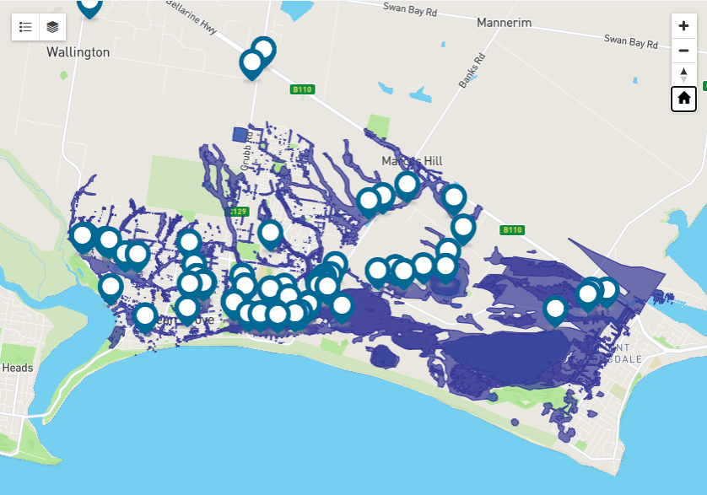

|  |
| --- |
| WHO WE ENGAGED WITH |

PARTICIPATION

During the consultation period more than 1,180 people visited the Ocean Grove Stormwater project Have Your Say page with 123 pieces of feedback provided via the two collection tools.

Community members will be provided with multiple ways to engage with the City, online, email and over the phone.

|  |
| --- |
| WHAT WE HEARD |

**SNAPSHOT OF WHAT WE HEARD**

When asked if they were concerned that their property could be flooded in the future, 81 per cent of respondents said yes, 8 per cent said no, and 11 per cent were unsure.

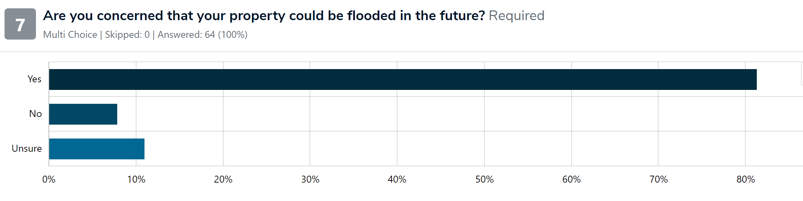

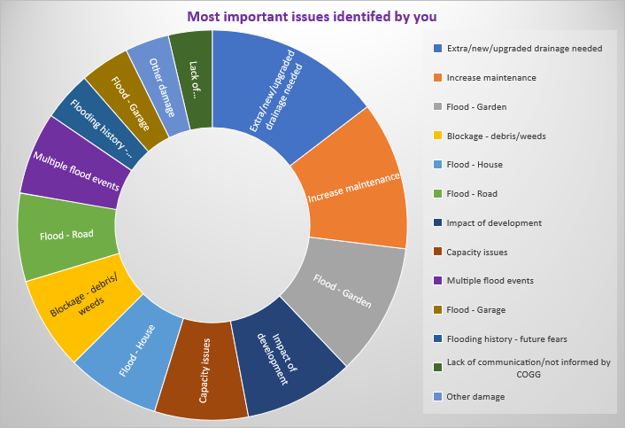

When asked what their concerns were, you told us:

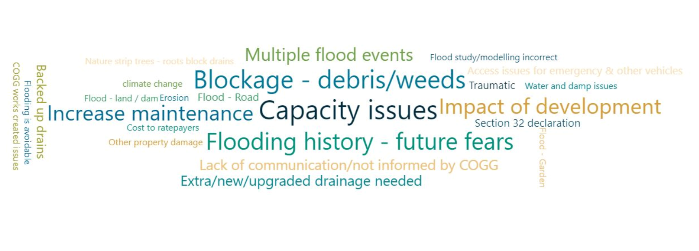

Some verbatim comments below:

Issue or Concern

“*During heavy rain we observe large volumes of water flowing across our property, it flows down the public footpath, and also from the side of our house across the lawn to the public footpath, onto our drive and then into the storm water drains. There is minimal pooling provided the water can flow across the lawn and down the footpath”*

“*The drainage channel that runs from Begola wetlands and around the rear of Collendina Football oval needs regular maintenance and cleaning”*

Idea or opportunity

*“We concur with other comments that the drainage channel system from Begola onwards to Lake Victoria needs an improved maintenance regime.”*

*“this area regularly floods which is fine as it attracts waterbirds etc.. maybe we just accept it and construct a larger stormwater detention ponds/wetlands..”*

*“*

Past flood event

**“***Had garage, house and yoga studio flooded twice since we moved here in 2021….”*

*“This area of Field St South floods every time it rains. Drains do not drain & cannot handle the amount of water that collects there during a rain event. This needs URGENT attention. The SES are constantly called to flooding events here. The new drainage system does NOT work despite the huge amount of money spent there recently which has not fixed the flooding problem.”*

*“Previous flooding during very heavy rain event. Storm water drains could not cope with volume.”*

‘We asked…..’

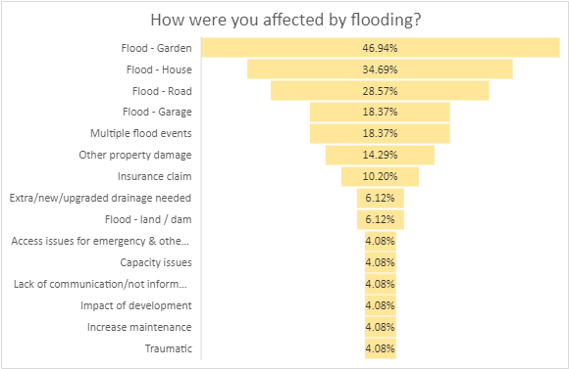

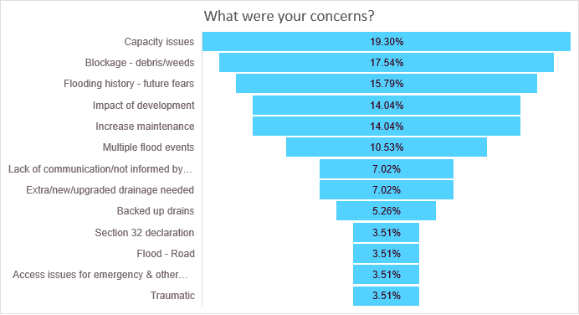

A number of key themes came out of the engagement, below is a summary:

**OVERALL KEY FINDINGS**

* The most important issue that respondents identified is a need for new or upgraded drainage,
* Respondents also believe that increased maintenance is important.

**OVERARCHING THEMES**

Four overarching themes came through survey responses:

* Drainage, including capacity of the system, is inadequate and needs to be improved
* Maintenance should be more frequent due to blockages from debris and weeds
* Community concerns about the impact of development on drainage and flooding
* Future fears based on a history of flooding.

|  |
| --- |
| NEXT STEPS – round Two community engagement |

The City will be undertaking Round Two engagement with the community and stakeholders in the latter half of 2023. The community engagement will present the flood mapping from the calibration and design event modelling and also seek to gain feedback on up to three proposed stormwater mitigation options and their locations. It is also aimed to highlight the importance of catchment-wide mitigation prioritisation.