The City Of
Greater Geelong

Ocean Grove District Ride Centre

Engagement report

  - OCTOBER 2022

Contents
Introduction 3
Project Background 3
Engagement Purpose 3
About this Report 3
How we engaged 4
At a glance 4
Have your say project page 4
COmmunications 4
Who we engaged 6
Who we planned to engage 6
Participation 6
Demographics 6
Where were the respondents from 7
What we asked 8
What we asked 8
What we heard 9
Key Findings overview 9
Breakdown of findings 9
What we have done and next steps 16
What we have done 16
Next Steps 16

Introduction

Project Background
In 2020 Council removed some poorly constructed jumps within Woodlands Reserve, Ocean Grove and following this proceeded to engage with the local community to develop a concept plan for their replacement. This process identified key issues with the existing Woodlands Reserve location, and it was agreed to seek an alternative location within Ocean Grove for a district ride centre.
Over 60% of the makeshift bike jumps created during the COVID pandemic were located in the suburbs of Barwon Heads and Ocean Grove. A site selection process was undertaken to identify potential sites for a district ride centre within Ocean Grove. Each site was assessed against a set of criteria, and through this process Kingston Park was determined as the most suitable site in which to locate this facility, as it is the only district level park in Ocean Grove with existing amenities, in a central location. Council has created a concept plan, by Synergy Trails, to understand the type and location of facilities that could be located within Kingston Park.
The City undertook engagement to understand if the community is supportive of a district ride centre being located in Kingston Park, in line with Council Approval Procedure for Open Space Development Projects. This included a Have Your Say (HYS) page with a quick poll, survey and formal submission form. Council officers also conducted two on site sessions to hear how the community values the existing spaces and facilities within Kingston Park and their thoughts on the location of a District Ride Centre within Kingston Park.
The engagement also sought feedback on the Draft Concept Plan to understand the types of features the community would like to see in a District Ride Centre.

Engagement Purpose
The purpose of this engagement was to seek community feedback on the location of the District Ride Centre within Kingston Park and share the Draft Concept Plan.
This feedback will allow Council to make a decision on whether a District Ride Centre should be located within Kingston Park, and if so seek funding for the project to progress with detailed design and construction.

About this Report
This report has been prepared to present the community engagement feedback to inform the community about the engagement process, findings and outcomes. This report will also present feedback to Councillors for consideration as part of the decision-making process in deciding if a District Ride Centre should be located within Kingston Park.

How we engaged

At a glance
The community consultation was open from 9 am Friday 29 July to 5 pm Friday 26 August 2022. The following consultation methods were included as part of the engagement period.

Have your say project page
The Have Your Say (HYS) platform was the main engagement tool. https://yoursay.geelongaustralia.com.au/OGDRC
Background on the project, the reasons for engagement and the various ways to engage with the project were included in the page. The Draft Concept Plan was available for viewing and detail on the proposed features included.
Responders could complete the quick poll on whether they supported or objected to the location of the District Ride Centre in Kingston Park. They could also complete the survey to provide more detail on why they support or object to the location and what they thought of the Draft Concept Plan. A Formal Submission option was provided for those who wanted to discuss their comments with the project team and was progressed in accordance with the Approval Procedure for Open Space Development Projects Council Policy.
The HYS page also included a FAQs section which provided detail on the site selection process, and how the proposed project would interact with the existing space.
Hard copies of the key information included on the HYS page, the Draft Concept Plan, Survey and Formal Submission forms were available and provided to community members upon request.

Communications
Social Media
The engagement was promoted via Social Media including targeted Facebook ads, Facebook, Twitter and Instagram posts on the 30 July 2022 and again on 16 August 2022.
Face to Face on site sessions
Two on site face to face sessions were held at Kingston Park to understand how the adjacent residents and existing users of the park utilise and value the existing open space and discuss the project. Fourteen (14) people attended the session on Thursday the 18th August and twelve (12 ) people attended on Saturday the 20th August.
Printed Media
Media releases were published directing people to the Council website to leave feedback, and picked up by the Geelong Advertiser, the Bellarine Times, and the Ocean Grove Voice.
Details on the project, the engagement period and a link to HYS page were included in the CityNews public notices section in the following publications on the following dates:
- Bellarine Times 28/7 and 18/8
- Geelong Independent 29/7 and 19/8
- Geelong Advertiser 30/7 and 20/8
On site signage
On site signage was installed in multiple locations throughout Kingston Park on Friday the 29 July 2022 for users to be aware of the consultation and directing users and residents to the HYS page to provide feedback.
Letters/emails
Letters notifying residents and businesses adjacent to Kingston Park were distributed by Council Officers on Friday the 29 July. The letters included a brief overview of the project, details of the engagement period closing date and time, details of the on-site face to face sessions and a link to the HYS page for further information.
Emails to key stakeholders within the community and Kingston Park were sent out letting them know the engagement period dates and included a link to the HYS page.

Who we engaged

Who we planned to engage
The engagement process aimed to engage with local users of Kingston Park, the adjacent residents, members of the Ocean Grove bike riding community, members of the broader Ocean Grove community and members of the broader Geelong region who visit the reserve.
The engagement process set out to understand how the existing users and residents adjacent to Kingston Park use and value the existing park and gain their feedback on the proposed location of a District Ride Centre in Kingston Park. The engagement also sought feedback from the broader Ocean Grove community to understand if the local riders of all ages and abilities supported or objected to the location in Kingston Park and get their feedback on the Draft Concept Plan.

Participation

203
Surveys received
Quick poll responses
351
Formal submissions
27
26
People attended the 2 on site sessions

Demographics
Of the 203 survey responses we received we had respondents aged from under 9 to 84 years old. Our highest participation age groups were between 40 and 44 years of age with 21% respondents in this age group and under 20’s with approximately 25% of respondents.
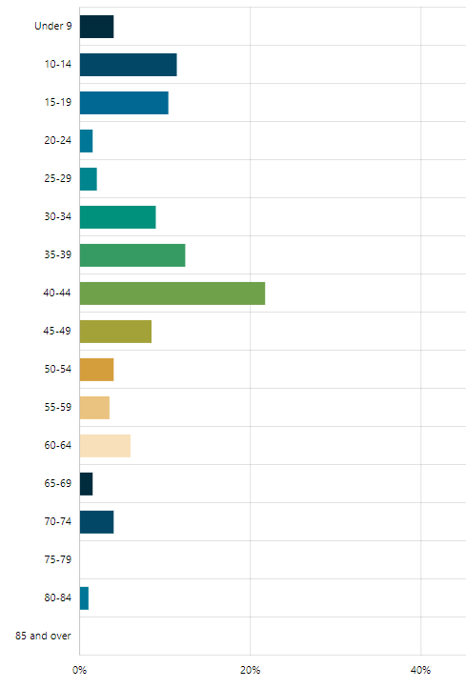
Figure 1 - Respondent’s age
A majority of the survey respondents (39%) were local Ocean Grove/Barwon Heads riders or parents of local Ocean Grove/Barwon Heads riders (23%). Residents adjacent to Kingston Park made up 5% of survey respondents.
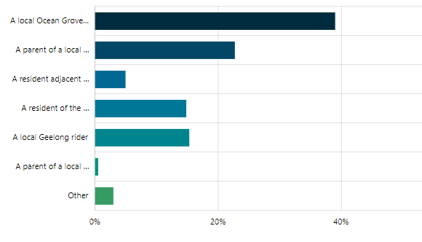
Figure 2 – Who responded

Where were the respondents from
203 respondents provided an answer to this question. Locations include:
- 78% (158) of respondents were from Ocean Grove
- 6% of the respondents were from towns on the Bellarine, including Drysdale (5), Barwon Heads (3), Bellarine (1), Clifton Springs (1), Curlewis (1), Point Lonsdale (1), and Wallington (1).
- 14% were from other areas of Geelong.
- Four respondents were from outside the City of Greater Geelong.

What we asked

What we asked
The HYS page had one key question we were asking the community which was: Do you support the location of a District Ride Centre facility within Kingston Park, Ocean Grove? As the introduction of the District Ride Centre would be a change of use for Kingston Park, it requires formal consultation with the local community in line with the Approval Procedure for Open Space Development Projects Council Policy.
This question could be responded to through the quick poll, the survey or the formal submission.
We also asked for feedback on the Draft Concept Plan to understand if the facility contained the types of features the local riders would want to ride and guide the development of the project if the location is approved.
Questions we asked in the survey included the following on the location and the Draft Concept Plan:
- Do you support the location of a District Ride Centre facility within Kingston Park, Ocean Grove?
- Can you tell us why you don’t support the location of a District Ride Centre in Kingston Park?
- Do you like the concept design?
- Please tell us what you love about the concept design?
- Please tell us what you don’t like about the concept design or what you’d prefer to see?
- What changes do you think should be made to improve the concept plan?
- Would you ride the pump track if built?
- Would you ride the jumps if built?
- Would you ride the skills and trials area if built?
- Is there anything else you would like to share with us about the location or concept plan?
We also asked specific questions related to riders skills and experience:
- What best describes you as a rider?
- What type of riding do you do?
- How often do you ride?
- Where do you currently ride?
- Have you ever been riding on makeshift jumps and/or tracks in the region?
Additional demographic questions were asked to gain an understanding of who we were engaging with.

What we heard

Key Findings overview
The key questions we wished to have answered through this engagement were:
- Do you support a District Ride Centre in Kingston Park?
- Do you have any feedback to provide on the concept?
The key findings from the quick poll were:
- 88.6% (311) of respondents supported the location of the District Ride Centre in Kingston Park
- 11.4% (40) of respondents did not support the location of the District Ride Centre in Kingston Park
The key findings on the location of the District Ride Centre from the survey were:
- 86.7% (176) respondents supported it
- 13.3% (27) respondents did not support it
Through these two forms of feedback on this key question we had strong support from the respondents for the location of the District Ride Centre within Kingston Park.
We received 27 formal submissions through the HYS form and through direct email and mail. Of the formal submissions received 14 were in support of the location of the District Ride Centre in Kingston Park and 10 were in objection to the location of the District Ride Centre in Kingston Park. One was not in relation to the location of the District Ride Centre in Kingston Park, one was unclear if they supported or objected and one submission was withdrawn.
As part of the survey feedback, we asked whether people liked the Draft Concept and a majority (150) of the respondents loved the Draft Concept. There were some suggestions and changes that were provided as comments which will be broken down further as part of this report.

Breakdown of findings
Quick Poll
The quick poll results showed a majority of respondents, 311 out of the 351 respondents supported the location of the District Ride Centre in Kingston Park.

Figure 3 – Quick poll results
Survey
- Do you support the location of a District Ride Centre facility within Kingston Park, Ocean Grove?
Of the 203 survey respondents, 176 (88.7%) supported the location of the District Ride Centre in Kingston Park and 27 (13.3%) were unsupportive.
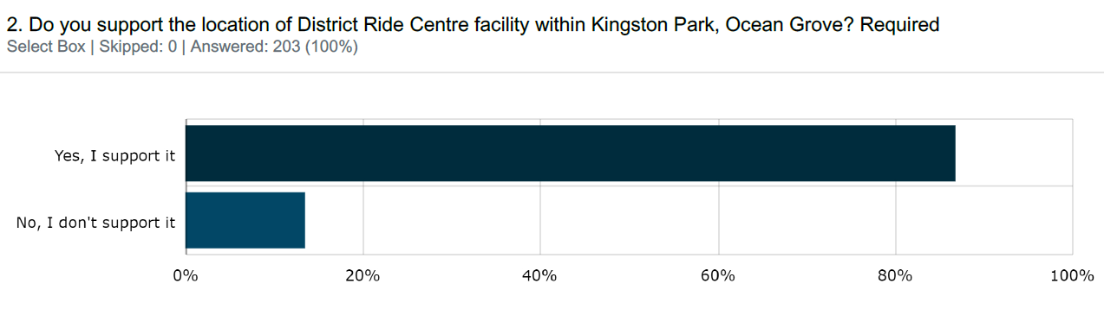
Figure 4 – HYS Survey Do you support the location of a District Ride Centre facility within Kingston Park, Ocean Grove?
Supportive
For the 176 respondents who were supportive of the District Ride Centre being located within Kingston Park, 76 identified as being a local Ocean Grove/Barwon Heads rider, 46 identified as a parent of a local Ocean Grove/Barwon Heads rides, 30 identified as local Geelong riders, 13 as residents of the wider Ocean Grove Community and four as residents adjacent to Kingston Park.
Of the 76 local Ocean Grove/Barwon Heads riders, 23 were under 20 years old, 12 were aged 35-39 years old, 11 were aged 40-44 years old and the remainder between 20-35 and 50-74 years old.
Unsupportive
For the 27 respondents who were unsupportive of the District Ride Centre being located within Kingston Park, six identified as residents adjacent to Kingston Park, 17 identified as a resident of the wider Ocean Grove Community. Three identified as local Ocean Grove/Barwon Heads riders and one a local Geelong rider.
- Can you tell us why you don’t support the location of a District Ride Centre in Kingston Park?
All 27 participants who responded that they were unsupportive of the District Ride Centre being located within Kingston Park provided a response to this question. Key concerns raised by respondents unsupportive included:
- Loss of off-leash dog areas
- Loss of open space
- Kingston Park is a peaceful and natural space
- Unsafe pedestrian connections to Kingston Park
- Increase in rubbish, traffic, and anti-social behaviour.
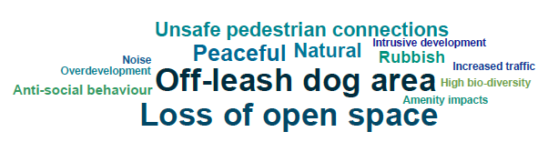
Figure 5 – HYS word cloud: unsupportive key word tags
- Do you like the concept design?
All 203 survey participants provided a response to this question. 150 (74%) respondents loved the concept design, 37 (18%) liked the concept design with some changes and 16 (8%) don’t like the concept design.
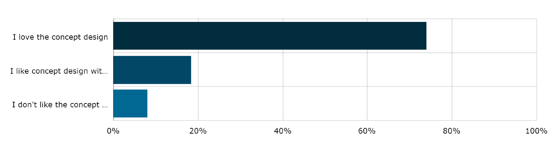
Figure 6 – responses to question 3: Do you like the concept design?
- Please tell us what you love about the concept design?
For those who loved the concept design elements they liked included:
- Catered to all skill levels
- Included a mix of features
- Catered to all ages
- Allowed for advanced riding and challenging
- Allowed for progression of skills
- Was a good use of space and close to amenities
- Central location
- Had an asphalt pump track, jumps including gap jumps and skills and trials area.
Figure 7 – HYS word cloud: what respondents loved about the concept
- Please tell us what you don’t like about the concept design or what you’d prefer to see?
For the respondents who didn’t like the concept, 16 out of the 150 respondents, key themes included that it was the wrong the location and the loss of open space. Key concerns included:
- Loss of passive open space
- Wrong location
- Loss of off-leash dog walking areas
- Increase in rubbish, graffiti traffic and noise
- Too big.
Figure 8 – HYS word cloud: what respondents didn’t like about the concept
- What changes do you think should be made to improve the concept plan?
Of the 37 respondents to this question the top four themes raised were:
- Make sure there is sufficient parking (8%)
- It’s the wrong location (8%)
- Provide more BBQ’s (8%
- Is there enough elevation for jumps? (8%)
Other changes were related to the types of riding or features the respondents wanted the concept to include such as single track, downhill trail, making features bigger, providing a mulch jump, rock gardens, berms, separate pump tracks for beginners and more advanced riders and timber balance features.
Respondents also requested specific amenities to be provided such as bins, fencing, shelter from rain and wind, safe connections, more toilets, security and a fenced dog park.

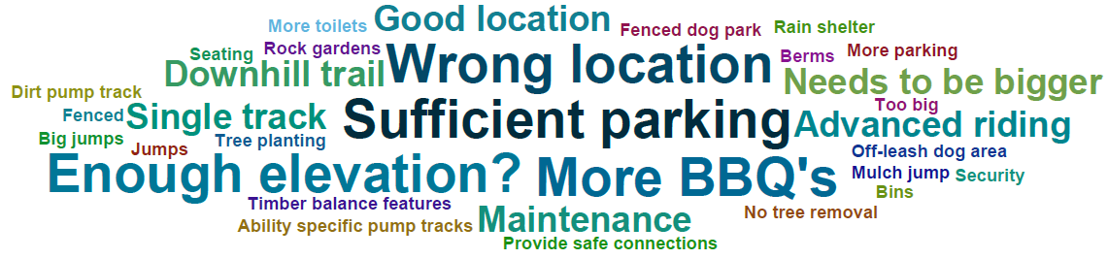
Figure 9 – HYS word cloud: what respondents liked, or thought could change
- Would you ride on the pump track if built?
146 (72%) respondents indicated they would ride the pump track if built. 43 (21%) respondents would not, and 13 (7%) respondents answered ‘other’. Of the ‘other’ respondents, 8 indicated their children or nieces and nephews would ride the pump track.
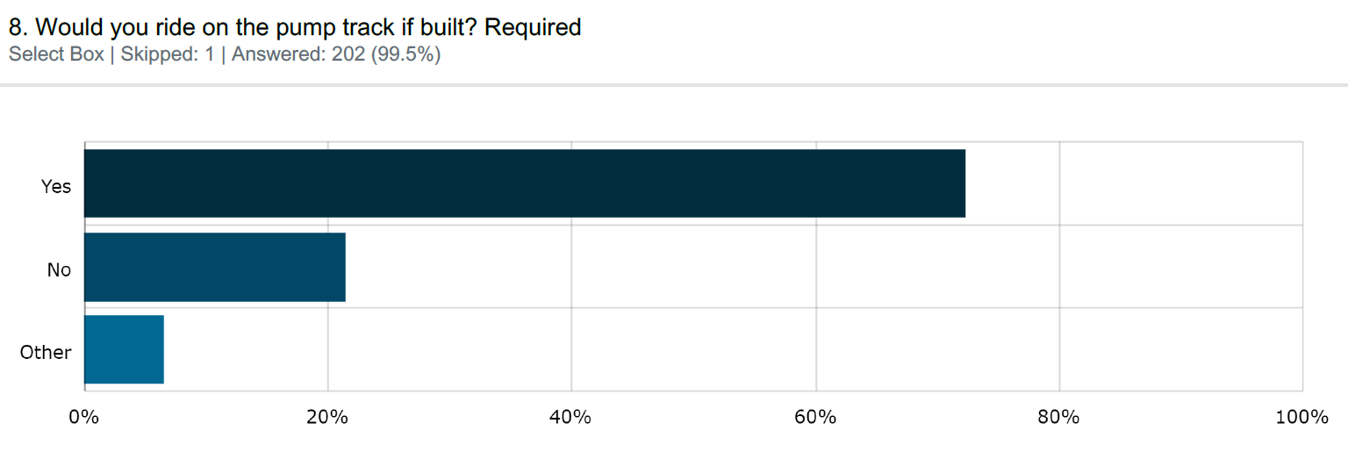
Figure 10 – HYS Survey Would you ride on the pump track if built?
- Please tell us why?
Of the 43 respondents who indicated they would not ride the pump track, 43% identified it was due to their age, and 10% as they didn’t ride. Other reasons for not riding the pump track included not interested, respondents found pump tracks boring, not their style of riding.
- Would you ride the jumps if built?
145 (72%) of respondents indicated they would ride the jumps if built, 50 (25%) would not and 7 (3%) answered ‘other’. All the ‘other’ respondents indicated that their kids would ride the jumps.
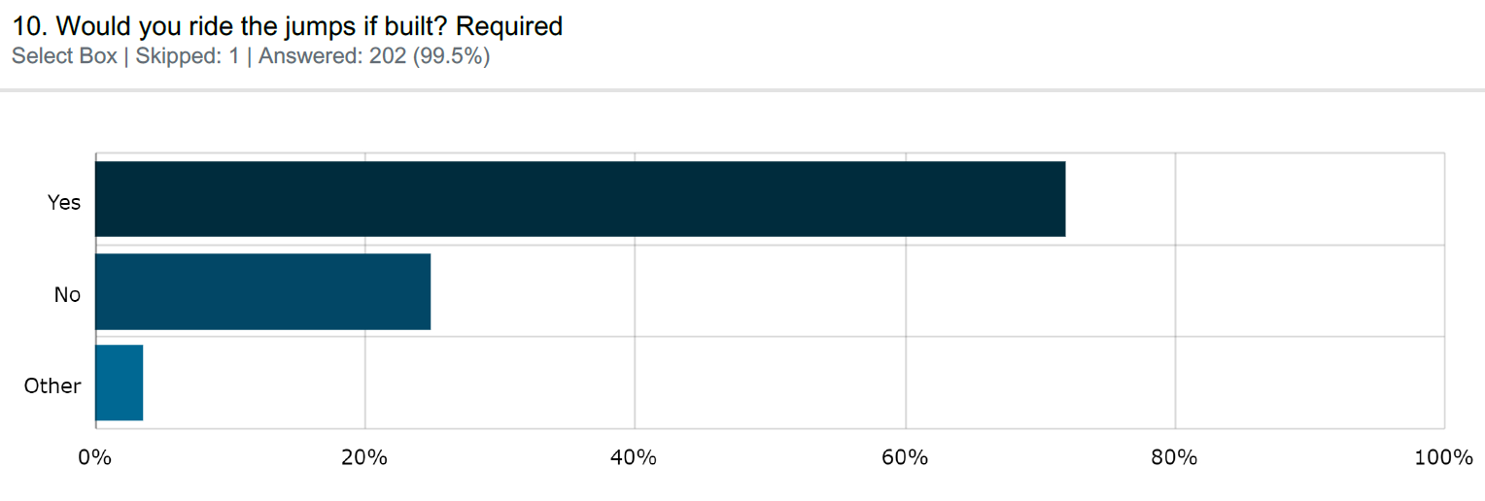
Figure 11 – HYS Survey Would you ride the jumps if built?

- Please tell us why?
Of the 41 respondents who indicated they would not ride the jumps, 59% indicated it was due to their age, and 12% as they didn’t ride. Other reasons for not riding the jumps included lack of experience, not in their skill set or not interested.
- Would you ride the skills and trails area if built?
145 (73%) of respondents indicated they would ride the skills and trials area if built, 41 (21%) would not and 13 (6%) answered ‘other’. Of the respondents that answered ‘other’, 5 (3%) indicated that their kids would, 4 (2%) indicated that it would depend on the level of difficulty, with participants indicating a preference for difficult features.
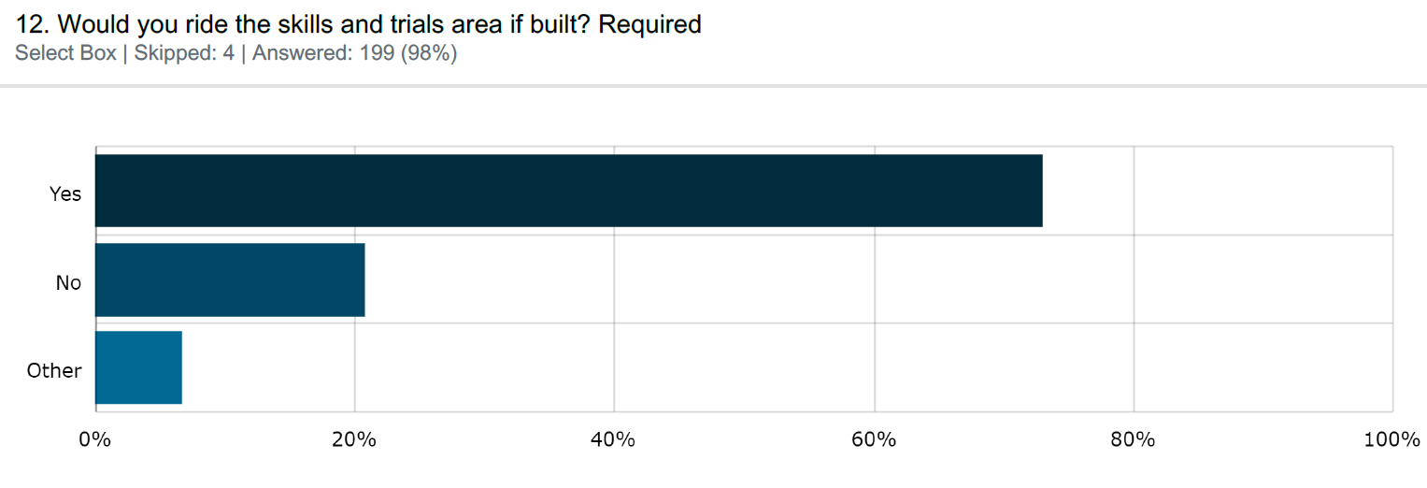
Figure 12 – HYS Survey Would you ride the skills and trials area if built?
- Please tell us why?
Of the 41 respondents who indicated they would not ride the skills and trials area, 29 told us why. 31% indicated it was due to their age. Other reasons for not riding the skills and trials areas included not interested in that type of riding, the respondents don’t ride, and it is not a popular type of riding.
- What best describes you as a rider?
This question was asked to understand the skill level of the riders participating in the survey. All 203 survey participants responded to this question. 104 (51%) of respondents identified as intermediate riders, 45 (22%) identified as expert and 34 (17%) identified as beginner. Of the respondents who answered ‘other’ 21(10%), reasons included non-riders, parents or grandparents of kids who would ride, recreational or regular riders.
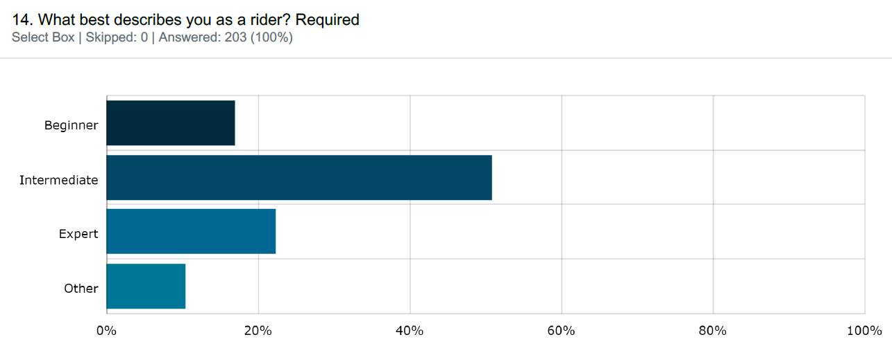
Figure 13 – HYS Survey What best describes you as a rider?
- What type of riding do you do?
To understand the types of riding the survey participants might undertake we asked: What type of riding do you do? 86 survey participants responded to this question and with respondents able to select multiple options. The most popular type of riding was Mountain Bike with 147 respondents, followed by Road cycling 59, BMX 40, Competition 23 and Other 23. Of the 23 participants that respondents that selected ‘other’ 5 were non-riders and other types of riding included trials, cyclocross, commuting, socially, casually, for exercise, rail trails, time trials and triathlons.
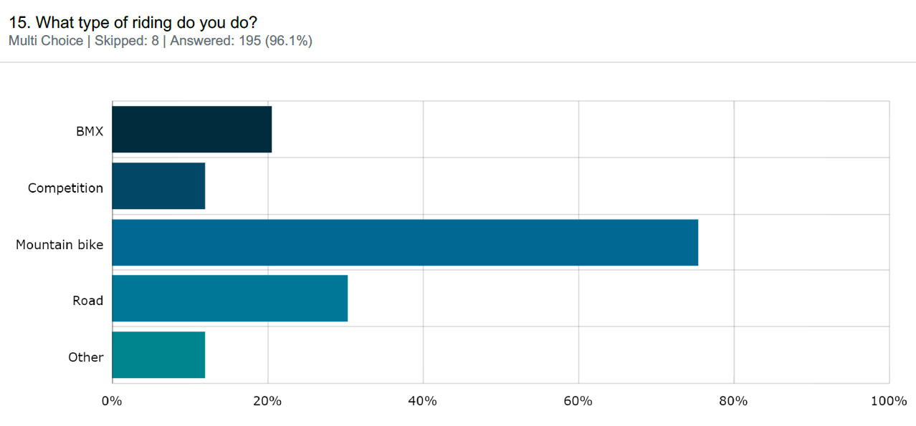
Figure 14 – HYS Survey What type of riding do you do?
- How often do you ride?
190 survey participants responded to this question. Most respondents, 58 (31%) ride multiple times per week, 51 (27%) ride weekly, 28 (15%) ride daily and 28 (15%) ride monthly, 18 (9%) ride less than monthly and 7 (3) respondents selected ‘other’. Of the respondents that selected ‘other’ reasons included, never, rarely, answering for their kids who ride daily.
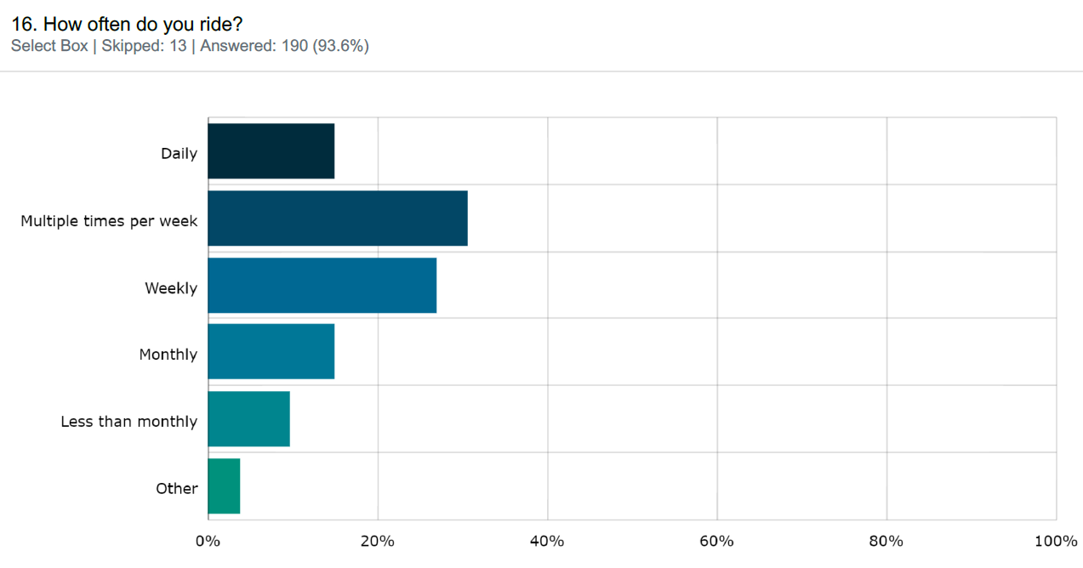
Figure 15 – HYS Survey How often do you ride?
- Where do you currently ride?
This question was asked to understand where riders currently ride. All 203 survey participants responded to this question, and 166 respondents selected multiple locations. The most common answer was Streets / shared paths with 104 respondents selecting this location. Over half the respondents ride makeshift jumps or tracks and travel outside the municipality to ride.

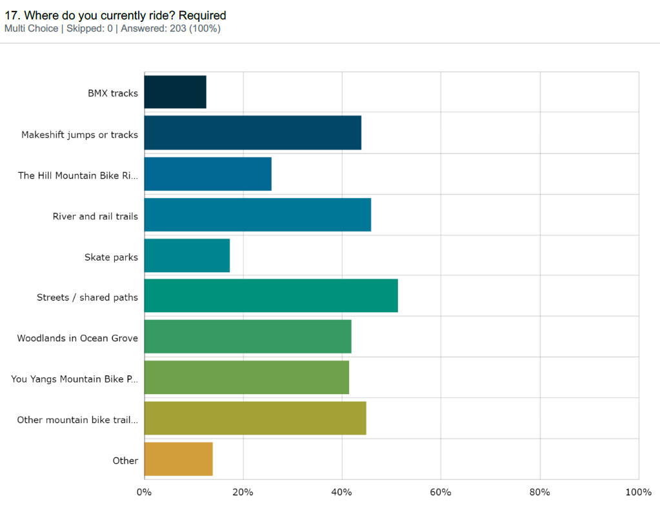
Figure 16 – HYS Survey Where do you currently ride?
28 respondents selected other. Reasons for selecting ‘other’ included road, fire trails in Ocean Grove Nature reserve, Anglesea trails and bike park, pump tracks in Creswick, Mount Buller, Mount Baw Baw, Falls Creek, Harcourt, Ballarat, Albury, Victorian High Country, and non-riders.
- Have you ever been riding on makeshift jumps and/or tracks in the region?
To understand if the proposed District Ride Centre would cater to the riders of makeshift jumps this question was asked. 125 (63%) respondents answered yes, 73 (37%) answered no.

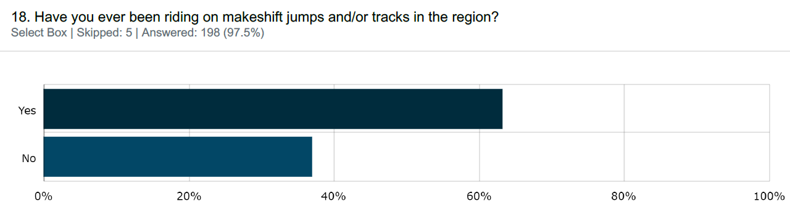
Figure 17 – HYS Survey Have you ever been riding on makeshift jumps and/or tracks in the region
- Is there anything you would like to share with us about the location or concept plan?
The responses received to this question captured the concerns and sentiments raised in response to earlier questions in the survey. Below are some key quotes which capture concerns raised by those who do not support the District Ride Centre in Kingston Park and thoughts on why those who do support it.
“Don't spoil a beautiful asset to the community”
“I support this project as it’s very important to have recreational facilities for this age group. It is an excellent location, central, accessible & plenty of surrounding open space.”
“Improve cycling and road infrastructure leading to the site.”
“It is an amazing location. But terribly dangerous to get to if you live in Old Ocean Grove, Woodlands or Yellow Gums.”
“Access to the location is dangerous for cars, particularly turning right into Adco from Grubb.”
“Kingston Park is a treasured open space that is rich in the sights and sounds of birdlife. It is very popular as somewhere easy to get to, to just sit or to walk around and enjoy the natural environs. I think it would be heartbreaking, and inappropriate, to lose this rare passive open space.”
“Great idea. Can't wait until it is completed so that I can take my kids for a safe and enjoyable ride on the course.”
“I know my daughter and I will be visiting this regularly. We definitely need something like this in the area!”
“It is great having it near the existing playground. Having kids of different ages, the older ones can use the track, whilst the younger ones can use the playground.”
“Having scope for users to advance is important to me. Features that have a high level of challenge should be encouraged. This will reduce illegal jumps being built.”
Formal submissions
The community had the opportunity to provide a formal submission in support or objection to the location of a District Ride Centre within Kingston Park.
27 formal submissions were received through the HYS page, and via email and letter. Of the formal submissions received 14 were in support of the location of a District Ride Centre within Kingston Park, 10 were in objection, one submission was withdrawn, one was unclear and one was not in response to the question or unclear.
Submissions in support
Of the 14 submissions in support of the location within Kingston Park key themes included:
- There are limited things for kids in their early teens to do within the area
- The facility would provide a safe location for kids to ride
- The facility would be a great community resource and support people to get outdoors and be a part of their community
- Kingston Park is currently not used to its full potential
- A crucial piece of infrastructure
- Shows that the community values outdoor, self-directed, non screen-based activity.
- Will build fitness and resilience
- It will not be a facility for just males, parents of young girls who would use the facility support the location
- Central location to older and newer parts of Ocean Grove, allows equity of access
- Existing facilities on site such as parking and multi-age facilities used by entire families
- Good off-road links to Kingston and Oakdene estates
- Safe road crossings for users coming from the south
- Amenity for nearby residents protected by an existing vegetated buffer
- Appropriate zoning, PPRZ encourages active recreation
- Other users such as dog walkers will have adequate space
- The location within the park provides high visibility
- Fencing the facility to prevent conflicts between bike riders and other park users
- Important to improve and increase the capacity of the existing facilities (shelter, seating, water fountain)
The 14 formal submissions in support of the location noted the following concerns as part of their submission:
- The spatial separation of the bike jump runs, quite close together and could be intimidating to young, beginner riders
- Access to Kingston Park by road and path, the plan does not identify demand impact or indicate approaches to address impact and improvement for safety
- The intersection of Grubb Road and Adco Grove will need improvement and is currently dangerous.
- Safe access routes should be provided for youths accessing the park from the south and needing to cross Shell Road.
- There will be an increased demand for car parking.
- Displaced dog walkers and cyclists travelling to and from the facility could impact on the Kingston Park Biodiversity Reserve.
- Consideration should be given to the installation of CCTV cameras and clear signage to help discourage potential anti-social behaviour.
Submissions in objection
Of the 10 submissions in objection to the location of the District Ride Centre in Kingston Park, Ocean Grove the following key concerns were raised:
- Intersection of Grubb Rd/Adco Grove – very busy, traffic safety concerns.
- How cyclists, in particular children will access the site safely – including crossing Shell Road, Grubb Road and through the industrial estate to the north.
- How will traffic in and around Kingston Park be managed – car parking is currently full on weekends.
- Impact on spaces for off-leash dog walkers.
- Loss of passive, natural, quiet open space – currently used as a space for picnics, dog walking, community connection, safe space for older women etc.
- Impacts on flora and fauna within Kingston Park and the fenced conservation area – in particular birdlife.
- Management objectives in the 2012 Master and Management plan identified protection of vegetation, protection and enhancement of conservation area and green space, passive recreation, protection of native grasses.
- Could see an increase in bikes through the nature reserve and revivalist camp.
- Conflicts with existing users - adjacent to playground used by young families, concerns around increased bikes and traffic near children and dogs.
- Industrial estate users have raised concerns around increased traffic.
- Existing problem with litter, graffiti and anti-social behaviour, lack of passive surveillance and open sight lines.
- Noise for adjacent residents.
- Tree removal.
- The DRC will only be for one type of user and restricts the use of the space – predominantly male bike riders.
- The project would be intrusive.
- Flood prone/existing drainage issues.
- Concerns that putting bike jump infrastructure within Kingston Park would see jump building activity spill out into surrounding areas.
- Concerns around events being held.
- Existing amenities won’t be adequate – more toilets etc.
- Concerns on the type of fencing proposed.
- Would be better located in the growth areas/new developments.
- Not sure who would want a bike park in Ocean Grove.
- Insufficient notice given for feedback and consultation on concept wasn’t sought.
- Internet users did not have access.
All submissions in objection to the project were offered a mediation session to make sure their concerns were captured. A mediation sessions was held on Monday 19 September 2022.
A Submissions Review Panel was held on Wednesday 12 October 2022 where formal submitters presented their formal submissions to a panel of Councillors.
Face to Face sessions
Two face to face sessions were held on site in Kingston Park on Thursday the 18 August from 4.30pm to 6.30pm and on Saturday the 20 August from 10am to 12pm.
Adjacent residents and users of the park attended to discuss and raise their concerns on locating a District Ride Centre in Kingston Park, or show their support for the project.
Key themes discussed at the face to face sessions included:
- Kingston Park is a quiet and natural space with abundant bird life – concerns around disturbance to bird life with introduction of District Ride Centre.
- Concerns on loss of passive open space/green space, community sentiment that there is a lack of passive space like Kingston Park in Ocean Grove.
- Once the open space is lost it is hard to get it back.
- Concerns that the District Ride Centre does not align with the original intent of the 2012 master plan and management plan for Kingston Park.
- Concerns over loss of off-leash dog walking space.
- Concerns on attracting people and an increase in anti-social behaviour.
- Concerns on the amount of car parking available – during busy periods the car park can be full and there is limited space for overflow parking in the surrounding streets.
- Concerns increased visitation would increase the amount of rubbish and waste left behind.
- It is a great proposal, the kids are very excited.
- Queried if Shell Road Reserve considered, this would have better passive surveillance, parking and is in an existing active precinct.
- Consider locating the District Ride Centre next to a sporting ground to prevent loss of open space.
- Daily user of the park is very supportive, happy that fencing is proposed and there is plenty of space for everyone.
- Great idea, make sure rubbish is collected regularly and bins are provided.
- Concerns about connections into the park from surrounding areas and lack of safe crossing points at Grubb Road and Shell Road.
- Consider connections from surrounding areas to Kingston Park including from the rail trail, Drysdale and Point Lonsdale.

What we have done and next steps

What we have done
The engagement process for this project managed to reach over 300 people. With 311 quick poll responses, 203 survey submissions and 27 formal submissions. The reach of the engagement was strong in the Ocean Grove community, with 78% of the survey respondents from Ocean Grove and 96% of the formal submission respondents from Ocean Grove. We also received feedback from residents around Geelong and surrounding municipalities.
What we heard from the community was that the location of a District Ride Centre in Kingston Park was supported (88.6% in support through the quick poll, 86.7% in support through the Survey and 52% in support through formal submissions) and would be used by riders of all skill levels. The facility would need to be designed for multiple skill levels and age groups, and include opportunities for progression.
Valid concerns were raised in objection to the location within Kingston Park, including:
- Provision of safe pedestrian and cycling connections from the surrounding areas, including safe crossings over Grubb Road and Shell Road.
- Existing safety concerns with the intersection of Adco Grove and Grubb Road
- Loss of passive open space and off-leash dog areas
- Increase in rubbish and anti-social behaviour
- Potential impacts on existing flora and fauna and the conservation areas with activities spilling out into other areas of the reserve.
A mediation session was held with the formal objectors to make sure their concerns were captured and outline the next steps.

Next Steps
Next steps include the Submissions Review Panel hearing held on Wednesday 12 October 2022. Following the Panel hearing, a report will progress to the November Council meeting to make a decision on the location of the District Ride Centre in Kingston Park, Ocean Grove.
The community and stakeholders will be updated on the engagement process following the Council meeting. This will be through an update on the Have Your Say page, an email to those who follow the page, and direct email to formal submitters and stakeholders who engaged with the project. For survey participants who requested direct follow up (due to lack of internet access) hard copies of the engagement summary will be sent out and they will receive a phone call notifying them of the Council decision.

