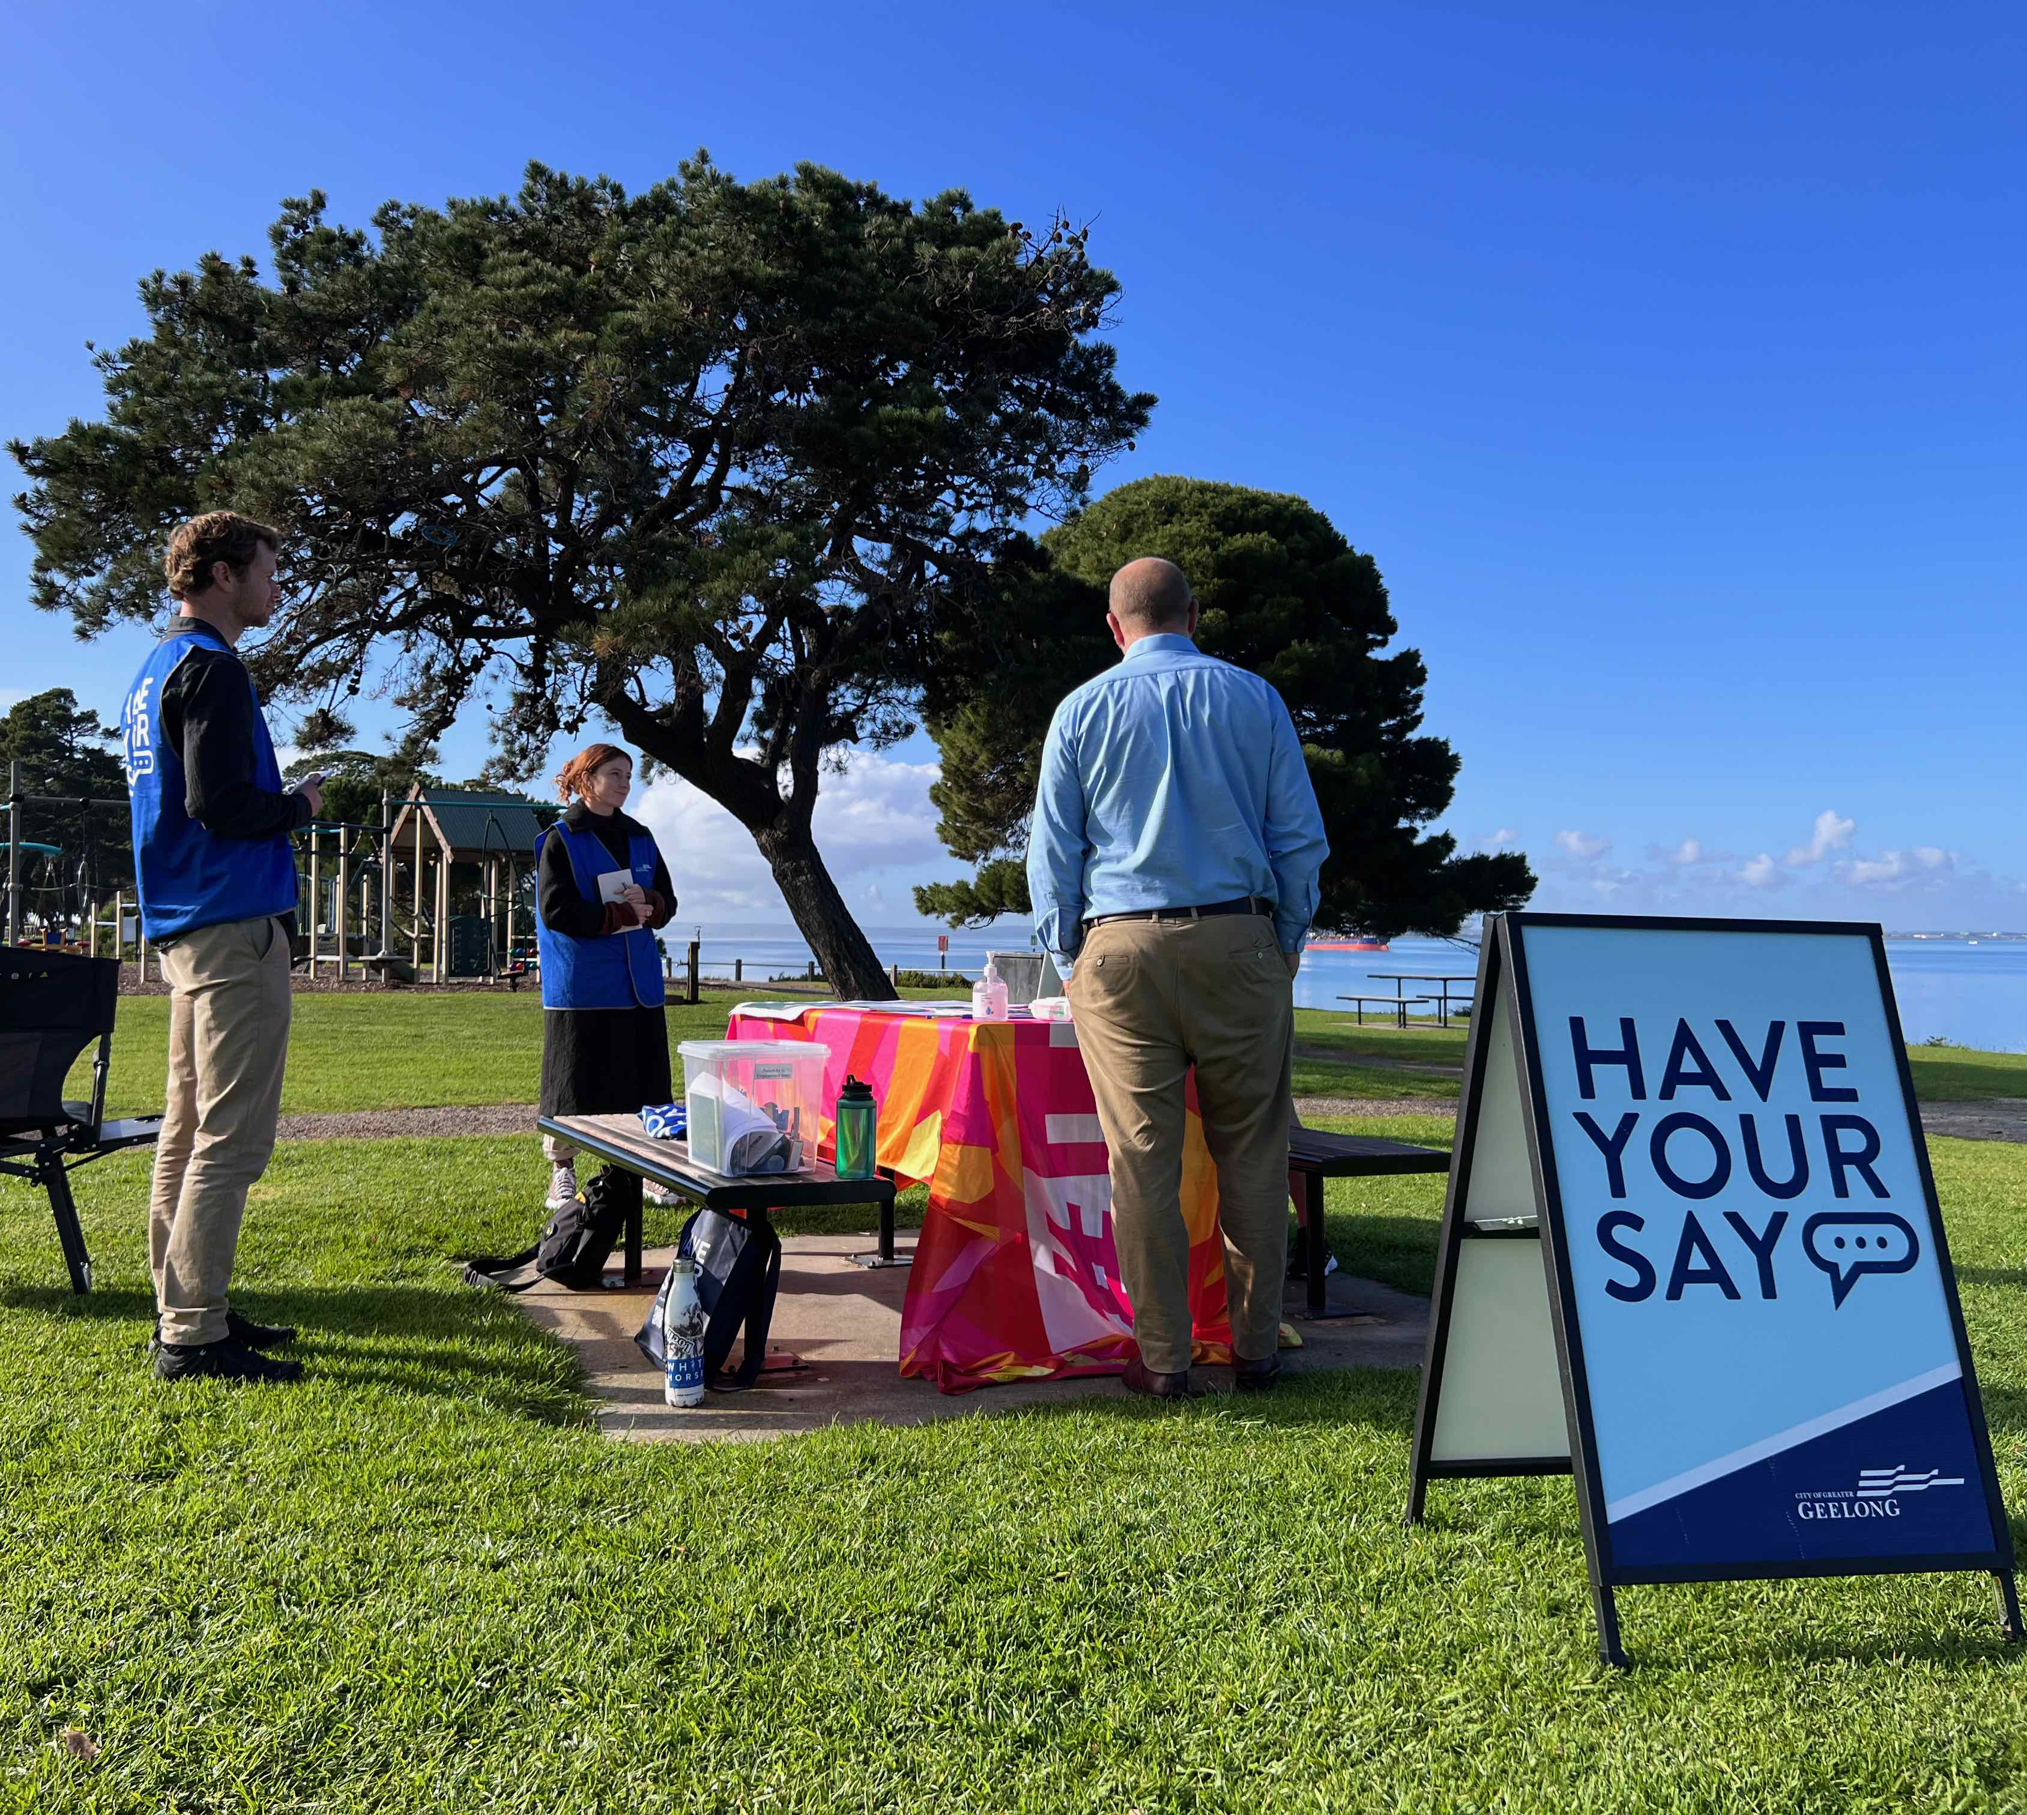

Engagement Report prepared by Pollen Studio in collaboration with the City of Greater Geelong.

INTRODUCTION
Feedback on the Draft Moorpanyal Park Master Plan has closed. Thank you to everyone who provided feedback, your contribution is valued and appreciated.
The primary objective of this master plan is to accurately reflect the diverse spectrum of community needs and aspirations, while also upholding fiscal prudence, environmental sensitivity, and optimizing the park's utility and purpose for the community.
The engagement for the project was split across two phases. During the first phase an on-site workshop session was held between the City, the Landscape Architect (Pollen Studio) and the North Shore Residents Association. We asked the North Shore Residents Association to share their local knowledge and what they perceive to be the most significant issues and opportunities for the site. This workshop provided important insights into the way that residents currently use Moorpanyal Park and how they want to use it into the future. These ideas and conversations were recorded and were imperative for the development of the draft master plan.

The first phase also included early engagement with key stakeholders to ensure the needs and views of each stakeholder are understood, reflected, and accommodated where possible. Stakeholders consulted through this first phase include:
- City of Greater Geelong Project Working Group;
- Department of Energy, Environment and Climate Action - DEECA (Formerly DELWP);
- Incitec Pivot;
- Midway;
- North Shore Residents Association;
- Victorian Fisheries Authority; and
- A number of other relevant stakeholders within the area.
The City has engaged with the Wadawurrung Traditional Owners during the development of the master plan.
The second phase of engagement was conducted in April and May 2023. The purpose of the engagement was to get broad community feedback on the draft master plan, essentially asking ‘Are they satisfied with the master plan? What excites them about this plan? What concerns they have? and any other specific feedback? This feedback will determine if the community supports the master plan or if there are changes that should be made to better reflect the community’s needs.
The following report will focus on the findings of the second phase of engagement.
HOW WE ENGAGED
WHAT DID WE DO?
The second phase of community engagement was undertaken from 28 April to 29 May 2023. The purpose of the engagement was to get broad community feedback on the Draft Moorpanyal Park Master Plan. This feedback will determine if the community supports the master plan or if there are changes that should be made to better reflect the community’s needs. All comments are considered before the master plan is finalised. An online ‘Have Your Say’ page and an in-person listening post were the focus for data collection and recording.

27
People attended 1 on-site session

61
Surveys received
32 DAYS
of engagement

990
Visitors to the Have Your Say Page
Letters dropped to adjacent residents & businesses
387

People following the project
14
SOCIAL MEDIA
27,422
Reach/Impressions
705
Actions (Clicks, reactions,
shares, comments
etc.)

Signs installed onsite for duration of engagement
3
X

ENGAGEMENT OBJECTIVES
The objectives of the engagement process:

- Maintain a positive relationship between City of Greater Geelong and its community.
- To ensure the engagement is accessible and inclusive by hearing a wide range of perspectives.
- To consult with the community and stakeholders about the values, issues and opportunities of the site and provide an opportunity for the community to have input on the design and future uses of the reserve.
- Provide clear direction for the master plan.
- To enable broad support of the master plan by the community, stakeholders and authorities.

ENGAGEMENT TOOLS AND TECHINQUES
The City developed a project specific Have Your Say engagement page to provide project information and inform the community how they could engage.
The engagement focussed on two main data collection activities,
- an online Have Your say (HYS) project page and
- an onsite Listening Post.
The City used a wide range of different communication methods to reach people in the municipality to encourage engagement with the project.
The main tools and techniques are explained in further detail below:

HOW WE ENGAGED
HAVE YOUR SAY ONLINE PORTAL | An online HYS project page was designed to share relevant information to encourage community feedback on the draft master plan.
SURVEY (ONLINE) | A survey was distributed via the online HYS page and was available to be completed at the onsite listening post event.  The objective of the survey was to understand if the community was in support of the draft master plan document and to understand what changes can be made to the plan prior to finalisation.
LISTENING POST | A listening post was conducted onsite on Saturday May 13th 2023 from 10 am to 1pm. The listening post sought to engage and collect the input of local people or users of the park who were otherwise unaware of the project or those who preferred face-to-face consultation over online engagement. Community members were invited to take project information with them, have a discussion with staff and/or complete a survey on the day.
LETTERBOX DROP | The City undertook a mail-out campaign to all 387 residences and businesses that are located in the North Shore suburb to inform them about the project. The letters directed people towards the HYS page to complete the survey and informed them about the listening post where they could meet Council officers and the consultant team onsite to discuss the project face to face. See Appendix A for the letter that was distributed.
SOCIAL MEDIA CAMPAIGN | Two paid social media campaigns via Facebook, Instagram and X (formerly Twitter) were arranged during the engagement period. The first social media campaign went live the week of 4th May and was directed at surrounding suburbs (North Shore, Norlane, North Geelong, Corio, Rippleside, Bell Park, Bell Post Hill, Lara, Lovely Banks). The second social media campaign went live the week of 24th May and was directed at the whole municipality. This resulted is 27,422 impressions and 705 actions. See Appendix B.
ONSITE SIGNAGE | Three A3 corflute signs were erected in prominent locations within the Moorpanyal Park reserve during the 32-day engagement period. The signs direct readers to the Have Your Say page for further information and outline the date on the on-site listening post. See Appendix C.
MEDIA RELEASE | On Thursday 27th April the City published a Media Release (refer Appendix D) which was run by the Geelong Times (16 May 2023).  https://timesnewsgroup.com.au/geelongtimes/news/north-shore-park-plan-seeks-input-but-funding-uncertain/

WHO WE ENGAGED WITH

PARTICIPATION
During the second phase of the consultation period, 28 April to 29 May 2023, there were 990 unique views of the Have Your Say webpage. Of these 990 views, 61 people completed the survey. Our assumption is that large number of people viewed the draft master plan and had felt that they did not need to make any comments as they were generally comfortable with what was proposed in the draft master plan.

The survey was designed to gain insight into the participants level of involvement in the project, their key priorities, as well as their overall key sentiments regarding the draft master plan. The survey consisted of 10 questions including a mix of multiple choice, long (text) answer and one ranking question.
The community was invited to share some demographic data with us through the HYS page survey. The following is a snapshot of these people. Demographic data was not recorded from the onsite listening post.
survey results
Please note the first question is not shown as this is a question about the reading and agreeing to the privacy statement and not relevant to the analysis.
A large majority (62%) of respondents identified as being local residents, we did not receive substantial responses from people who are employed in the area or who own local businesses. However, it is worth noting that some people who selected ‘local resident’ may also be employed in the area which may be an explanation for the lack of responses from these groups. It is also worth noting that the adjacent businesses were engaged in the development of the draft master plan via stakeholder interviews.
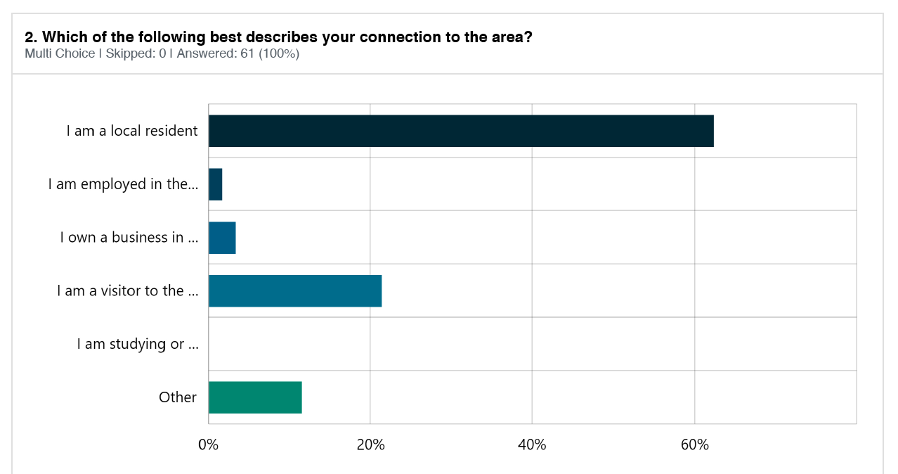

A high number of survey respondents recorded being frequent users of the park. From this information we can infer that many people providing feedback have an intimate knowledge of the park and are likely to have strong investment in the project. The survey also engaged a number of people that use the park less frequently indicating there may be reasons for their infrequent use that could be addressed through this master plan. It is great to see that we had a broad cross section of park users from those who use the park often to those may use the park infrequently.
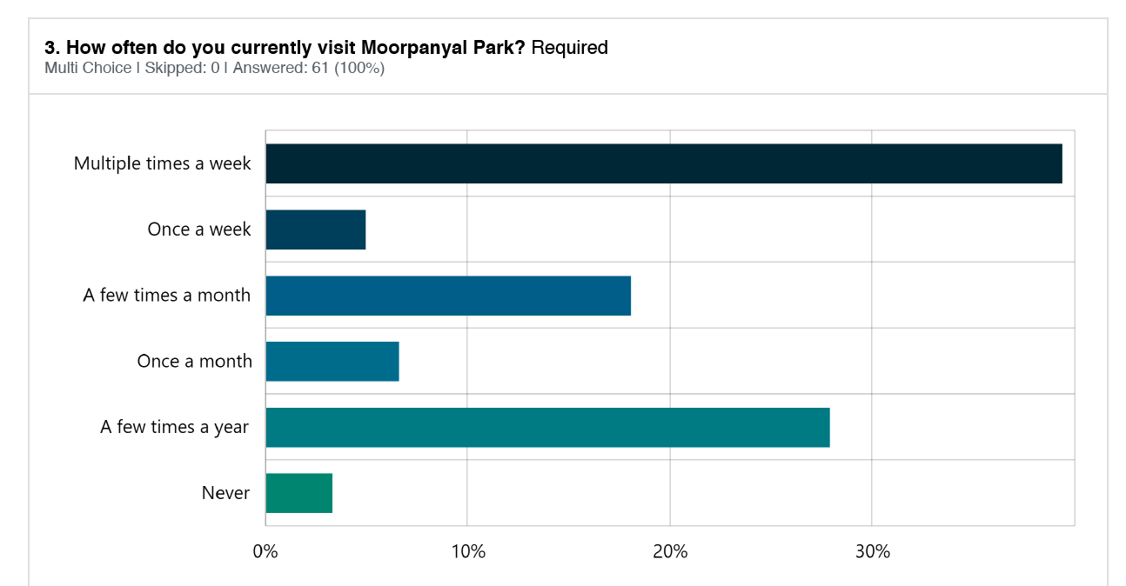

This next question was about the main reason for visiting Moorpanyal Park. Respondents were allowed to select multiple options. The top responses were Walking & Running (37) Enjoying the views from the park (32) Enjoying the views from my Vehicle (21) Dog walking (21).
From this data, we can understand that most survey respondents use the park to walk, run or take in ocean views. This information may be useful when considering the prioritisation of future works at Moorpanyal Park. It is also worth noting that some of the listed activities may be seasonal but still hold great importance to the community.

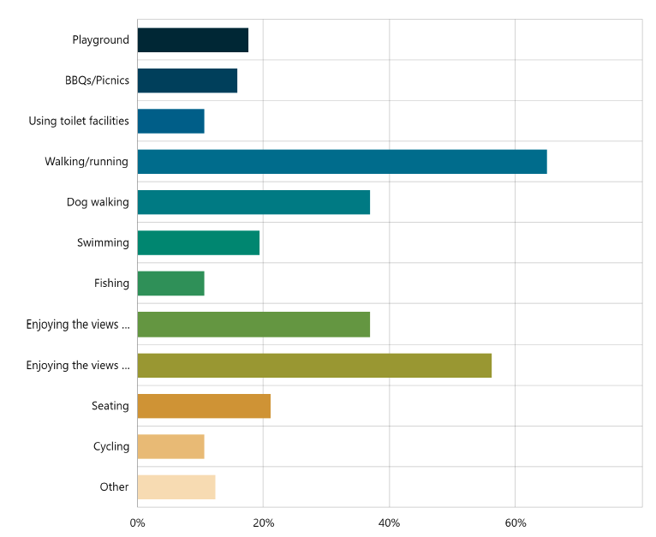
Enjoying the view from the park
Enjoying the view from my vehicle

The survey showed the majority of participants visiting Moorpanyal Park travel by car or motorbike (68%) while 44% walk or run. The results showed public transport was not a popular choice and that some people (14%) used a bike or scooter to access the park. Note that respondents could choose multiple answers.
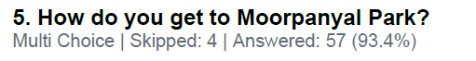
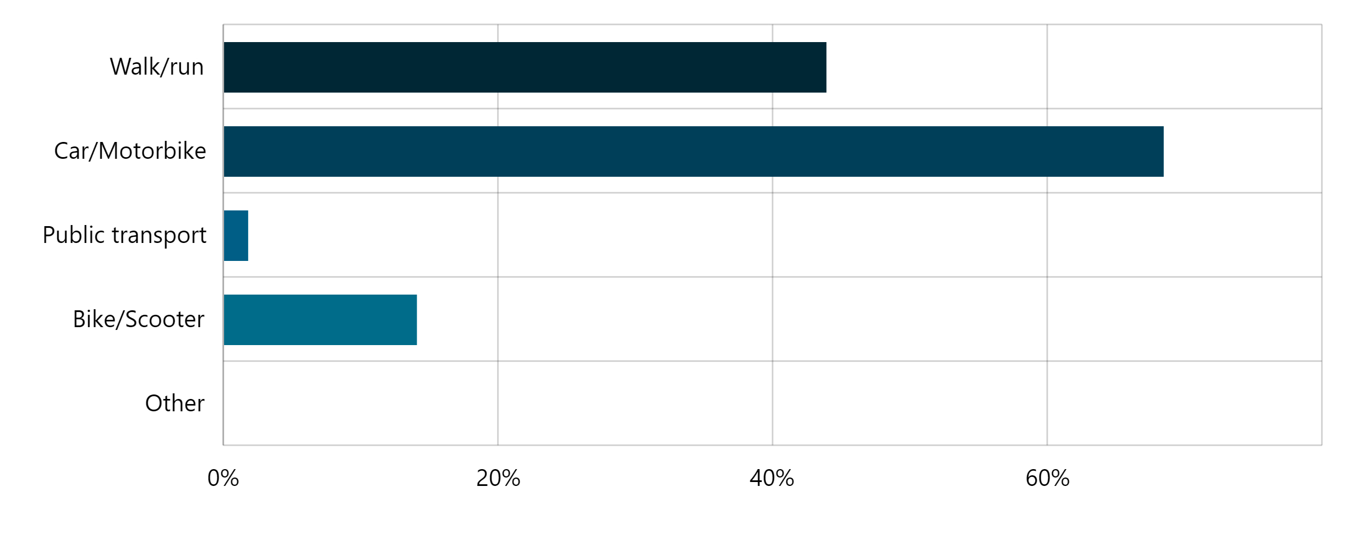
Almost three quarters (72%) of survey respondents reported that overall, they felt positively towards the proposed draft master plan document (23% Very Satisfied, 49% Somewhat Satisfied). 12% of respondents reported feeling ‘unsure’ and 16% reported feeling negatively towards the draft master plan.
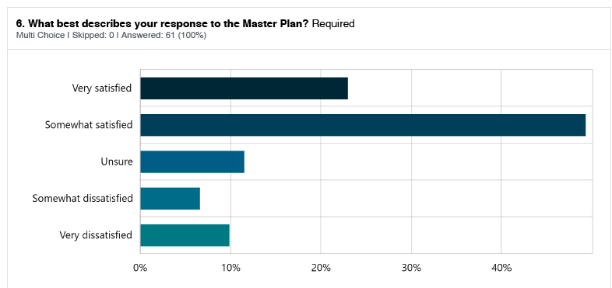

This was a long text answer question, allowing people to describe in more detail what they were most excited about from in the draft master plan. Answers were varied indicating the draft plan was appealing to a community with diverse priorities.
A snapshot of responses is provided below, the top 5 answers grouped using data tags:
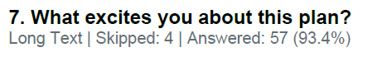
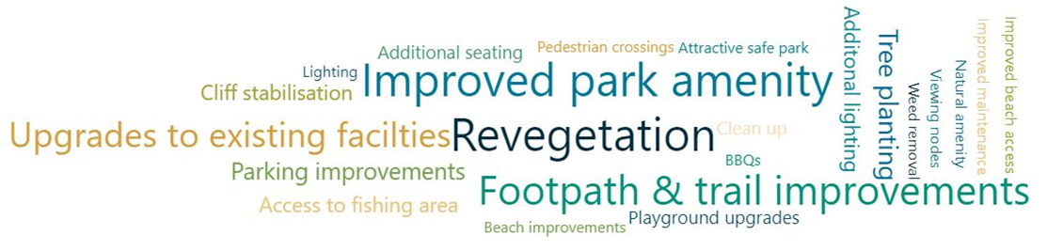

Many participants took the time to write their responses to the question “Do you have any concerns about the plan?” indicating a strong level of engagement and concern for Moorpanyal Park. The draft master plan aimed to present detailed qualitative information to allow the City to make decisions on what could be included or omitted in the final version to better serve the community’s needs and aspirations. The City is aware that not all community members had the opportunity to engage with the project in earlier phases, therefore it was important to allow ample opportunity for people to voice their concerns in this engagement. A snapshot of responses is provided below:
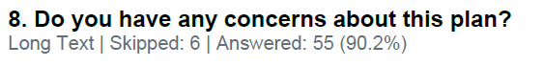

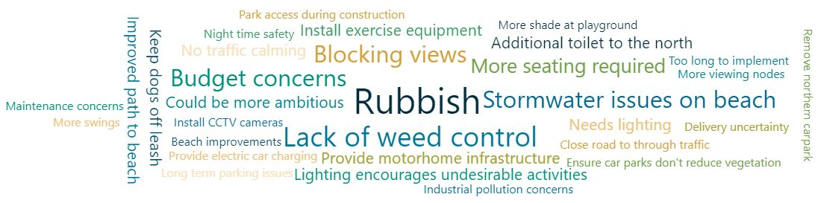

70% of respondents reported they would be likely to visit Moorpanyal Park more frequently should the proposed draft master plan be implemented.
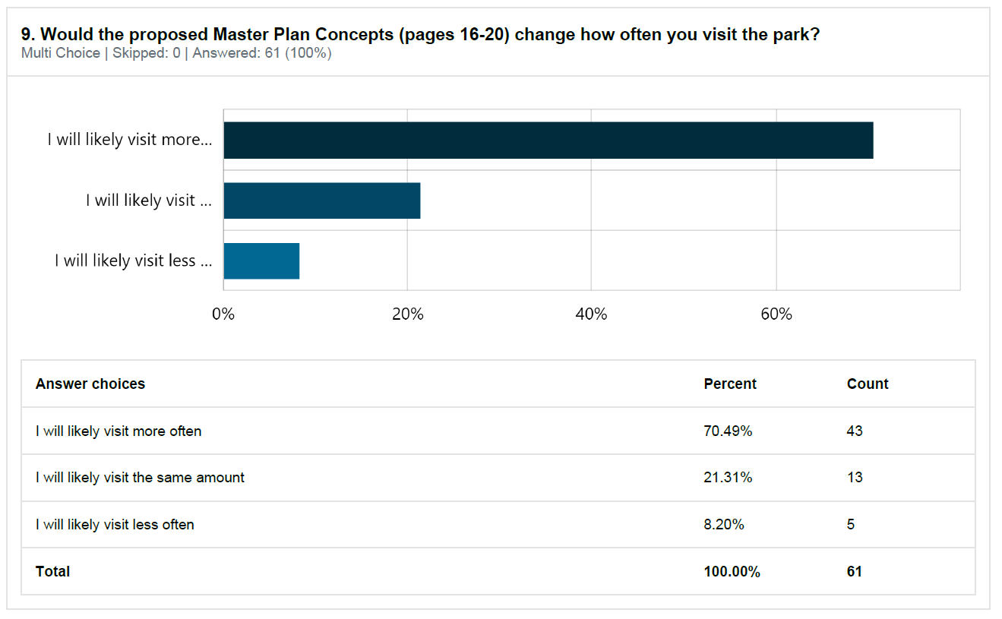

While we were consulting the project had a budget allocated to deliver works. Unfortunately, the budget was removed due to financial constraints. However, this question is still very relevant and important as it identifies the respondents top 3 priorities for implementation. The top 5 identified items by the respondents were:
- Connections to the Bay Trail
- Revegetation / infill plating throughout the site
- Cliff stabilisation works
- Lighting along the path
- Additional seating

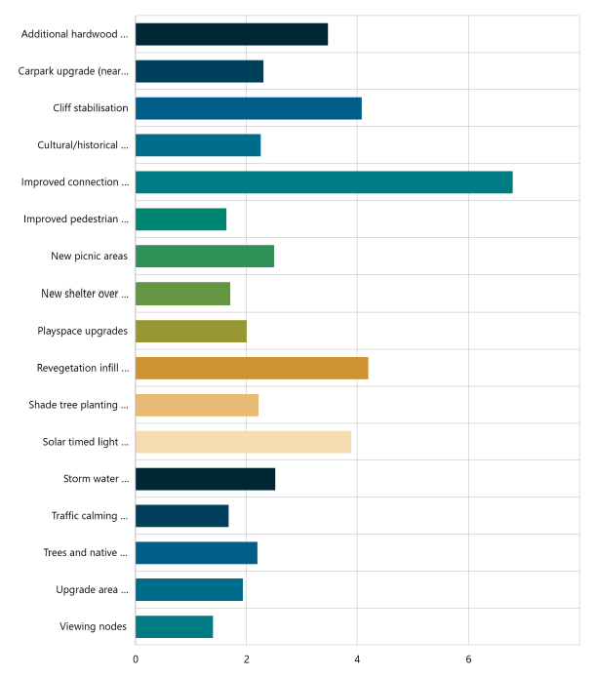
Stormwater treatment to remove pollution from carpark runoff
Solar timed lighting bollards along path
Shade tree planting throughout the site
Revegetation/infill planting throughout the site
New shelter over existing BBQ area
Improved connection to the bay trail in the form of a concrete shared path….
Cultural/historical
interpretive signage
Carpark upgrade to roadside perpendicular parking
Viewing nodes
Playspace upgrades
Upgrade area adjacent to existing fishing jetties…
Trees & native vegetation improvements to South-eastern area
Traffic calming measures along The Esplanade
New picnic areas
Improved pedestrian access to fishing jetties
Cliff stabilisation
Additional hardwood seating throughout the site

This last question aimed to capture any final comments that may not have fitted neatly into any of the earlier questions. This question was skipped by 40% of respondents, many of the respondents used this as an opportunity to summarise their answers to previous questions. A snapshot of responses is provided below:

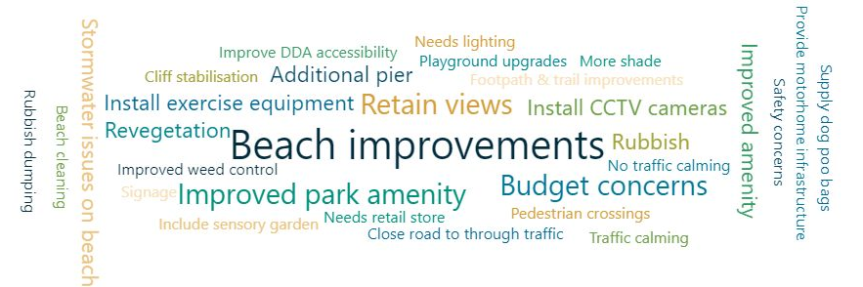

WHAT WE DID

CONCLUSION

Feedback on the Draft Moorpanyal Park Master Plan has closed. Thank you to everyone who provided feedback, your contribution is valued and appreciated.

The final master plan is being prepared in response to community consultation and further engagement with DEECA and the Wadawurrung Traditional Owners. The final master plan will be presented at a Council meeting for formal endorsement later this year.

APPENDIX A – Letterbox Drop

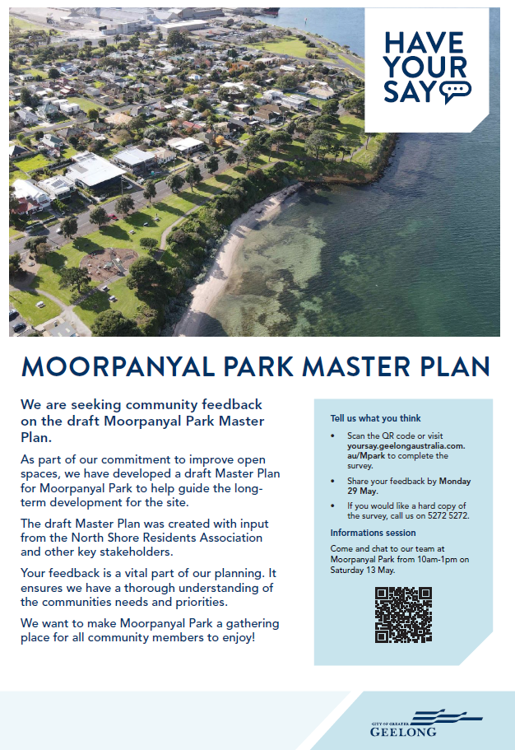

APPENDIX B – Social Media

Round 1 - Facebook, Instagram, X (formerly Twitter)
Target: North Shore, Norlane, North Geelong, Corio, Rippleside, Bell Park, Bell Post Hill, Lara, Lovely Banks
We're developing a Master Plan for Moorpanyal Park 🌳 in North Shore, and we want your input.

The park is located right next to Corio Bay, and it currently has a range of features including a playground and BBQ facilities.

Have your say 💬on what improvements you'd like to see by completing the survey on the Have Your Say page or by attending the onsite engagement event on Saturday 13 May from 10:00am to 1:00pm.

Don't miss out on the chance to shape the future of Moorpanyal Park!

Have your say at 👉 yoursay.geelongaustralia.com.au/MPark

Feedback closes on Monday 29 May 2023.

Round 2 - Facebook, Instagram, X (formerly Twitter)
Target: Greater Geelong 18-65+
It’s your last chance to have your say on the Master Plan for Moorpanyal Park 🌳 in North Shore.

Have your say 💬on what improvements you'd like to see by completing the survey on the Have Your Say page at 👉 yoursay.geelongaustralia.com.au/MPark

Feedback closes on Monday 29 May 2023.

Social Media Feedback

This social media engagement attracted 27,422 impressions and 705 actions and 278 comments. While these social media posts attracted many comments, the majority of these comments were in relation to Councils decision to no longer refer to January 26 as Australia Day and were not applicable to this master plan. For the comments that were related to the draft master plan, a large portion expressed budget concerns while the remaining comments broadly reflected the sentiment and themes gathered through the formal engagement process.

APPENDIX C – Onsite Signage

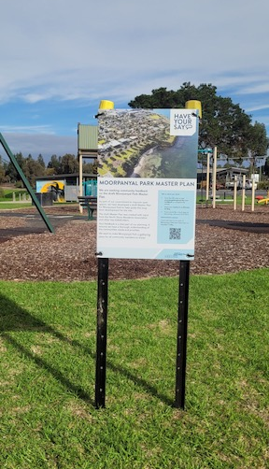
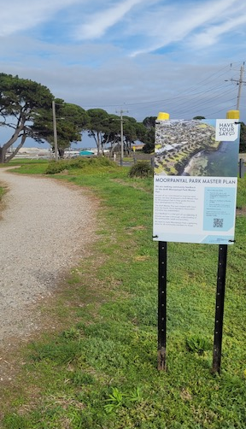

APPENDIX D – Media Release

