pakington north precinct

community panel

expression of interest

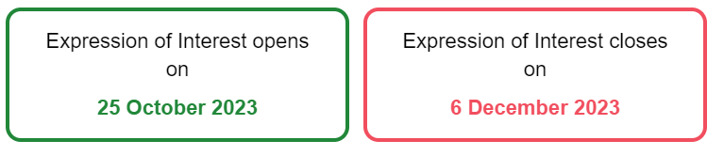

To express your interest in joining the Community Panel please complete the form below.
If you have any trouble answering the questions, or prefer to provide your answers over the phone, please call 03 5272 5007.
Recruitment will be completed independently by Capire ensuring we gather a diverse group of up to 60 participants who are genuinely invested in the betterment of the community and area.
Check this box to indicate that you have read, and agree to the privacy statement provided for this consultation (Privacy Statement can be found at the end of this form)
Yes

Session details:
The Community Panel will come together over six in-person sessions in or around Geelong West.
- Session 1 : Setting the Scene and Understanding the Drivers for Change
Thursday, 8 February 5.30pm – 8.30pm (3 hours)
- Session 2 : The Public Realm
Saturday 10 February 12.30pm – 5.30pm (5 hours)
- Session 3a : Built Form
Thursday, 29 February 6.00pm – 8.30pm (2.5 hours)
- Session 3b : Built Form
Thursday, 7 March 6.00pm-8.30pm (2.5 hours)
- Session 4 : Access and Movement
Saturday, 16 March 12.30pm – 5.30pm (5 hours)
- Session 5 : UDF Endorsement
Thursday, 18 April 6:00pm-8:00pm (2 hours)

- Please confirm that you can attend each of the sessions listed above. ^{Required}
Select one answer only
Yes
No
- If no, please tell us the reason you are unable to attend and this will be taken into consideration when reviewing all expressions of interest.

Your details

- First Name ^{Required}
- Last Name ^{Required}
- Contact phone number ^{Required}
- Email address ^{Required}
- Residential street address
Your response to this question will help us identify a mix of participants from across the study area.
- Town or Suburb ^{Required}

- Preferred method of contact ^{Required}
Select one answer only
Phone
Email
- Age Group ^{Required}
Select one answer only
Under 18
18-24
25-34
35-49
50-59
60-69
70-84
85+
- What is your gender? ^{Required}
Select one answer only
Man
Woman
Non-binary
Prefer not to say
Self-described (please specify)

- Do you identify as any of the following?
Please select all that apply
Aboriginal origin
Torres Strait Islander origin
Both Aboriginal and Torres Strait Islander origin
Migrant
Refugee
Asylum Seeker
LGBTIQA+
Carer
Parent/Guardian
Person with disability
English is not my main language
None of the above
- What best describes your housing situation? ^{Required}
Select one answer only
Own home / mortgage
Renter
Public housing tenant
Other

- What best describes your housing type? ^{Required}
Select one answer only
Separate house / free standing
Apartment /unit
Other

- What best describes your family composition? ^{Required}
Select one answer only
Family (with child/ren of any age)
Couples without children
One parent family
Group household
Lone household
- What is your relationship to the Pakington North Precinct study area (see area outlined in black in image below)? ^{Required}
Please select the one that most closely aligns with your connection.
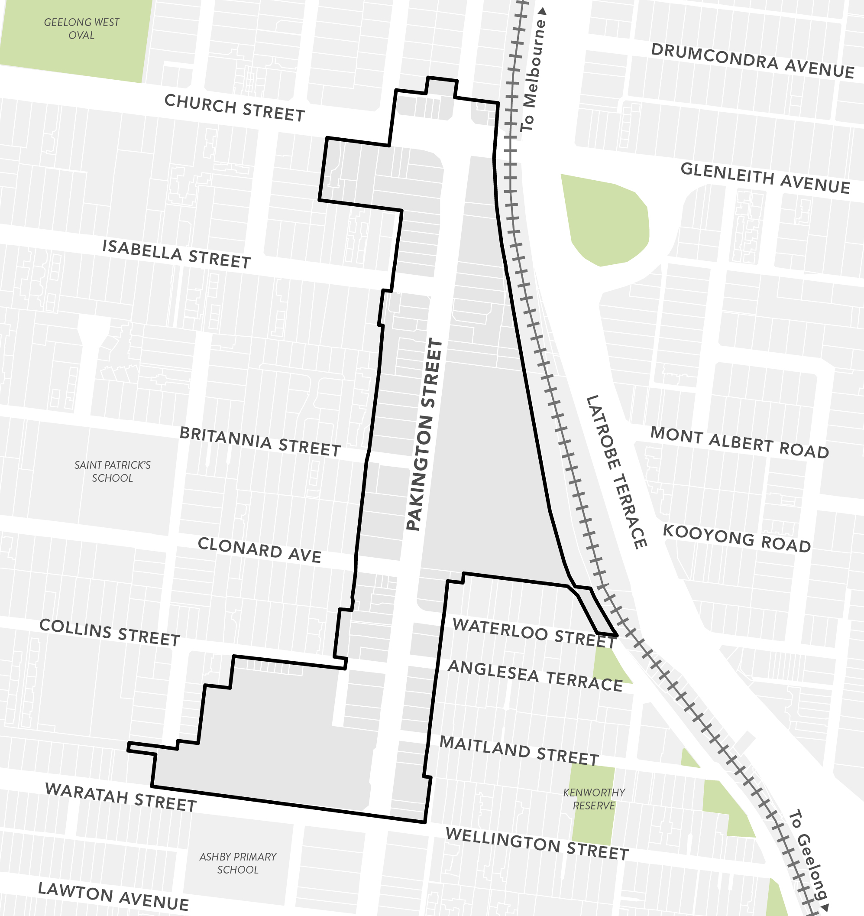
Pakington North Precinct Study Area
Select one answer only
A resident of the study area
A local business owner in the study area
Work in the study area
Visitor to the study area
Study in the study area
- If you selected ‘business owner’ or ‘work in the area’, please provide the address of business.
- If you said you ‘study in the area’, ‘please provide the location of the school / education centre.

- How long has your relationship to the study area been? ^{Required}
Select one answer only
Less than 12 months
1 - 4 years
5 - 10 years
11+
- Please name any business group, community group or interest group you are affiliated with relevant to the study area.
For example, formal or informal community-based group.
- Please indicate your participation in a local or state government community engagement activity? ^{Required}
For example, have you completed a survey, provided feedback and / or submission to a formal community engagement run by local or state government in recent times.
Select one answer only
Within the last 12 months
Within the last 3 years
Never, or longer than 3 years
- What is your interest in joining the Community Panel? ^{Required}

- Is there anything we can do to support you to participate on the Community Panel?
For example, translation services, support to get to the session, etc.
- Please declare any potential conflict of interest(s) that may impact your ability to serve as a panel member? ^{Required}
For example, you are a councillor, employee, or family member of City of Greater Geelong councillor or employee. You are an elected Member of Parliament, or you are a candidate.

Thank you for your expression of interest. Please return this to a City of Greater Geelong Customer Service Centre by the 6 December or post to:
City of Greater Geelong
Wadawurrung Country
Urban and Heritage Department
P.O. Box 104
Geelong VIC 3220

Alternatively, you can scan and email to: urbandesignandheritage@geelongcity.vic.gov.au

Privacy Statement

The personal information requested on this page is being collected by City of Greater Geelong for the purpose of the Pakington North Precinct Community Panel Expression of Interest process or any other directly related purpose. If the personal information is not collected, we may not be able to contact you for further questions or solutions.
All expressions of interest will be provided to Capire Consulting Group who will be independently assessing and recruiting participants.
Your personal information will only be disclosed to carry out a deeper analysis of the data* or as required to do so by law. Our privacy policy is available on our website. If you wish to alter any of the personal information you have supplied to City of Greater Geelong, please contact us by sending an email to privacy@geelongcity.vic.gov.au.
*In order to gain a deeper understanding of the data provided to the City and improve our services to you, we may disclose the information you provide to us to AWS Comprehend and Converlens Pty Ltd which carry out analysis of the data. Your personal information may be disclosed to AWS Comprehend and Converlens based in Sydney only in relation to the primary purpose of collection. View the AWS Comprehend’s Data Privacy statement at www.aws.amazon.com/compliance/data-privacy-faq/

