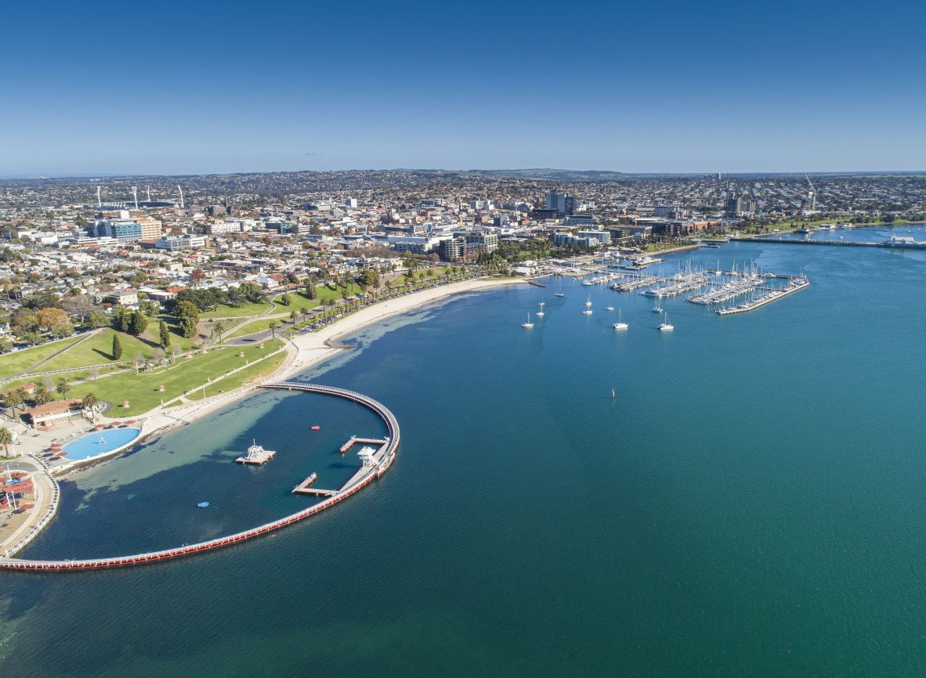
Geelong Economic Development Strategy
Background Report
Report prepared for
City of Greater Geelong
February 2024

Document Control

lucid
/’lu:sid/
adjective
- expressed clearly; easy to understand
- bright or luminous
Job Name: GEELONG Economic Development Strategy
Client: City of Geelong
Client Contact: Tennille Bradley
Version Control
Version | Date | Authorisation
Draft v1 | 10/9/23 | MC
Draft v2 | 21/9/23 | MC
Draft v3 | 23/9/23 | MC
Draft v4 | 7/2/24 | MC

Disclaimer:
While every effort has been made to ensure the accuracy of this document, Lucid Economics Pty Ltd is unable to make any warranties in relation to the information contained herein. Lucid Economics Pty Ltd, its employees and agents accept no liability for any loss or damage that may be suffered as a result of reliance on this information, whether or not there has been any error, omission or negligence on the part of Lucid Economics Pty Ltd, its employees or agents. Any forecasts or projections used in the analysis and relied upon for any findings can be affected by a number of unforeseen or unknown variables, and as such no warranty is given that a particular set of results will in fact be achieved or realised.

Acknowledgement of Country
Lucid Economics acknowledges the Traditional Custodians and Elders of Country throughout Australia, and their connection to land, sea and community. We pay our respects to Aboriginal and Torres Strait Islander Elders past, present and emerging.

Summary
Geelong is a case study in resilience and transition. The closure of Ford and Alcoa nearly a decade ago were meant to deal a blow to the Geelong economy for a generation. However, the economy has evolved and transitioned since this time into a vibrant regional economy with a bright future. The foundations for Geelong’s resilience were set many years ago and include its strategic location (1 hour west of Melbourne), major port and airport facilities, Deakin University as well as a strong and highly skilled workforce.
Geelong is a large region, with a population of over 276,000, which makes it the third largest local government in Victoria. The economy is also large, with Gross Regional Product (GRP) of $17.6 billion in 2021-22, which is almost half the size of the Tasmanian economy and 67% of the Northern
Territory’s economy.
The region is also rapidly growing. The population of Geelong is expected to reach 400,000 by the year 2041. Over the last five years, GRP has been growing at an average annual rate of 5.4%, which is more than twice as fast as the State’s economy is growing. Over the last year, the economy expanded by 10.3%.
The healthcare and construction industries have grown significantly over the last five years, and now represent the largest contributors to GRP and employment. Manufacturing remains very important to the local economy and is the third largest contributor to GRP and the largest exporting sector. The manufacturing sector today in Geelong is diverse. While some large producers, such as Viva Energy’s Geelong refinery, still exist, the sector is very diverse including food production, machinery and metal fabrication, transport equipment and many others. Hanwha’s Avalon production facility will anchor a new defence manufacturing cluster in Geelong that joins other advanced and high-tech manufacturing already in the region, such as carbon fibre manufacturing.
White-collar employment has also been growing solidly, adding to the diversity of the local economy. Professional services, finance and insurance combine to contribute 11% of GRP and valuable employment. These services are an important export for the Geelong region and have the ability to drive activity and vibrancy in the Geelong CBD.
Other sectors such as tourism and the creative industries make important contributions to the local economy as well. Tourism injects $1.6 billion into the local economy every year and the majority of this money is spent with locally owned businesses. Tourism is the second largest export sector after manufacturing. The creative industries is relatively small, contributing 7,660 jobs (5.7% of total) and
$691 million to GRP (4.7% of total). However, together with the tourism industry, these sectors are important as they can contribute positively to local liveability and building a unique character and vibe into the future.
The Geelong region is not without its own challenges. With some of the lowest unemployment rates in a decade, there is a shortage of workers in Geelong, despite the region experiencing significant population growth. Geelong is not alone in this challenge, as most parts of Australia are experiencing worker shortages that are linked to the housing crisis gripping most of the country. Residential vacancy rates across Geelong are relatively low (based on historical information), demonstrating the tightness in the local market. Workforce projections show that worker shortages will be experienced into the future, particularly across the healthcare, child care and aged care sectors. For example, the region will likely need over 1,000 new nurses over the next ten years. In total, the growing economy is expected to generate another 19,500 new jobs over the next decade.
Construction trades will be another area of severe worker shortages. Geelong currently has a pipeline of $16.9 billion worth of construction work, which will drive economic growth and continue to see construction as one of the region’s key industry sectors.

Based on a range of factors, there will be numerous industries that can grow and provide value to the future Geelong economy, including:
- Advanced manufacturing (including defence)
- Professional services, finance and insurance
- Tourism
- Creative industries
The Geelong economy is already evolving and transforming into an innovative and diverse economy. Through focusing on high-value, export oriented future opportunities, this evolution can continue to shepherd in a new era for the Geelong region. Geelong is emerging as a key centre of commerce in Australia and can solidify this position over the coming decade.

Table of Contents

Summary ii
Table of Contents iv
- Introduction 1
- Population and Demographics 2
  - Historical Population 2
  - Projected Population 3
  - Age Profile 3
  - Income 5
- Economy 7
  - Size and Structure of the Economy 7
  - Trade 10
  - Shift-Share Analysis 13
  - Business Counts 14
  - Tourism 16
  - Creative Industries 18
  - Defence Industry 19
  - Hydrogen Industry 20
- Workforce and Skills 21
  - Employment and Unemployment 21
  - Employment 22
  - Value of Employment 24
  - Journey to Work 25
  - Workforce Projections 25
- Property 27
  - Median House Prices 27
  - Vacancy Rates 28
  - Industrial Land 28
- Major Projects 29
- Competitive Advantages and Opportunities 31
  - Local Competitive Advantages 31
  - Cluster Mapping 32
- Important Trends 36
  - COVID-19 Pandemic 36
    - Global Trends 37
    - Local Trends 37
  - Recycling and Waste to Energy 38
  - Carbon and Renewable Power Generation 39
  - Working from Home 39
  - Labour Shortages 40
  - Victorian Priority Industries 41
  - Sustainability and Circular Economy 42
- Next Steps 43
References 44

Introduction
Lucid Economics Pty Ltd (Lucid Economics) has been engaged to assist the City of Greater Geelong create a meaningful Economic Development Strategy.
Geelong is a City of over 276,000 people and is located 1 hour west of Melbourne (Figure 1.1). The City has undergone a major transformation over the last ten years in the face of significant change. The significant challenge of the closure of Ford and Alcoa were later followed by new challenges such as the COVID-19 pandemic. Throughout, Geelong has maintained a resilience and has a more diverse and stronger economy today than a decade ago.
The City is on the cusp of emerging not only as a major centre in Victoria and Australia, but the world. Its economic evolution has been underpinned by strong local fundamentals including its strategic location (1 hour west of Melbourne), major port and airport facilities, Deakin University, a strong and highly skilled workforce (particularly in manufacturing) as well as the City’s grit and determination.
Figure 1.1. City of Greater Geelong
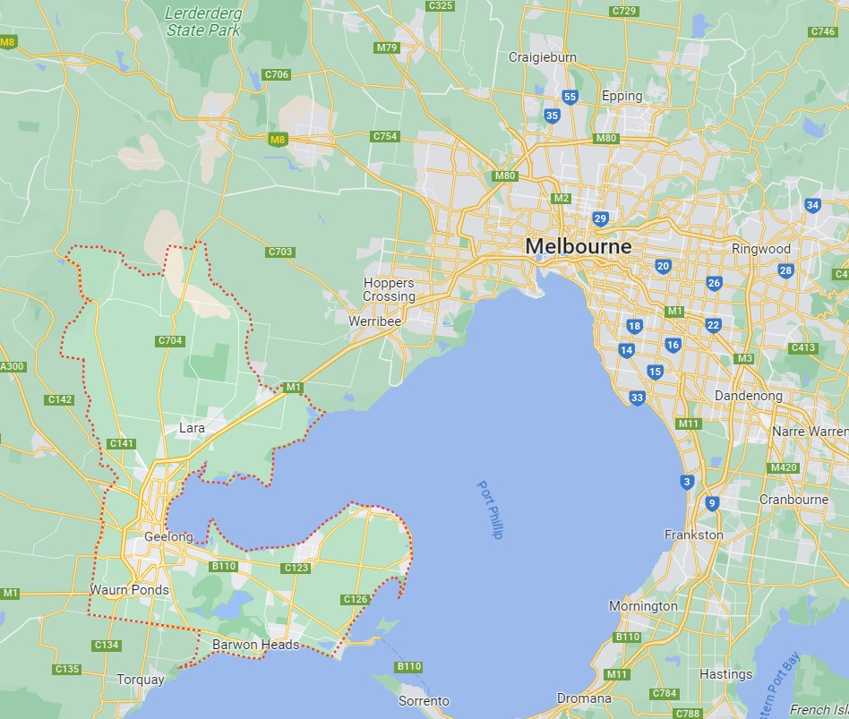
Source: Google Maps
This report represents a background assessment of the economy and will form the foundation for the Economic Development Strategy. Any reference to ‘Geelong’ or the ‘ Geelong region’ refers to the local government area of the City of Greater Geelong, unless otherwise specified.

Population and Demographics

Historical Population
The Geelong region had an estimated resident population of 276,116 persons as of June 30, 2022 (Figure 2.1). Population growth in the region has been very strong over the past decade, averaging 2.3% per annum in the decade to 2022, considerably above the Greater Melbourne (1.6%) and Victoria (1.1%) averages over the same period.
Further, despite trending modestly lower since the onset of the COVID-19 pandemic, Geelong’s population growth has remained robust, rising 2.0% in both 2021 and 2022. This is a remarkable result when compared to the 1.6% decline in Greater Melbourne in 2021 and the small decline across Victoria.
While Geelong’s sustained strong population growth over the past decade is likely driven by its strong labour market conditions and significantly more affordable housing compared to Greater Melbourne (which has seen very strong house price growth over the past decade), the continued strength in growth in the post-pandemic years suggests Geelong has benefited from the increased use of ‘work from home’ and remote working arrangements.
Figure 2.1. Historical Population, Geelong
300,000 4%

225,000 3%

150,000 2%
Annual Growth (%)
Population (no.)

75,000 1%

0 0%

-75,000 -1%

-150,000

2001 2004 2007 2010 2013 2016 2019 2022
-2%

Greater Geelong Greater Geelong (%) Greater Melbourne (%) Victoria (%)
Population Matters
Population growth is important to support economic growth in the local area. An increasing number of local residents will increase demand for a range of products and services offered from local businesses. Roughly one-third of the economy is directly related to local residents and includes local services such as retail trade, education, healthcare and others.
Source: ABS (2023a).

Projected Population
Population growth forecasts show the Geelong region’s population growth is expected to remain strong over the 19 years to 2041, averaging 1.9% per annum over this period. This equates to the population in the region being forecast to be almost 400,000 by the year 2041, an increase of almost 120,000 people by 2041, or over 40% from 2022 levels.
By sub-region, the Armstrong Creek, Lovely Banks - Batesford – Moorabool, Marshall – Charlemont and Mount Duneed regions are all expected to experience very strong growth out to the year 2041, with total population increases over more than 10,000 persons in each region.
Figure 2.2. Projected Population, Geelong
500,000 2.5%

400,000 2.0%
Average annual population growth

300,000 1.5%
Population (no.)

200,000 1.0%

100,000 0.5%

0
2022 2026 2031 2036 2041
Greater Geelong Greater Geelong
0.0%

Sources: ABS (2023a), EconomyID (2023).

Age Profile
Population growth trends between the 2016 Census and the 2021 Census show two key demographics migrating to Geelong – young families and older residents (aged 60 years and over).
The number of Geelong residents aged 25-39 years accounted for more than a third of population growth between 2016 and 2021, rising by almost 13,000 persons. This demographic includes young families, many of which are likely to have become attracted to the Geelong region due to its more affordable housing compared to Melbourne and the availability of work.
The number of residents aged 60 years and over also increased strongly between the census years (almost 12,000 residents), accounting for just under a third of population growth. This strong increase in elderly residents suggests the health care industry in Geelong will grow strongly in the near-term.
Figure 2.4 shows the Geelong region had a slightly older population than the Victoria average in 2021. Geelong recorded a higher proportion of its population aged 60 years and older (26%) than the state average (22%). Relative to many other regional centres, Geelong has a significant population in the 20 to 39 year old cohort, representing the local access to Deakin University as well as the availability of jobs.

However, while the median age in the Geelong region remained above the state average in the 2021 Census (39 years in Geelong vs 38 in Victoria), the gap between the two regions has reduced (reflecting the strong migration of young families to Geelong between 2016 and 2021). The median age in Geelong actually reduced between the 2016 and 2021 Census, from 40 to 39 years, indicating growth in young families and young people.
Figure 2.3. Population Growth by Age Group, Geelong, 2016-2021
5,000

4,500

4,000

3,500
Population Change (no.)

3,000

2,500

2,000

1,500

1,000

500

0
0-4 5-9 10-14 15-19 20-24 25-29 30-34 35-39 40-44 45-49 50-54 55-59 60-64 65-69 70-74 75+
Sources: ABS (2022), ABS (2017).
Figure 2.4. Share of Population, 2021
10%
9%
8%
7%
6%
% of Population
5%
4%
3%
2%
1%
0%
0-4 5-9 10-14 15-19 20-24 25-29 30-34 35-39 40-44 45-49 50-54 55-59 60-64 65-69 70-74 75+
Greater Geelong Victoria
Source: ABS (2023a).

Figure 2.5. Median Age, 2011 - 2021
45

40

35

30

25
Median age

20

15

10

5

0
2011 2016 2021
Greater Geelong Victoria
Sources: ABS (2022), ABS (2017).

Income
Incomes in Geelong are below Victoria and the Greater Melbourne Region, however, between 2016 and 2021, incomes (both household and individual) grew at a faster rate than both Victoria and Greater Melbourne. Both household and individual incomes grew by an average annual rate of 5.1% between 2016 and 2021, compared to 4.3%-4.6% for Greater Melbourne and Victoria.
Figure 2.6. Median Household Income ($/week)
$2,000
$1,800
$1,600
$1,400
$1,200
$1,000
$800
$600
$400
$200
$0
2011 2016 2021
Geelong Greater Melbourne Victoria
Sources: ABS (2022), ABS (2017).

Figure 2.7. Median Individual Income ($/week)
$900
$800
$700
$600
$500
$400
$300
$200
$100
$0
2011 2016 2021
- Geelong ■ Greater Melbourne Victoria
Sources: ABS (2022), ABS (2017).

•
•
-o·. LUCID 6
_ ECONOMICS

Economy

Size and Structure of the Economy
The Geelong region’s Gross Regional Product (GRP) was $17.6 billion in the 2021-22 financial year, growing incredibly strongly in the two post-COVID years of 2020-21 (up 4.6%) and 2021-22 (up 10.3%). While the Geelong economy represents 3.5% of the total Victorian economy, it is almost half the size of the Tasmanian economy and 67% of the Northern Territory’s economy.
Geelong’s economic growth has significantly outperformed the Victoria over the past five years, growing at an average rate of 5.4% per annum compared to the state average of 2.2%.
Figure 3.1. Gross Regional Product, Geelong
$18 12%

$15 10%

$12 8%
Gross Regional Product (real, $B)

$9 6%
Annual Change (%)

$6 4%

$3 2%

$0 0%

-$3

2002 2006 2010 2014 2018 2022
-2%

Greater Geelong Greater Geelong (%) Regional Victoria (%) Victoria (%)
Sources: EconomyID (2023).
The largest industries by Industry Value-Add (IVA) in the Geelong region in 2021-2022 were:
- Health care and social assistance
- Construction
- Manufacturing
- Education and training
- Retail trade
- Public administration and safety.
The key industries in the Geelong region are industries typically associated with strong population growth, including health care, construction, retail trade and education.

Health care is by far the largest industry in the Geelong region, accounting for 15% of industry value- added (IVA), considerably higher than the state average (10%). The industry has grown rapidly over the past decade, rising an average rate of 7% per annum, with growth accelerating since the onset of the COVID-19 pandemic (up an average of 11% per annum since 2019-20). Strong growth over the past decade is likely driven by the higher proportion of persons aged 60 years and older in the region than the state average. With the latest census data showing a strong increase in residents aged 60 years and over between 2016 and 2021, healthcare is likely to continue to be an important industry moving forward.
The construction industry has also grown strongly over the past decade, rising at an average rate of 8% per annum, consistent with strong population growth.
Other industries experiencing strong growth in recent years included the professional, scientific, and technical services and wholesale trade industries. These industries have grown at an average rate of 7% and 9% per annum over the past decade, with growth accelerating in the post-pandemic period (to an average of 15% per annum for professional, scientific, and technical services and 14% per annum for wholesale trade).
However, the manufacturing industry has been in long term decline, falling a total of 16% over the decade to 2021-22. Sub-industry analysis shows the declines have largely been centred in the Petroleum and Coal Product Manufacturing (down $238 million), Transport Equipment Manufacturing (down $107 million) and Primary Metal and Metal Products Manufacturing (down
$48 million). These declines are associated with the closure of the Alcoa and Ford production sites in Geelong in 2014 and 2016, respectively, as well as changes at the local Geelong Refinery.
By contrast there has been strong growth in the Fabricated Metal Product Manufacturing (up $102 million) and Food Product Manufacturing (up $84 million) sub-industries.
Figure 3.2. Industry Value-Add, 2021-2022

Health Care and Social Assistance
Construction Manufacturing Education and Training
Retail Trade Public Administration and Safety Professional, Scientific and Technical Services
Wholesale Trade Financial and Insurance Services Administrative and Support Services Transport, Postal and Warehousing Rental, Hiring and Real Estate Services Electricity, Gas, Water and Waste Services Accommodation and Food Services
Other Services Agriculture, Forestry and Fishing Information Media and Telecommunications
Arts and Recreation Services
Mining

Source: EconomyID (2023).

Greater Geelong Regional Victoria Victoria
0% 5% 10% 15% 20%
Industry Value-Add (% of total)

Figure 3.3. Industry Value-Add by Top 6 Industries, Geelong
$2,500

$2,000

$1,500

$1,000

$500

$0
2012 2013 2014 2015 2016 2017 2018 2019 2020 2021 2022
Health Care and Social Assistance Construction
Manufacturing Education and Training
Retail Trade Public Administration and Safety
Note: Industry Value-Add refers to the industry contribution to GRP. Source: EconomyID (2023).
Figure 3.4. Industry Value-Add by Manufacturing Sub-Industries, 2021-2022

Fabricated Metal Product Manufacturing
Food Product Manufacturing Petroleum and Coal Product Manufacturing Transport Equipment Manufacturing
Non-Metallic Mineral Product Manufacturing Textile, Leather, Clothing and Footwear Manufacturing Basic Chemical and Chemical Product Manufacturing Machinery and Equipment Manufacturing
Wood Product Manufacturing Beverage and Tobacco Product Manufacturing Primary Metal and Metal Product Manufacturing Furniture and Other Manufacturing
Polymer Product and Rubber Product Manufacturing Printing (including the Reproduction of Recorded Media) Pulp, Paper and Converted Paper Product Manufacturing

Greater Geelong Regional Victoria Victoria

0% 1% 2% 3% 4%
Industry Value-Add (% of total)
Note: Industry Value-Add refers to the industry contribution to GRP. Source: EconomyID (2023).

Figure 3.5. Manufacturing Sub-Industry Value-Add by Top 6 Sub-Industries, Geelong
$450
$400
$350
$300
$250
$200
$150
$100
$50
$0
2012 2014 2016 2018 2020 2022
Fabricated Metal Product Food Product
Petroleum and Coal Product Transport Equipment
Non-Metallic Mineral Product Textile, Leather, Clothing and Footwear
Note: Industry Value-Add refers to the industry contribution to GRP. Source: EconomyID (2023).

Trade
Exports are important as they provide value to a local business based on a customer that is not within the local region, often commanding a premium price. At the same time, imports may represent an opportunity to replace a product or service from outside the local economy with one provided by a local business, thereby creating considerable value for the local economy.
Unsurprisingly, ‘manufacturing’ is the largest export sector representing 31% of exports, or approximately $2.2 billion.
Geelong has significant imports, with the ‘manufacturing’, ‘financial services’ and ‘professional,
scientific, and technical services’ industries the most notable importing industries in the Geelong region (Figure 3.6). Imports to the ‘manufacturing’ sector would largely represent inputs into the large manufacturing businesses in the region.
Geelong imported such a significant amount of goods and services in 2021-2022 that it would have detracted from GRP growth, given that growth in imports exceeded exports growth, with a fall in net exports indicating a detraction from GRP growth. In fact, data shows imports to the region rose by
$1.0 billion in 2021-2022, detracting more than 6.3%-points from local GRP growth in the financial year. With local exports increasing $900 million in the year (contributing 5.8%-points to GRP growth), this indicates the overall trade sector (net exports) detracted around 0.5%-points from GRP growth in 2021-22. This highlights the potential economic opportunity for replacing any product or service from outside the local economy with one from within the local economy.
Further detailed analysis shows that ‘machinery and equipment manufacturing’, ‘finance’ and ‘agriculture’ are the key sub-industries driving local imports, while ‘petroleum and coal product manufacturing’, ‘insurance and superannuation funds’ and ‘social assistance services’ were the key exporting sub-industries.
While replacing all of the imports into these local sub-sectors would be difficult, there may be opportunities to strengthen the local supply chains to cater for these specific goods and services.

Figure 3.6: Regional Trade by Industry, Geelong, 2021-2022

Manufacturing
Health Care and Social Assistance
Wholesale Trade Education and Training Financial and Insurance Services
Retail Trade Public Administration and Safety Transport, Postal and Warehousing Electricity, Gas, Water and Waste Services Agriculture, Forestry and Fishing
Professional, Scientific and Technical Services Accommodation and Food Services Rental, Hiring and Real Estate Services Arts and Recreation Services Administrative and Support Services
Information Media and Telecommunications
Mining Construction Other Services

Source: EconomyID (2023).

Exports Imports

$0 $1,000 $2,000 $3,000 $4,000 $5,000
Trade ($M)

Figure 3.7: Regional Imports by Sub-Industry, Geelong, 2021-2022

Machinery and Equipment Manufacturing
Finance
Agriculture Basic Chemical and Chemical Product Manufacturing
Transport Equipment Manufacturing Computer System Design and Related Services Primary Metal and Metal Product Manufacturing
Professional, Scientific and Technical Services…
Defence Auxiliary Finance and Insurance Services Food Product Manufacturing Telecommunications Services
Oil and Gas Extraction
Textile, Leather, Clothing and Footwear…
Metal Ore Mining

Source: EconomyID (2023).
$0 $500 $1,000 $1,500
Trade ($M)

Figure 3.8: Regional Exports by Sub-Industry, Geelong, 2021-2022

Petroleum and Coal Product Manufacturing
Insurance and Superannuation Funds
Social Assistance Services
Basic Material Wholesaling
Fabricated Metal Product Manufacturing
Other Store-Based Retailing
Tertiary Education
Food Product Manufacturing
Hospitals Public Order, Safety and Regulatory Services Primary Metal and Metal Product Manufacturing
Preschool and School Education Other Goods Wholesaling
Transport Equipment Manufacturing
Professional, Scientific and Technical Services…

Source: EconomyID (2023).
$0 $200 $400 $600 $800
Trade ($M)

Shift-Share Analysis
Shift Share Analysis breaks down the growth in an industry into three components to help understand what is driving the change. These three change components are commonly known as:
- State/National growth effect - the amount of growth in an industry that could be attributed to the overall growth of a larger area that encompasses the region's economy, usually state or national.
- Industry mix effect - the amount of growth in an industry that could be attributed to the performance of the specific industry at the national/state level.
- Regional competitive effect - the amount of growth in a specific industry that could be attributed to a local advantage or disadvantage. This is generally the most interesting component as it clearly quantifies the level of advantage or disadvantage an industry has in the local area.
The regional competitive effect for an industry generally indicates how the local industry performed against benchmark trends. An industry with a positive regional competitive effect suggests local characteristics supported above trend growth in that period. For example, if retail trade in a region grew by 3% but at a state/national level it only grew by 2%, some regional specific factors (e.g. new shopping centre, population growth) must have contributed to this above trend growth. A negative effect suggests the opposite.
This analysis shows that in the Geelong region the strongest regional competitive effects in terms of industry-value add and employment between 2016-17 and 2021-22 were experienced in the ‘construction’, ‘wholesale trade’, ‘healthcare and social assistance’ and ‘professional, scientific and technical services’ industries.
Figure 3.9: Industry Value-Add Shift-Share Analysis, Geelong, 2016-2017 - 2021-2022
1,000

800

600

400

200

0

-200
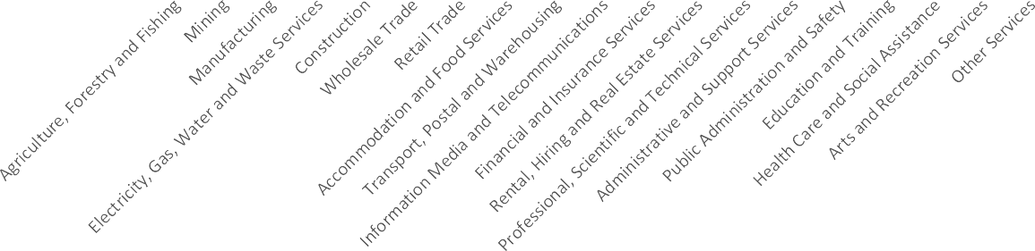
Benchmark growth effect Industry mix effect Regional competitive effect Aggregate
Source: EconomyID (2023).

Figure 3.10: Employment Shift-Share Analysis, Geelong, 2016-2017 - 2021-2022
7,000
6,000
5,000
4,000
3,000
2,000
1,000
0
-1,000
-2,000
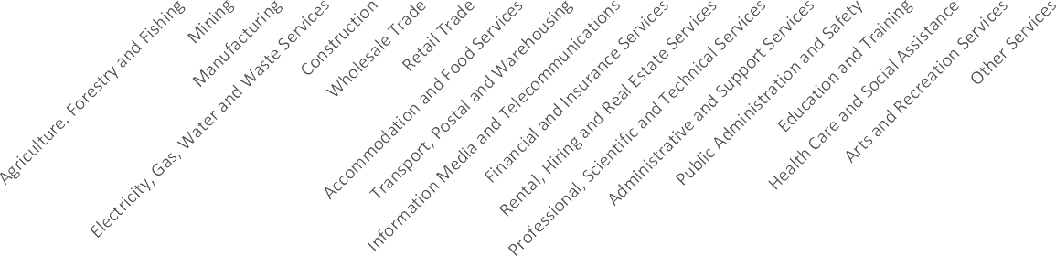
Benchmark growth effect Industry mix effect Regional competitive effect Aggregate
Source: EconomyID (2023).

Business Counts
The Geelong economy is dominated by small businesses (97.8% of all businesses have 19 employees or fewer, Figure 3.11). This structure is similar to most local economies in Australia. Most of the top industries by number of businesses (‘construction’, ‘professional, scientific and technical services’, and ‘rental, hiring and real estate’) are typical industries where there is a great number of individual traders and small businesses.
Business Counts from the ABS
It is important to keep in mind that this data reflects the registered business address of companies (only), so larger businesses such as Coles, Woolworths and other major retail businesses may not be captured in the data. Furthermore, the ABS often excludes many sole traders and focuses on businesses with an active Australian Business Number (ABN) that are registered for Goods and Services Tax (GST). This methodology usually underestimates the total number of businesses in a local economy, specifically many of the sole traders and/or home-based businesses.

Figure 3.11. Business Counts, Geelong, 2022
2.1% 0.1%
9.8%

Non employing
1-4 Employees

27.8%

60.2%
5-19 Employees
20-199 Employees
200+ Employees

Note: Location based on registered address of businesses. ‘Non employing’ business is an owner operator business.
Source: ABS (2023b)
Figure 3.12. Business Counts, by Industry, Geelong, 2022

Agriculture, Forestry and Fishing
Mining Manufacturing
Electricity, Gas, Water and Waste Services
Construction Wholesale Trade Retail Trade
Accommodation and Food Services Transport, Postal and Warehousing Information Media and Telecommunications Financial and Insurance Services
Rental, Hiring and Real Estate Services Professional, Scientific and Technical Services Administrative and Support Services
Public Administration and Safety Education and Training
Health Care and Social Assistance
Arts and Recreation Services
Other Services

Source: ABS (2023b).

Non employing
1-4 Employees
5-19 Employees
20-199 Employees
200+ Employees
0 1,000 2,000 3,000 4,000 5,000 6,000
Businesses (no.)

Figure 3.13. Business Counts, by Industry, 2022

Construction Professional, Scientific and Technical Services Rental, Hiring and Real Estate Services Transport, Postal and Warehousing
Health Care and Social Assistance
Retail Trade
Other Services Accommodation and Food Services Administrative and Support Services
Manufacturing Financial and Insurance Services Agriculture, Forestry and Fishing
Wholesale Trade Arts and Recreation Services Education and Training
Information Media and Telecommunications Electricity, Gas, Water and Waste Services Public Administration and Safety
Mining

Source: ABS (2023b).

Tourism

Greater Geelong
Victoria

0% 5% 10% 15% 20% 25%
% of Total

In the lead up to the COVID-19 pandemic, tourism in the Geelong region was growing relatively strongly. Naturally, during the pandemic visitation figures dropped and have been volatile since initial restrictions were lifted.
The Geelong region receives a high proportion of day trip visitors, making up almost three-quarters of total visitors in the year ending March 2023. Domestic overnight visitation has recovered strongly from COVID-19 restrictions, to be above the pre-pandemic level in March quarter 2023. International visitation to the Geelong region is virtually non-existent, making up 1% of total visitation
pre-pandemic.
Tourism directly accounts for 1.8% of the Geelong region’s Gross Regional Product and 3.7% of employment.
Table 3.1. Visitation and Nights, Geelong and the Bellarine Tourism Region (YE March 2023)
 | Day | Domestic Overnight | International | Total
Visitors ('000) | 4,533 | 1,693 | 34 | 6,260
Nights ('000) | NA | 4,679 | 672 | 5,351
Visitors
Annual Change (%) | 82.4% | 45.3% | 2,470.6% | 71.4%
3 year Change (%) | 3.8% | 6.5% | -39.7% | 4.1%
Nights
Annual Change (%) | NA | 42.7% | 2,885.2% | 62.0%
3 year Change (%) | NA | 11.7% | -48.1% | -2.5%
Source: TRA (2023)

Figure 3.14. Visitation by Type, Geelong and the Bellarine Tourism Region
7,000

6,000

5,000

4,000
Visitors ('000)

3,000

2,000

1,000

0
2016 2017 2018 2019 2020 2021 2022 2023
Day-trip Domestic overnight International

Note: Year ending March data. Source: TRA (2023)
Figure 3.15. Visitor Nights by Type, Geelong and the Bellarine Tourism Region
7,000

3.4

6,000 3.3

5,000 3.2
Average Length of Stay (nights)

4,000 3.1
Visitor nights ('000)

3,000 3.0

2,000 2.9

1,000 2.8

0
2016 2017 2018 2019 2020 2021 2022 2023
Domestic overnight International Average length of stay
2.7

Note: Year ending March data.
Source: TRA (2023)

Figure 3.16. Visitor Expenditure, by Type, Geelong and the Bellarine Tourism Region (YE March 2023)
$50.0

$617.9

$948.4

Day-trip Domestic overnight International
Source: TRA (2023).
Table 3.2. Economic Contribution of Tourism (2021-22)
 | Gross Regional Product ($m) | Employment (No.)
Direct | $264.9 | 4,987
Indirect | $429.7 | 4,193
Total | $694.6 | 9,180
Total (Direct % of Total) | 1.8% | 3.7%
Source: EconomyID (2023).

Creative Industries
As highlighted in the Creative Industries Strategy (A Creative Industries Strategy for the G21 region 2021-26), the creative industries can be defined as:
Creative industries are an evolving mix of sectors spanning arts, culture, screen, design, publishing and advertising. They cover disciplines as diverse as game development and graphic design, fashion and filmmaking, performing arts and publishing, architecture and advertising, media and music, comedy and craft. They include activities that are commercially-driven and community based, experimental and export-intense.
The creative industries can be an important feature of the economy as these areas tend to have high-levels of innovation which often add considerable value to the local economy. Additionally, many of the creative industries in arts and culture can also increase the social and cultural capital in a community, delivering community benefits and support talent attraction and retention.

A New Approach (ANA) identified the creative industries by identifying specific industry sectors that met the above definition using the four-digit Australian and New Zealand Standard Industrial Classification (ANZSIC) system. Through data available in the 2021 Census, jobs in these industry sectors can be identified and quantified. Using this definition of the creative industries, the sector contributed 7,660 jobs (5.7% of total) and $691 million (4.7% of total IVA) to the Geelong economy in 2021-22.
Table 3.3. Creative Industries, Geelong (2021-22)
Industry | Employment (No.) | Industry Value Added ($M)
Agriculture, Forestry and Fishing | 0 | $0.0
Mining | 0 | $0.0
Manufacturing | 382 | $28.9
Electricity, Gas, Water and Waste Services | 0 | $0.0
Construction | 0 | $0.0
Wholesale Trade | 281 | $39.5
Retail Trade | 3,264 | $230.6
Accommodation and Food Services | 0 | $0.0
Transport, Postal and Warehousing | 0 | $0.0
Information Media and Telecommunications | 714 | $81.4
Financial and Insurance Services | 0 | $0.0
Rental, Hiring and Real Estate Services | 0 | $0.0
Professional, Scientific and Technical Services | 2,335 | $274.7
Administrative and Support Services | 0 | $0.0
Public Administration and Safety | 0 | $0.0
Education and Training | 140 | $5.3
Health Care and Social Assistance | 0 | $0.0
Arts and Recreation Services | 542 | $30.7
Other Services | 0 | $0.0
Total | 7,660 | $690.9
Source: ABS (2022a), ANA (2020), Lucid Economics.

Defence Industry
The Australian Bureau of Statistics (ABS) defines the defence industry as ‘The Australian defence
industry represents the production of goods and services invoiced to the Department of Defence’. The ABS estimates that the defence industry contributed $10.6 billion to the Australian economy in 2021-22, an increase of 20.3% from the previous year. Over the last five years, the defence industry has grown by an average annual rate of 11.0% (ABS, 2022c).
According to the Defence Portfolio Budget Statement (Defence, 2023), $217.7 billion is the planned expenditure from the current financial year until 2026-27, representing an average of $54.4 billion in annual defence expenditure.
The defence industry is often a sector that include a high level of technology and innovation, which can provide significant value to the economy. Furthermore, as a government expenditure program, the industry is less susceptible to global market changes as many other industries.

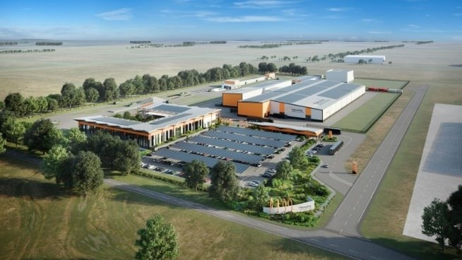
Hanwha Defence Australia
In 2022, Hanwha Defence Australia announced that it would build a $170 million, 32,000 sqm defence vehicle production centre at the Avalon Airport. The project will create more than 300 new jobs. The facility is required to deliver self-propelled vehicles to the Australian Defence Force. In July 2023, it was announced that Hanwha Defence would also deliver Redback vehicles as part of an additional $10 billion contract.
The new facility, supported by these two Government contracts will cement a new defence industry sector in Geelong, building on the long and proud history of the automotive and advanced manufacturing sector in the region. The new Hanwha Defence facility will anchor a new defence industry cluster in the Geelong region.

Hydrogen Industry
Hydrogen is a clean-burning fuel that can be used in transport, energy storage and electricity generation. Australia is expected to become the second largest exporter of hydrogen by 2030 and was the first country in the world to export hydrogen in 2022. By 2040, exports of hydrogen could be worth up to $10 billion and Australia has more than 100 hydrogen projects in the development pipeline.
Geelong Port has entered into a joint venture with Fortescue Future Industries (FFI) to create the Geelong Hydrogen Hub. The Geelong Hydrogen Hub will include pier infrastructure, an export terminal, a production facility as well as the necessary infrastructure to distribute hydrogen.
FFI is currently building its Green Energy Manufacturing Centre (GEM) in Gladstone, which will be
the world’s largest electrolyser production facility.

Workforce and Skills

Employment and Unemployment
Geelong’s labour market has undergone a remarkable turnaround over the past decade. The region’s unemployment rate recently hit a low of 2.4% in December quarter 2022, having consistently fallen in recent years from a peak of 8.4% in March quarter 2015.
The strengthening in the region’s labour market has accelerated in the post-COVID-19 pandemic years. In fact, employment has risen at an average annual rate of 5.0% since March quarter 2020 (the pre-pandemic level), or more than 20,000 persons in total. Further, the number of unemployed persons has decreased almost 1,300 persons, seeing the unemployment rate fall from 4.2% in March quarter 2020 to 2.7% in March quarter 2023.
In other signs of the strength of the Geelong labour market, growth in the labour force (up an average of 5.5% per annum) has increased at a faster rate than population growth over the past three years (around 2%), suggesting there has been a very strong increase in labour force participation in recent years.
More timely state level labour force data from the Australian Bureau of Statistics shows the Victoria labour market continuing to remain strong throughout the June quarter 2023, with the unemployment rate falling to 3.6% in July 2023. This suggests the Geelong unemployment rate has likely also continued to remain low in recent months.
Labour Force and Unemployment Data
These data sets are from the Department of Education, Skills and Employment (DESE) and track the number of people in the labour force (total), employed and unemployed. This data is based on place of residence, which differs from the analysis above regarding Gross Regional Product/Industry Value-Add as well as the analysis below regarding employment, which focuses on data based on place of work. For the labour force survey, the definition of ‘employed’ includes all persons aged 15 years and over who worked for one hour or more during the reference week.

Figure 4.1. Labour Force, Employment and Unemployment Rates
160,000 9%

140,000 8%
Employment / Labour Force (no.)

120,000 7%

100,000 6%
Unemployment rate

80,000 5%

60,000 4%

40,000 3%

20,000 2%

0 1%
Mar-11 Mar-13 Mar-15 Mar-17 Mar-19 Mar-21 Mar-23 Geelong employment Geelong labour force
Geelong unemployment rate Greater Melbourne unemployment rate
Regional Victoria unemployment rate Victoria unemployment rate Source: DESE (2023).

Employment
The key growth industries by employment in the Geelong region over recent years are industries typically associated with strong population growth, including health care, construction, retail trade and education.
Health care is by far the key employing industry in the Geelong region, accounting for 19% of total employment (or 26,347 total persons), considerably higher than the state average (14%). Further, employment within the industry has grown rapidly over the past decade, rising an average rate of almost 6% per annum. The strong growth in the sector is likely driven by the higher proportion of persons aged 60 years and older in the region than the state average.
Interestingly, there has been very strong employment growth in the professional, scientific and technical services industry over the five years to 2021-22, up 2,753 persons or an average of 8.6% per annum. While jobs in this industry are typically located in capital cities, the fact many occupations within this industry can be completed away from an office environment suggests the strong growth in recent years could be linked to the increased use of ‘work from home’ employment arrangements.

Figure 4.2. Employment by Industry, Geelong, 2021-2022

Health Care and Social Assistance
Construction
Retail Trade
Education and Training
Manufacturing Accommodation and Food Services Public Administration and Safety
Professional, Scientific and Technical Services
Other Services
Transport, Postal and Warehousing
Wholesale Trade Administrative and Support Services Financial and Insurance Services Rental, Hiring and Real Estate Services Agriculture, Forestry and Fishing
Arts and Recreation Services Electricity, Gas, Water and Waste Services Information Media and Telecommunications
Mining

Source: EconomyID (2023).

Greater Geelong Regional Victoria Victoria

0% 5% 10% 15% 20% 25%
Employment (% of total)

Figure 4.3. Employment by Industry, Geelong, 2011-12 to 2021-22

Health Care & Social Assistance
Construction Retail Trade Education & Training Manufacturing
Accommodation & Food Services Public Administration & Safety Professional, Scientific & Technical Services
Other Services
Transport, Postal & Warehousing
Wholesale Trade Administrative & Support Services Financial & Insurance Services Rental, Hiring & Real Estate Services Agriculture, Forestry & Fishing
Arts & Recreation Services Electricity, Gas, Water & Waste Services Information Media & Telecommunications
Mining

Source: EconomyID (2023).

2011-12
2016-17
2021-22

0% 5% 10% 15% 20% 25%
Employment by industry (% of total)

Value of Employment
Different industries contribute varying degrees of value to the local economy based on a variety of factors including supply chains, price of goods sold and overall position in the economy. As highlighted below ‘utility services’, ‘real estate services’, and ‘financial services’ are amongst the highest value-adding industries in the local economy.
Some of the key employing industries in the region including ‘health care’, ‘education’ and ‘retail trade’ are amongst the lowest value-adding industries in the local economy.
Figure 4.4. Industry Value-Add per Employee, 2021-2022
Electricity, Gas, Water & Waste Services Rental, Hiring & Real Estate Services Financial & Insurance Services
Wholesale Trade Information Media & Telecommunications Administrative & Support Services
Mining Construction Manufacturing
Transport, Postal & Warehousing Public Administration & Safety Agriculture, Forestry & Fishing
Professional, Scientific & Technical Services
Education & Training Health Care & Social Assistance
Retail Trade Arts & Recreation Services
Other Services
Tourism Accommodation & Food Services

High Value-Adding Jobs
In terms of economic development, growing high value-adding jobs will have greater benefits to the overall economy than increases in low value-adding jobs. The core difference is related to the relevant supply chains of these industries as well as the wages that are often paid across those industries. High value-adding jobs will provide a greater ability to spend more in the local economy, which will create a greater flow-on benefit locally. Additionally, businesses that have more local supply chains (or the opportunity for them) will have the ability to support additional businesses, creating more value in the local economy.
Because one job may offer greater value than another, it does not mean that lower value-adding jobs are not important. These jobs often provide employment for youth and offer an entry point into the workforce for many residents. Rather, understanding the value of employment should guide the balance of effort and resources in terms of various industry development and investment attraction activities.

Source: EconomyID (2023).
$0 $50 $100 $150 $200 $250 $300 $350
Industry value-add per employee ($'000)

Journey to Work
Table 4.1 and Table 4.2 show the region’s workforce is quite self-sufficient, with just over 80% of workers in Greater Geelong also living in Greater Geelong, while around 74% of employed residents in Greater Geelong work in Greater Geelong.
Table 4.1. Journey to Work, Greater Geelong Workers, 2021
 | Number | %
Live and work in Greater Geelong | 96,343 | 81.8%
Work in Greater Geelong, but live elsewhere | 21,491 | 18.2%
Total workers in Greater Geelong | 117,834 | 100.0%
Source: EconomyID (2023).
Table 4.2. Journey to Work, Greater Geelong Employed Residents, 2021
 | Number | %
Live and work in Greater Geelong | 96,343 | 74.4%
Live in Greater Geelong, but work outside | 26,711 | 20.6%
No fixed place of work | 6,452 | 5.0%
Total employed residents in Greater Geelong | 129,506 | 100.0%
Source: EconomyID (2023).

Workforce Projections
Based on the latest National Skills Commission (2022) employment projections, employment in Greater Geelong is expected to increase by almost 20,000 persons out to the year 2031, with the strongest employment growth expected to be in the professionals, and community and personal service worker occupations. By sub-occupation, the strongest growth is expected to be in the aged and disabled carers, and registered nurses sub-occupations.
Figure 4.5. Change in Employment by Occupation, 2021-2031, Greater Geelong

Professionals

Community And Personal Service Workers

Managers

Technicians And Trades Workers

Labourers

Clerical And Administrative Workers

Sales Workers

Machinery Operators And Drivers

0 2,000 4,000 6,000 8,000
Change in Employment (2021-2031)
Sources: ABS (2022a), National Skills Commission (2022), Lucid Economics.

Table 4.3. Top 20 Sub-Occupations by Forecast Employment Growth, Greater Geelong
Sub-Occupation | 2021 | 2031 | Avg annual  % change | No.
Aged and Disabled Carers | 2,993 | 4,657 | 4.5 | 1,664
Registered Nurses | 3,662 | 4,676 | 2.5 | 1,014
General Clerks | 2,329 | 2,929 | 2.3 | 600
Welfare Support Workers | 977 | 1,466 | 4.1 | 489
Education Aides | 1,062 | 1,430 | 3.0 | 368
Management and Organisation Analysts | 509 | 834 | 5.1 | 325
Cafe and Restaurant Managers | 537 | 828 | 4.4 | 291
Fast Food Cooks | 785 | 1,066 | 3.1 | 281
Chefs | 989 | 1,262 | 2.5 | 273
Software and Applications Programmers | 464 | 713 | 4.4 | 249
Waiters | 1,036 | 1,283 | 2.2 | 247
Electricians | 1,190 | 1,432 | 1.9 | 242
Other Information and Organisation Professionals | 464 | 706 | 4.3 | 242
Kitchenhands | 1,488 | 1,717 | 1.4 | 229
Plumbers | 1,313 | 1,539 | 1.6 | 226
Welfare, Recreation and Community Arts Workers | 519 | 744 | 3.7 | 225
University Lecturers and Tutors | 681 | 905 | 2.9 | 224
Sales Assistants (General) | 6,676 | 6,897 | 0.3 | 221
Health and Welfare Services Managers | 415 | 633 | 4.3 | 218
Commercial Cleaners | 1,481 | 1,697 | 1.4 | 216
Sources: ABS (2022a), National Skills Commission (2022), Lucid Economics.

Property

Median House Prices
House prices have been volatile across Geelong over the last two years and the range of pricing across Geelong shows the diversity of housing stock across the region. The most current prices are aligned with prices achieved in the fourth quarter of 2021, demonstrating how the market can fluctuate over time.
Figure 5.1. Median House Prices, Geelong
$1,400,000

$1,200,000

$1,000,000

$800,000

$600,000

$400,000

$200,000

$0
Oct - Dec 21 Jan - Mar 22 Apr- Jun 22 Jul - Sep 22 Oct - Dec 22 Jan - Mar 23 Apr - Jun 23
East Geelong Geelong Geelong West Newtown
North Geelong South Geelong Thomson
Source: Department of Transport and Planning (2024).

Vacancy Rates
While residential vacancy rates have eased since peak lows in 2022, they remain very low across Geelong. A shortage of housing causes street not only amongst the community but for many businesses seeking to expand their workforce (that require local residential property). Without available housing stock, it can be difficult for businesses to attract workers.
Figure 5.2. Residential Vacancy Rates, Geelong
3.0%

2.5%
Residential Vacancy Rate (%)

2.0%

1.5%

1.0%

0.5%

0.0%
Jan-22
Feb-22 Mar-22 Apr-22 May-22 Jun-22 Jul-22 Aug-22 Sep-22 Oct-22 Nov-22 Dec-22 Jan-23 Feb-23 Mar-23 Apr-23 May-23 Jun-23 Jul-23 Aug-23 Sep-23 Oct-23 Nov-23
Dec-23

East Geelong Geelong Geelong West North Geelong
Source: SQM Research (2024).

Industrial Land
A report in 2018 (Land Supply Report) found that Geelong has sufficient land to support industrial development into the future. The report identified 480 ha of available industrial land. The Geelong Ring Road Employment Precinct (GREP) represented the majority of available industrial land in the City (281 ha or 59% of the total). Between 2015 and 2018, average industrial land consumption was 23 ha per year.
Since the publication of this report, the South-West Geelong Employment Land Review has been conducted and identified an additional 170 ha of industrial land. Planning is also progressing for the Greater Avalon Employment Precinct which totals over 780 ha of raw land.
Given these increases in supply, the Geelong region should have sufficient industrial land supply to support the future economic development of the area. However, while there is sufficient industrial land supply for the long-term, current market sources indicate that there is a shortage of industrial land that is serviced and currently available to the market. If not rectified in the near term, this short-term shortage could see the region miss out on economic and investment opportunities.

Major Projects
There is currently $16.9 billion worth of construction work in the pipeline in the Greater Geelong region. By type, much of this work is within the roads and transportation ($6.4 billion), public buildings and utilities ($2.8 billion), industrial and commercial ($1.7 billion) and medical and allied health ($1.5 billion) sectors.
By project, the largest projects in the construction pipeline include the Melbourne to Geelong Fast Rail ($4.0 billion), the recently completed Western Plains Correctional Centre ($1.1 billion) and the Regional Rail Revival Project Geelong Line Upgrade and Greater Avalon Business Park (both $1.0 billion).
Figure 6.1. Major Projects by Type, Greater Geelong

Roads and Transport Public Buildings and Utilities Industrial and Commercial Medical and Allied Health
Accommodation, Tourism and Hospitality
Sport and Recreation
Residential Entertainment, Social and Cultural
Office Building
Residential Subdivision Aged Care and Retirement Development
Education
Retail

Source: City of Greater Geelong (2023).
$0 $2 $4 $6 $8
Project Value ($B)

Table 6.1. Top 20 Major Projects by Value, Greater Geelong
Project | Type | Status | Value ($M)
Melbourne To Geelong Fast Rail | Public | Proposed | $4,000
Western Plains Correctional Centre | Public | Recently Completed | $1,119
Regional Rail Revival Project Geelong Line  Upgrade | Public | Commenced | $1,000
Greater Avalon Business Park | Private | Proposed | $1,000
Waurn Ponds Innovation, Education & Healthcare Precinct | Private | Proposed | $600
Barwon Womens & Childrens Hospital | Public | Proposed | $514
Barwon Solar Farm | Private | Proposed | $450
Barwon Heads Road Duplication - Stage 1 | Public | Commenced | $365
Geelong Ring Road Extension (Bellarine Link) | Public | Proposed | $350
Mcmanus Road Lara - Waste To Energy Facility | Private | Proposed | $300
Neoen Australia Victorian Big Battery Project - Stage 2 | Private | Approved | $300
Brougham Street Mixed Use Precinct (Gurner) | Private | Proposed | $300
Geelong Convention & Exhibition Centre | Public | Commenced | $294
Cunningham Place Geelong Mixed Use Development | Private | Approved | $250
Home Of Motorsport Avalon Airport Precinct | Private | Proposed | $250
Barwon Heads Road Upgrade - Stage 2 | Public | Proposed | $250
Avalon Airport Rail Link | Public | Proposed | $250
Geelong Civic Precinct - Wurriki Nyal Civic Precinct | Public | Recently Completed | $220
Australian Centre For Disease Preparedness -  Australian Animal Health Laboratory | Public | Approved | $220
Holiday Inn And Suites Geelong | Private | Commenced | $200
Source: City of Greater Geelong (2023).

Competitive Advantages and Opportunities

Local Competitive Advantages
Identifying Competitive Advantages
Identifying and leveraging competitive advantages is important for successful economic development efforts at the local level. Competitive advantages can exist in many forms including location, natural resources, industry specialisation and/or infrastructure. This section seeks to identify the unique competitive advantages of the Geelong region using various analytical techniques, including:
- Location quotient analysis
- Cluster mapping
This analysis will identify various industry opportunities for the Geelong region to be tested and verified through consultation.
The following graphs show the Geelong region’s competitive advantages by industry due to local employment specialisation. Essentially, the location quotients show the proportion of workers in individual industries with the ‘1’ line representing parity with Victoria. Industries showing a specialisation above the ‘1’ line indicate areas of natural competitive advantage.
The analysis shows the largest natural competitive advantages for the Geelong region in population- driven industries including healthcare, construction, retail trade and education.
Figure 7.1. Employment Location Quotients, Geelong (benchmarked to Victoria), 2021-2022

Agriculture, Forestry and Fishing
Mining Manufacturing
Electricity, Gas, Water and Waste Services
Construction Wholesale Trade Retail Trade
Accommodation and Food Services Transport, Postal and Warehousing Information Media and Telecommunications Financial and Insurance Services
Rental, Hiring and Real Estate Services Professional, Scientific and Technical Services Administrative and Support Services
Public Administration and Safety Education and Training
Health Care and Social Assistance Arts and Recreation Services
Other Services

Sources: EconomyID (2023).
0.0 0.5 1.0 1.5
Location Quotient

Cluster Mapping
The following cluster maps help us to understand the relative competitive advantage against a backdrop of future expected employment growth, as well as existing local employment strengths.
Cluster Mapping
Cluster mapping is an analytical tool to consider future economic growth opportunities and to show the importance and growth opportunities for various clusters or industries within the economy. The cluster maps for the Geelong region show the significance and importance of the existing education and health clusters. The mapping also shows the growth potential of various other clusters such as the accommodation and food services, professional scientific and technical services, finance and insurance as well as transport.
Interpreting the Cluster Map
Cluster mapping is an analytical tool that can simultaneously present the size and scale of a location’s competitive advantages with future anticipated growth trends by industry. In cluster mapping, a location’s competitive advantage is viewed through labour specialisation (i.e. the relative scale of employment in specific industries). There are three main components to the cluster map:
- Location quotient: the community’s location quotients are presented along the vertical axis and these points represent the proportional employment in the community versus a comparison, in this instance Victoria (i.e. compared with Victoria, how many people are employed in the sector; 1 = the same, 1.2 = 20% more than the state, etc.).
- Employment Growth: future employment growth expectations per industry, from 2021 to 2026, form the horizontal axis and tell us the percentage growth expected for a sector. In this instance, projections from the National Skills Commission (2022) have been used.

- The Cluster: or the ‘bubble’ represents the size of local employment in that given sector,
which shows the significance of the sector locally.
Overall, cluster mapping helps to identify industry areas of focus for further development in the future.

Figure 7.2. Cluster Map (1-digit), Geelong
1.6
High Competitive Advantage / Weak Growth High Competitive Advantage / Strong Growth

1.4

See Next Page

Education and Training
Health Care and Social Assistance

1.2
Location Quotients (2021-22)

1.0

0.8

0.6
Construction
Retail Trade
Public Administration and
Rental, HirinSgaafnedtyReal Estate
ervices
Waste S nufacturing
Electricity, Gas, Water and
Other ServiceAsdministrative and Sup
Services
Services
Wholesale Trade
port

Arts and Recreation Services

AgricultuTrera, nFsopMroeirsntti,rnyPgoasntdal and
FisnhaWincgaiarel haonudsIinsguranc

e
Services

Accommodation and Food
Services

0.4
Information Media and
Telecommunications
Professional, Scientific and
Technical Services

= 10,000 Employees
0.2

Weak Competitive Advantage / Weak Growth Weak Competitive Advantage / Strong Growth
0.0
-2% 0% 2% 4% 6% 8% 10% 12% 14% 16% 18%
Employment Growth 2021-2026
Note: Location quotient calculated by proportion of Geelong employment divided by proportion of Victoria employment. Location quotient of greater than 1 indicates industry makes up larger proportion of Geelong employment than it does across Victoria.
Sources: EconomyID (2023), National Skills Commission (2022).

Figure 7.3. Cluster Map (1-digit) – Zoomed-In, Geelong
1.3
High Competitive Advantage / Weak Growth High Competitive Advantage / Strong Growth

1.2

1.1

= 10,000 Employees

Retail Trade
Construction
Public Administration and
Safety

1.0
Location Quotients (2021-22)

Wholesale Trade
Rental, Hiring and Real
Estate Services

0.9

Manufacturing
Other Services
Administrative and Support
Services

0.8

0.7
Electricity, Gas, Water and
Waste Services
Mining

Agriculture, Forestry and Fishing

Transport, Postal and
Warehousing

0.6

0.5

Information Media and
Telecommunications

Financial and Insurance Services

0.4
Weak Competitive Advantage / Weak Growth

Weak Competitive Advantage / Strong Growth

0% 1% 2% 3% 4% 5% 6% 7% 8%
Employment Growth 2021-2026
Note: Location quotient calculated by proportion of Geelong employment divided by proportion of Victoria employment. Location quotient of greater than 1 indicates industry makes up larger proportion of Geelong employment than it does across Victoria.
Sources: EconomyID (2023), National Skills Commission (2022).

The analysis above indicates that there are future economic development growth opportunities in a number of industries. It should be noted that while the analysis shows health care, education and accommodation and food services are potential industries for development.
Of interest to the Geelong region is expected employment growth in the professional, scientific and technical services industry. Geelong has recently experienced strong employment growth in this
industry, likely supported by increased use of ‘work from home’ options following the COVID-19 pandemic. This analysis suggests there is an area of opportunity to continue to build on the recent strong growth in this industry in the Geelong region.
Naturally, given the strength of the local advanced manufacturing sector and recent growth in food and beverage production, these areas should also be considered for the future.

Important Trends

COVID-19 Pandemic
On 31 December 2019, the World Health Organisation (WHO) was alerted to a pneumonia of unknown causes detected in Wuhan, China. The outbreak spread quickly and was declared a Public Health Emergency of International Concern on 30 January 2020 and a Pandemic on 11 March 2020. The WHO named the new virus COVID-19.
There have been millions of deaths from COVID-19 around the world and the emergence of variants of the virus including the Delta-variant and more recently the Omicron-variant has created more uncertainty about the outlook for the global economy.
Restrictions brought in by the Australian and Victoria Governments have changed the way that people live and work. The current crisis will have a lasting effect on the lives of the people who are living through it. It will likely become a defining element of the current generation, similar to the Great Depression or World War II for earlier generations.
While the initial disruption from the COVID-19 pandemic has long subsided, there have been numerous on-going impacts including the impact on traditional retail, workplace practices as well as on-going changes in Australia’s tourism landscape.
Figure 8.1. COVID-19 Cases and Deaths, Australia
2,500 3.0

2,000
Cases (30-day sum, '000)

1,500

1,000

500

0
2.5

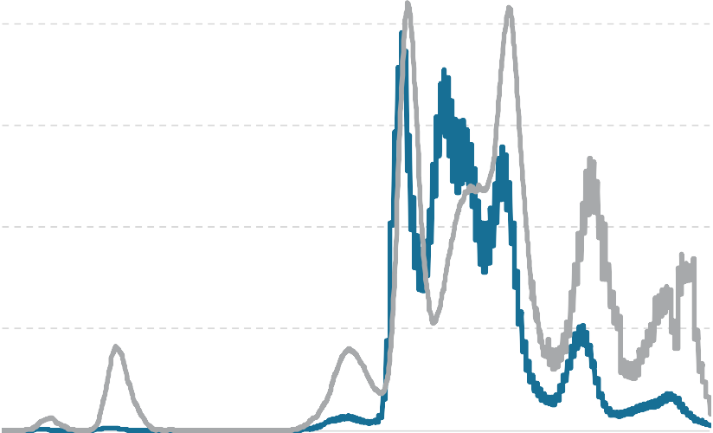
2.0
Deaths (30-day sum, '000)

1.5

1.0

0.5

0.0

Feb-20 Aug-20 Feb-21 Aug-21 Feb-22 Aug-22 Feb-23 Aug-23 Cases (rolling 30-day sum) Deaths (rolling 30-day sum)
Source: WHO (2023).

Global Trends
In 2021, McKinsey published a report (McKinsey, 2021) highlighting the key trends that will emerge following the COVID-19 pandemic. A summary of the key future trends, includes:
      - Part 1: How the COVID-19 crisis and the recovery are shaping the global economy:

        - The return of confidence unleashes a consumer rebound (given the constraints put on to the economy through the COVID-19 crisis, consumers will spend heavily)
        - Leisure travel bounces bank but business travel lags
        - The crisis sparks a wave of innovation and launches a generation of entrepreneurs
        - Digitally enabled productivity gains accelerate the Fourth Industrial Revolution
      - Part 2: How businesses are adjusting to the changes prompted by the COVID-19 crisis:

        - Pandemic-induced changes in shopping behaviour forever alter consumer businesses
        - Supply chains rebalance and shift (with many multi-national corporations seeking to shorten their supply chains and produce more products closer to their key markets)
        - The future of work arrives ahead of schedule (with an acceleration of working remotely and other technological solutions in the workplace)
        - The biopharma revolution takes a hold (with a generation of new drugs unfolding)
        - Portfolio restructuring accelerates (with capital flowing from some traditional industries into others, based on the risks and experiences from the COVID-19 crisis)
        - Green, with a touch of brown, is the colour of recovery (that expects sustainability to become as pervasive throughout the economy as technology has been over the last decade)
      - Part 3: How the COVID-19 crisis could change society:

        - Healthcare systems take stock – and make changes (with most governments seeking to prepare for future pandemics and ensure that the healthcare system is stronger)
        - The hangovers begin as governments tackle rising debt (so much stimulus has been provided that governments will need to consider how to effectively deal with the ensuing debt)
        - Stakeholder capitalism comes of age (the requirement for businesses to ensure they are acting in a morally responsible manner will become more important)
All of these trends will have impact on the Australian, Victoria and Geelong economies.

Local Trends
Figure 8.2 shows total payroll jobs by the main Statistical Area Level 3 (SA3) regions that comprise the Geelong LGA compared to the Victoria average.
The data shows the Geelong SA3 region has recovered its payroll job levels since the onset of the pandemic. As of the week ending 13 May 2023 (latest sub-state level data available), payrolls in the Geelong SA3 were more than 5% above the level recorded in the week ending 14 March 2020 (the beginning of the pandemic). However, payrolls in the Geelong SA3 have not recovered as strongly as the Victoria average.

Figure 8.2. Payroll Job Index by SA3 Region
120

115
Employment Index (14-Mar-20 = 100)

110

105

100

95

90

85
Jan-20 Jul-20 Jan-21 Jul-21 Jan-22 Jul-22 Jan-23 Jul-23
Geelong SA3 Victoria
Note: Sub-state level data stopped being published beyond 13 May 2023. Source: ABS (2023c).

Recycling and Waste to Energy
Recycling is a growing industry in Australia that is directly related to waste-to-energy technology. Recycling seeks to repurpose a number of waste streams that are earmarked for landfill, including plastics and metals. These materials can be used in a number of products and the technology to recycle these materials from waste is ever growing.
Waste to energy technologies refer to a range of technologies varying according to the type of waste used, how it is processed and the type of energy it generates. There are three main types of waste to energy processes including:
- Capturing methane from landfill emissions for use in electricity generation
- Biological processes such as anaerobic digestion which effectively manages clean streams of food waste, with any residual waste streams being used as an agricultural application
- Thermal processes including incineration, gasification, pyrolysis and plasma arc technologies
Currently, there are a number of small scale bio-fermentation units that exist. The Kwinana Waste to Energy Project ($700 million) will process approximately 400,000 tonnes of municipal solid waste, commercial and industrial waste and/or pre-sorted construction and demolition waste per annum to produce approximately 36 MW of baseload power. It is expected to be in operation by the end of 2022. The East Rockingham Waste to Energy Project, also currently under construction, will generate 29 MW of baseload power, sufficient to supply 36,000 homes.
Major waste companies including, Suez and Veolia, are pursuing waste to energy solutions within Australia.

Carbon and Renewable Power Generation
As highlighted in Section 8.1.1, sustainability will become as pervasive across the economy, just as digital technologies have touched every industry sector. The Australian Government has announced plans to reach zero emissions by 2050. Many large corporations established net zero emission targets even earlier. Almost all mining companies in Australia have announced plans to become net zero carbon emitters before 2050. The Australian red meat industry has set the goal to be carbon neutral by 2030.
Renewable energy is a large component of sustainability and how business and industry seek to contribute to it. Renewable power generation contributed just 7% of Australia’s total electricity requires in 2019-2020, however, has been growing at an average annual rate of 11% over the past decade. Solar power has grown dramatically, representing over one-third of renewable power generation with wind power representing another third (Figure 8.3).
Australia’s main electricity grid is predicted to surpass 50% renewable generation by 2025 and reach 69% by 2030. A similar pattern has been identified for Victoria, reaching 61% renewable generation by 2030 (Department of Climate Change, Energy, the Environment and Water, 2023).
Figure 8.3. Renewable Power Generation, Australia
70,000

60,000

50,000
Gigawatt Hours (GwH)

40,000

30,000

20,000

10,000

0
1994–95
1995–96
1996–97
1997–98
1998–99
1999–00
2000–01
2001–02
2002–03
2003–04
2004–05
2005–06
2006–07
2007–08
2008–09
2009–10
2010–11
2011–12
2012–13
2013–14
2014–15
2015–16
2016–17
2017–18
2018–19
2019–20

Hydro Wind Bioenergy Solar
Source: Department of Industry, Science, Energy and Resources (2022).

Working from Home
While the technology to host and conduct virtual meetings has existed for some time, until the COVID-19 pandemic, it was not widely used. The Melbourne Institute’s Household, Income and Labour Dynamics in Australia (HILDA) Survey identified that around 8% of employees in 2019 had formal work from home arrangements, which equated to around 2% of total hours worked. These results were supported by the 2016 Census, which indicated that 5% of employees were working from home on Census Day.

The ABS identified that 41% of workers in Australia regularly worked from home in August 2021 (ABS, 2021). The Productivity Commission found that 75% of workers identified that they were just as productive at home as they were in the office. Flexibility and avoiding the daily commute are highly prized by employees, but few workers prefer to fully work remotely with most wanting to spend some time in the office. The corporate real estate industry is now focused on ‘giving employees a reason to come to the office’ with considerable attention paid to office amenity and initiatives to support collaboration and interaction of staff.
The majority of jobs that can work remotely tend to be associated with various ‘knowledge intensive industries’ such as professional business services, finance and technology. The Central Business Districts (CBDs) in Australia have been most impacted through this major shift as fewer workers in the city means fewer customers for the businesses located there. Property Council of Australia (PCA) surveys have continually showed that occupancy rates in major CBDs have yet to reach their pre- pandemic levels, with the Melbourne CBD at only 47% of its pre-pandemic occupancy rate in February 2023 (PCA, 2023).
While CBDs will not ‘die’ as has been reported in the media previously, the shift of office workers to their suburban residential locations will create new opportunities in these locations for retail, hospitality and personal services. As at August 2023, SEEK was showing almost 9,000 work from home jobs currently advertised across Australia.

Labour Shortages
Closed international borders and the strong economic rebound has resulted in severe labour shortages across several industries throughout Australia. Figure 8.4 shows a sharp increase in the proportion of Victoria employers recruiting since the height of the pandemic in 2020. Further, the proportion of employers nationally reporting difficulty in finding suitable labour has also risen sharply since 2020.
Figure 8.4. Employers Recruitment Difficulty
80%

70%

60%

50%

40%

30%

20%

10%

0%
Sep-20 Dec-20 Mar-21 Jun-21 Sep-21 Dec-21 Mar-22 Jun-22 Sep-22 Dec-22 Mar-23 Jun-23
Victoria Australia
Source: Jobs and Skills Australia (2023a).

At a more localised level, Figure 8.5 shows demand for labour in the Geelong region towards its highest levels since 2010, having risen sharply since the height of the pandemic. This is unsurprising given the strong employment growth in the region over recent years.
Figure 8.5. Internet Vacancy Index
250

200
Internet Vacancy Index October-10 = 100)

150

100

50

0
Oct-10 Apr-13 Oct-15 Apr-18 Oct-20 Apr-23
Geelong & Surf Coast Victoria
Source: Jobs and Skills Australia (2023b).

Victorian Priority Industries
The Victoria Government (Victoria Department of Treasury and Finance, 2023) has identified several priority industries that will drive Victoria’s economic growth and jobs, including:
- Construction technologies
- Creative industries
- Defence technologies
- Digital technologies
- Food and fibre
- International education medical technologies and pharmaceuticals
- Professional services
- Retail, transport distribution and logistics and postal
- Transport technologies
- Visitor economy
- Social and community infrastructure.

Sustainability and Circular Economy
The Sustainable Development Goals were adopted by the United Nations in 2015 as a global call to action to end poverty, protect the planet, and ensure that by 2030 all people enjoy peace and prosperity (UNDP, 2023).
The 17 Sustainable Development Goals include:
- No poverty
- Zero hunger
- Good health and wellbeing
- Quality education
- Gender equality
- Clean water and sanitation
- Affordable and clean energy
- Decent work and economic growth
- Industry, innovation and infrastructure
- Reduced inequalities
- Sustainable cities and communities
- Responsible consumption and production
- Climate action
- Life below water
- Life on land
- Peace, justice and strong institutions
- Partnerships for the goals.
A recent PricewaterCooper’s (2021) report stated that adopting the concept of a circular economy could mean that ‘Australia could generate $1,860 billion in direct economic benefits over twenty years and save 165 million tonnes of CO2 per year by 2040.’
PricewaterhouseCoopers (PWC, 2022) has also outlined the following trends for corporate Environmental, Social, and Governance (ESG) standards, including:
- Global move to align capital markets with sustainability goals through standards and regulation
- Biodiversity and natural capital becoming a greater focus with increasing recognition of risks and opportunities
- Focus on Scope 3 emissions in climate change related reporting
- Science based net-zero targets becoming the norm
- Australian regulators set to look seriously at ESG credentials and exposure to ESG-related risks
ESG has become a major feature of corporate real estate and become a key factor for large businesses in their day-to-day operations.

Next Steps
This information provides an evidence base for the Economic Development Strategy. The information contained in this report will establish the basis for initiatives and actions to be undertaken in the Economic Development Strategy.

References
ABS (2023a). Regional Population. Australian Bureau of Statistics, Canberra.
ABS (2023b). Counts of Australian Businesses, including Entries and Exits, Jun 2016 to Jun 2020.
Australian Bureau of Statistics, Canberra.
ABS (2023c). Weekly Payroll Jobs and Wages in Australia. Australian Bureau of Statistics, Canberra. ABS (2022a). Census of Population and Housing, 2021. Australian Bureau of Statistics, Canberra.
ABS (2022b). Regional internal migration estimates, provisional. Australian Bureau of Statistics, Canberra.
ABS (2022c). Australian Defence Industry Account. Australian Bureau of Statistics, Canberra.
ABS (2017). Census of Population and Housing, 2016. Australian Bureau of Statistics, Canberra. ANA (2020). Australia’s Cultural and Creative Economy – A 21st Century Guide. A New Approach,
October 2020
Department of Climate Change, Energy, the Environment and Water (2023). Australian electricity generation renewable sources. Available from: Australian electricity generation renewable sources | energy.gov.au. Accessed 23 August 2023.
Department of Transport and Planning (2024). Victorian Property Market Sales Report. Available from: https://discover.data.vic.gov.au/dataset/victorian-property-sales-report-median-house- by-suburb. Accessed 7 January 2024.
Defence (2023). Portfolio Budget Statements 2023-24, Defence Portfolio, Budget Related Paper No.
1.4A. Commonwealth of Australia, Canberra.
DESE (2023). LGA Data Tables — Small Area Labour Markets — March quarter 2023. Department of Education, Skills and Employment, Canberra.
EconomyID (2023). Geelong Economic Profile. Available from: https://economy.id.com.au/geelong.
Accessed 23 August 2023.
Jobs and Skills Australia (2023a). Recruitment Experiences and Outlook Survey. Available from: Recruitment Experiences and Outlook Survey | Jobs and Skills Australia. Accessed 23 August 2023.
Jobs and Skills Australia (2023b). Internet Vacancy Index. Available from: Internet Vacancy Index | Jobs and Skills Australia. Accessed 22 August 2023.
McKinsey (2021). The next normal arrives: Trends that will define 2021—and beyond. McKinsey and Company. Kevin Sneader and Shubham Singhal.
National Skills Commission (2022). Employment Projections. Available from: https://www.nationalskillscommission.gov.au/topics/employment-projections. Accessed 23
August 2023.
PCA (2023). Office Occupancy – February 2023. Property Council of Australia. Available from: Office Occupancy - February 2023 - Property Council Australia. Accessed 19 August 2023.
PWC (2022). ESG trends in 2022. PricewaterhouseCoopers, Sydney.
PWC (2021). Building a more circular Australia March 2021 – The opportunity of transitioning to a circular economy. Available from: building-a-more-circular-australia.pdf (pwc.com.au).
Accessed 23 August 2023.

Roy Morgan (2019). New Roy Morgan Research Finds Australia Prefer Australian. Available from: https://australianmade.com.au/latest-news/2019/new-roy-morgan-research-finds- australians-prefer-australian- made/#:~:text=The%20research%20found%20that%2080,in%20building%20and%20renovatio n%20materials. 2 May 2022.
SEEK (2023). Job search ‘working from home’. Available from www.seek.au. Last accessed 18 August 2023.
SQM Research (2024). Residential Vacancy Rates, SQM Research. Available from: www.sqmresearch.com.au. Accessed 7 January 2024.
UNDP (2023). What are the Sustainable Development Goals? Available from: Sustainable Development Goals | United Nations Development Programme (undp.org). Accessed 23 August 2023.
Victoria Department of Treasury and Finance (2023). Government’s priority areas for market led proposals. Available from: https://www.dtf.vic.gov.au/sites/default/files/2018- 05/Governments%20priority%20areas%20for%20market-led%20proposals.DOCX. Accessed 23
August 2023.
WHO (2023). WHO Coronavirus (COVID-19) Dashboard. World Health Organisation. Available from: https://covid19.who.int/data. Accessed 23 August 2023.

Lucid Economics Pty Ltd

www.lucideconomics.com.au info@lucideconomics.com.au

