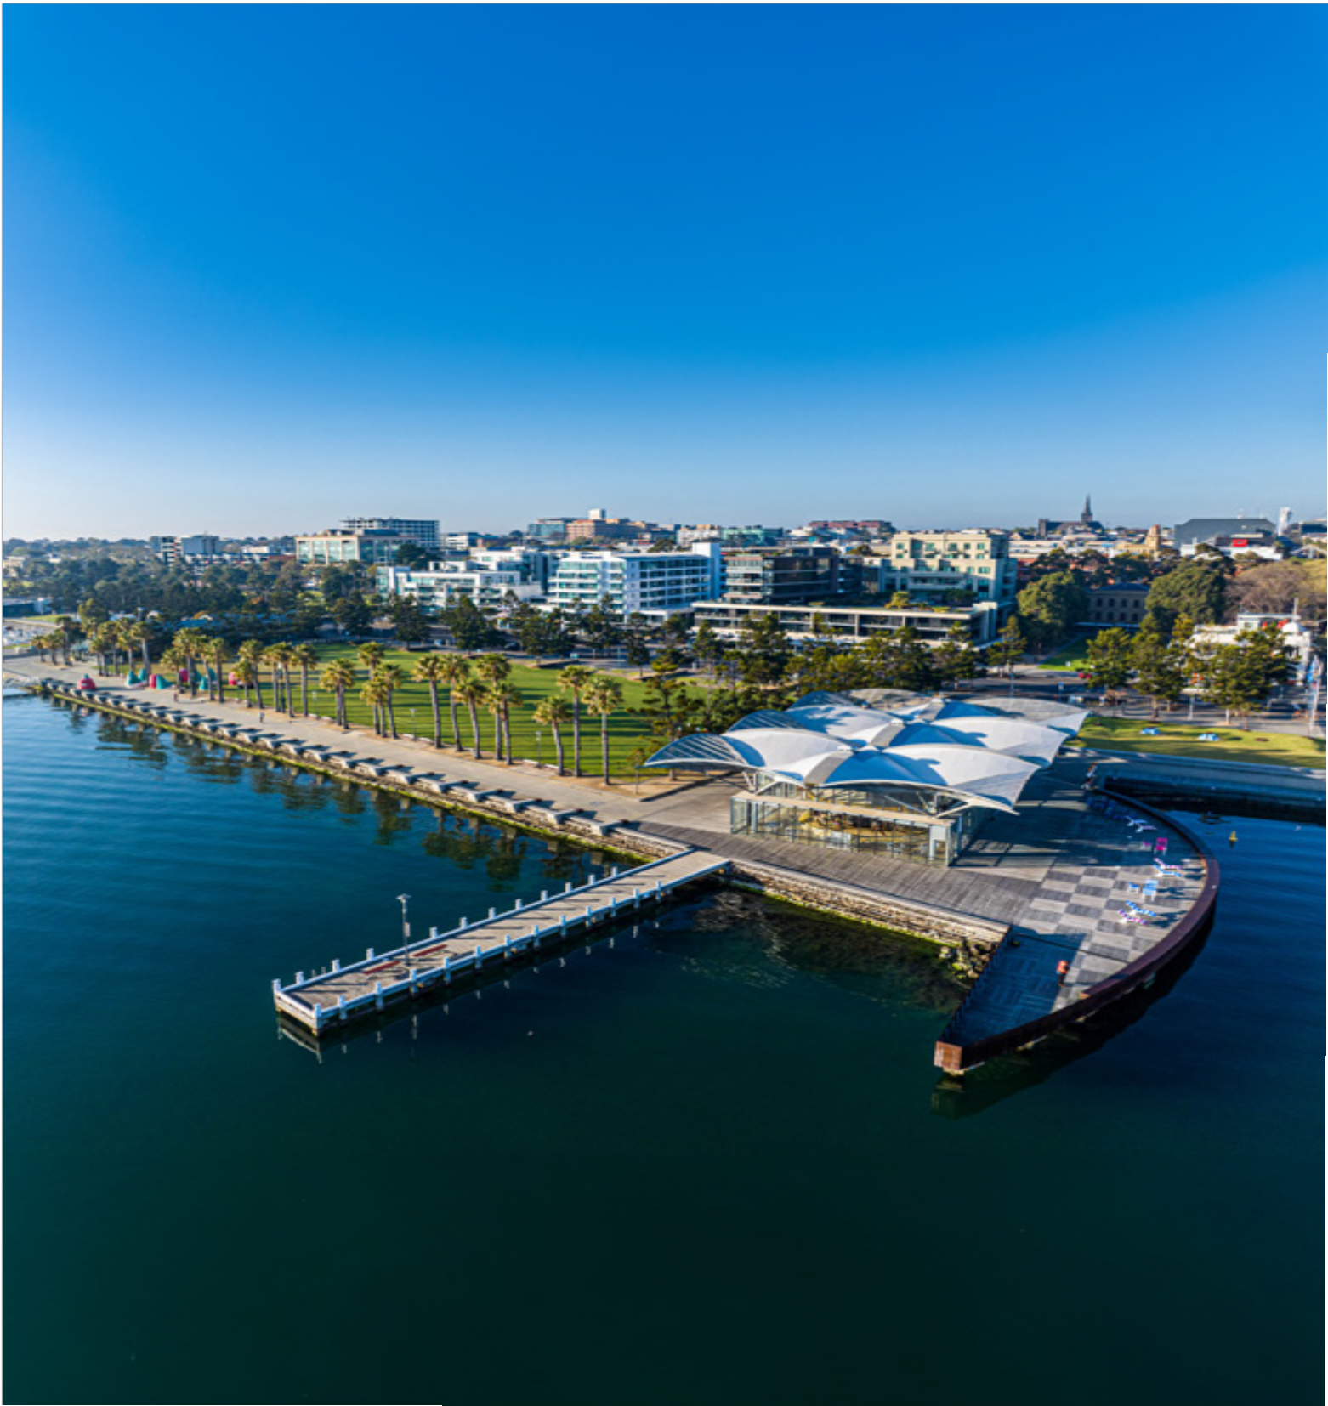
GEELONG ON THE RISE: A CLEVER
AND CREATIVE
INTERNATIONAL CITY
GREATER GEELONG ECONOMIC DEVELOPMENT PLAN 2024–2034

We Acknowledge the Wadawurrung People as the Traditional Owners of the Land,
Waterways and Skies. We pay our respects to their Elders, past, present and emerging. We Acknowledge all Aboriginal and Torres Strait Islander people who are part of our Greater Geelong community today.

View of the You Yangs from Lake Connewarre, Leopold

2.

CONTENTS

Introduction 5
Mayor’s Message 6
CEO’s Message 7
Strategic Context 8
Our Past, Present and Future 10
Our Past 10
Our Present 11
Our Future 13
Our Advantages and Challenges 14
Our Competitive Advantages 14
Our Challenges and Barriers 18
Our Future Growth Opportunities 20
Our Bold Plan 24
Positioning Geelong 25
Collaboration and Support 28
Talent Attraction and Development 30
Planning and Advocacy 32
Monitoring Progress 34
References 34

3.

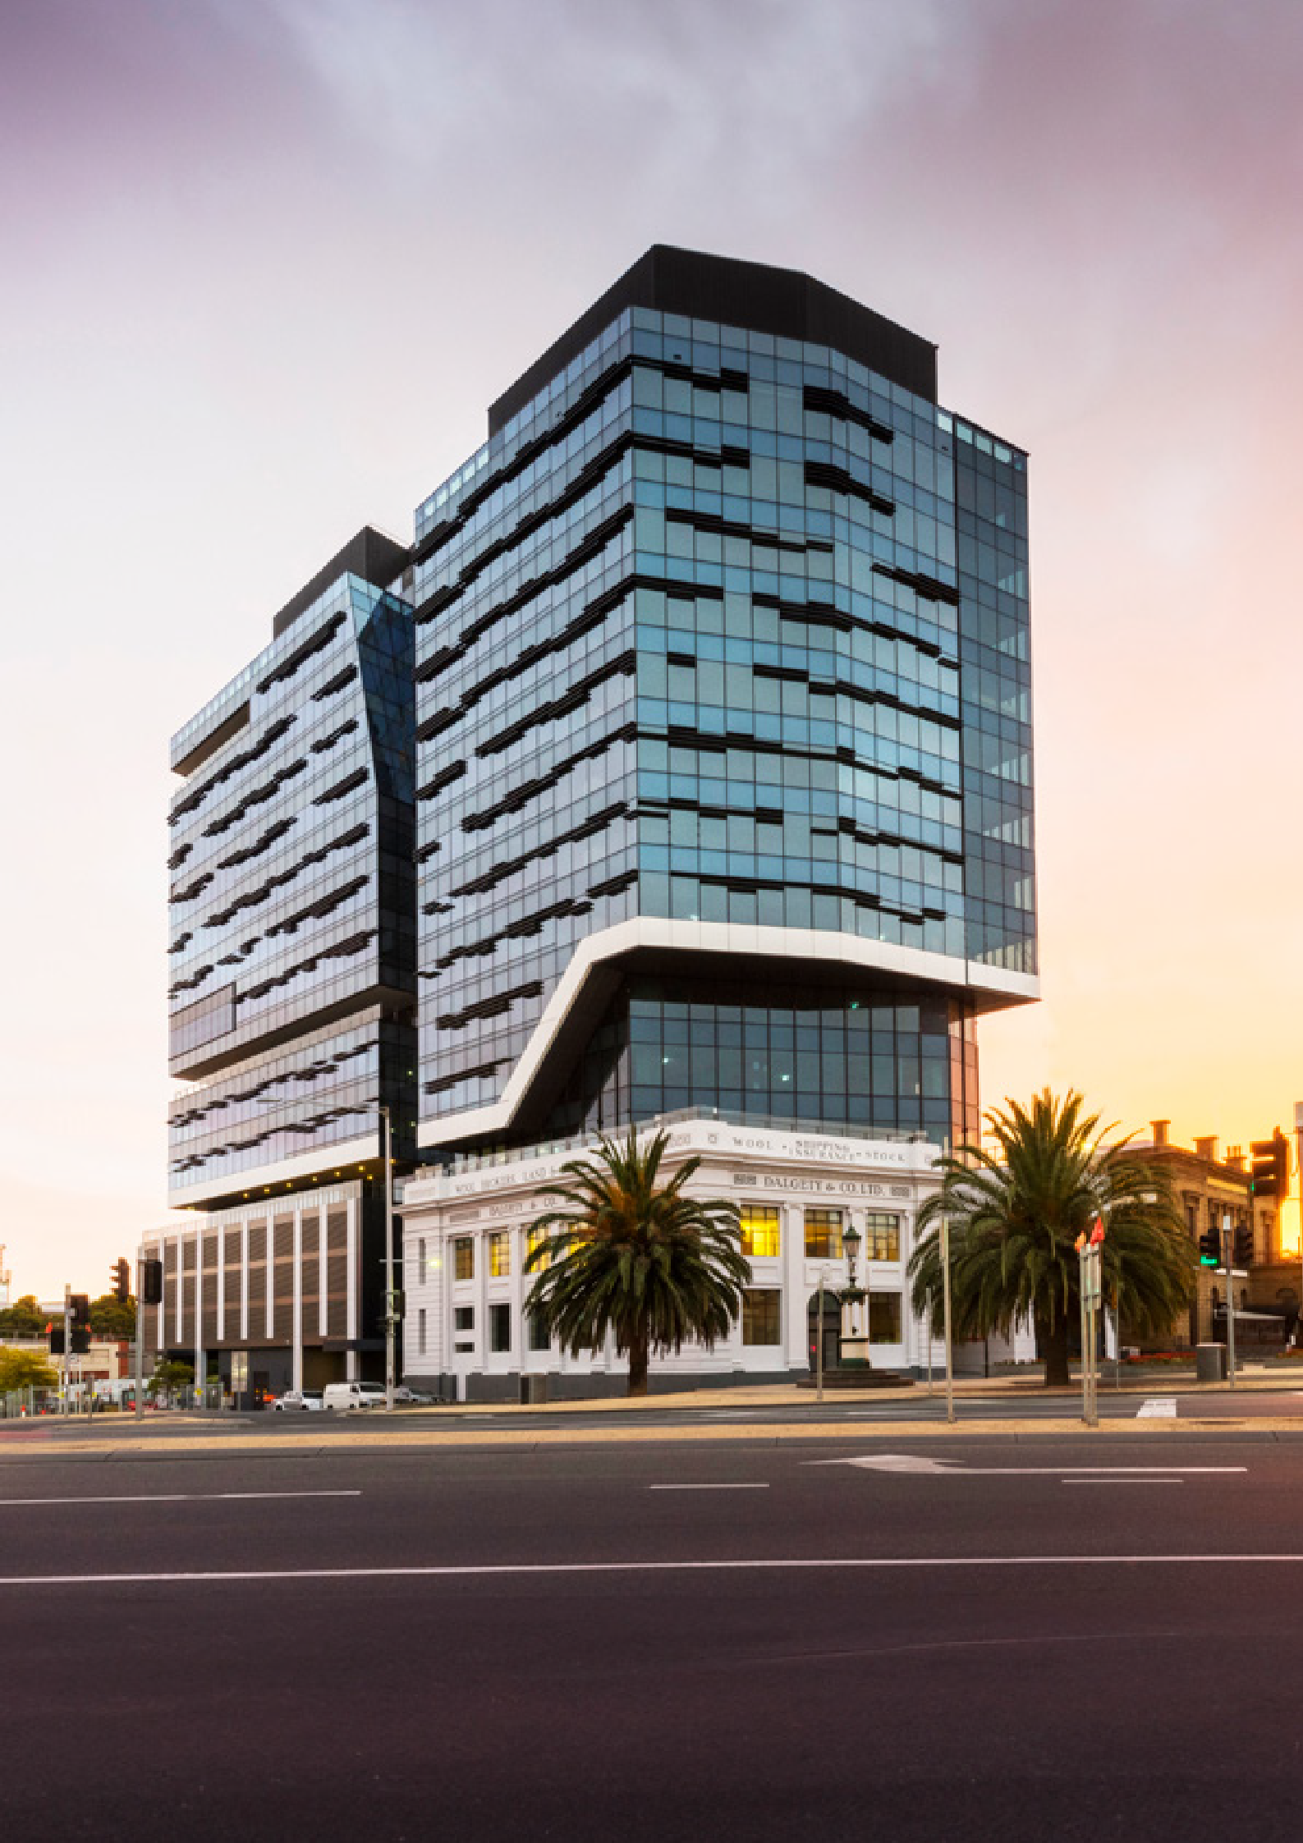

WorkSafe Victoria Head Office, Geelong

4.

INTRODUCTION

Geelong on the Rise is a contemporary and very local story, one focused on innovation and creativity. Geelong has always been a clever and creative place. It has always been a place of business and industry.
For thousands of years, Wadawurrung People lived on this land and knew it as a land of plentiful resources and valuable trading materials.
The story of modern Geelong was born of the wool trade, as European settlers came to the area to access its plentiful resources and attractive grazing lands for sheep. These events represent the first significant economic evolution of Geelong, as it was established as the export terminal for wool. Geelong’s second great economic evolution arrived in 1868 as Victoria’s first woollen mill was built in Geelong, ushering in a period of industrialisation. Geelong’s commitment to celebrating the arts came in the late 1800’s with the establishment of Geelong Gallery in 1896. The Gallery is now one of Australia’s leading and oldest regional art galleries.
Geelong’s industry prowess accelerated in the 1920s to include multiple woollen mills, fertiliser plants, a cement factory and the first automotive assembly plant
in Australia (Ford’s Geelong Factory). Before World War II, the first (and largest) International Harvester Factory in Australia and the Shell Refinery were established, bringing more innovation, investment and jobs to Geelong. Geelong boomed in the post war period, with the population surging and more industry and jobs as Alcoa established its Geelong Smelter.
The 1970s and 1980s saw further economic evolution as the woollen mills closed when Government policy and macro-economic factors shifted. The International Harvester Factory also closed. This period saw Deakin University establish in Geelong as well as the Geelong Arts Centre open, representing a new wave of education, innovation and creativity.
The 21st century became another disruptive period. Geelong’s City Centre began to evolve and change through various investments. The office headquarters of the Transport Accident Commission, National Disability Insurance Agency and WorkSafe relocated to Geelong, demonstrating the City’s ability to support a large, corporate business. This period also witnessed the closure of Ford’s Geelong Factory and the Alcoa Smelter. In the wake of these closures, new advanced manufacturing operations were established focused on carbon fibre, leveraging the innovation and specialist expertise of Deakin University. Most recently, COVID-19 disrupted the City and and Barwon Health established the first regional public health unit in Victoria.
Geelong has emerged from COVID in a strong growth position, with the population again surging and more industry announcements. Hanwha is establishing a large defence manufacturing operation located at the Avalon Industrial Precinct and The Spirit of Tasmania relocated to the GeelongPort.
This story is one of innovation and creativity, about adaption and evolution. It’s Geelong’s story and a story of a city on the rise. Geelong has a significant population of more than 280,000 (set to reach 400,000 by 2041) and is Victoria’s second capital city, it has a
major international airport and major port, it has a large CBD and waterfront precinct that can support significant growth. Geelong has strong education and training organisations and an attractive and growing lifestyle offer. The City has all the ingredients required to be a significant economic player nationally and internationally. Geelong on the Rise is about a sustained elevation and evolution of the Geelong economy over the next 20 years.

5.

MAYORS MESSAGE

It is a great pleasure to unveil our strategic 10-year Economic Development Plan for Greater Geelong.
This plan represents a significant step towards realising our long-term vision of becoming a prosperous, sustainable, innovative, and creative city-region.
Geelong is growing at a rapid rate and is now home to more than 280,000 people. This growth has been fuelled by an attractive
lifestyle, diversifying economy, and a diverse and welcoming community.
This has transformed our economic landscape, creating new job opportunities across a range of sectors.
As Australia’s only UNESCO Creative City of Design, we have a strong culture of innovation.
We are pioneering innovation and fostering technological
advancements across cutting-edge industries, particularly in advanced manufacturing.
We now have a significant opportunity to align our Clever and Creative vision with a sharpened focus on growth industries that will help drive our future economy.
Alongside advanced manufacturing there is defence, transport and logistics and the visitor economy,
as well as creative industries, digital technology, the clean economy, major public and private healthcare services, and professional business services.
Our strategic location, natural environment, air and sea ports, transport hubs, defence capabilities, innovative businesses and research facilities all provide us with competitive advantages.
With these assets – and a skilled workforce – Geelong is poised for growth and success on a global scale.
Our 10-year plan, Geelong on the Rise, is the culmination of extensive collaboration with regional businesses, industry
leaders, government agencies, and community organisations.
It embodies our collective vision for Greater Geelong and will forge the path for future work.
Together with our valued stakeholders and partners, we are committed to bringing this vision to life, ensuring a prosperous and vibrant future for Greater Geelong.

CR TRENT SULLIVAN
Mayor

6.

CEO’S MESSAGE

Over the past decade, Greater Geelong has undergone remarkable growth. Geelong is outpacing every other region in Australia, boasting the fastest population growth in Victoria and second fastest in Australia, the largest regional economy in the state, and the fastest jobs growth of all Australian regional cities.
Cementing Geelong’s current population and economic growth is a strong $13.2 billion investment pipeline.
Leveraging our current economic growth, major infrastructure assets and UNESCO City of Design designation, Geelong
will increasingly feature on the global stage alongside prominent international cities committed to developing thriving and sustainable cities and communities.
Our 10-year plan, Geelong on the Rise, will stand as a blueprint for future work, guiding our actions to create an environment conducive to economic growth and investment, and focus on our key strengths, strategic priorities and milestones.
It will drive a more sustainable and diversified economy that is resilient and adaptive, even to sudden changes, and will shape an innovative and future focused
economy that defines new trends and opportunities.
This plan will guide our work towards positioning Geelong as a global business centre that attracts international investment.
It will help us focus on fostering collaboration that proactively supports local business growth, the development of industry clusters, strategies for talent attraction and future workforce skills and strategic projects that underpin future business and industry growth.
Our community vision to be internationally recognised as a clever and creative city-region that is forward focused, enterprising, and adaptive and cares for its people and environment is central to our future growth.
The City is proud to be playing a key role in bringing the community vision to life, however it’s essential that we facilitate collaborative
and supportive environment that works across business, industry, government and the community.
Together, we have incredible opportunities in front of us and all the ingredients to realise a highly innovative, sustainable, and successful future for Greater Geelong.

ALI WASTIE
Chief Executive Officer

7.

STRATEGIC CONTEXT

We recognise that this Plan is part of a broader, comprehensive Community Plan to support a proud, safe and healthy community. This Plan also recognises important work that has been done previously to support specific industries and we have aligned the Plan to this broader strategic context.

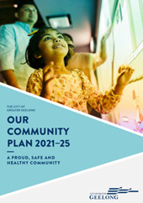
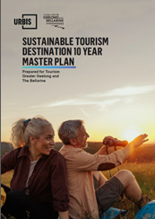
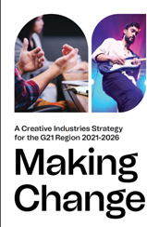
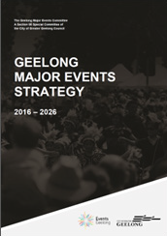
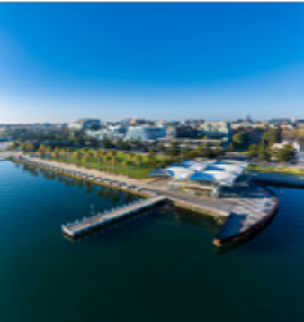
Our Community Plan 2021-25 is Council’s plan to deliver on the desired future of the community.
Strategic Direction 3: Strong Local Economy provides direction for the Economic Development Plan.

The Economic Development Plan provides specific actions and initiatives to deliver on Our
Community Plan 2021-25 and also establishes the direction for the next significant evolution in the local

GREATER GEELONG
ECONOMIC DEVELOPMENT PLAN 2024–2034
economy, to become an international clever and creative city.

The Economic Development Plan supports other existing strategies and plans that can assist in delivering an international clever and creative city.
Other key complementary documents include the Smart Cities Strategy Advocacy Framework and International Engagement Strategy.

8.

ROLE OF COUNCIL IN ECONOMIC DEVELOPMENT
Local government plays a key role in the promotion of the local economy and employment growth. Economic development creates employment, provides essential goods and services and establishes communities as attractive places to live, work, learn, visit and invest.
According to the Victorian Auditor-General’s Office, local governments play a key role in facilitating economic development by attracting businesses and residents to municipalities. Local governments are well placed to drive economic outcomes, as they are the closest level of government to business and the community.
The role of local government in economic development can be expressed across a number of spheres where local government has a direct responsibility or area of influence:
- Influencing Geelong’s economic growth
- Advocating for new infrastructure and services needed by existing and future industries
- Partnering with others to leverage our competitive strengths
- Facilitating small business support, workforce development, investment attraction and events
- Marketing and positioning Geelong’s competitive strengths
- Leading tourism, creative and innovative industries
Overall, through these spheres of influence, local government is seeking to create an environment that is conducive to future economic growth and vibrancy.

Influencing

Leading

Marketing and Positioning

Economic Development
Advocating

Partnering

Facilitating

9.

OUR PAST, PRESENT AND FUTURE

OUR PAST
For tens of thousands of years, the Aboriginal people of the Wadawurrung were the first residents living in the region. They lived in close connection to the land, water and seasons, caring for country.
The Wadawurrung People were Geelong’s first residents. They originally called the Central Geelong area ‘Dijilang’ and the surrounding land and waters ‘Corayo’.
Geelong’s population in 1838 is 450
1838 | The first wool store and general store are built.
1840 | First shipment of wool is exported to London.
First edition of the Geelong Advertiser is published.
1840s-50s Industries included flour mills, lime kilns, soapworks, tanneries and a ropeworks.
1852 | Geelong Hospital opens.
First shipping channel established in Corio Bay.
Geelong’s population in 1854 is 20,000
1857 | Geelong to Melbourne railway line opens.
1868 | Victoria’s first woollen mill is built in Geelong ushering in a period of industrialisation.
1887 | Gordon Technical College opens.
1896 | Geelong Art Gallery is established.
Geelong’s population in 1907 is 28,000
1920s | Industry accelerates including the development of multiple woollen mills, fertilizer plants and cement factory.
1925 | Ford Motor Company opens the first automotive assembly plant in Australia in Geelong.
1926 | What is now Target Australia opens its first store in Geelong.
1940 | International Harvester begins manufacturing agricultural equipment.
1952 | Avalon Airport founded.
Geelong’s population in 1954 is 73,000
1954 | Shell Refinery opens at Corio.
Mid-1950s Geelong is an industrial powerhouse with manufacturing employment peaking at 46 per cent.
1963 | Alcoa aluminium smelter opens at Point Henry.
1970s-80s Wool manufacturing begins to decline, woollen mills and International Harvester close. A new wave of education, innovation and creativity gets underway.
1974 | Deakin University formally establishes (opens to

on-campus students in Waurn Ponds in 1977).
Geelong’s population in 1981 is 141,300
1981 | Geelong Performing Arts Centre (now Geelong Arts Centre) opens.
1991 | The first Cotton On store opens in Geelong.
1995 | First passenger flights out of Avalon Airport.
1996 | Deakin University’s Waterfront campus opens.
2001 | Redevelopment of Geelong’s Waterfront is completed.
Geelong’s population in 2006 is 197,500
2007 | Carbon Revolution is founded commercialising carbon fibre wheel technology.
2009 | TAC headquarters moves to Geelong.
2010 | Geelong Ring Road is completed.
2014 | Alcoa closes Point Henry operations.
NDIA headquarters opens in Geelong (moving into a new building in 2019).
2016 | Ford ceases manufacturing in Geelong.
Geelong Future Economy Precinct is set up at Deakin University – accelerating research in advanced manufacturing.
2017 | Geelong designated a UNESCO Creative City of Design.
ManuFutures establishes at Deakin University.
2018 | WorkSafe’s new Geelong headquarters opens.
An international terminal opens at Avalon Airport.
2019 | Pivot City Innovation District celebrates 1,000 onsite employees, surpassing the number originally employed at Federal Woollen Mill and automotive glass factory.
2022 | Spirit of Tasmania launches from its new terminal at the Port of Geelong.
Government announces $500+ million to construct the new Barwon Women’s and Children’s at University Hospital Geelong.
Geelong’s population in 2023 is 276,500
2023 | Redeveloped Geelong Arts Centre opens, becoming the largest regional arts centre in Australia.
Construction commences on the Hanwha Armored Vehicle Centre of Excellence at Avalon Airport.
Work on Nyaal Banyul Geelong Convention and Event Centre gets underway.

10.

OUR PRESENT

Geelong is Victoria’s second Capital City and one of the state’s fastest growing areas.
Population: 276,116 (2022)
Growth of 5,340 over last year
Growth of 29,873 over last five years
Source: ABS (2023)

TOP INDUSTRIES

Contribution to Economy ($b)
Healthcare $2.2 (15%)
Construction $2.1 (14%)
Manufacturing $1.2 (9%)
Education and training $1.2 (8%)
Retail trade $1.1 (7%)
Geelong is the largest economy in regional Victoria, third largest in the state.
GRP (2021-22): $17.6 billion 1 year growth: 10.3%
5 year average annual growth: 5.4%
Source: Economy ID (2023)

Top Exporting Industries ($m)
Manufacturing $2,171 Healthcare $875 Wholesale trade $745 Education $569
Finance and insurance $521
Geelong is booming
$13.2 billion in major projects Recently completed $2.1b Commenced $3.6b Approved $2.3b
Proposed $5.2b

Contribution to Jobs (No.)
Healthcare 26,347 (19%)
Construction 15,515 (11%)
Retail trade 14,974 (11%)
Education and training 13,127 (10%)
Manufacturing 9,326 (7%)
Source: Economy ID (2023)
Recently Completed Projects
Geelong Quarter (incl. Holiday Inn and Suites Geelong) ($200 million)
Geelong Arts Centre redevelopment ($140 million)
Spirit of Tasmania Terminal ($135 million)
Charles Brownlow Retirement Village ($100 million)

Important Exporters
Viva Energy Herd Group Golden Farms Godfrey Hirst Incitec Pivot
University Hospital Geelong Deakin University
Source: Economy ID

VISITOR ECONOMY AND EVENTS CREATIVE INDUSTRIES

Geelong and the Bellarine Visitation
Visitors (YE September 2023):
6.3 million
Visitor nights (YE September 2023): 4.6 million
Visitor expenditure (2021-22):
$1.8 billion
Source: Tourism Research Australia (2023)
Major Events (2022-23)
Number of events: 18 Event visitors: 757,500
Economic impact: $77.5 million
Economic Contribution of Visitor Economy and Events on the Geelong Economy
Direct contribution to GRP:
$265 million (1.8% of total)
Direct contribution to employment: 4,987 jobs
(3.7% of total)
Source: Economy ID (2023)
Geelong is Australia’s first (and only) City of Design and a member of the UNESCO Creative City Network.
The Creative Industries are an evolving mix of sectors spanning arts, culture, screen, design, publishing, advertising and a range of professional services.
Direct contribution to GRP:
$691 million (4.7% of total)
Direct contribution to employment: 7,660 jobs
(5.7% of total)
Source: Lucid Economics (2023)
Geelong has world- leading innovative talent across a variety of creative pursuits, from fashion and the arts to engineering and production.

11.

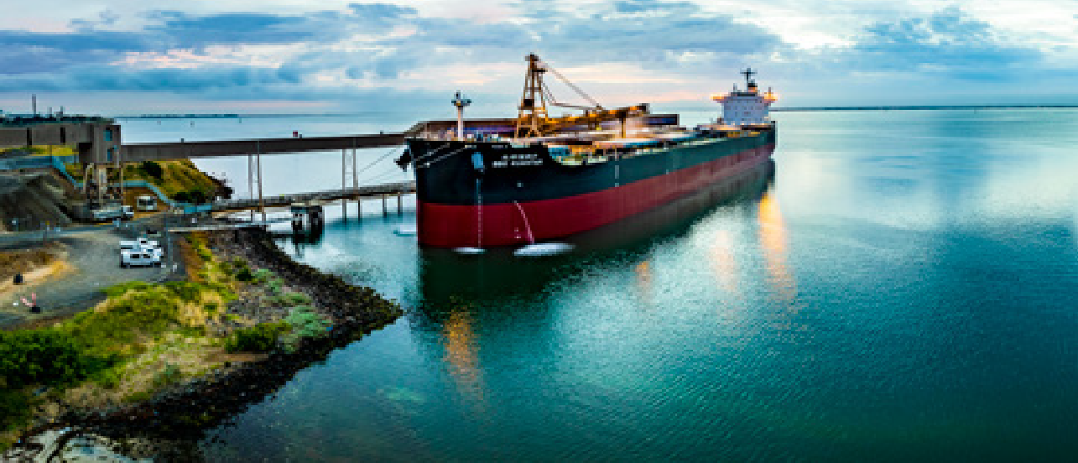
GeelongPort, North Geelong

Geelong is a city on the rise. Unlike most parts of the world, Geelong’s economy did not decline
during COVID and it has emerged from the pandemic stronger amidst a significant growth phase. This situation is not a function of luck or good fortune, but is based on a strong economic foundation, based on innovation, diversity and major infrastructure assets.
The perception of Geelong may be based on its blue-collar, manufacturing history, but the modern Geelong is very different. While manufacturing remains very significant to the Geelong economy, it has been eclipsed by healthcare and construction, in terms of its contribution to the economy. In terms of jobs, four other industries employ more people than manufacturing. This economic diversity will continue to support the evolution and diversification of the Geelong economy.
Manufacturing remains Geelong’s largest export sector, but its diversity has increased dramatically from a traditional reliance on the automotive sector or textiles. Geelong produces significant exports in food and beverage, petroleum, textiles, defence, automotive parts, clean economy products, and
a wide variety of other advanced manufactured goods. In today’s modern Geelong, there are also significant exports in healthcare, education and
tourism. Geelong’s innovative and creative people and businesses have been responsible for driving this evolution.
Additionally, Geelong has a number of emerging sectors, including tourism and events as well as the creative industries. These industries make an
important contribution to the economy but also help to further build the creative and innovative capacity of Geelong. These industries will not only add jobs and value to the economy but will also contribute
to the city’s liveability and attractiveness for future innovative and creative residents. Many of these future residents will bring their business to Geelong as well, while others will fill important roles in local businesses and contribute to a growing talent pool of clever and skilled people.
Beyond Geelong’s population and economic growth, the current economic boom is underwritten by a strong investment pipeline. $2.1 billion of recently completed investment into Geelong and the future pipeline includes $11.1 billion, of which $3.6 billion of projects have already commenced.
Geelong’s current economic evolution will cement its position as Victoria’s second capital city and extend its position as a clever and creative city on the international stage.

OUR KEY ASSETS/INFRASTRUCTURE
Avalon Airport | GeelongPort | Geelong CBD | Deakin/  The Gordon TAFE | Princes Freeway | V/Line Geelong- Melbourne
Annual Passengers  Pre-COVID:  1 million+ | Annual Throughput  2022-23: 11.6  million tonne | Investment  Recently Completed:  $410 million | Student Enrolments:  25,000+ | 1 hour to Melbourne | 1 hour to Southern Cross Station
Future: 5 million | 2048: 32 million tonne | Future: $2.6 billion

12.

OUR FUTURE
Geelong’s future is bright. The City has already forged a strong economy based on innovation and diversity. As Geelong continues to rise, the economy will become more advanced, more innovative and more creative. New residents and businesses will be attracted to the area, some coming for jobs, others coming for lifestyle, some will be attracted to the clever and creative environment that Geelong offers (and will offer increasingly into the future).
In addition to welcoming new and emerging industries to our region, we will see the scaling up of existing businesses at 5-19 or 20-199 employees and the maturing of those with 1-4 employees. This will
ensure sustainable growth of supplementary or new industries that may become the future backbone of the local economy.
As Geelong continues to evolve as a clever and creative city, its reputation on the national and international level will grow. Our local businesses will export more products around Australia and the world. We will attract additional national and international businesses as well as highly skilled talent from around the country and the world.

Population (No.) | Jobs (No.) | Gross Regional Product ($m)
2022: 276,116 | 2022: 135,561 | 2022: $17,584
2041: 395,491 | 2041: 190,602 | 2041: $27,319

Geelong is a city on the rise and by 2041 we will attract an additional:
- 120,000 people
- 55,000 new jobs
- $9.7 billion in Gross Regional Product
Geelong on the Rise will deliver:
- A more sustainable economy that is based on circular economy principles
- An innovative economy where knowledge and talent are the most significant assets
- A diversified economy that is resilient and adaptive, even to sudden changes
- A future-focused economy that defines new trends (as opposed to reacting to them)

GEELONG UNESCO CITY OF DESIGN
Geelong has a long and proud history as a creative city and a leader in design. In October 2017 Geelong was designated a member of the UNESCO Creative Cities Network (UCCN).
The City of Design designation is about using creativity and innovation to build more sustainable, resilient and inclusive communities. It fits perfectly with our 30-year, community-led vision to be internationally recognised as a clever and creative city-region.

Geelong is one of 43 Cities of Design in the UCCN. Our designation opens opportunities to showcase and celebrate our achievements on an international stage. We’ll learn from and share knowledge to improve our industrial and commercial activities, our urban form and our liveability.
The designation will also support future investment attraction and our on-going economic development into a clever and creative international city.

Saint-Étienne

Kortrijk
België
Kolding
Denemarken

Helsinki
Finland

Kaunas

Montréal
Canada
Frankrijk
Dundee
Groot-Britannië

Turijn
Italië
Berlijn
Duitsland

Graz
Oostenrijk
Litouwen
Boedapest
Hongarije
Baku
Istanbul
Azerbeidzjan

Beijing
China

Asahikawa

Wuhan

Bilbao
Spanje
Turkije
Japan China

Detroit
U.S.A

Seoul
Zuid-Korea

Kobe
Japan

Nagoya
Japan

Shanghai
China

Querétaro
Mexico

Hanoi
Vietnam
Shenzhen
China

UNESCO
Cities of Design Network
Mexico City
Mexico

Puebla
Mexico

San José
Costa Rica

Buenos Aires
Argentinië

Curitiba

Fortaleza
Brazilië

Brasilia

Dubai
UAF

Muharraq
Bahrein

Kaapstad
Zuid-Afrika

Bandung
Indonesië
Cebu City
Filipijnen

Bangkok
Thailand

Singapore
Singapore

Geelong

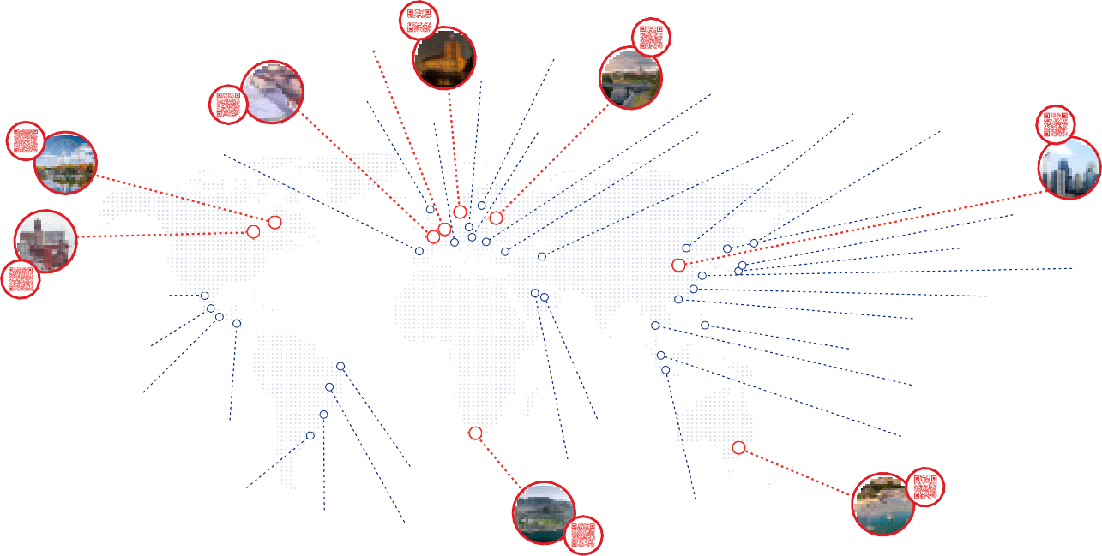
Brazilië Brazilië
Australië

13.

OUR ADVANTAGES AND CHALLENGES
STAKEHOLDER ENGAGEMENT
We engaged with well over 100 stakeholders regarding our future economy and we appreciate everyone’s contribution. Input from these stakeholders have guided our desired future and allowed us to identify our competitive advantages, opportunities, barriers and challenges.
This plan is guided by our local businesses and stakeholders, which makes it realistic and fit for purpose.

OUR COMPETITIVE ADVANTAGES
Geelong is fortunate to have a number of competitive advantages:

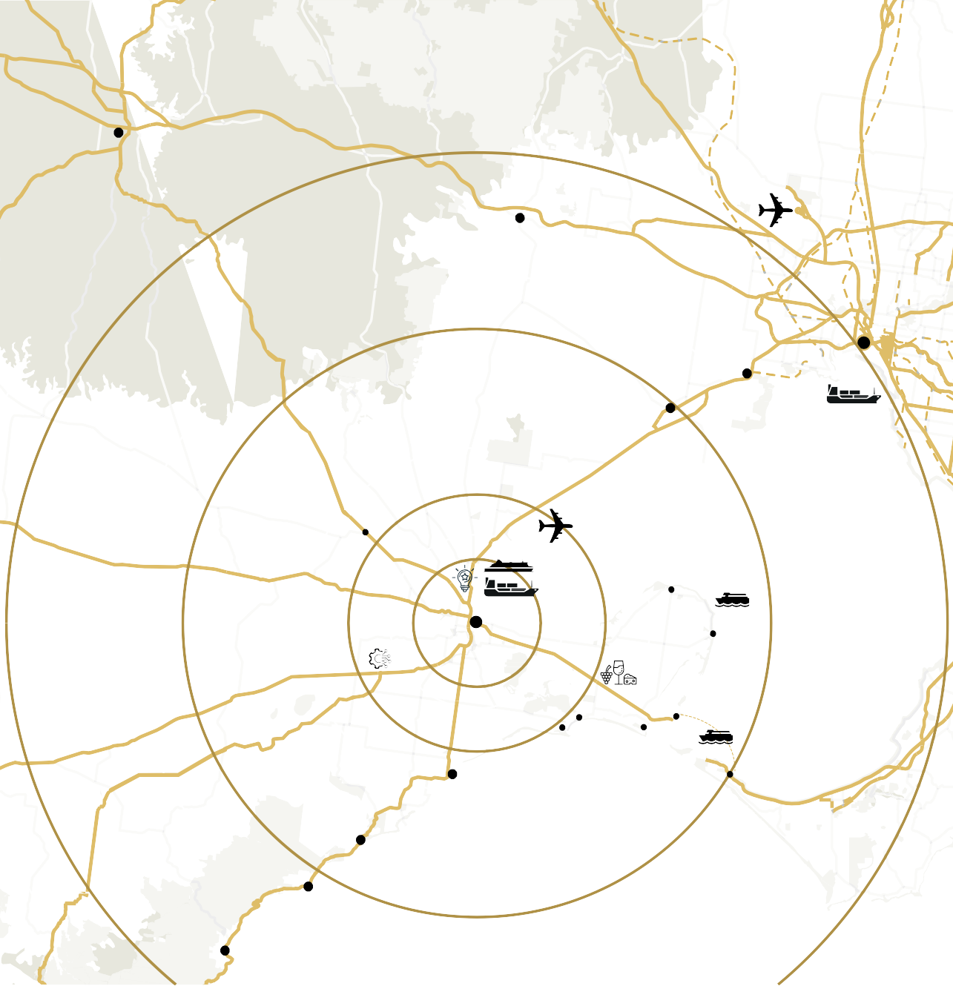
Ballarat
Strategic location: Geelong is located in a strategic position, 1 hour to Melbourne and easy access
to key national freight routes. Geelong also has easy access to the large consumer base located in the Melbourne Metropolitan Region.
Bacchus Marsh
Melbourne Airport

60mins
40mins
Laverton
Werribee
MELBOURNE
Port of
Melbourne
Bannockburn
20mins
Avalon Airport
PORT PHILLIP BAY
Pivot City Innovation District
CORIO BAY
Spirit of Tasmania
Deakin University Future Economy Precinct
GEELONG
Port of Geelong
10mins
Bellarine
Peninsula
Portarlington
Port Phillip Ferries
St Leonards
Ocean
Grove
Barwon
Torquay
Heads
Pt Lonsdale
Queenscliff
Vehicular & Passenger Ferry
Sorrento
Anglesea
Aireys Inlet
BASS STRAIT
Lorne

14.

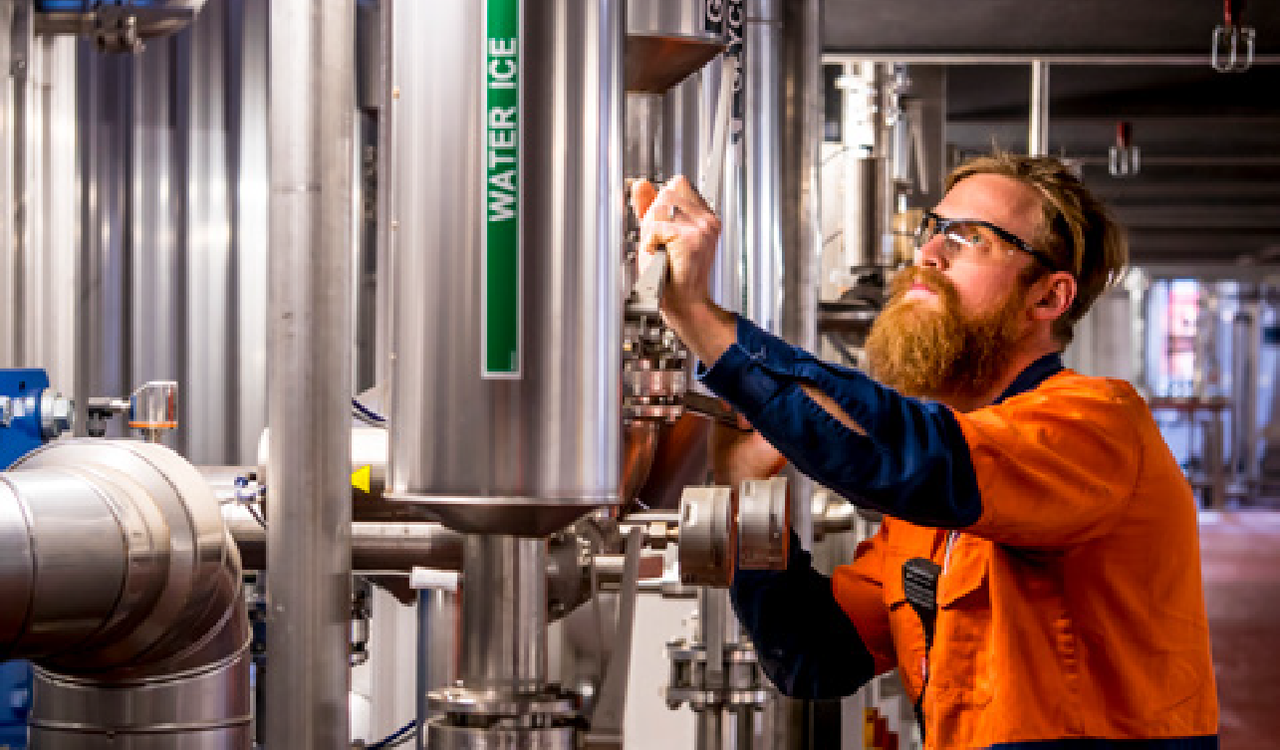
Attractive lifestyle: Geelong residents enjoy an enviable lifestyle that includes a big city feel without the congestion, a stunning coastline, diverse night life and food culture, vibrant arts and cultural scene, redeveloped waterfront, growing skyline, strong sporting culture and a wide variety of recreation and residential living options.
Fast growing region: Geelong is one of Victoria’s fastest growing regions and has a future investment pipeline of $11.1 billion.
This fast pace of growth provides investors with confidence and ensures a rapidly growing workforce and population.
Significant transport assets: Geelong has the Avalon International Airport, GeelongPort and easy access to main road and
rail transport corridors. Our advanced logisitcs capability provides business with strong accessibility to move people and products.

Strong industry: Geelong has always had a strong manufacturing sector which continues today with industrial strengths in advanced manufacturing, carbon fibre, agriculture and primary production, energy and resources, textiles, automotive parts, defence, construction, transport and materials handling.
Geelong’s diverse commercial landscape now boasts business, professional and public administration services, health and social assistance, tourism, events and hospitality.’

15.

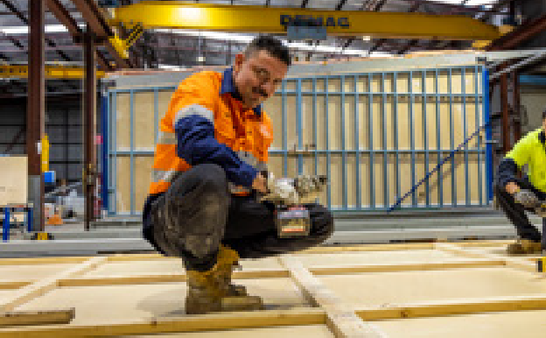
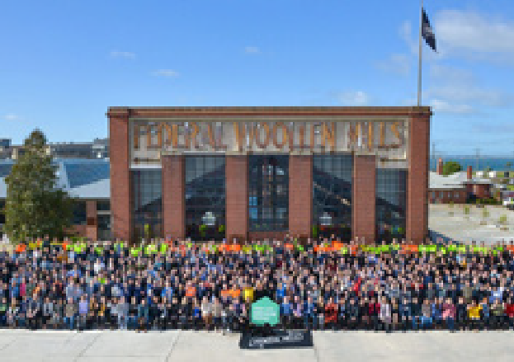
Cost competitive: Geelong is very cost competitive relative to Melbourne and various capital cities across Australia in terms of land and facility costs, housing, cost of living and other factors.
Diverse and skilled workforce: Geelong is well known for its diverse workforce, covering executive/ professional and highly skilled, trade based workers and those of lower skill levels (or skillsets for manufacturing, care and the visitor economy). Geelong’s educational ecosystem allows for continual educational attainment and skills development for life-long learning to ensure a future-fit workforce.
Strong leadership and collaboration: Geelong has a long and proud history of strong industry leadership and collaboration across industries and amongst businesses. This environment leads to strong advocacy capability and infrastructure provision as well as new ideas, knowledge,
and innovation. Geelong’s transition from a significant reliance on major strongholds in textiles, alumina and automotive to disperse sectors, a knowledge-based economy and an appetite plus hubs that allow for innovation incubation is a testament to the local economy’s collaborative and enterprising spirit.

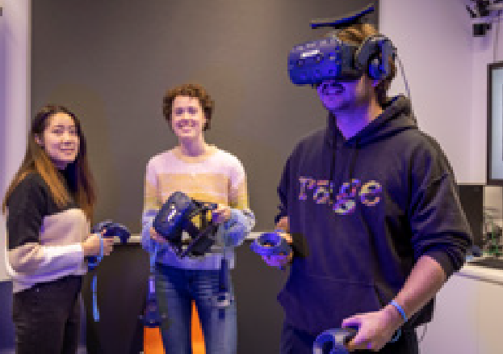
16.
Research, education and innovation assets: Geelong’s Deakin University Campuses together with the Gordon TAFE provide a wide range of education and learning options for residents
as well as a variety of bespoke research and innovation assets for business and industry focused research. Areas of specialised capability include advanced manufacturing, renewable energy, carbon fibres, circular economy, battery research, digital futures and other bespoke areas, such as the Geelong Tech School (the Gordon TAFE’s Centre for Design Excellence).
This infrastructure provides businesses with access to cutting-edge, internationally competitive innovation and creativity.
Economic diversity: Geelong’s economy is very diverse, which allows it to better manage future economic shocks but also provides businesses and future workers with a variety of options and opportunities.

GEELONG FUTURE ECONOMY PRECINCT
Deakin University’s Geelong Future Economy Precinct is a world-leading innovation precinct generating high- value knowledge economy jobs for the region.
The 325 hectare precinct epitomises the innovative and collaborative spirit that drives the Geelong economy. Over the last six years, the precinct has generated 2,000 jobs and is home to a number of high technology organisations, such as Carbon Revolution (carbon fibre wheel manufacturer), Carbon Nexus (a purpose built, open-access carbon fibre/composite research facility), FLAIM (the world’s first multi-sensory

immersive learning solution for firefighters) and a number of key research institutes (Institute for Frontier Materials, Institute for Intelligent Systems Research and Innovation, ManuFutures, Recycling and Clean Energy Commercialisation Hub, Battery Research and Innovation Hub, Deakin Energy, Renewable Energy Microgrid, and the Circular Economy Factory).
The precinct has capacity to host future businesses that can leverage Deakin’s research capability and collaboration to support future business expansion, investment and job growth.

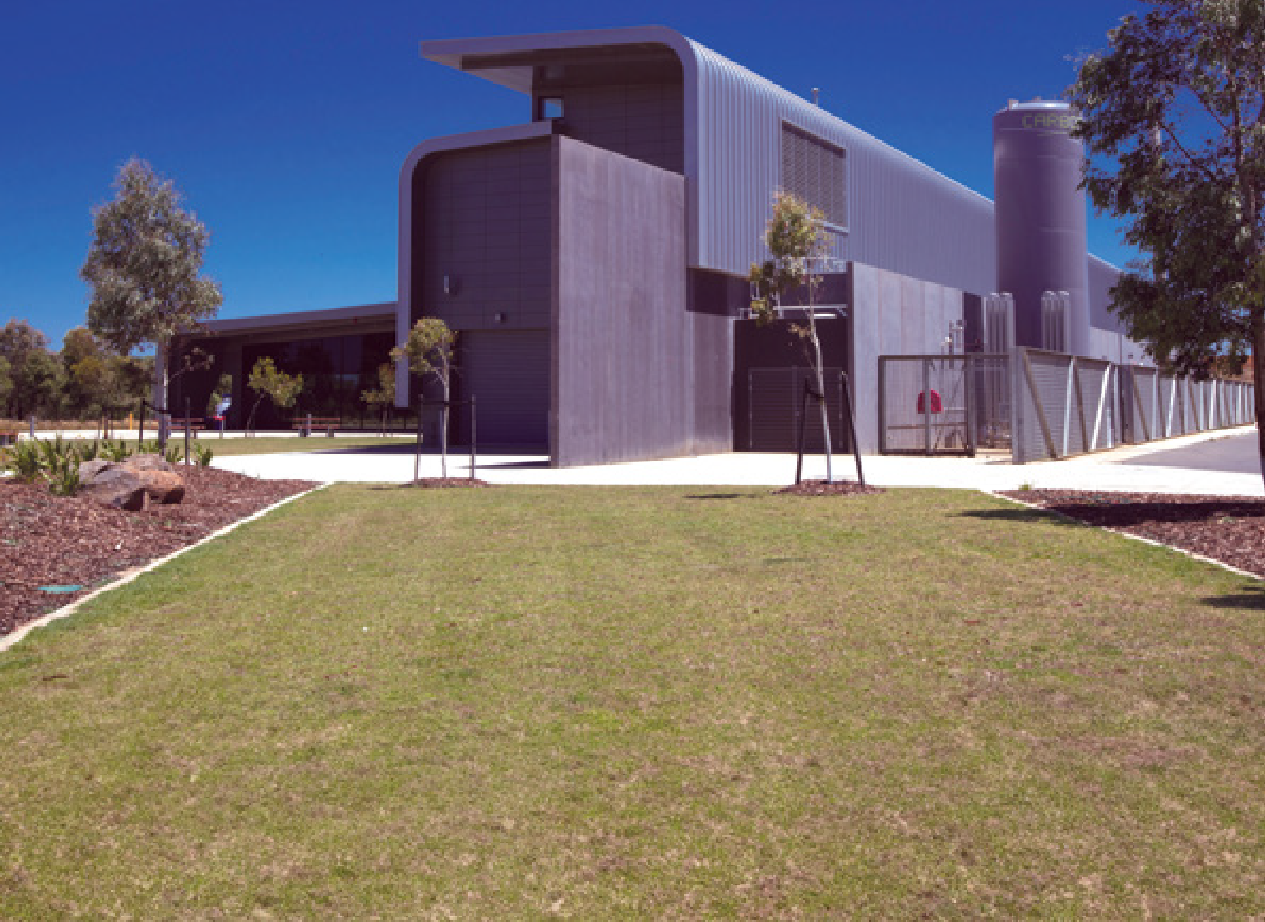

A SUPPORTIVE AND COLLABORATIVE ENVIRONMENT
As Geelong’s economy has evolved, it has become more sophisticated, which includes having numerous industry organisations that contribute to and support our future economic development. These groups play an important role and work collaboratively together as partners and with stakeholders to support the growth and diversification of various industries and clusters.
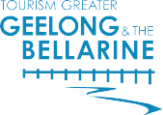

OUR CHALLENGES AND BARRIERS
Our future economic development is not without its challenges and barriers:
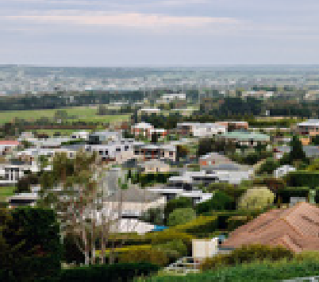
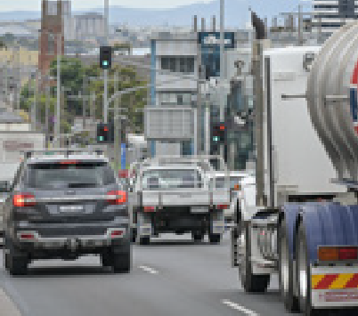
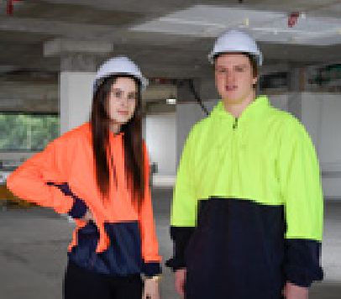
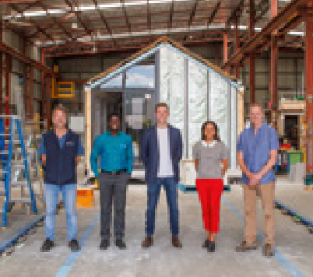
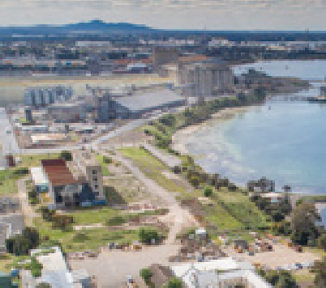

Lack of available and affordable housing: like all parts of Australia, Geelong is suffering from a lack of housing as well as a lack
of affordable housing. Insufficient stock of housing as well as a lack of variety of housing stock can stifle future growth. Additionally, a lack of affordable housing can make it difficult for some workers to move or stay in Geelong, impeding future workforce growth.

Traffic, congestion and a lack of public transport: stakeholders identified that due to strong recent growth, traffic and congestion are emerging as issues for businesses. Additionally, a lack of public transport was cited as a growing concern. As the region continues to grow in population, ensuring that residents can access employment centres will be
important and public transport can provide a solution that can also reduce traffic, congestion and greenhouse gas emissions.

Rapidly changing environment: as demonstrated by the COVID-19 pandemic and overseas conflicts, all businesses live in a rapidly changing environment, which requires constant attention and a nimble approach to business.
The rapidly changing environment would also include new technology development and application as well as the changing energy environment.
Pockets of high socio- economic disadvantage: like many parts of Australia,
Geelong has pockets of high socio-economic disadvantage. Future economic development
must consider how growth can be accessible and equitable for all residents.
Climate change and sustainability: climate change and sustainability are on-going challenges for everyone. As Geelong continues to grow, efforts need to be made to embrace circular economy principles, the transition to renewable energy and sustainable practices.
Lack of serviced industrial land: stakeholders identified that there is a severe shortage of serviced industrial land. While zoned industrial land may exist
in abundance, a lack of serviced land can severely hinder future economic growth.

18.

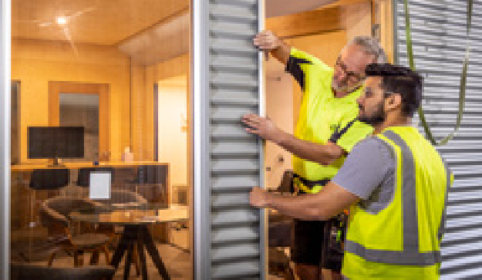
Changing skills base and shortages within the workforce: With the workforce needs of our region’s key employers and future skills Geelong requires there will be a shortage of workers with the right mix of skills. To ensure we have the right skills in place to adapt to shifts in the economy and its workforce, we will continue to retrain currently skilled workers to meet short-term needs, we will prioritise education attainment, skills enhancement and life-long learning so that our workforce is equipped with the long-term entrepreneurship, leadership and digital skills to keep pace with Geelong’s transforming landscape. In addition to building and boosting the skills of our people, we will present Geelong as a destination to live and work to those outside. the region.
LIMITED EXHIBITION SPACE - GEELONG GALLERY
Currently Geelong Gallery is challenged by a lack of space to display our nationally important collection (less than 2 per cent on display)
and to attract and present major exhibitions of local, national and international content.
Our diverse, clever, creative and rapidly expanding population needs cultural assets and infrastructure to match the changing needs of our people and support future growth.
The barrier of limited exhibition space can impede our collective creativity and innovation into the future.
ECONOMIC DEVELOPMENT INCLUSIVENESS
We want to have vibrant communities and a local economy that everyone can benefit from. Beyond residents that may be suffering from high level of socio-economic disadvantage, we want our economy to tap into the culturally and linguistically diverse community, be inclusive for First Nations people, people living with a disability and social enterprises.
Through ensuring all residents have future job prospects and supporting workforce development pathways, we can assist all residents to attain gainful employment.
Additionally, we can encourage businesses to tap into the local First Nations and disability workforce. We can also seek to promote and encourage First Nations, disability owned businesses and social enterprises.
Through pursuing inclusive economic development, we can ensure that future growth benefits all parts of our community.

19.

OUR FUTURE GROWTH OPPORTUNITIES

20.
Building on our competitive advantages and understanding current trends, while acknowledging current challenges and barriers, the following future growth opportunities have been identified:
- Advanced Manufacturing: Geelong has a long history in advanced manufacturing and has constantly been a leader in Australia for various industries. Geelong has always leveraged innovation and creativity to move to the next evolution of advanced manufacturing and has opportunities across a range of areas*:
› Food production
› Beverage production
› Fibre and textiles
› Chemicals and refining
› Automotive parts
› Metal and machinery
› Clean economy
› Various niche opportunities
*These opportunities do not preclude other avenues being pursued but provide focus for targeted action to deliver on our future potential.
- Defence: Geelong already has an emerging defence cluster with location of Hanwha Defense Australia’s Avalon manufacturing precinct as well as several local businesses that supply the defence industry. The Australian Government has identified over $200 billion in defence spending over the next five years, which will continue to drive strong growth in this industry in Australia.
- Visitor Economy and Events: while relatively small, the visitor economy will provide an important input into Geelong’s rise over the next two decades and will be strengthened through such major developments as the Geelong Convention and Events Centre. The visitor economy and events provide a $1.6 billion injection into Geelong and the Bellarine, representing an important export. Additionally, increasing tourism infrastructure and experiences not only creates more economic opportunity but further augments the region’s liveability and will aid in attracting top talent into the future. Major events not only attract a significant number of visitors to the area but help to market and promote the destination. Business events can attract prospective future investors into the region.
- Creative Industries and Digital Technology: creative industry opportunities in Geelong include an evolving mix of sectors spanning arts, culture, screen, design, publishing and advertising. They cover a wide diverse range of disciplines including game development and graphic design, fashion and filmmaking, performing arts and publishing, architecture and advertising, media and music, comedy and craft, as well as a variety of specialised consulting. These opportunities would generally include activities that are commercially- driven and export oriented.
- Clean Economy: the clean economy encompasses initiatives, practices and products which address climate change mitigation and adaptation, encourage renewables, and compliment the transition to a circular economy. Expanding the clean economy is paramount for Geelong to reach its full potential. Clean economy opportunities include clean energy generation, investments
into innovations, advanced manufacturing or businesses to deliver products and services.
- Professional Business Services: professional business services include a range of business services from accounting, financial, legal, consulting, engineering, insurance and more. Geelong has demonstrated that it can attract and sustain these types of businesses that generally offer ‘white collar’ employment opportunities, as evidenced by TAC, KPMG, GHD, WorkSafe, NDIA, URBIS and others. These businesses benefit from Geelong’s strategic location, affordability and attractiveness for professionals wishing to move from a metropolitan environment.
- Transport, logistics and fulfilment: logistics is the fastest growing part of the industrial market in Australia due to ever increasing demand for imports based on increasing population and transitioning nature of industry in Australia.
Geelong has considerable potential to support the transport and logistics industry into the future through its existing infrastructure at the Avalon Airport as well as the Port of Geelong and access to major road and rail freight corridors.

Visitor Economy Priorities
The Sustainable Destination Master Plan identified the top ten demand driving projects for Geelong and the Bellarine:
- Wadawurrung Traditional Owner Cultural Experiences
- 5 star Hotel in Central Geelong
- Development of Mineral Spa Facility
- Adventure Tourism Experiences
- Distinct Maker and Grower Experience
- Visitor Experience at You Yangs Regional Park
- Redevelopment of the Geelong Gallery
- Queenscliff Harbour Eco-Tourism
- Cruise Ship Infrastructure
- Experiential and Diverse Accommodation Options

21.

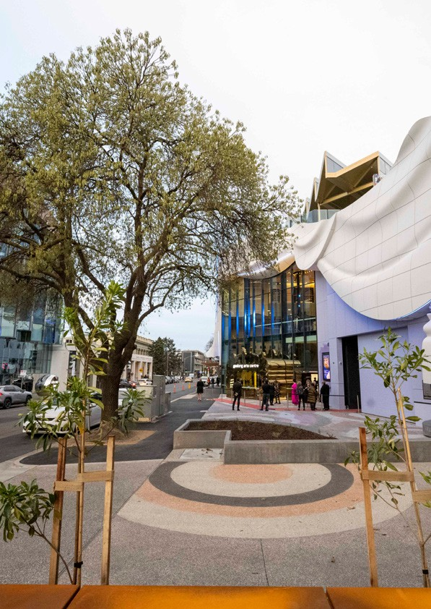

Geelong Arts Centre
The Geelong Arts Centre celebrated a $140 million redevelopment of its Little Malop Street facility, which includes:
- The Story House: a multi-format, 550-seat theatre (which can expand to 850 seat facility)
- The Open House: a 250-seat contemporary hybrid venue
- New foyer and bar facilities
- A range of event spaces, including alfresco dining on Little Malop Street
- The new facilities will continue to support and help grow the creative arts in Geelong.

22.

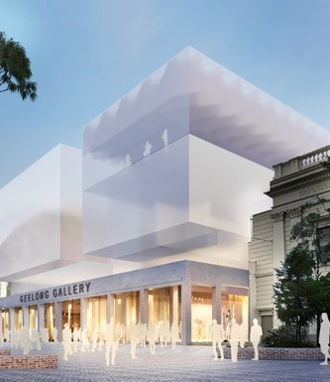
Geelong Gallery Expansion
As the expanded Geelong Library and Heritage Centre and evolving Geelong
Arts Centre continue to transform our cultural offering, Geelong Gallery’s expansion will ensure
the completion of a 21st century arts and cultural precinct for our UNESCO City of Design.
Geelong Gallery is working closely alongside the City of Greater Geelong to ensure our Gallery keeps pace as
a regional facility of state significance to provide a vibrant cultural, learning and social space that connects to the unique heritage
of our City and historic buildings. It will offer expanded exhibition space and provide numerous spaces to exhibit, embrace and enrich our clever and creative spirit.
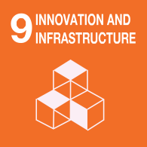
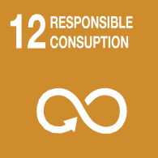
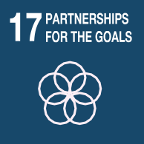
UN Sustainable Development Goals
The United Nation’s Sustainable Development Goals (SDGs) have been established to provide a road map for the world to achieve a more sustainable future for the world. This Plan acknowledges the SDGs and will proactivity contribute to achieving many of them. As a UNESCO City of Design, Geelong is particularly committed to SDG11: Sustainable Cities and Communities

23.

OUR BOLD PLAN

It is time for Geelong to rise and take its rightful place on the national and international stage. Geelong has all of the right ingredients to be a clever and creative international city and now is the time. Like all major international cities, Geelong has an international airport, port, major CBD, university, a large and diverse economy and a large and growing population base.
We want to have vibrant communities and a local economy that everyone can benefit from. Through pursuing inclusive economic development, we can
ensure that future growth benefits all parts of our community.
This Plan is designed to catapult Geelong onto the national and international stage and foster an
entrepreneurially-minded, innovation-focussed and growth-obsessed city. It is focused on Geelong’s unique strengths and capabilities. It is focused on key industries where Geelong can compete and leverage to deliver an international scale clever and creative city.

Geelong on the Rise: a Clever and Creative International City
As our economy evolves, it will: By 2041, Geelong will have:

- Be more sustainable and circular
- Be more innovative and resilient
- Be future focused (City of Design)
- 120,000 additional people
- 55,000 new jobs
- A $27 billion economy

Our priority industries that will get us there:

- Advanced manufacturing
- Defence
- Healthcare
- Visitor economy and events
- Agribusiness and food manufacturers
- Transport, logistics and fulfilment
- Professional business services
  - Clean economy
  - Creative industries and digital technologies

Our strategies

Positioning Geelong
Collaboration and Support
Talent Attraction and Development
Planning and Advocacy

    - Promote Geelong as a global centre of business and innovation district
    - Attract investment from around the world
    - Deliver vibrant arts and cultural experiences and world class events
  - Proactively support the development of industry clusters
  - Support local businesses to thrive
  - Take a place-based approach to the delivery of vibrant retail precincts and City Centre
- Promote our lifestyle and liveability to attract talent
- Support workforce development, training and skills innovation
- Support programs and initiatives that seek to reduce disadvantage
- Plan well so there is sufficient land supply
- Advocate for key enabling infrastructure
- Advocate for site activation and investment to assist in facilitating
positive place-based outcomes

24.

POSITIONING GEELONG
Not everyone is aware of Geelong’s economic prowess and for many, traditional perceptions of Geelong prevail. This must change. Geelong’s story of innovation, creativity and resilience is a powerful one.
Sharing this story will increase Geelong’s profile on both the national and international stage. Geelong has numerous businesses that are leaders in their field, developing technology and innovative products that are on the cutting edge. Promoting Geelong’s unique capabilities will support the narrative of Geelong on the Rise.
Geelong is fortunate that there is no need to invent new stories to promote the region, we simply need to tell our story collectively with other local organisations to highlight our natural competitive strengths and unique capabilities.

We will promote Geelong as a global centre of business and innovation district by:
- Attract and support business investment into the region, leveraging the City’s investment and professional services prospectuses to create a unique identity in the minds of government and investors
- Support Business Events Geelong to grow and deliver as a Convention Bureau, working closely with local assets to attract major business events and conferences
- Working collaboratively with Deakin University and key public and private sector businesses to attract investment to develop a global innovation district
- Continuing to promote local success stories via LinkedIn, industry publications, social media and identified international channels
- Establish a formal Geelong-based stakeholder group which will manage an investment pipeline to catalyse deal closures, and track and share learnings to increase investment.

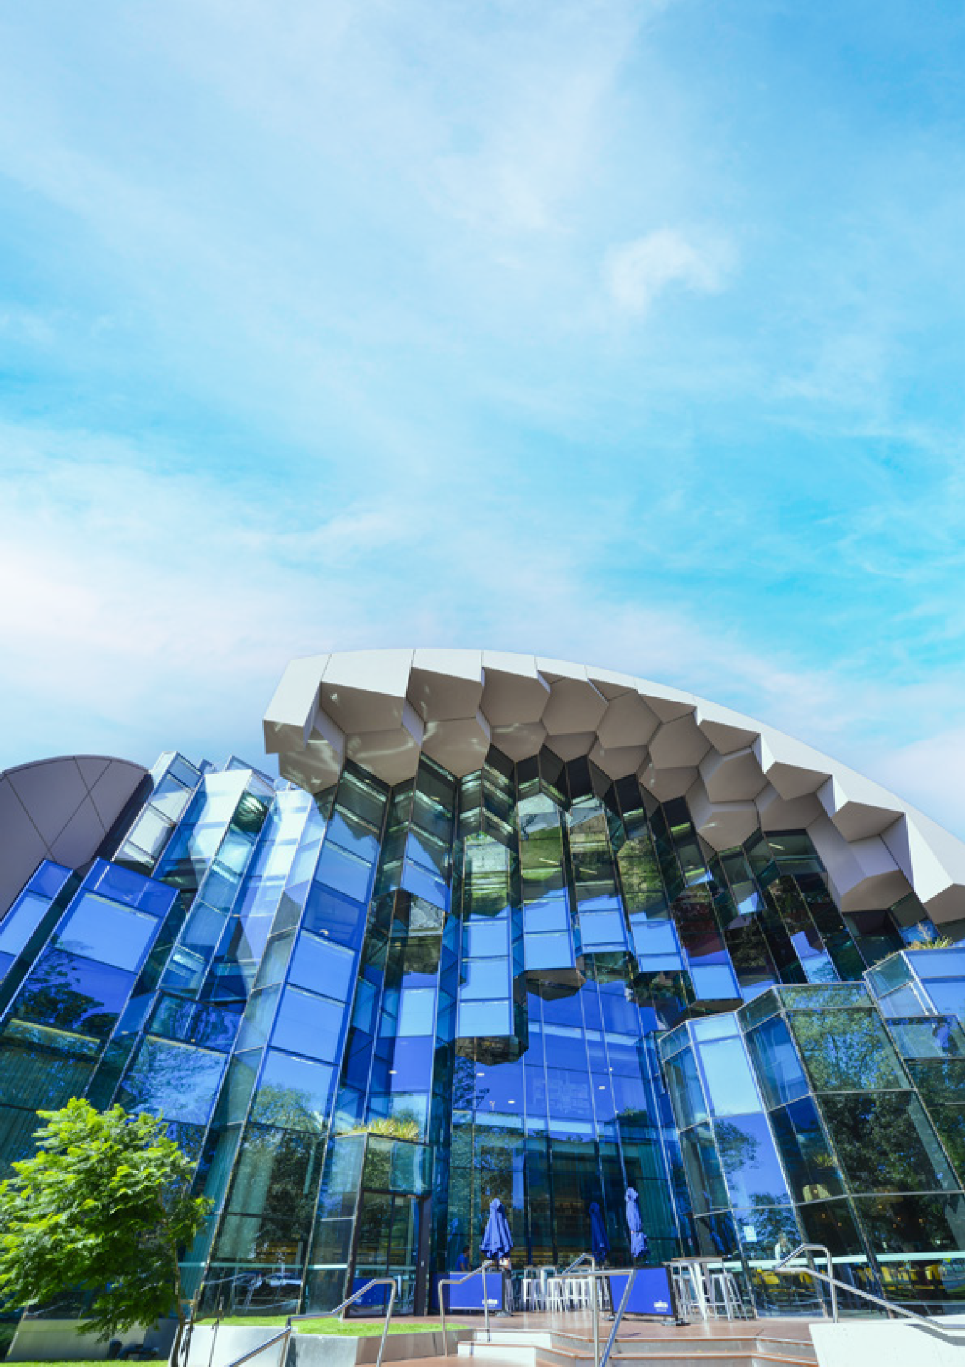

25.

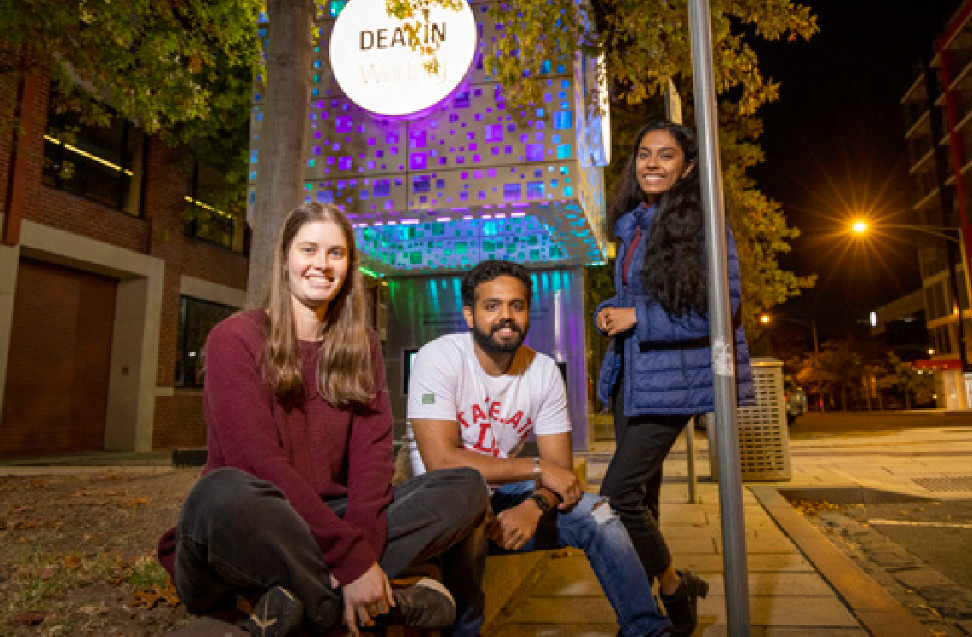

By raising the profile of Geelong, we will be able to attract investment into the region. We will focus our efforts in areas where we have competitive advantages:
We will attract investment from around Australia and the world by:
- Delivering a proactive investment attraction strategy and program identifying key sectors and connecting with State and Federal Governments
- Developing an International Engagement Strategy to identify and prioritise efforts in regards to industry and strategic relationships
- Working with key partners that have an international presence (i.e. Deakin University and GeelongPort) to identify international growth opportunities
- Continuing to provide a dedicated concierge service to facilitate strategic business investment
- Continuing to promote and profile Geelong on the world stage via the UNESCO City of Design designation
  - Advanced Manufacturing
  - Healthcare
  - Agribusiness and food manufacturers
  - Visitor Economy and Events
  - Creative Industries and Digital Technology
  - Clean Economy
  - Professional Business Services
  - Transport, logistics and fulfilment
These industries will not only create new jobs and investment but they will contribute to the rise of Geelong on the national and international stage. We will work with partners to facilitate investment into the region by supporting projects with information and data to support business cases as well as assistance with site selection and through the planning process by offering a concierge service for investors.
We will establish an international engagement program, working collaboratively with local and state partners. This program will extend the reach of our story beyond the shores of Australia. We will continue to promote and leverage our UNESCO designation as a City of Design through all of our promotional efforts as it champions our clever and creative spirit.

26.

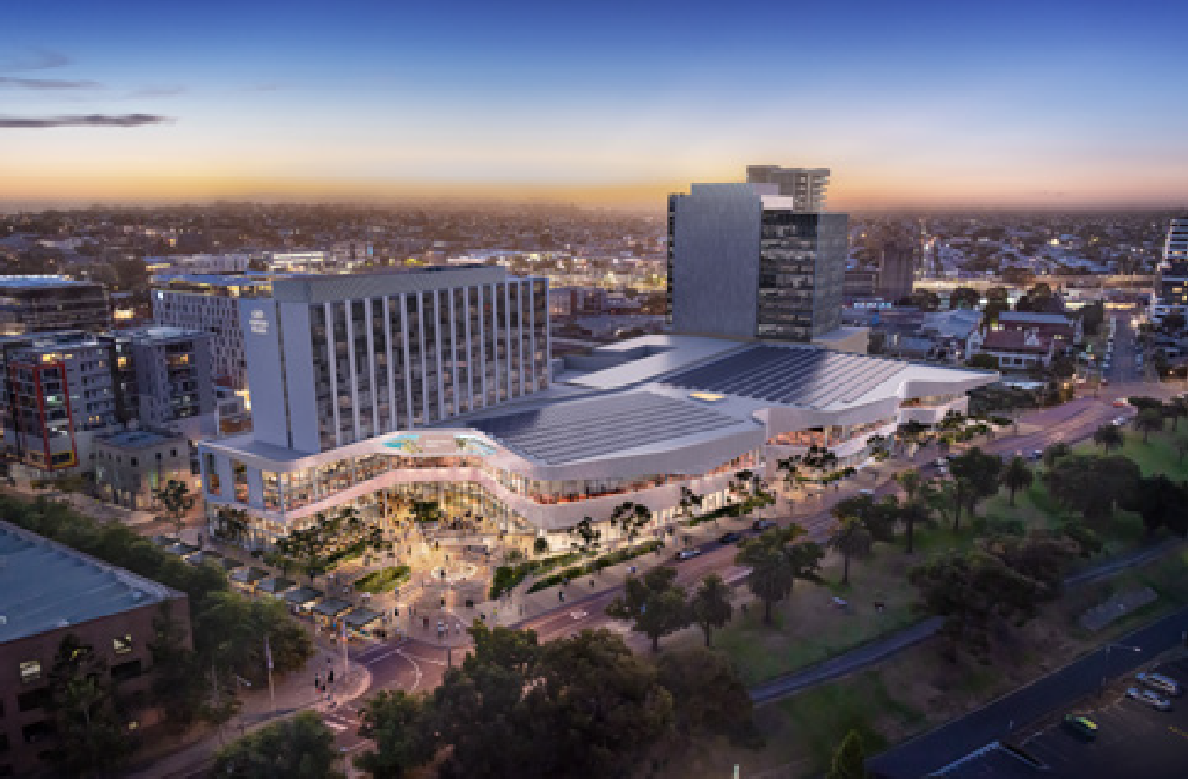
Artist impression of Nyaal Banyul Geelong Convention and Event Centre

Our stakeholders and local businesses told us that the lifestyle offer in Geelong is a significant strength of the area. However, this can always be augmented and improved. Geelong’s art and culture scene is impressive, particularly for a regional city, but through investing into arts and cultural experiences and events, we can not only support existing creative industries but further increase our lifestyle offer and attractiveness for new residents and workers.

We will deliver vibrant arts and cultural experiences, and world class events by:
- Proactively seeking out the attraction and procurement of Major Events informed by the Geelong Major Events Strategy
- Leveraging key infrastructure including Nyaal Banyul Geelong Convention and Event Centre, Geelong Arts Centre and Geelong Art Gallery to attract international- standard exhibitions and events
- Curating major anchor events that seek to put Geelong on the map i.e. Geelong
Design Week and immersive cultural festival
The Nyaal Banyul Geelong Convention and Event Centre will provide a 1000 seat venue, two large exhibition spaces, meeting rooms, conference facilities and flexible event spaces. The precinct will also be home to retail spaces for food and beverage offerings, a large public plaza and a 200-room Crown Plaza hotel. The project will transform the Geelong Waterfront and project completion is expected in 2026.
The new facility will allow Geelong to greatly augment its major events calendar through the attraction of major conventions and events. Beyond leveraging the Nyaal Banyul Geelong Convention and Events Centre, supporting major events drives visitation to the area, providing a strong boost for local businesses. Major events can also be used to target specific areas and industries that will support Geelong’s rise onto the domestic and international stage.

27.

COLLABORATION AND SUPPORT
Geelong has a very collaborative and supportive business environment, and we have a number of important industry clusters. We are fortunate to have a variety of business and industry organisations that support our key industries and provide a supportive environment for future business growth. We will continue to partner and support these business and industry organisations to grow our economy and encourage individual businesses to expand. A recent example of these efforts is the City’s partnership with the Geelong Chamber of Commerce in the delivery of the Geelong Small Business Festival.
We seek to grow our collaborations and explore options in creative and digital technologies to further support various emerging industries including film, gaming, architecture, media and music. We seek to equip and educate businesses through collaborative partnerships and programs to achieve sustainable business practices and foster growth.
We will also proactively engage with and support business owners in our peri-urban area through providing information and other initiatives.

We will proactively support the development of industry clusters by:
- Continuing to work with key industry representative groups to support the expansion and development of key growth industries in the region.
- Exploring collaborative opportunities for the Creative and Digital Technology industries including film, gaming, architecture, AI, media and music
- Proactively engaging and supporting our peri-urban business owners including provision of information and support initiatives
- Exploring collaborative opportunities with Deakin University and others to develop an innovation district

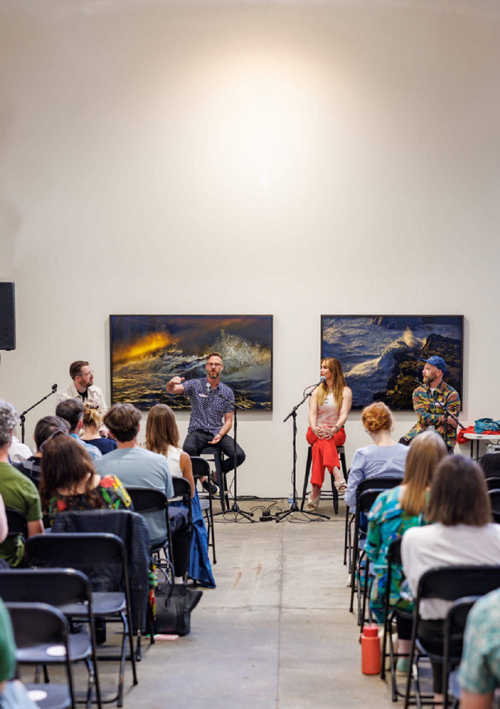

28.

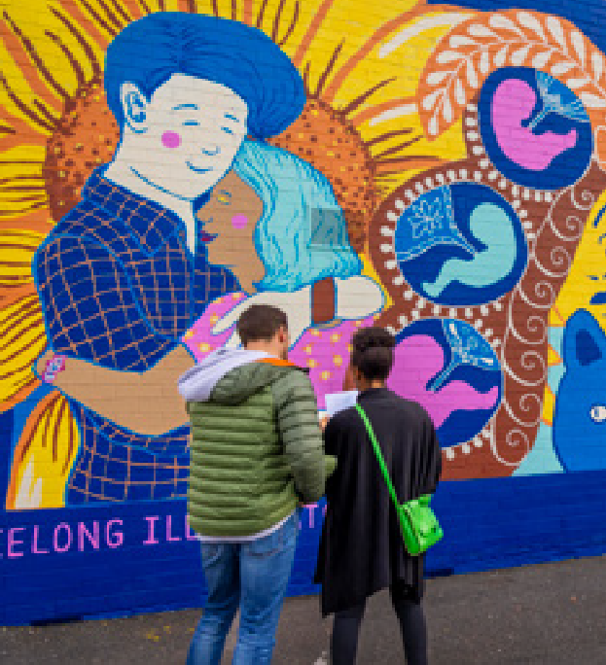

Our local, existing businesses are responsible for our current economic evolution and expansion. Existing businesses typically represent at least 60 per cent of new jobs and investment and we wish to support our existing industries to continue to expand and grow. We will continue to build relationships with our local business community through a dedicated business visitation program, creating a dialogue that can lead to future business expansion, investment and jobs growth.
By reducing economic leakage from the region, we can provide an economic stimulus and support our existing businesses to grow. We recognise the importance of keeping as much expenditure as
possible within our local economy so will be a leader in buying local and using our own procurement of goods and services to support local businesses.
Geelong has significant infrastructure including Avalon Airport, GeelongPort, major hospitals, major road
and rail infrastructure, Deakin University, The Gordon TAFE as well as several lifestyle and community infrastructure facilities. Increasing the capacity and utilisation of these key assets will support the future rise of the local economy.
We will work to deliver major streetscape improvements to support local businesses and develop an Integrated Place Activation Framework to support all of our business precincts. We will also develop a framework to support public art installations and maintain existing public art in an
effort to support place activation and a sense of place across our diverse precincts.

We will support local businesses to thrive by:
- Delivering a range of data, information, programs, support and initiatives for our small business community
- Continuing to build relationships with local organisations through both a dedicated business visitation program and promotion of local business incubators, start-up programs and co-working spaces
- Promoting information and support to local businesses on major procurement and supply chain opportunities
- Support the growth and development of businesses of all scales to drive maturity and expansion.

We will take a place-based approach to the delivery of vibrant retail precincts and City Centre that offers a diversity of retail options, and experiences:
- Delivering major streetscape improvement works
- Developing an Integrated Place Activation Framework to establish a place hierarchy across the municipality and Council’s role in each place
- Developing a framework to support new public art installations and maintain the existing public art collection in partnership with local artists and First Nations.
- Deliver low-cost business precinct interventions, activations and incentives, partnering with the creative industries.

29.

TALENT ATTRACTION AND DEVELOPMENT

Geelong’s skilled workforce has always been a key feature of the economy that has attracted investment over many decades. The accessibility of a local skilled workforce has become a key site selection factor for key business decision makers considering investments into new locations. As technology continues to drive automation across the economy, the ability to attract and develop top talent will become increasingly important for Geelong to reach its full economic potential into the future.
We will run proactive campaigns and partner with others to promote Geelong as the ideal residential location for skilled workers that are (and will be)
in high demand within both critical employment sectors and key growth industries. The promotional messaging will include not only information regarding the lifestyle and residential housing offering in Geelong, but also the key future growth industries and the opportunities that may exist in the region for these workers. We will partner and collaborate with key industry groups to ensure our efforts are targeted in the right areas.
Beyond the marketing and promotion of the area for top talent, we will also support the relocation of skilled workers to the region. We will provide
materials that highlight the local lifestyle offer and benefits of relocating to Geelong. Beyond our efforts to promote the region, these materials will be made available to local businesses actively recruiting workers to the region.

We will promote our lifestyle and liveability aspects of Greater Geelong to attract talent to the region by:
- Implementing the Sustainable Destination Master Plan
- Developing and implementing a dedicated lifestyle brand campaign for Geelong
- Advocating and planning for a variety of housing options that support our diverse workforce including Central Geelong and other precincts within proximity to key transport infrastructure
- Develop a toolkit for new and potential residents, offering the information and resources they need to make the move.

30.

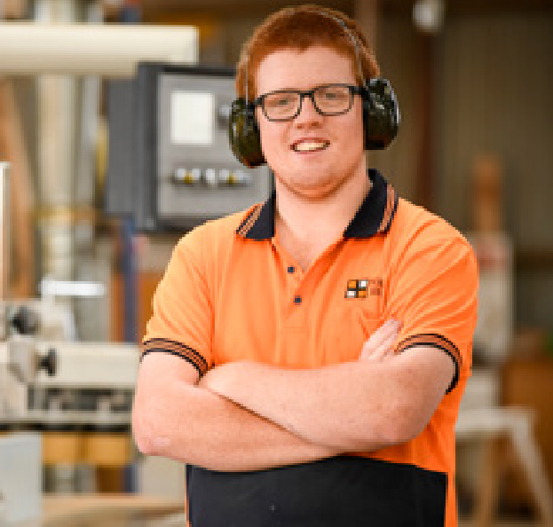

Beyond the attraction of top talent, we will also support local workforce development efforts so we can leverage our young people to build the next generation workforce. We recognise the important role that all our education and training providers in secondary and tertiary schooling play in providing our young people with the skills they will need in the future. We will work with local businesses and our
education providers to ensure that our local workforce development is providing workers that have the skills that our local businesses need.
We want our economy to be inclusive for First Nations people, our CALD community, people living with a disability and social enterprises. Through ensuring all residents have future job prospects and supporting workforce development pathways, we can assist all residents to attain gainful employment.
This Plan seeks to provide more equitable and inclusive economic development to ensure the entire community benefits from future growth.
We will support support residents from areas of high socio-economic disadvantage to access
traineeships and apprenticeships. We will use our own procurement processes to effect change for our disadvantaged communities. We will lead by example and encourage other businesses to follow in our footsteps.
Social enterprises provide a strong platform to not only achieve economic growth but also ‘for purpose’ business that can have a dramatic impact for a diverse range of people in our community.

We will support workforce development, training, and skills innovation across the region by:
- Championing excellence in the Clean Economy through representation on industry- based projects, programs and groups
- Providing information, mentoring and industry support to the region’s fast- growing creative industry
- Supporting businesses to tap into the local First Nations, CALD and disability workforce and promote social enterprises to pursue inclusive economic development.
- Partnering with Deakin University, The Gordon TAFE, Barwon Health and other training providers and major employers to promote training innovation and excellence in the region

We will support programs and initiatives that seek to reduce disadvantage in employment and workplace training by:
- Providing in-kind support to, and promoting the Northern Futures Construction Pathways Program
- Developing a social procurement framework that provides traineeship and apprenticeship outcomes targeted at areas with high disadvantage
- Promoting social enterprises operating in Geelong and supporting opportunities for business growth

31.

PLANNING AND ADVOCACY
Making Geelong the easiest and most logical place to do business is a priority for the City of Greater Geelong. The City has a statutory role to play in terms of planning for the local area. The provision of
sufficient residential and employment land is of critical importance for the rise of the Geelong economy to be achieved. There is currently a shortage of serviced industrial land that must be addressed to ensure industrial growth is not stifled. We will support and facilitate the development of employment land in South West Geelong to meet current and future demand. We will also work with the Victorian Planning Authority to prepare a Precinct Structure Plan (PSP) for a state-significant employment precinct in Avalon.

We will plan well so there is sufficient land supply to support population growth, business expansion and attraction by:
- Continuing the planning of employment land south of the Barwon River
- Working with the Victorian Planning Authority in the preparation of the Precinct Structure Plan for a state-significant employment precinct in Avalon
- Continuing to progress planning for the Northern and Western Geelong Growth Areas including the proposed network of activity centres and employment precincts

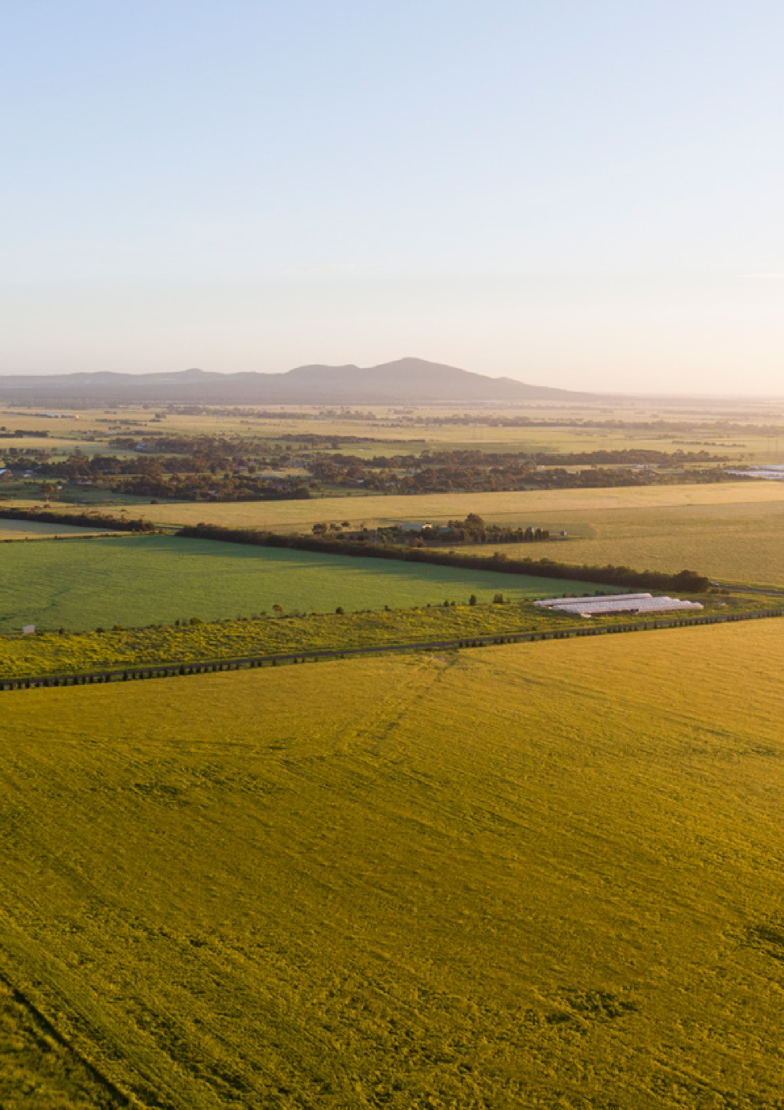

32.

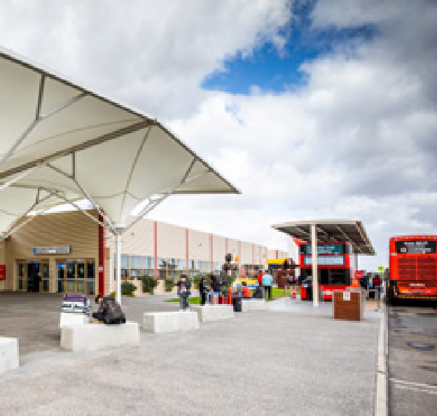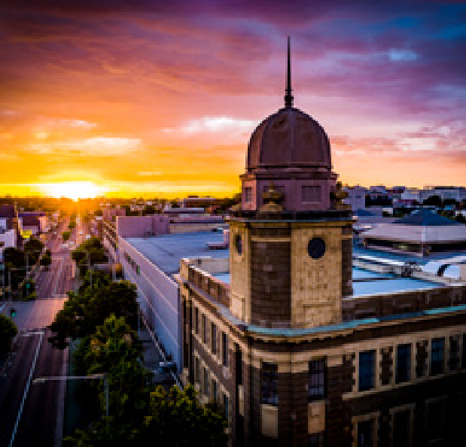

The planning and provision of future infrastructure will need to support the future economic growth of the region. We will proactively work with partners to ensure sufficient infrastructure is provided across the region to support the rise of our economy.
The expansion of road, rail and public transport infrastructure as well as future opportunities for the Avalon Airport and GeelongPort will be pursued. The lack of enabling infrastructre and freight routes into GeelongPort is a signifiacnt barrier to future growth potential. We will continue our approach to Smart and Innovative Cities including the attraction of data centres to further enhance large-scale investment in the region.
We will advocate for key enabling infrastructure to support and facilitate economic growth by:
- Working closely with and identifying collaborative economic growth opportunities with both Avalon Airport and GeelongPort.
- Partnering with G21 Geelong Region Alliance, Committee for Geelong and through such forums as Future Geelong to continue to advocate for road, rail and public infrastructure.
- Continuing our approach to Smart and Innovative Cities including the attraction of data centres to further enhance large-scale investment in the region
- Working collaboratively, support the delivery of the Central Geelong Framework Plan and Central Geelong Settlement Stratgey to drive high-density infill developments within the CBD
We will continue to invest in community infrastructure that will enhance amenity and activation.
Together with our partners, stakeholders and other businesses, we will advocate for our region, led and informed by our Advocacy Framework. We will strongly pursue important investments from the State and Federal Governments that can provide a catalyst for future growth and support our region to rise to its potential. We will pursue opportunities at a local, regional, national and international level.
In addtion, we will support and deliver on the Central Geelong Framework Plan and Settlement Strategy to see the CBD grow to 10,000 people living made possible though high-density infill developments. Central Geelong sits at the heart of Victoria’s second largest city and the fastest growing region in the state. It supports key services and economic activity for the whole Barwon South West region. It is strategically positioned to accommodate significant growth in population and employment over the next 30 years. This growth will need to be managed to ensure that future development supports the shared vision for Central Geelong.

We will advocate for site activation and investment to facilitate positive place-based outcomes by:
- Facilitating and brokering positive outcomes for Central Geelong as part of the Market Square Masterplan process
- Seeking funding opportunities through State and Federal Government for the development of the Waterfront Masterplan
- Working collaboratively with other levels of government, organisations, developers, and community to enhance amenity and activation of activity centres and catalyst sites across the municipality

33.

7. MONITORING PROGRESS

Geelong on the Rise is about the next economic evolution for Geelong and its emergence onto the national and international arena. We have identified future aspirational goals to help define what this future looks like. This Plan seeks to support a future where by 2041 Geelong has a population of 400,000 and an economy of $27.3 billion and over 190,000 jobs.
We will track our progress towards these aspirational goals.
Additionally, we will conduct an annual economic review that will help us understand not only how we are tracking against these identified goals, but also how our economy is continuing to evolve and
change. This annual economic review will consider the structure of the economy and how it is changing as well as important and emerging trends. This review will help to guide future economic development activities and initiatives, so that this Plan can constantly adapt to an ever changing environment.
Beyond tracking economic change and progress towards goals, the identified initiatives should also be evaluated to ensure their on-going effectiveness and
Population

Economy (GRP)

$17.6 billion (2021-22)
276,116 (2022) 400,000 (2041)

Jobs
190k

135k

to allow activities and initiatives to evolve over time to maximise their impact.

REFERENCES

ABS (2023). Regional Population. Australian Bureau of Statistics, Canberra.
ABS (2022). Census of Population and Housing, 2021. Australian Bureau of Statistics, Canberra.
Cordell (2023). Cordell Connect, Cordell. Economy ID (2023). Geelong Economic Profile.
Available from: https://economy.id.com.au/geelong. Last accessed 14 December 2023.
TRA (2023). National and international Visitor Surveys. Tourism Research Australia. Canberra.
$27.3 billion (2041)
2022
2041

34.

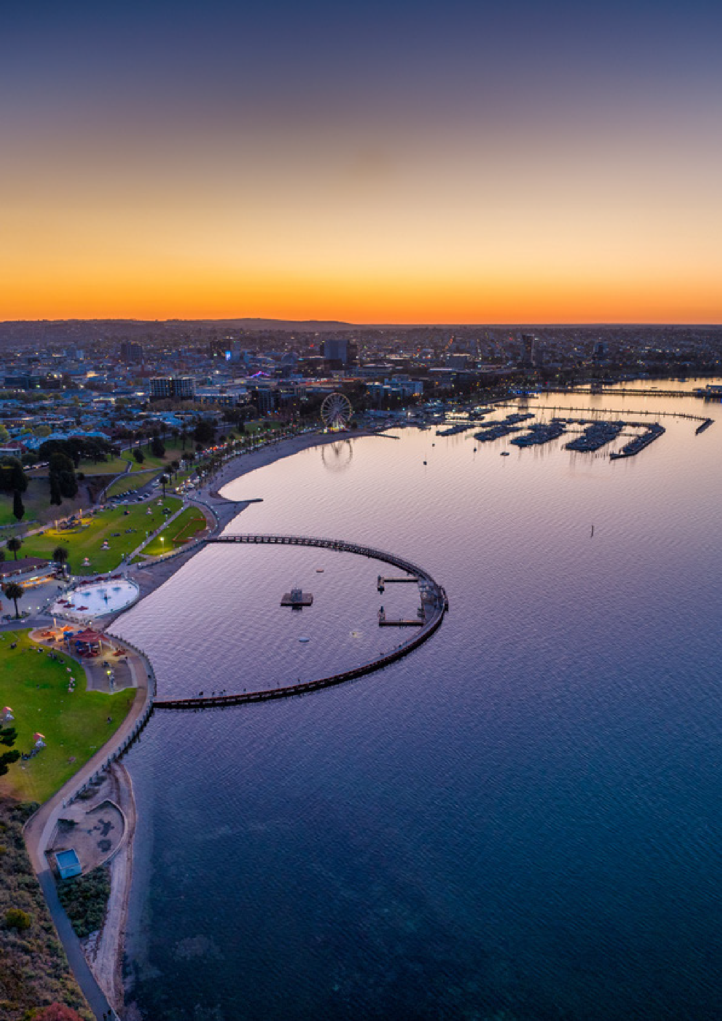

35.

CITY OF GREATER GEELONG
Wadawurrung Country PO Box 104
Geelong VIC 3220
P: 5272 5272
E: contactus@geelongcity.vic.gov.au www.geelongaustralia.com.au

© City of Greater Geelong 2024 ISSN:

LATEST NEWS:
@CityofGreaterGeelong @GreaterGeelong @CityofGreaterGeelong CityofGreaterGeelong

