COUNCIL POLICY

Community Engagement |  | Document No: | CPL10.2
 |  | Approval Date: | 25 July 2017
 |  | Approved By: | Council
 |  | Review Date: | 25 July 2020
Responsible Officer: |  | Version No | 03
Manager Strategy and Program Delivery
Authorising Officer: | Chief Executive Officer

- PURPOSE
This policy outlines our commitment and approach to community engagement at the City of Greater Geelong (the City).
The City is committed to working with our community and considers community engagement an essential element of good governance.
- SCOPE
This policy applies to all areas of the City and provides a framework for Councillors, Council Officers and consultants/agencies acting on behalf of the City.
This policy should be implemented in line with the City’s Corporate Communications Strategy and Internal Communication Strategy, which support internal and external engagement through appropriate corporate communication and marketing activities.
- REFERENCES
- Code of Conduct - Councillor
- Code of Conduct - Staff
- IAP2 Code of Ethics for Community Engagement Practitioners
- Victorian Charter of Human Rights and Responsibilities Act 2006
- Local Government Act 1989
- Planning and Environment Act 2007
- Public Health and Wellbeing Act 2008
- Municipal Early Years Plan 2013-2017
- Multicultural Action Plan
- Karreenga Aboriginal Action Plan
- Youth Development Strategic Plan
- Disability Action Plan
- Corporate Communications Strategy
- Internal Communications Strategy
- Plain English Guide and Writing Standard
- Diversity Policy
- DEFINITIONS
Community - a real or online group of people united by at least one common characteristic such as geography, shared interests, experiences, values or attitudes.
Engagement - refers to the many ways in which a council connects with its community, and the community connects with a council to exchange views, ideas and information in the development and implementation of strategy, policies, programs and services.
Communication - refers to the many ways in which a council connects and engages with its community to provide information to help its members understand how we spend public money and why.
Stakeholder - a person, group or organisation who may be affected by, have a specific interest in, or influence over, a council decision or issue under consideration.
- COUNCIL POLICY
5.1 OBJECTIVES OF COMMUNITY ENGAGEMENT
Continuous quality community engagement at the City will lead to:
- Improved decision making by the City and its Council that reflects the best interest of all sections of our community;
- Improved community confidence in Council and the decisions that it makes;
- Increased capacity and participation by all sections of the community in engagement activities;
- Improved community knowledge about the role of the City and its Council, and the democratic decision-making process; and
- Increased opportunities for the City and its Council to collaborate with its stakeholders.
5.2 OUR APPROACH
The City’s Community Engagement Plan is focused around our organisational purpose Working together for a thriving community. Quality community engagement practice is embedded and supported through our values:
- Make people the centre of business;
- Create a healthy and safe environment for all;
- Respect and encourage each other; and
- Embrace new ideas and better ways to work.
When we will engage:
The City will identify the most appropriate engagement methods in order to uphold our values and improve outcomes when:
- we’re making plans – for example, developing strategies
- we’re changing something – for example levels of service
- our decision is likely to impact on people and the places they live, work and play
- we’re required by law to do so.
There are times when we will not engage:
Some situations are not suited to community engagement. These include:
- when decisions must be made immediately
- when decisions relate to the City’s day-to-day business operations
- when legal or commercial restrictions prevent it.
Our community engagement promise:
We will:
- Plan our engagements to be timely, open and easily understood.
- Make sure engagement activities are inclusive, accessible and seek a diverse range of perspectives.
- Be upfront about how much opportunity there is to influence a decision.
- Define the community’s role in any community engagement process using the IAP2 Public Participation Spectrum (see below).
- Provide information to support meaningful community participation.
- Use a variety of engagement techniques that meet the needs and interests of the community.
- Let the community know how their input has influenced our decision.
- Learn from each experience to review and improve our practice.
5.3 CODE OF ETHICS
As members of the International Association of Public Participation (IAP2), the City commits to the IAP2 Code of Ethics for community engagement practitioners. This set of principles guides us in our practice of enhancing the integrity of the public participation process.
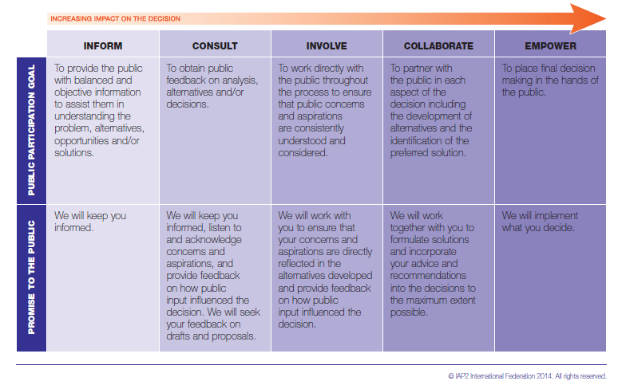
- QUALITY RECORDS
Quality records shall be retained for at least the period shown below.
Record | Retention/Disposal Responsibility | Retention Period | Location
- ATTACHMENTS
- Community Engagement Plan

