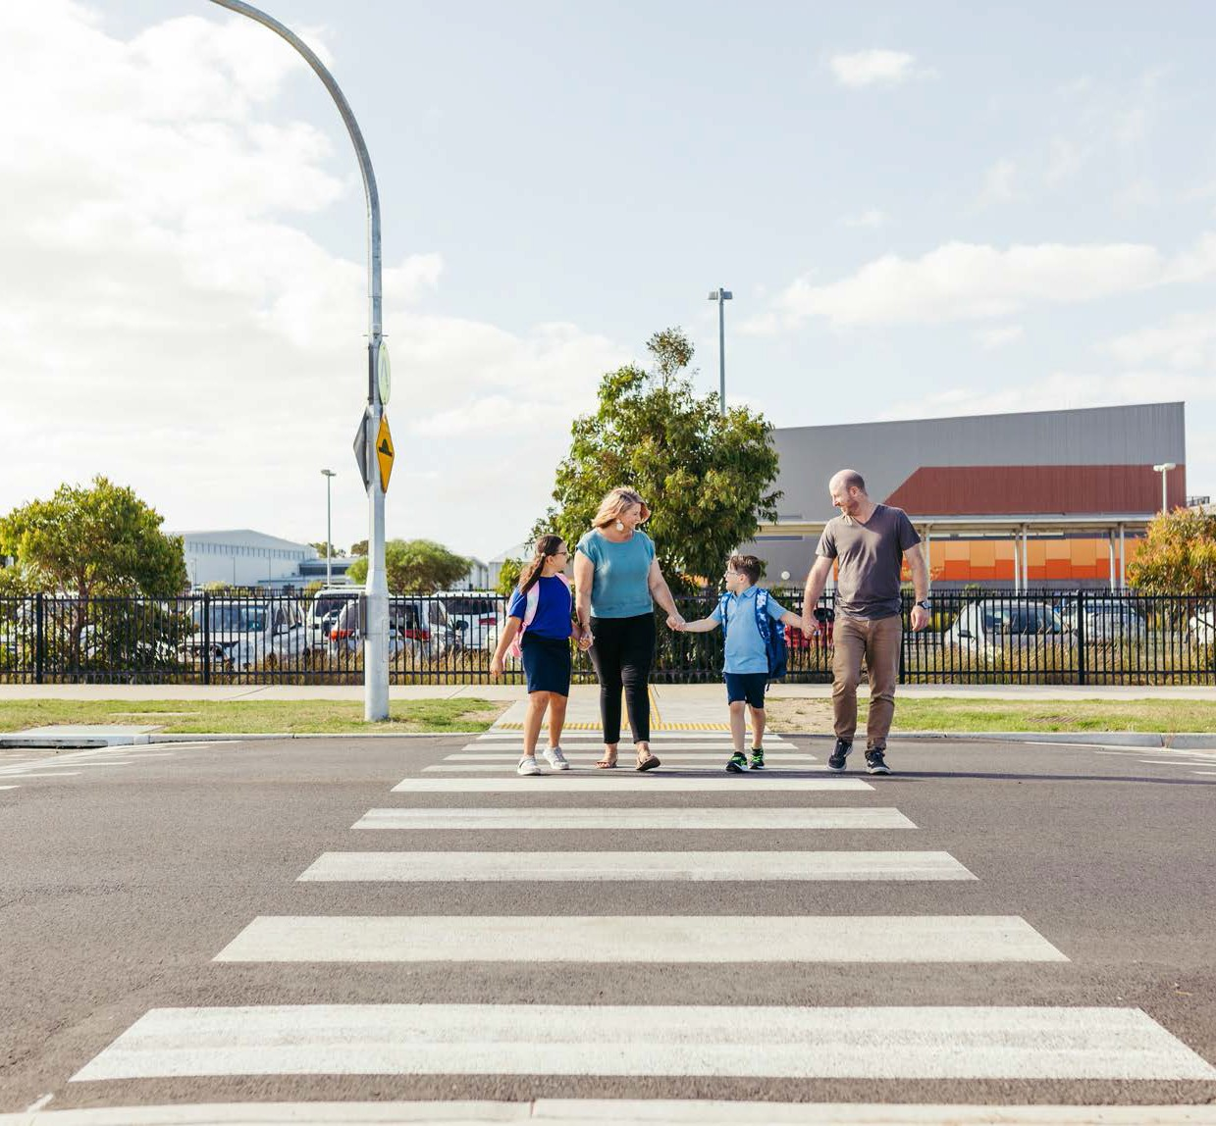

THE CITY OF
GREATER GEELONG
VISION ZERO
GEELONG: SAFE LOCAL TRAVEL
2022–27

MAYOR AND CEO MESSAGE

The City of Greater Geelong works with the community to create a vibrant, diverse and sustainable city. We all want a liveable city where people feel connected and able to access opportunities to live life to the full. To achieve this requires a transport system that functions safely and efficiently.
As our population grows, and visitors and businesses are attracted to the area, we can expect more people on our roads. To accommodate this growth, we are working to improve and maintain the road network, facilitate efficient traffic movements and keep road safety as our top priority.
Over the last decade the number of fatal and serious injury crashes on our roads has fluctuated from year to year, but overall the number has remained steady. We average 200 fatal and serious injury crashes every year, eight of which are fatal. This is too high.
We have a long-term vision of achieving the Vision Zero target of zero deaths and serious injuries on our roads. The Victorian Road Safety Strategy 2021–2030 sets an interim target of halving road deaths and reducing serious injuries by 2030. We aim to play our part in reaching these targets, and making our roads and streets safer.
To understand the road safety issues we face, we asked road users what they thought, worked with road safety experts and looked at the engineering data collected for local crashes.
Using this information, we identified four strategic themes that will drive our road safety program over the next five years:
- Leadership and Best Practice – We are committed to Vision Zero and the Safe System Approach and we will act as an exemplar for road safety.
- Working Together – We will work with our Road Safety Partners and the local community to shape the future of road safety together.
- Safe System Approach – We will apply the globally recognised Safe System approach, which addresses the four main factors that contribute to a crash:
- Safe roads and paths
- Safe Speeds
- Safe People
- Safe Vehicles

- Active and Public Transport – We will reduce risks for active transport users, recognising how important this is for a healthy and sustainable community.
Using these themes, we have set ourselves an ambitious action plan, which we will deliver with your support, and the support of our road safety partners.
We thank the Department of Transport and the Transport Accident Commission (TAC) for their input and contributions to the development of this strategy. These two organisations have provided valuable data and technical advice, recommendations for strong and innovative actions to help reach our ambitious targets.
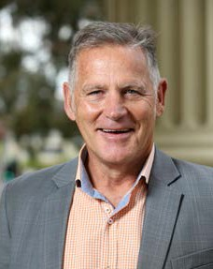We value the support of these two organisations and look forward to delivering the actions in this strategy with our stakeholders.

Cr Peter Murrihy
MAYOR
City of Greater Geelong

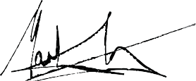
Martin Cutter
CEO
City of Greater Geelong

2

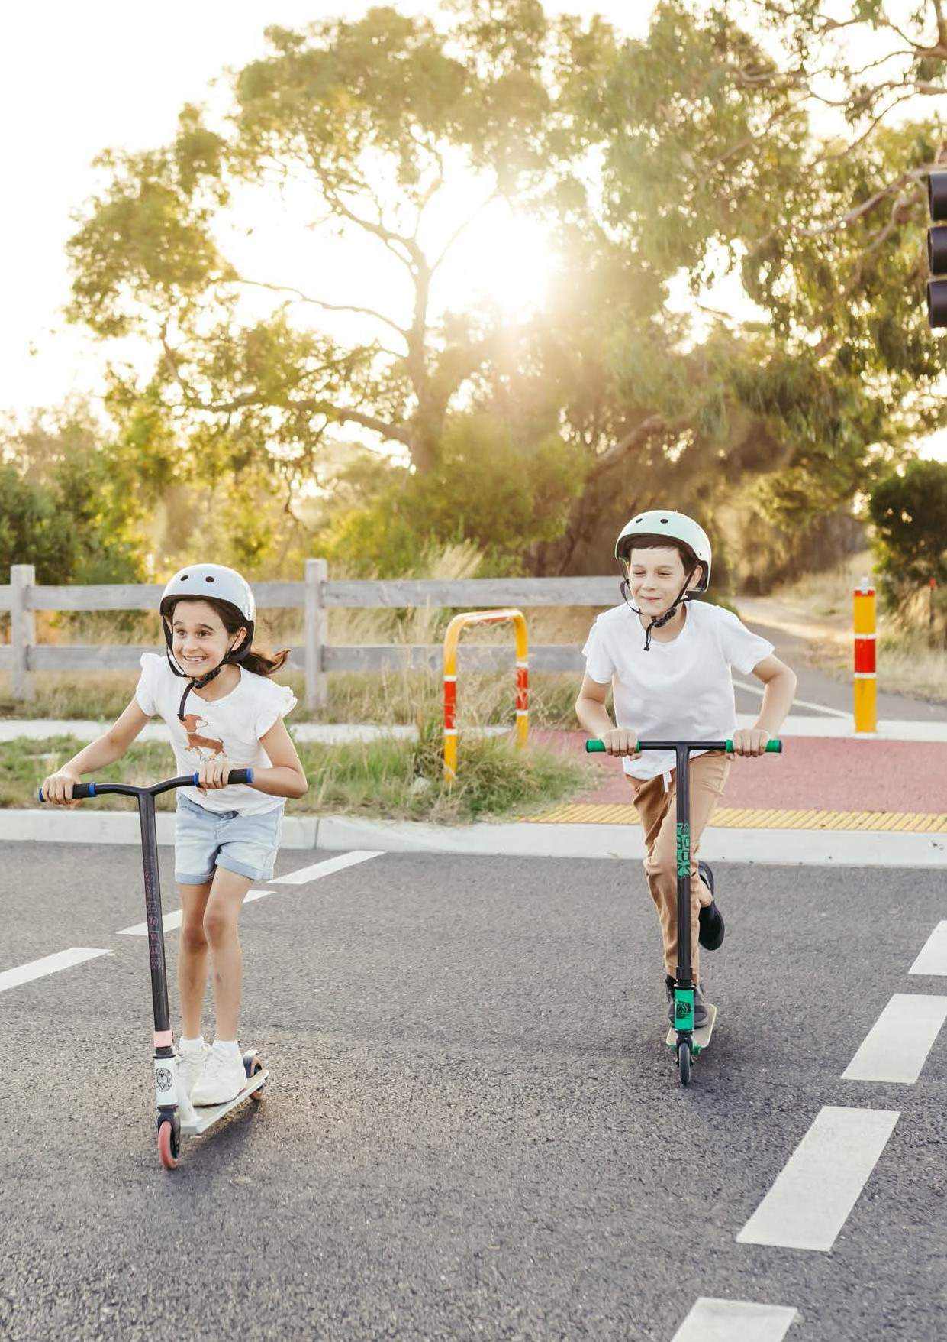

Road Safety Strategy and Action Plan 2022–2027 3

Pictured: Pedestrian operated signals help Bellarine Rail Trail users safety cross Tivoli Drive, Curlewis

4

We acknowledge the Wadawurrung People as the Traditional Owners of the Land, Waterways & Skies. We pay our respects to their Elders, past and present. We acknowledge all Aboriginal and Torres Strait Islander
people who are a part of our Greater Geelong community today.

Artwork: Corio by Dr Jenny Murray-Jones

CONTENTS

MAYOR AND CEO MESSAGE 2
OUR VISION 4
ABOUT OUR MUNICIPALITY 6
ROADS IN OUR REGION 6
OUR ROLE 8
OUR APPROACH TO ROAD SAFETY 11
PRINCIPLES OF THE SAFE SYSTEM 12
ELEMENTS OF THE SAFE SYSTEM 13
DEVELOPING OUR VISION ZERO STRATEGY 14
CRASH DATA – COMPARISON 16
CRASH DATA – TREND 18
OUR STRATEGY AND ACTION PLAN 22
ACTION PLAN 24

ACKNOWLEDGEMENTS
We would like to extend our gratitude to Safe System Solutions for helping us to prepare this strategy, as well as the many community members and stakeholders whose feedback helped shape this plan.
Road Safety Strategy and Action Plan 2022–2027 3

OUR VISION

The City of Greater Geelong aims to eliminate death from our roads by 2050, with a first step of halving road deaths and reducing serious injuries by 2030, in line with state objectives in the Victorian Road Safety Strategy 2021–2030.
Together with our road safety partners, and the contribution of our communities, we aim to play our part in reaching these targets and making our roads and streets safer.
Our aims are ambitious and we will deploy the latest thinking, tools and techniques to identify issues and implement solutions.

KEY MOVES

Following is the list of key moves from our action plan that we believe will make the biggest difference to road trauma, and help us reach our road trauma targets:

Develop a program of Local Area Traffic Management Plans for precincts to
proactively review and address identified road safety issues
Area-wide Local Area Traffic Management treatments give greater safety and amenity outcomes than individual treatments
Implement area wide
40 km/h zones in residential areas where studies and/or community feedback show that speed is a safety issue
Lower speeds in residential streets reduce the risk of serious injury or death in the event of a crash

Work with the Department of Transport to develop a speed limit strategy for all local and arterial roads
Making sure all speed limits in Greater Geelong suit the category of road and their role within the transport network will reduce road trauma
Trial road safety treatments that target road safety issues arising from seasonal visits
The population of tourist towns greatly increases during the holidays. Focusing on this transient population will reduce road trauma

Trial school zone safety treatments
Primary school students are among our most vulnerable road users to serious injury or death in the event of a crash
Work with existing cycling advisory group to identify a list of prioritised routes for separating cyclists from vehicular traffic
Separating bicycles from vehicle traffic greatly reduces the risk of a crash

4

KEY THEMES

LEADERSHIP AND BEST PRACTICE
We are committed to achieving zero lives lost on all roads and the Safe System Approach. We will act as an exemplar by integrating this ethos into our way of working, while encouraging others to do the same. We will continuously build our capability and deliver improvements based on sound evidence, the latest ideas and technologies, and carefully considered prioritisation.

WORKING TOGETHER
Creating a safe road network is everyone’s responsibility. We will work with:
- road safety partners, including the Department of Transport, Transport Accident Comission (TAC), Victoria Police and health services, to achieve more than we can alone
- our community, by listening and engaging with you so that you can help to shape the future of road safety in Greater Geelong.

SAFE SYSTEM APPROACH
We will apply the four interacting elements of the Safe System approach to address the main factors contributing to crashes. This means:
- Safe Roads – our roads and streets should be
designed, built and maintained so that the risk of a crash is minimised and the severity of crashes are reduced.
- Safe Speeds – our roads should have appropriate speed limits and road users should travel at speeds that are safe for the road conditions, reducing the chances and consequences of a crash.
- Safe People – we should all exercise care, attention and awareness of others for our safety and the safety of others.
- Safe Vehicles – modern vehicles include features which improve the safety of drivers, passengers and other people.

ACTIVE AND PUBLIC TRANSPORT
We will reduce risks for active transport users, recognising how important this is for a healthy and sustainable community, and that pedestrians and cyclists are particularly vulnerable. By reducing vehicular traffic, active transport supports healthier lifestyles and a healthier environment.
This strategy is not a stand-alone document. It is part of a suite of strategies and plans designed to promote a vibrant, attractive, inclusive and sustainable future.

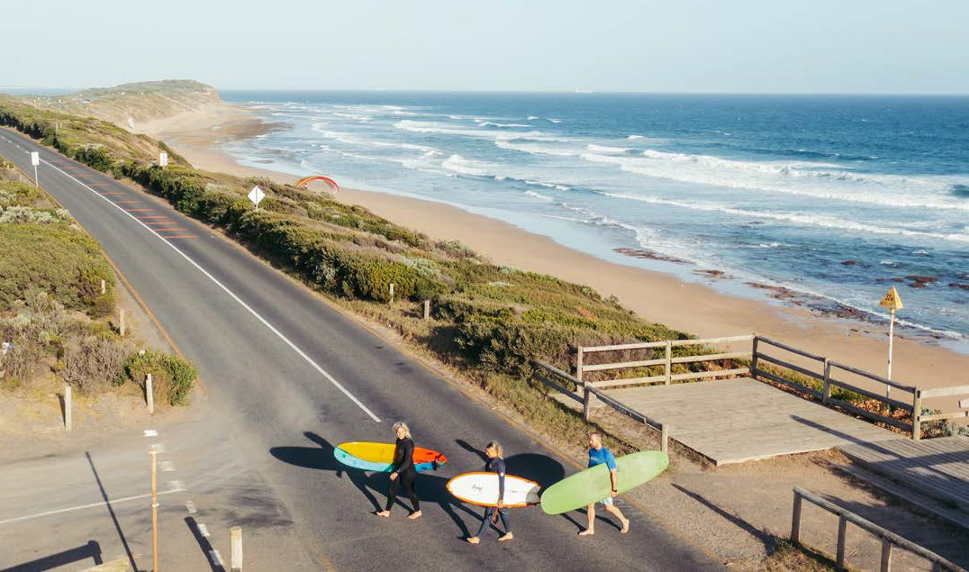
Pictured: Seasonal speed reductions and rumble strip treatments
help improve safety on Thirteenth Beach Road, Barwon Heads

Road Safety Strategy and Action Plan 2022–2027 5

ABOUT OUR MUNICIPALITY

Located 75 kilometres from the Melbourne CBD, the municipality covers 1,247km, comprising country, coastal and suburban areas.

Between 2010–19 the population increased by over 46,000 people. Growth is projected to continue and has been concentrated most heavily in suburban Geelong, as well as Lara and Leopold. During peak holiday season, the population can increase by up to 70 per cent.

ROADS IN OUR REGION
Our region has strong links with Victoria’s wider transport networks and is a major transport hub. The primary road link to the wider region is the Princes Freeway (M1), which links the Geelong road network to Melbourne. Geelong is also the gateway to the Great Ocean Road scenic roadway – a popular tourist route.
Many of the region’s highways converge in Geelong, including:
  - the Midland Highway
  - Hamilton Highway
  - Princes Highway
  - the Geelong-Bacchus Marsh Road
  - Bellarine Highway and
  - Surf Coast Highway.
When the Geelong Ring Road was completed in early 2013, it resulted in all regional-level highways linking with the M1, thus providing through access to Melbourne.
While Regional Roads Victoria manages over 500 kilometres of arterial roads within the municipality, we manage approximately 2250km of roads, including:
  - sealed roads = 1765 kilometres
  - unsealed roads = 358 kilometres
  - sealed lanes = 34 kilometres
  - unsealed lanes = 38 kilometres
  - unformed fire tracks = 14 kilometres
  - recreation tracks = 46 kilometres.

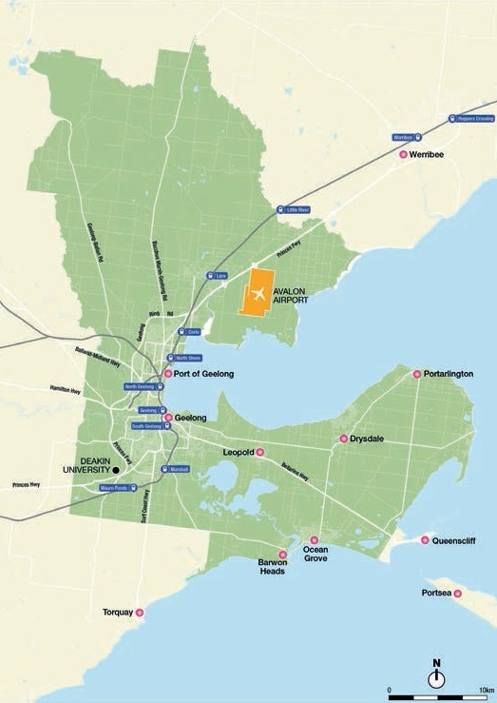

Figure 1: Major roads in our municipality

6

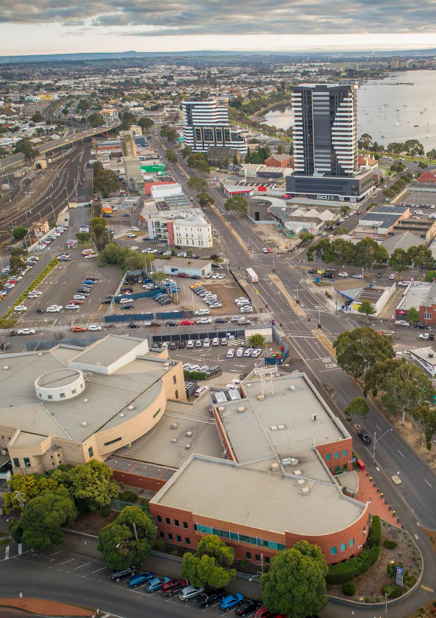

Road Safety Strategy and Action Plan 2022–2027 7

Pictured: Victoria Police is an important stakeholder in road safety

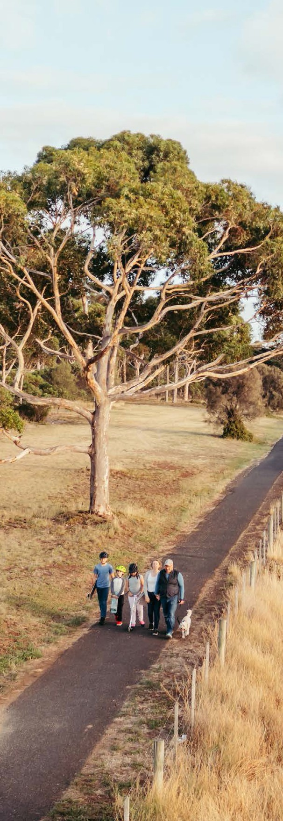

OUR ROLE

Like all local government authorities, we have an important role to play in improving road safety.
Our roles include:
  - Road Authority – managing the safety of the roads we own and manage, including a duty of care towards road users
  - Planning Authority – making decisions about land use and development that won’t compromise road safety
  - Employer – maintaining safe fleet vehicles and making sure our employees behave responsibly on the roads, while extending these principles to our contractors
  - Lobbyist – advocating to government for funding that improves transport infrastructure and services, as well as changes to legislation that will benefit the community
  - Community advocate – engaging and empowering our community to contribute to road safety by supporting community education and coordinating local resources

8

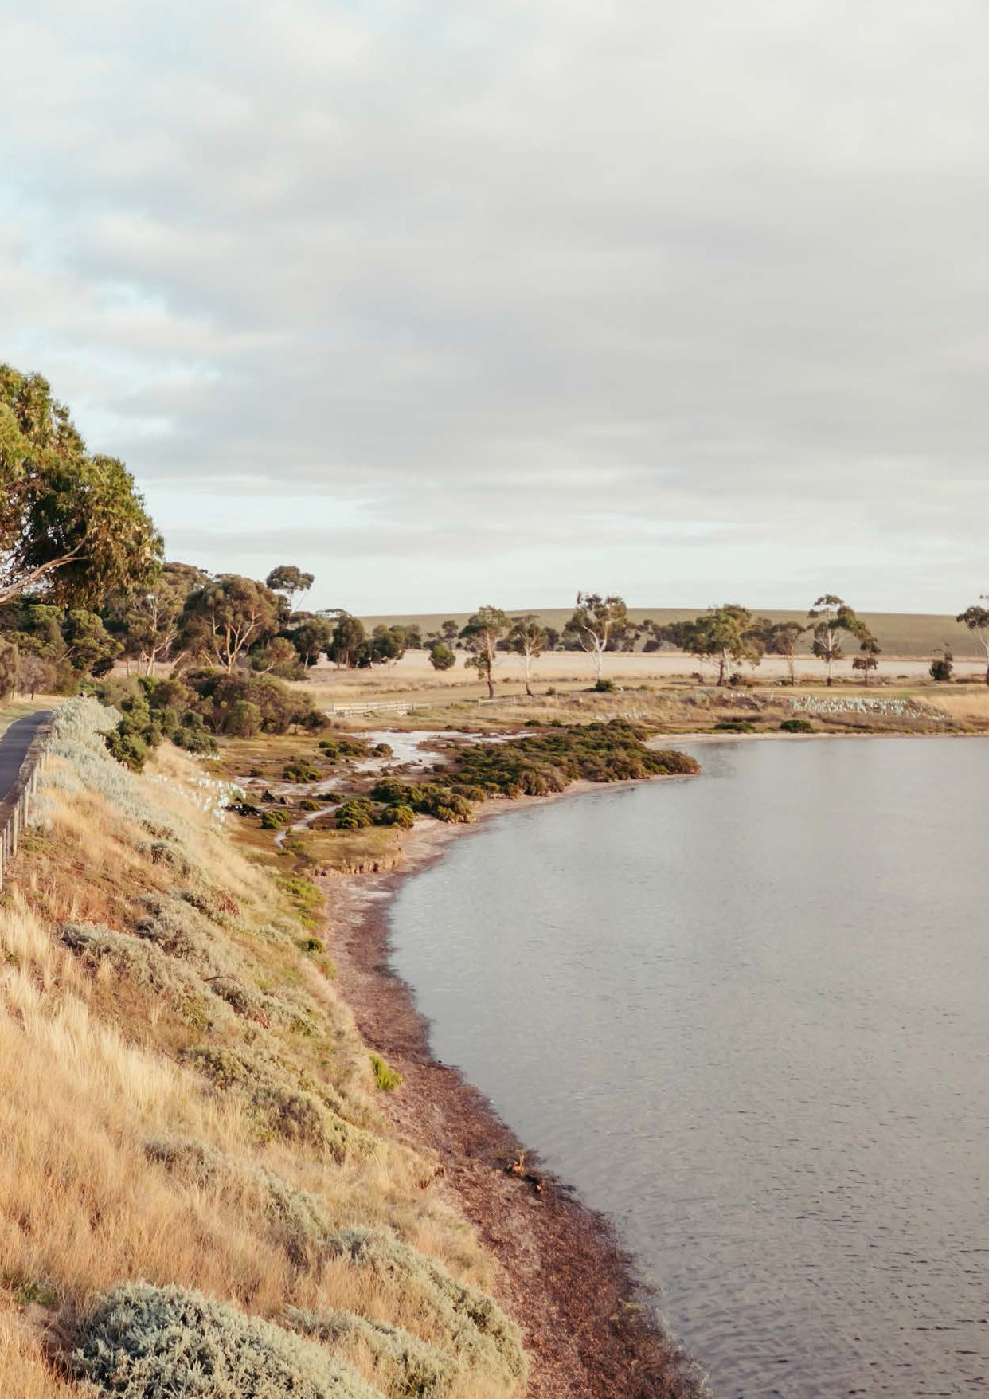Pictured: Hovells Creek Shared Path provides an off-road pedestrian and cyclist link between Lara and Geelong

Road Safety Strategy and Action Plan 2022–2027 9

We can improve road safety through all of these roles, but we are also reliant on other levels
of government to fund and provide certain infrastructure, services, policies, legislation and guidance. The split of responsibilities between different levels of government are shown below in simplified form.

THE CITY OF GREATER GEELONG
    - Building and maintaining local roads
    - Local bike and pedestrian networks
    - Advocating and supporting delivery of state infrastructure and services

VICTORIAN GOVERNMENT
    - Building and managing freeway, arterial roads and public transport networks
    - Providing train and bus services
    - Strategic bike networks
    - Speed limit policy (for all roads)
    - Road Rules/Legislation/Law
    - Vehicle standards

AUSTRALIAN GOVERNMENT
    - Funding for national highway network
    - City-shaping transport projects
    - Program funding for local government transport projects

While we identify and implement road safety improvements within our sphere of influence, we also advocate for improvements that are the responsibility of other parts of government. We support the Department of Transport’s infrastructure upgrades on arterial roads, particularly those that protect vulnerable road users and decrease the severity of crashes.

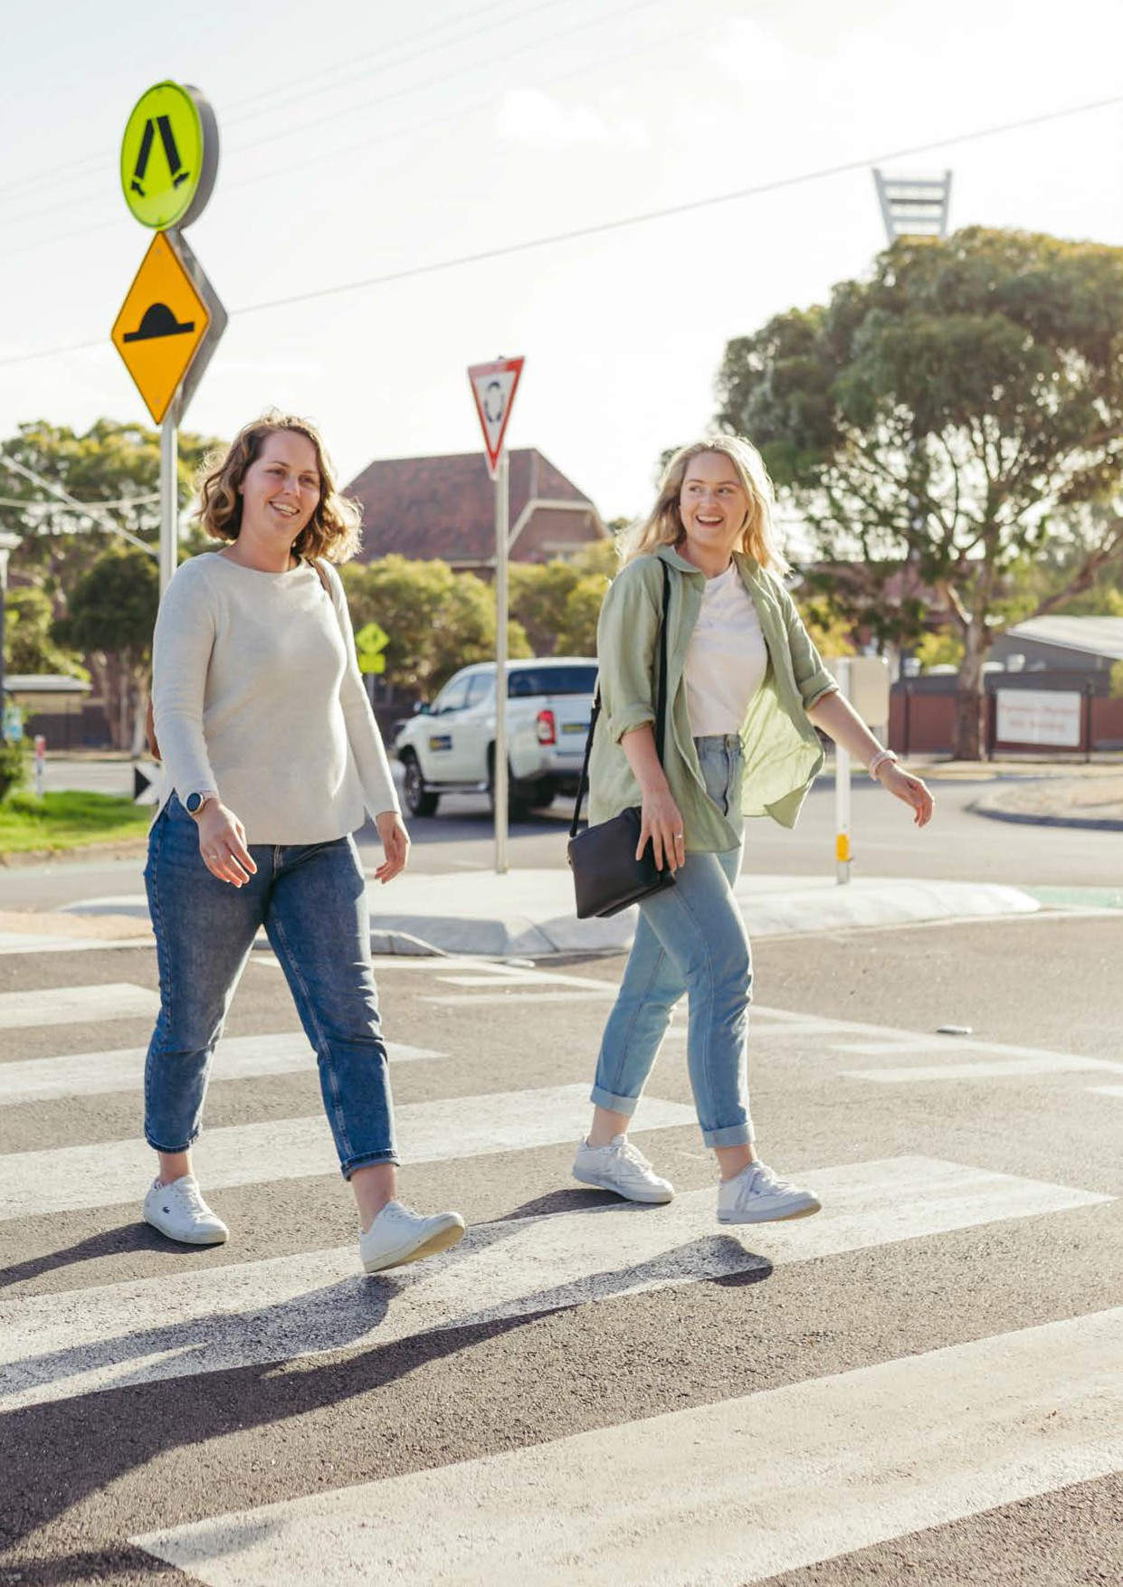

10

Pictured: The raised pedestrian crossing treatments at this intersection give pedestrians priority over vehicles at all times.
KILGOUR & YARRA
STREETS, SOUTH GEELONG
This project was designed to give pedestrians priority over vehicles at the roundabout. The features of the treatment include: speed reductions on Yarra and Kilgour streets; reduced approach speeds to the roundabout; designated crossings to give pedestrians; and visual separation of cyclists.
This project addresses a key principle of the Safe System: people are vulnerable. The treatment also supports the Principle Bicycle Network
east-west and north-south links between Latrobe Terrace and St Albans Road, and between Eastern Beach and the Barwon River.

Upgraded as part of the Safe Travel in Local Streets program, funded by the Victorian Government, in partnership with TAC.

OUR APPROACH TO ROAD SAFETY

This strategy has been informed by internationally recognised approaches to road safety, as well as national, state and local government legislation, policies, standards and practices. Two key approaches – Vision Zero and The Safe System – are described below.
This strategy also aligns with Greater Geelong: A Clever and Creative Future, the community's 30-year vision for our region. In particular, it aligns with these community aspirations:
  - A fast, reliable and connected transport network.
  - People feel safe wherever they are.
VISION ZERO
In developing this strategy, we aim to align with Vision Zero – the global movement to end traffic-related fatalities and serious injuries by taking a systemic approach to road safety. The road safety principles that can drive fatalities down are in place across most Australian states and territories. Overseas, many other countries have also adopted these principles, including Sweden, Canada, the United Kingdom, France, Norway and many large cities in the United States.
THE SAFE SYSTEM
The Safe System (see Figure 2) is an internationally recognised framework to reduce road trauma. The system, based on a Swedish framework that reduced fatal and serious injuries by 40 per cent over 10 years, is recognised in many countries, including Australia, as best practice.

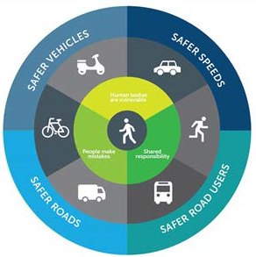

Figure 2: The Safe System

Road Safety Strategy and Action Plan 2022–2027 11

PRINCIPLES OF THE SAFE SYSTEM

Principle 1: The only acceptable fatality or serious injury toll on our roads is zero (zero tolerance)
Everyone is susceptible to being injured, so no one can be missed. Road safety needs to be focused towards reducing fatal and serious injuries.

Principle 2: People are vulnerable
When vehicles crash at high speeds, our bodies are subject to forces they cannot withstand. The approximate tolerances for the human body under different crash conditions are:
- Head-on crash: 70 km/h
- Side-impact crash with another vehicle: 50 km/h
- Side-impact crash with a tree: 30 km/h
- Pedestrian crash: 30 km/h
While our ability to withstand the impact of a crash is outside of our control, there is a lot that we can do to reduce or avoid these potential impacts.

Principle 3: People make mistakes
Human error is inevitable and, on our roads, human error can result in crashes and trauma. The Safe System recognises the unavoidable nature of human error.
Rather than placing the blame on the road user, it recognises the need for those involved in road design, road maintenance and road use to share responsibility for the many factors that contribute to serious injury or death on our roads.

Principle 4: Shared responsibility
Creating a safe road network is everyone's responsibility. Businesses, organisations, governments, communities and individuals all have a role to play in helping us achieve Vision Zero.

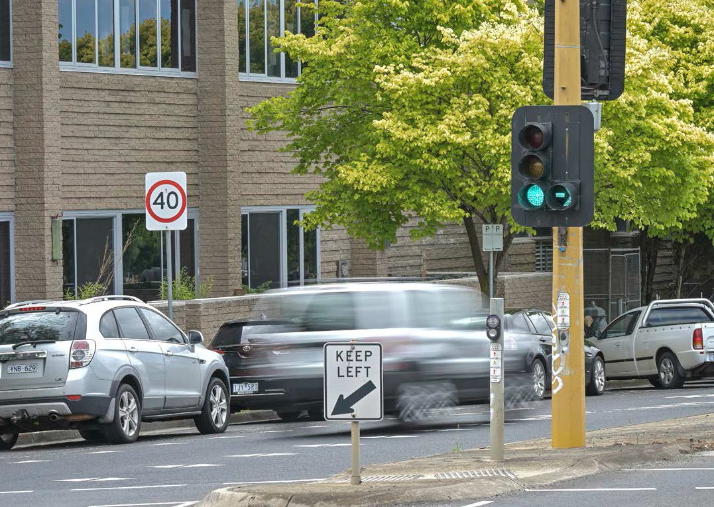
Pictured: Safer speeds save lives

12

ELEMENTS OF THE SAFE SYSTEM

There are four elements that make up the Safe System:
- Safe roads and paths – roads and paths should be designed and maintained to minimise or avoid risk in all conditions, and forgive human error.
- Safe speeds – even minor differences in speed can change the outcomes in an accident situation. Setting appropriate limits for the road
environment, and getting road users to comply, will reduce fatalities and serious injuries.
- Safe people – road safety can only be achieved if individual drivers know and follow the road rules and show respect for all other road users, regardless of their mode of transport.
- Safe vehicles – through better safety technology, vehicles will help reduce the likelihood of serious crashes.

Post-crash care
The length of time between a serious crash and the arrival of emergency treatment is critical to the outcomes of an accident. Emergency vehicle
accessibility must therefore be considered in our road safety planning.

Doing what works
Research shows that road trauma can be reduced when:
- leaders are committed
- road safety is addressed methodically
- the community is involved in planning and delivering road safety outcomes
- adopted safety measures have been proven to be effective.

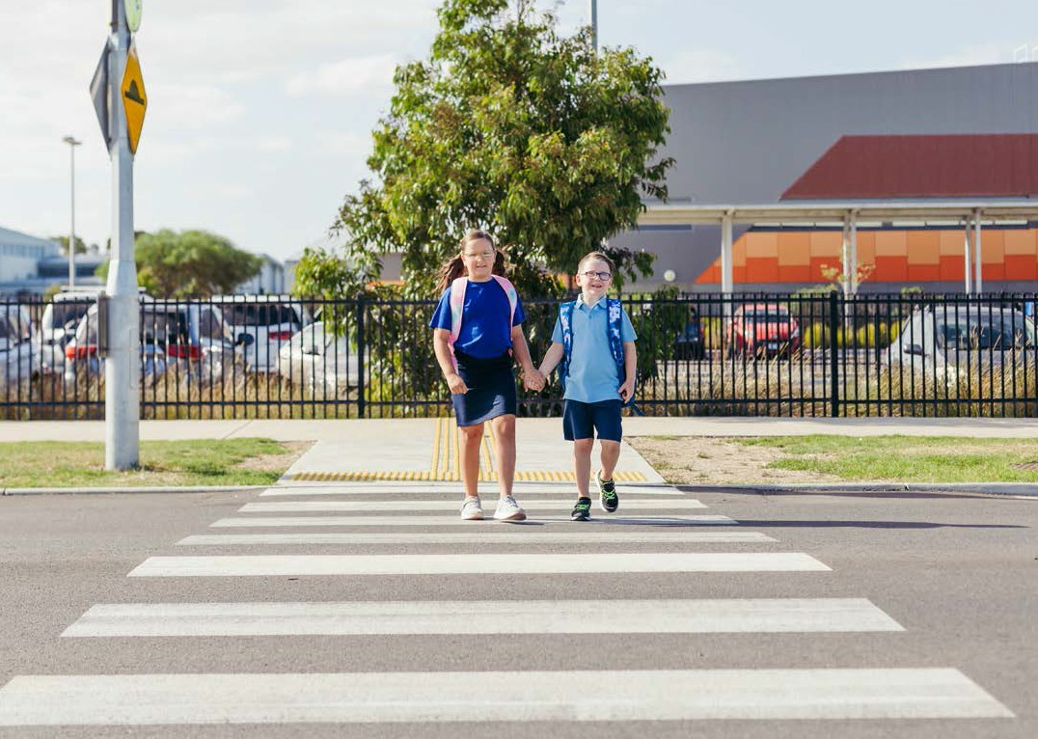
Pictured: These raised pedestrian crossings in
Armstrong Creek help families, teachers and students access the primary and secondary school.

Road Safety Strategy and Action Plan 2022–2027 13

DEVELOPING OUR VISION
ZERO STRATEGY

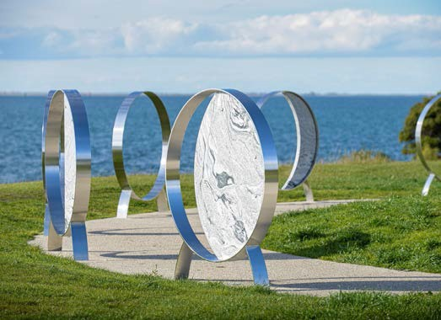To better understand road safety issues in the City of Greater Geelong, we looked at local crash data, listened to the perspectives of people in our community, and worked with road safety experts.
Pictured: Solace (2020) by Don Walters, road trauma memorial at Limeburners Point

Talking to road users and the community
We conducted an online public survey, and held community consultations and workshops with key road safety partners. We also collected feedback through regular forums, our website and other communication channels. This information gave us a better insight into the road safety issues that matter to the community.
A summary of feedback is available in Section 9 of the
Vision Zero Background Data Report.

Working with road safety experts
We consulted with a range of experts and knowledgeable stakeholders, especially those with local knowledge, to identify issues and potential solutions.
These discussions helped us to shape our strategic approach, action themes and actions.

Crash data
We analysed road safety crash data for the most recent five-year period that complete data was available (2015– 19). This gave us an insight into the types of crashes occurring, when and where they were happening, road conditions at the time, and who was involved.
High-level data is shown in Section 9 of the Vision Zero Background Data Report.

14

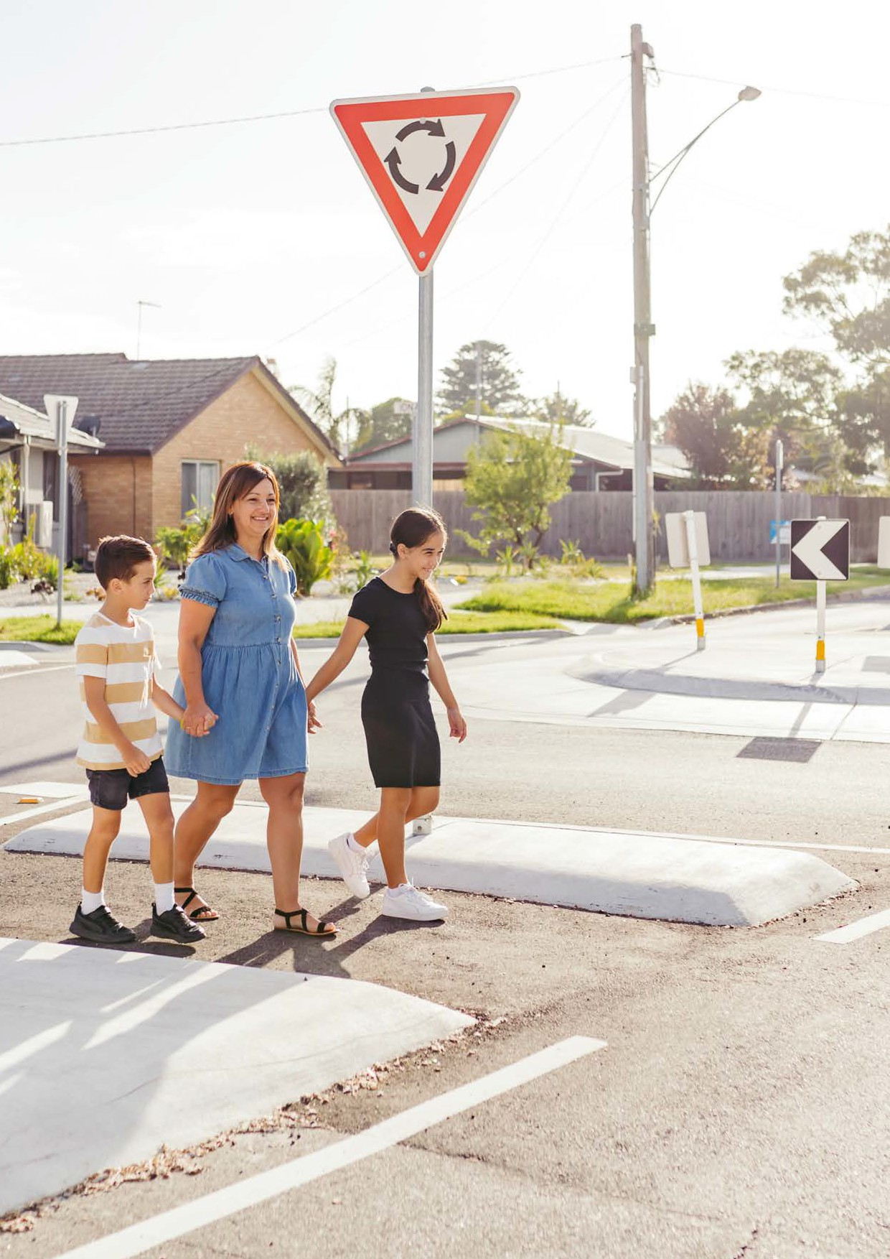

Road Safety Strategy and Action Plan 2022–2027 15

Pictured: Pedestrian refuges allow people to wait safely for a gap to cross
SPARKS ROAD, NORLANE
This project was designed to reduce vehicle approach speeds, reduce the number of vehicle conflict points and provide a safer crossing environment for pedestrians. The key features of the treatment include: an upgrade of the
Sparks Road and Iona Street intersection to a roundabout; installing a speed hump nearby and a raised pedestrian crossing to slow vehicles down as they approach; and building pedestrian refuges, so pedestrians can cross the road in two stages.
Safe roads and paths that forgive human error are a key element of the Safe System.

* Upgraded as part of the Safe Travel in Local Streets program, funded

by the Victorian Government, in partnership with TAC.

CRASH DATA - COMPARISON

Crash history between 2010 and 2019 shows there has been a decrease in serious injury crashes in our municipality, but fatal crashes are (on average) not decreasing.

CRASH COMPARISON BETWEEN GREATER GEELONG AND VICTORIA
Prior to 2016, Greater Geelong generally had a lower crash rate per 100,000 population compared to the Victorian average. Since 2016, the rate has been higher.
Over the identified ten-year period, Greater Geelong averaged 86 fatal and serious injury crashes per 100,000 population, compared to the Victorian average of 80.

Fatal and Serious Injury Crashes per 100,000 population

- Greater Geelong and Victoria (2010-2019)

120

93 100 78 90 79 83 82 105 97 58

100
94
96
87
87
88
84
84
73
61
48
FSI crashes per 100,000 population

80

60

40
2010 2011 2012 2013 2014 2015 2016 2017 2018 2019

Greater Geelong Victoria

Figure 3 – Greater Geelong and Victoria fatal and serious injury crashes per 100,000 population (2010–2019)

16

COMPARISON WITH OTHER REGIONAL CITIES
Greater Geelong’s fatal and serious injury crash rate does not compare favourably with the regional cities of Bendigo and Ballarat:

Greater Geelong
86 crashes*
Bendigo
77 crashes*
Ballarat
61 crashes*

*per 100,000 population on average

Fatal and Serious Injury Crashes per 100,000 population

- Bendigo, Ballarat and Geelong (2010-2019)

120

93 100 78 90 79 83 82 105 97 58

100
99
93
89
89
74
70
78
75
94
96
87
87
88
84
84
73
56
61
52
48
FSI crashes per 100,000 population

80

60

40
2010 2011 2012 2013 2014 2015 2016 2017 2018 2019

Greater Geelong

Ballarat

Bendigo

Figure 4 – Fatal and serious injury crashes per 100,000 population – Regional city comparison

Road Safety Strategy and Action Plan 2022–2027 17

CRASH DATA – TREND

We analysed detailed crash data for the five-year period between 2015 and 2019 (the latest year for which a complete data set is available). Over this five-year period, there were 1005 serious injury crashes and 37 fatal crashes, which resulted in 1073 serious injuries and 40 fatalities on our roads.

Fatal and Serious Injury Crashes - Trend

300

250
251

240

200
Number of crashes
190 185

150

139

100

50

4 11 7 4 11
0
2015 2016 2017 2018 2019

Fatal Serious

Figure 5 – Fatal and serious injury crash trend 2015–2019

Headline figures for fatal and serious injuries for 2021 show that seven lives were lost on Greater Geelong roads, and there were about 200 serious injuries.

WHERE ARE CRASHES HAPPENING?
Fatal and serious injury crashes are most likely to happen in locations with the following characteristics:
- Areas where there are high volumes of traffic and vehicles are able to cross paths – for example, arterial roads and local intersections.
- Areas where there is significant movement of motor vehicles in close proximity to pedestrians and cyclists – for example, local roads (speed limits up to 50 km/h). These crashes are more dispersed.
Figure 6 shows City of Greater Geelong crash hotspots. It shows a concentration of fatal and serious injury crashes in Geelong CBD, along the A10 between Corio and Belmont, and along the A300/B110 between Bell Post Hill and Leopold.

18

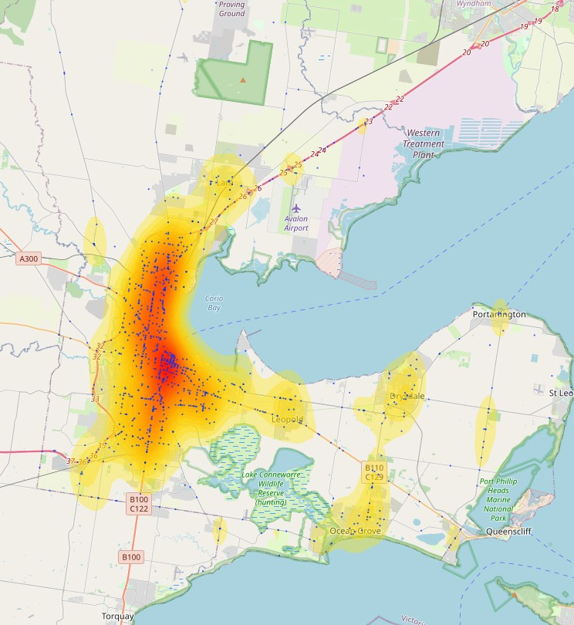

Figure 6: Heat map showing fatal and serious injury crash hotspots in the City of Greater Geelong

Forty per cent of fatal and serious injury crashes happen on local roads, while 60 per cent happen on arterial roads. The heat map helps us identify high-risk crash locations so we can focus our attention on areas where there is likely to be the most benefit.
A full breakdown of crash data is available in the Vision Zero Background Data Report. A breakdown of fatal and serious injury crashes in Greater Geelong is summarised in Table 1.

Road Safety Strategy and Action Plan 2022–2027 19

Table 1: Overview of fatal and serious injury crashes in Greater Geelong

ROAD USER | LOCAL ROADS | ARTERIAL ROADS | MOST COMMON TYPE | HOTSPOTS | COMMENTS
Pedestrians | 65 | 53 | Generally being struck when crossing the road, or crossing driveways. Approximately 60 per cent are mid-block – between intersections. | Roads with high pedestrian activity, such as Central Geelong. | Although pedestrian crashes occur more often on roads with lower speed limits, vehicle speeds are still high enough to cause significant trauma when a crash does happen.
Cyclists | 52 | 36 | Cyclist are most at risk when using intersections and making right turns. | Central Geelong, Corio,  Belmont/Highton, Grovedale/Marshall and Whittington
Motorcyclists | 55 | 62 | Right-turn crashes (both head-on and side impacts) are  relatively frequent, split fairly evenly between intersections and mid- block. Loss of control on a straight carriageway is also relatively frequent. | Central Geelong and along a north-south corridor from Corio to South Geelong, via Drumcondra.
Cars (private vehicles) | 384 | 557 | Rear-end crashes – especially on arterial roads. Cross traffic at intersections and right-turn crashes are  also relatively frequent, with a fairly even spread across other crash types. There is an even split between intersection and mid-block crashes. | Central Geelong and the corridor running north-south from Corio to Grovedale. There  is also a hotspot in Whittington. | Most of the crashes are on roads with 60 km/h or above because drivers are more likely to lose control at higher speeds and the crashes are likely to be more severe.
Heavy vehicles | 19 | 51 | Cross-traffic crashes at intersections.  Nearly 70 per cent of crashes occurred at intersections. |  | A little over 70 per cent of heavy vehicle crashes occurred on arterial roads, with hotspots between Geelong and Corio.

20

There are many Safe System treatments that can be used to address different crash types. Typical treatments for the prominent crash types in Greater Geelong are shown below. These treatments are just a part of our more holistic approach to road safety, which is described more fully in the Our Strategy and Action Plan section.

CATEGORY PROMINENT CRASH TYPES INTERVENTION 1 INTERVENTION 2

Pedestrians Pedestrian struck whilst crossing
the road (52 per cent of pedestrian fatal and serious injury crashes).

Wombat crossings Pedestrian refuge islands

Cyclists Using intersections and right turns (48 per cent of cycle fatal and serious injury crashes).

Protected intersection Hook turns

Motorcyclists Run off road (65 per cent) and
right turn crashes (65 per cent and 19 per cent of fatal and serious injury crashes respectively).
SPEED LIMIT

Fully controlled right turn Safe speed limits

Intersection Travelling through, or turning
at, intersections (23 per cent of private vehicle and nearly 34 per cent of heavy vehicle fatal and serious injury crashes).

Raised intersection Roundabout

Mid-block Rear-end crashes, mainly arterial.
(18 per cent of vehicle fatal and serious injury crashes on arterial roads).

Turning lane
Skid resistant (anti-skid) surfacing

Run-off road Run-off road crashes are evenly
split between arterial and local roads (20 per cent on both).

Safety barriers Audio tactile line markings

Road Safety Strategy and Action Plan 2022–2027 21

OUR STRATEGY AND ACTION PLAN

OUR STRATEGIC APPROACH
As Figure 7 shows, the first step in adopting a contemporary Vision Zero planning approach is to establish a vision that will guide us toward a future free of road injuries and death, transforming our city transport system to incorporate evolved road users, vehicles, roads and travel speeds. As we design the blueprint for our future city, we are analysing the existing system and its performance to find areas that do not fit with our vision.
Having a good understanding of the current system
- its risks and weaknesses, how its being managed, and its alignment with our vision – is central to the development of strategic actions. Identifying where the gaps are between our current and desired future state shows us where we've got work to do. If we identify gaps without proven solutions, we know we need to innovate, adjust or reorientate our approach to find new ways to prevent road trauma.
This will be an ongoing work. We continually monitor the road safety performance of our roads and check if our blueprint is still appropriate, or if we need to adjust our actions.

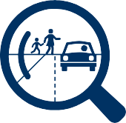
Develop our vision
and blueprint
What does a city free of death and serious injury on the roads look like?
Gap analysis
Where are the gaps between our current road system and the vision of our future safe city?
Strategic response
What needs to be done to fill those gaps? What are the known solutions?
Where do we need innovation?
Monitoring and
adapting
How are we performing? What do we need to adjust? What are the emerging trends?

Figure 7: Strategic approach to Road Safety – Vison Zero planning

22

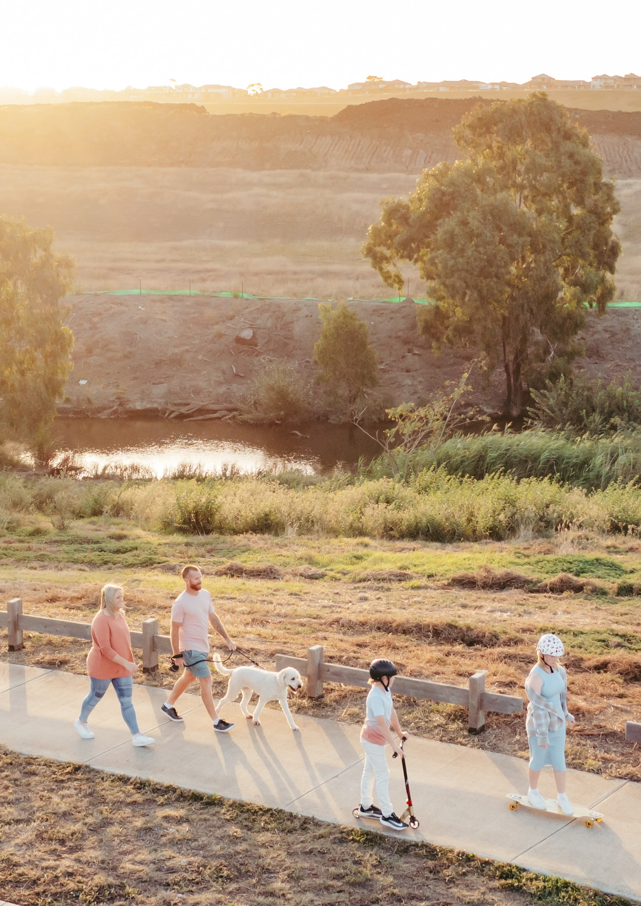

Road Safety Strategy and Action Plan 2022–2027 23

OUR ACTION THEMES
Based on our research, analysis, consultations, and application of best practice in road safety management, we have identified the following themes to guide our road safety response over the next 5 years:
  - Leadership and Best Practice - We are committed to Vision Zero and the Safe System Approach and we will act as an exemplar for road safety.
  - Working Together - We will work with our Road Safety Partners and the local community to shape the future of road safety together.
  - Safe System Approach - We apply the globally recognised Safe System approach, which addresses the four main factors that contribute to a crash:
  - Safe roads and paths
  - Safe Speeds
  - Safe People
  - Safe Vehicles
  - Active and Public Transport - We will reduce risks for active transport users, recognising how important this is for a healthy and sustainable community.
We have shaped an ambitious action plan around these themes.

Pictured: Monier Way Shared Path provides an off-road link between the Barwon River, Fyansford and surrounding suburbs.

ACTION PLAN

LEADERSHIP AND BEST PRACTICE
We will integrate Vision Zero and the Safe System approach into our way of working, and encourage others to do the same. We will also build our capability to deliver road safety improvements based on sound evidence, the latest ideas and technologies, and careful prioritisation.

NO. | AIM | ACTIONS/TASKS | MEASURE | TARGET | PARTNERS | TIMEFRAME
1 | Develop a Vision Zero Plan | Develop a process for identifying gaps between the current state of the transport  system and Vision Zero (with no trauma) | Document and trial the process | Formal process established | Dept of Transport, Victoria Police | Years 1–2
2 | Implement Vision Zero Plan | Use the plan to identify top priority safety interventions | Implementation of interventions | One intervention each year | Dept of Transport, Victoria Police | Year 3 onwards
3 | Improve organisational understanding of road safety | Include regular Safe System messages in internal communications, and integrate Safe System messages  into other relevant and appropriate communications | Publish internal communication articles | Two articles per year |  | Yearly
4 | Champion new road safety technology | Establish an annual technology review with regional partners to proactively identify and consider new transport- related technologies, and develop guidance to promote its use | Annual review completed | Identify technologies to promote | Dept of Transport, Victoria Police, G21 councils | Yearly
5 | Review and update our approach to promoting safe cycling | Develop a new Greater Geelong Cycling Strategy | Strategy document published on website | Strategy endorsed | Dept of Transport | Year 3 onwards
6 | Improve safety on road network | Maintain local roads and roadsides, in line with Making Roads Motorcycle Friendly Guidelines | Maintenance depots and contractors are aware of guidelines | Maintenance staff and contractors provided guidelines | Dept of Transport | Life of plan

24

ACTION
PLAN

7 | Provide professional development opportunities in road safety. | Road safety themed professional development session | 1 x session delivered | 20  professionals trained | Yearly
8 | Safe driving policy for employees. | Review current safe driving policy and update in line with Safe System principles | Policy updated and communicated to employees |  | Year 2
9 | Utilise a safe vehicle fleet. | Review and update our vehicle fleet policy to incorporate requirements for minimum ANCAP ratings, latest vehicle  safety technologies and establish a maximum vehicle and fleet age | Integrate updates into vehicle fleet policy | 5-star ANCAP  rating for all fleet vehicles | Year 1–5

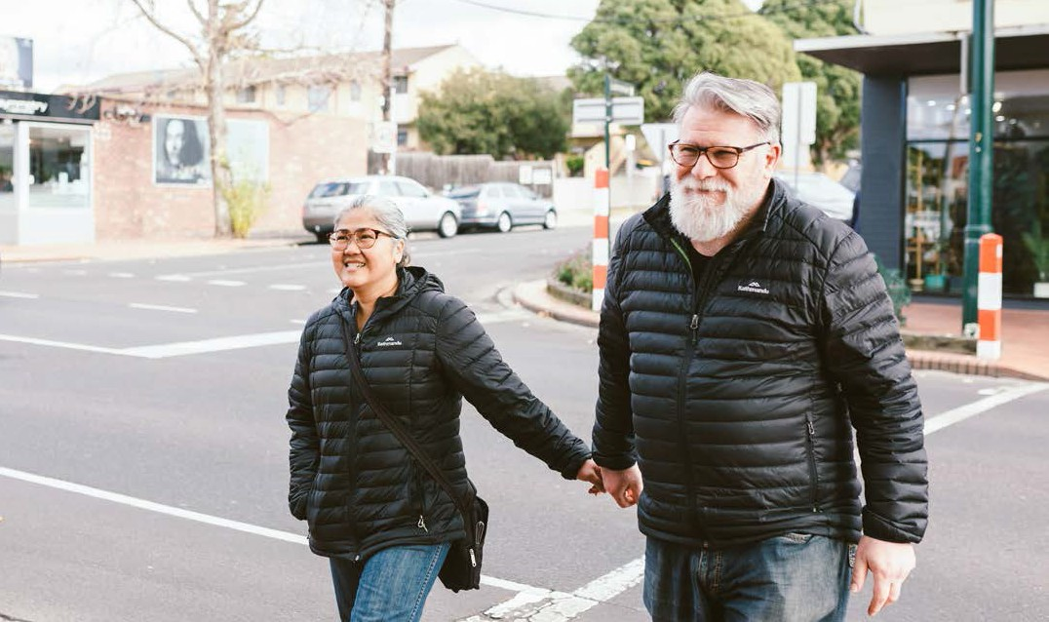
Pictured: Over half of fatal and serious injury pedestrian
crashes occur when pedestrians are crossing the road

Road Safety Strategy and Action Plan 2022–2027 25

- WORKING TOGETHER
Creating a safe road network is everyone’s responsibility. To achieve what we could not alone, we will work closely with road safety partners, including the Department of Transport, TAC, Victoria Police and our local health services. We will also work with our community to help shape road safety in a way that fits the local context.

NO. | AIM | ACTIONS/TASKS | MEASURE | TARGET | PARTNERS | TIMEFRAME
1 | Maintain cross- government organisational collaboration on road safety | Hold liaison meetings with the Department of Transport, VicTrack, bus operators, Public Transport Victoria, bordering councils and Victoria Police | Number of meetings held, follow-up on agreements and outcomes | Quarterly meeting forum |  | Life of the plan
2 | Maintain cross- government organisation collaboration on road safety | Work in collaboration with road safety partners to support the communication of key road safety messages relevant to the local community | Number of messages delivered from road safety partners |  |  | Life of the plan
3 | Engage the community on road safety projects and initiatives | Engage early on all major road safety projects and initiatives. | Public participation in accordance with IAP2 | Ensure engagement on all major road safety projects and initiatives |  | Life of the plan
4 | Increase resource commitments to road safety | Develop a list of funding sources and register  to online mailing lists for the TAC Grants  Program, Department of Transport, Community Road Safety Grants, and Federal Government Grants  Proactively seek funding and grants for road safety | Number of applications per year | Submit two applications each year |  | Life of the plan

26

ACTION
PLAN

- SAFE SYSTEM APPROACH
We will apply the four elements of the Safe System approach in our practice – safe roads, safe speeds, safe people and safe vehicles.

SAFE ROADS AND PATHS
Our roads and streets should be designed, built and maintained so that the risk of a crash is minimised and the severity of crashes are reduced.

NO. | AIM | ACTIONS/TASKS | MEASURE | TARGET | PARTNERS | TIMEFRAME
1 | Improve proactive identification of road safety issues | Develop a program of Local Area Traffic Management Plans for precincts to proactively review and address identified road safety issues | Delivery of plans | Complete plans | Dept of Transport | Yearly
2 | Improve safety for all road users through infrastructure improvements | Review crash data and associated maps to identify areas with high crash numbers  Identify the most common crash types within each area  Introduce road safety counter measures to target the identified common crash types | Reduction in fatal and  serious injury crashes for each road user group |  | Dept of Transport | Yearly
3 | Address intersection crashes | Develop a prioritised list of intersections requiring safety improvements  Identify safety treatments and develop a program of improvements, with possibilities including: improving safety for pedestrians crossing, reducing the number of conflict points, requesting installation of safety cameras | Number of intersections treated | Ensure engagement on all major road safety projects and initiatives | Dept of Transport | Yearly

Road Safety Strategy and Action Plan 2022–2027 27

SAFE ROADS CONT.

NO. AIM |  | ACTIONS/TASKS | MEASURE | TARGET | PARTNERS | TIMEFRAME
4 | Increase safety at Black Spot Sites or Black Spot areas | Review crash data and associated maps to identify areas with high fatality or serious injury crashes  Assess treatment required for each black spot  Submit application for funding to improve black spot safety. | Number of black spot sites removed over time | Two sites | Dept of Transport | Yearly
5 | Improve parking safety for Disabled Parking spaces | Undertake a rolling review of safety and accessibility of Disabled parking spaces  Conduct a program of upgrades | Upgrade 2 Disabled Parking  spaces each year | Two parking spaces | Dept of Transport

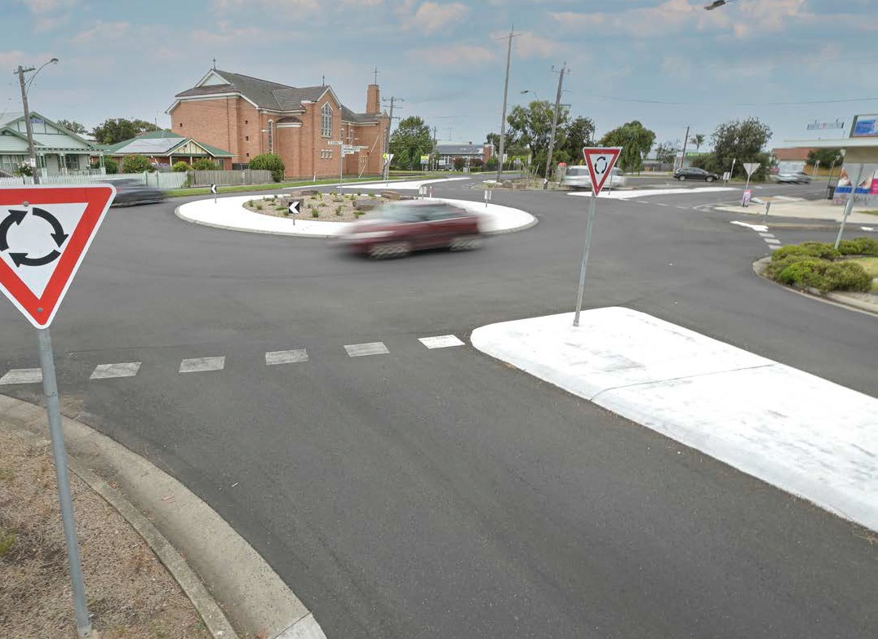
Pictured: Slowing vehicles as they
approach this roundabout helps improve safety for drivers and pedestrians
ST ALBANS ROAD, THOMSON
This project has improved safety with better crossing points and safer speeds through the intersection. The features of the treatment include: modified kerb outstands to reduce vehicle speed through the roundabout; new kerb outstands and footpath connections to provide safer crossing points and; an upgrade of an existing children's crossing to a raised pedestrian crossing.
Safer Roads and paths are an important principle of the Safe System. This treatment also supports the Principle Bicycle Network north-west and south-east links between McKillop Street and Boundary Road.
* Upgraded as part of the Safe Travel in Local Streets program, funded by the Victorian Government, in partnership with TAC.

28

ACTION
PLAN

SAFE SPEEDS
Our roads should have appropriate speed limits and road users should travel at speeds that are safe for the road conditions, so that the chances and consequences of a crash are reduced.

NO. | AIM | ACTIONS/TASKS | MEASURE | TARGET | PARTNERS | TIMEFRAME
1 | Safe and consistent speed limits in Greater Geelong | Work with Department of Transport to develop a speed limit strategy for all roads (local and arterial) in Greater Geelong | Develop strategy | Strategy completed | Dept of Transport | Years 1–3
2 | Improve safety on road network | Advocate for reducing default 100 km/h speed limit on unsealed roads to 80 km/h | Advocacy letter developed  and sent to Victorian Government | Completion | Dept of Transport | Year 3
3 | Increase safety for vulnerable road users around schools | Trial school zone safety treatments | Trial 30 km/h school zones and pavement marking project | Evaluation of project | Schools, Dept of Transport | Life of plan
4 | Increase safety in residential areas | Implement area- wide 40 km/h zones in residential areas where studies and/or community feedback show that speed is a safety issue | Undertake study and speed limit review and implement findings | Review and actions completed | Dept of Transport, Victoria Police | Years 1–2
5 | Improve community understanding and acceptance of safe speeds | Provide community information about the relationship between speed, safety and liveability, as per the Advocate the Movement and Place framework | Number of messages and mediums of delivery | Leading up to peak accident  months, such as holiday seasons |  | Life of plan

Road Safety Strategy and Action Plan 2022–2027 29

SAFE PEOPLE
We will encourage our community to exercise care, attention and awareness of others when using our roads.

NO. | AIM | ACTIONS/TASKS | MEASURE | TARGET | PARTNERS | TIMEFRAME
1 | Improve awareness of road safety issues in schools. | Review road safety information and develop key messages for school communities | Updates as required | Key messaging sent to schools for newsletters |  | Life of plan
2 | Improve road safety during peak holiday periods | Trial road safety treatments that target safety issues arising from seasonal visits | Implement and evaluate trial | Identify effective measures for future deployment | Dept of Transport, Victoria Police, Victorian Government, tourism industry | Years 1-3
3 | Support Safer Young Drivers | Support TAC-funded L2P Program, and steering committee meetings  Support successful education programs and look to expand where possible | Promote and support:  Looking After Our Mates (schools and sporting clubs), Fit2Drive (schools – Year 11), Road Smart (Department of Transport).  Raise awareness that 'Driving  is not a game' through social media |  | Dept of Transport, TAC, driving schools | Life of plan

30

ACTION
PLAN

SAFE VEHICLES
We will publicly support modern vehicles that include features that improve the safety of drivers, passengers and other people.

NO. | AIM | ACTIONS/TASKS | MEASURE | TARGET | PARTNERS | TIMEFRAME
1 | Improve safety of infant / young child vehicle passengers | Make information available via our communication channels and fund up to 200 child restraint fitting checks | Updates as required, plus number of checks completed | Increase monthly users of road safety web page by 2 per cent per year and provide 200 restraint checks per year |  | Life of plan
2 | Improve awareness of new vehicle technologies | Make information available via our communication channels, including our website and Community Update | New web pages and links to other sites established | New web pages created |  | Life of plan
3 | Improve safety of freight movement | Advocate to the Victorian Government and Victorian Transport Association for safer and cleaner trucks. Promote VicRoads Heavy Vehicle Rollover Prevention Program |  |  | Dept of Transport, Victorian Transport Association | Life of plan

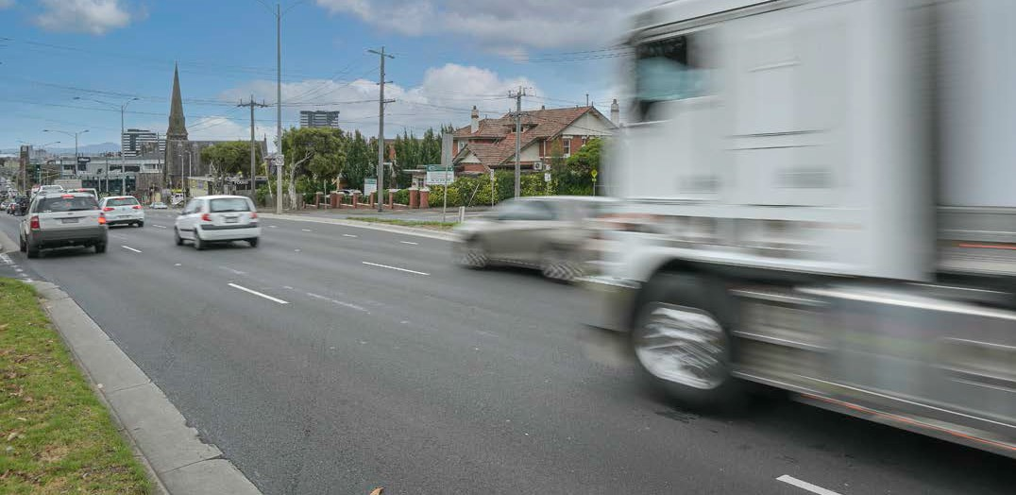
Pictured: Our arterial road network caters for
high traffic volumes and heavy vehicles

Road Safety Strategy and Action Plan 2022–2027 31

- ACTIVE AND PUBLIC TRANSPORT
As pedestrians and cyclists are particularly vulnerable on our roads, we will actively seek to reduce the risks for this group of road users. By doing so, we hope to encourage people to adopt healthier and more sustainable transport habits that will benefit the whole community.
Our strategy will focus on:
    - addressing high risks for pedestrians and cyclists, which will cover locations of high-pedestrian activity
    - making crossing the road safer for pedestrians and cyclists
    - implementing speed limits that are appropriate to the operating environment.

NO. | AIM | ACTIONS/TASKS | MEASURE | TARGET | PARTNERS | TIMEFRAME
1 | Safe journeys to school | Undertake safe access audits and/or road safety investigations to identify road safety issues and implement improvements  Apply for Safe Travel to School grants | Complete at least one audit each year | Implement audit findings |  | Yearly
2 | Improve walking/ cycling crossing facilities | Deliver walking/cycling crossing facilities in high risk/priority areas including areas of  high pedestrian use, schools, activity centres and public transport locations | Number of new walking/  cycling crossing facilities constructed | 2 sites per year |  | Yearly
3 | Improve pedestrian crossing facilities at roundabouts | Deliver raised priority pedestrian crossings at high-risk roundabouts | Seek grant funding and install | 1 site per year | TAC | Yearly
4 | Improve cycling crash accident data identification | Review and identify key sources | Establish sources and formats | Annual collation, review and publishing | TAC,  Victoria Police, Dept of Transport, Regional Roads Victoria, Geelong hospitals | Life of plan

32

ACTION
PLAN

5 | Separate cyclists from traffic | Work with existing cycling advisory group to identify a prioritised list routes for separating cyclists from vehicular traffic | Create priority list and implement trial(s) | Trial(s) completed and evaluated |  | Year 3
6 | Improve bike lane/shoulder maintenance on Principal Bicycle Network roads | Ensure existing shoulders are cleared and swept in cyclist envelope  Where there is no kerb or channel, road edges to be profiled to remove rainwater | Designate responsibility and accountability for action  Incorporate bike lanes/ shoulders in the City's 'Report a problem' app | Calendar of cyclist specific  maintenance schedules  Maintenance department awareness of City roads | Dept of Transport | Life of the plan
7 | Reduce risk of car  dooring along strategically identified bike routes | Review road widths along strategically identified bike routes for suitability | Car door buffer zones implemented | Review completed |  | Year 3
8 | Improve active transport links to schools | Work with schools to review active transport routes to schools | Active transport maps for participating schools | All participating schools |  | Yearly
9 | Improve student bike riding skills | Provide fully funded training opportunities for Bike Education Facilitators | 20 Bike Education facilitators trained | 1 Bike Education session per year, per participating school |  | Yearly for the life of the plan
10 | Awareness and behavioural change messaging for cyclists | Increase awareness of cycle helmet laws and make cyclists aware of high-risk locations on the road network | Behavioural change | Information published and awareness levels surveyed | Dept of Transport / Regional Roads Victoria

Road Safety Strategy and Action Plan 2022–2027 33

34

CITY OF GREATER GEELONG WADAWURRUNG COUNTRY PO Box 104
Geelong VIC 3220
P: 5272 5272
E: contactus@geelongcity.vic.gov.au www.geelongaustralia.com.au

CUSTOMER SERVICE CENTRE
100 Brougham Street
Geelong VIC 3220 8.00am –5.00pm

© City of Greater Geelong 2022

LATEST NEWS:
@CityofGreaterGeelong
@GreaterGeelong

@CityofGreaterGeelong

CityofGreaterGeelong

